Ork order

allo

Manhattan Active
Warehouse Management
Solution Design Document
Lands’ End – Dodgeville Site

Table of Contents

Document Revision History 10
Introduction to the Solution Design Document 11
1. Purpose 11
2. Terminology / Acronyms 11
2.1 Manhattan Terminology 11
2.2 Lands’ End Terminology 14
2.3 SAP Terminology 14
3. About Lands’ End 14
4. Warehouse Overview and Floor Plan 15
Warehouse Management 23
5. Key Decisions / Assumptions 23
5.1 General 23
5.2 Interfaces 23
5.3 Locations 24
6. Master Data 24
6.1 Organization 24
6.2 Facilities 25
6.3 Unit of Measure (UOM) 26
7. Interfaces 26
7.1 Inbound Interfaces – Download from HOST to WM 27
7.1.1 Vendor 27
7.1.2 Facility 27
7.1.3 Item 27
7.1.4 Purchase Order (PO) 29
7.1.5 Advanced Ship Notice (ASN) 29
7.1.6 Original Order and Production Order 30
7.1.7 Process Needs 30
7.2 Outbound Interfaces – Upload from WM to HOST 30
7.2.1 Perpetual Inventory Transactions (PIX) 30
7.2.2 Ship Confirmation 31
7.3 Gaps and Extensions 32
8. Pre-Receiving 32
8.1 Strategy 32
8.1.1 Purchase Orders (POs) and Advance Shipment Notices (ASNs) 32
8.1.2 Appointment Scheduling 32
8.1.3 Receiving Planning 33
8.1.4 Yard Management 33
8.1.5 Unloading 33
8.2 Assumptions 33
8.3 User Stories 34
8.3.1 User Story: Create ASN from PO 34
8.3.2 Create ASN (Blind Customer Returns) 36
8.3.3 User Story: Process Needs 36
8.3.4 User Story: Appointment Check-In 37
8.3.5 User Story: Yard Move Trailer 37
8.3.6 User Story: Appointment Check-Out 38
8.4 Features 38
8.4.1 Process Needs 38
8.4.2 Dock Doors 39
8.4.3 Yards 39
8.4.4 Appointments 39
8.5 Key Interfaces 39
8.6 Reports, Dashboards, Alerts 39
8.7 Gaps and Extensions 41
8.8 Labor Management 41
9. Receiving 41
9.1 Strategy 41
9.1.1 MHE Receipts Strategy 41
9.1.2 Non-Conveyable Receipts / Mobile Receiving Strategy 42
9.1.3 Returns Strategy 43
9.2 Assumptions 44
9.2.1 General Receiving 44
9.2.2 Returns 44
9.3 User Stories 45
9.3.1 User Story: MHE Receiving 45
9.3.2 User Story: Receive iLPN Level ASN 45
9.3.3 User Story: Receive Item Level ASN 46
9.3.4 User Story: Receiving & Palletize 47
9.3.5 User Story: Bulk ASN Receiving 47
9.3.6 User Story: Production Order - Outsource Receiving 48
9.3.7 User Story: Production Orders – Outsourcing Damages Receiving (Not used with EOM) 49
9.3.8 User Story: Production Order – Large Order Receiving 49
9.3.9 User Story: Production Order – Singles Receiving 50
9.3.10 User Story: Production Order – Multis, Name Badge & Enterprise Order Receiving 51
9.3.11 User Story: Returns Station UI 52
9.3.12 User Story: Mobile Returns 53
9.4 Features 54
9.4.1 Receiving Rules 54
9.4.2 Post Receiving Rules 54
9.4.3 Process Needs 54
9.4.4 LPN Disposition Strategy 54
9.4.5 Disposition Determination Priorities 55
9.4.6 Post Processing LPN Disposition 55
9.4.7 LPN Disposition & Sort Strategy 55
9.4.8 Receiving Exceptions 56
9.4.9 MHE Exceptions 57
9.4.10 WM Mobile Exceptions 57
9.5 Key Interfaces 57
9.6 Reports, Dashboards, Alerts 57
9.7 Gaps and Extensions 58
9.8 Labor Management 58
9.9 Key Interfaces 58
9.10 Reports, Dashboards, Alerts 58
9.11 Gaps and Extensions 58
9.12 Labor Management 58
10. Post-Receiving 59
10.1 Strategy 59
10.2 Assumptions 59
10.3 User Stories 59
10.3.1 User Story: Verify ASN in UI 59
10.4 Key Interfaces 60
10.5 Reports, Dashboards, Alerts 60
10.6 Gaps and Extensions 60
10.7 Labor Management 60
11. Sorting 60
11.1 Strategy 60
11.2 User Stories 61
11.2.1 User Story: Sort iLPN & Palletize. 61
11.2.2 User Story: End Container 61
11.3 Reports, Dashboards, Alerts 61
11.4 Gaps and Extensions 62
11.5 Labor Management 62
12. Vendor Performance 62
12.1 Strategy 62
12.2 Assumptions 62
12.3 User Stories 62
12.3.1 User Story: Vendor Performance 62
12.3.2 Updates 63
12.4 Reports, Dashboards, Alerts 63
12.5 Gaps and Extensions 63
12.6 Labor Management 63
13. Putaway 63
13.1 Strategy 63
13.1.1 Putaway Planning Strategy 63
13.1.2 Putaway Task Creation Strategy 64
13.1.3 Putaway Execution Flow 64
13.2 Assumptions 64
13.3 User Stories 65
13.3.1 User Story: Pallet Putaway (Suggest Putaway /Tasking Mode) 65
13.3.2 User Story: LPN Putaway (User Directed) 65
13.3.3 User Story: Pallet Putaway to Replenishment Belt 66
13.3.4 User Story: Putaway Cart - Fill Active 67
13.3.5 User Story: Fill Active 68
13.3.6 User Story: Post VAS Putaway 68
13.4 MHE Messages 69
13.5 Features 69
13.5.1 Alternate 69
13.5.2 Substitute 69
13.5.3 Radial Search 69
13.5.4 Vicinity Based Putaway (Suggested Putaway) 69
13.6 Key Interfaces 69
13.7 Reports, Dashboards, Alerts 70
13.8 Gaps and Extensions 70
13.9 Labor Management 70
14. Inventory Control 70
14.1 Cycle Counts Strategy 70
14.1.1 Assumptions 70
14.1.2 User Stories 71
14.2 Recall Inventory 76
14.2.1 User Story: Recall iLPN 76
14.3 Prepack Disassemble 77
14.3.1 Assumptions 77
14.3.2 User Stories 77
14.4 Miscellaneous Inventory Transactions 82
14.4.1 User Story: Modify iLPN 82
14.4.2 User Story: Consume iLPN 82
14.4.3 User Story: Pack iLPN (from Storage) 83
14.4.4 User Story: Create iLPN (from New) 83
14.4.5 User Story: Split Combine iLPN 84
14.4.6 User Story: Condition Code Assignment and Removal 84
14.4.7 User Story: Re-Identify Item / Bulk LPN Updates 85
14.4.8 User Story: Split Combine oLPN 85
14.4.9 User Story: Item Inquiry 86
14.4.10 User Story: iLPN Inquiry 86
14.4.11 User Story: Location Inquiry 87
14.4.12 User Story: Print iLPN Label 87
14.5 Features 87
14.5.1 Cycle Count Tolerance 87
14.6 Key Interfaces 87
14.7 Reports, Dashboards, Alerts 87
14.8 Gaps and Extensions 88
14.9 Labor Management 88
15. Flowthrough 89
15.1 Strategy 89
15.2 Assumptions 89
15.3 User Stories 89
15.4 Features 89
15.4.1 Order Selection Criteria 89
15.5 Key Interfaces 90
15.6 Reports, Dashboards, Alerts 90
15.7 Gaps and Extensions 90
15.8 Labor Management 90
16. Order Planning 91
16.1 Order Profile 91
16.2 Order Types 91
16.2.1 Customer Orders 92
16.2.2 Production Orders 92
16.2.3 Store Orders 99
16.2.4 Wholesale 99
16.2.5 Transfer Orders 100
16.2.6 Special Orders 100
16.3 Order Strategy 100
16.3.1 Order Aggregation 101
16.3.2 Order Prioritization 102
16.3.3 Order Pipeline 103
16.4 Order Planning Strategies 104
16.4.1 Unit Sorter Wave 105
16.4.2 Customer Order Planning (Non MHE Flows) 108
16.4.3 Production Order Wave 109
16.4.4 Retail Wave 109
16.4.5 Truck Load Wave 110
16.4.6 Chase Order Planning 110
16.4.7 Fill and Kill Order Planning 110
16.5 User Stories 111
16.5.1 User Story: Run Wave (Order Planning Strategy) 111
16.5.2 User Story: Run Wave (Orders UI) 111
16.5.3 User Story: Release Batches 112
16.5.4 User Story: Pre-VAS Batch and Task Label Printing 112
16.6 Features 113
16.6.1 Undo Wave 113
16.6.2 End Work 113
16.7 Key Interfaces 113
16.8 Reports, Dashboards, Alerts 113
16.9 Gaps and Extensions 114
16.10 Labor Management 114
17. Allocation 115
17.1 Assumptions 115
17.2 Strategies 115
17.2.1 Unit Sorter Allocation Strategy 115
17.2.2 Customer Order Allocation Strategy (Non MHE) 117
17.2.3 Retail Allocation Strategy 118
17.2.4 Production Orders Allocation Strategy (Non MHE) 118
17.2.5 Truck Load Allocation Strategy 119
17.2.6 Chase Allocation Strategy 120
17.2.7 Fill and Kill Allocation Strategy 120
17.3 Reports, Dashboards, Alerts 120
17.4 Gaps and Extensions 120
17.5 Labor Management 121
18. Routing 121
18.1 TL/LTL Carrier/Service/Ship Via 121
18.1.1 Service Provider 121
18.1.2 Service Level 121
18.1.3 Ship Via 121
18.2 Store Orders Routing Strategy 121
18.3 Parcel Routing Strategy 122
18.3.1 Parcel Determination Strategy 122
18.3.2 Parcel Resource 122
18.4 Outsource Production Order Routing Strategy 124
18.4.1 Bypass Routing 124
18.4.2 Routing Criteria 124
18.5 Truck Load Routing Strategy 125
18.5.1 Bypass Routing 125
18.5.2 Parcel Determination Strategy 126
18.5.3 Static Routing Strategy 126
18.5.4 Routing Criteria 126
19. Cubing 128
19.1 Assumptions 128
19.2 Container Types 128
19.3 Cubing Strategies 129
19.3.1 Sorter X Cubing Strategy 129
19.3.2 Sorter A and B Cubing Strategy 130
19.3.3 Pre-VAS Cubing Strategy 131
19.3.4 Truck Load Cubing Strategy 132
19.3.5 Non-Cubed Criteria 133
20. Work Release 134
20.1 Assumptions 134
20.2 Work 134
20.3 Resource Group Family Batching 134
20.3.1 Sorter A and Sorter B Resource Group Family 135
20.3.2 Sorter X Resource Group Family 137
20.3.3 HM Sorter Resource Group Family 140
20.4 Feedback Manager 146
20.5 Re-Prioritization 146
20.6 Sort Pack Resource Strategies 146
20.6.1 Sorter A and B Sort Pack Resource Strategy 146
20.6.2 Sorter-X Sort Pack Resource Strategy 147
20.6.3 HM Sorter Sort Pack Resource Strategy 147
20.7 Picking Task Creation Strategy 148
20.7.1 Sorter A and B Picking Task Creation Strategy 148
20.7.2 Sorter-X Picking Task Creation Strategy 149
20.7.3 HM Sorter Picking Task Creation Strategy 150
20.8 Direct Task Release 151
20.8.1 Direct Task Creation Strategy 151
20.9 MHE Messages 153
20.10 Gaps and Extensions 153
21. Replenishment 153
21.1 Assumptions 153
21.2 Replenish iLPNs to Unit Storage 154
21.2.1 User Story: Pull iLPNs to Pallet for Replenishment Conveyor 154
21.2.2 User Story: Build & Execute Putaway Cart for iLPNs 155
21.2.3 User Story: Pull iLPNs to Pallet for Bulk Unit Storage 155
21.2.4 User Story: Putaway Bulk iLPNs on Pallet 155
21.2.5 User Story: Pull iLPNs to Pallet for GOH Unit Storage 155
21.2.6 User Story: Putaway GOH iLPNs on Pallet 156
21.2.7 User Story: Pull Pallet for Replenishment 156
21.2.8 Process 156
21.3 MHE Messages 157
21.4 Features 157
21.4.1 Lean Time Replenishment 157
21.4.2 Auto Substitute iLPN 157
21.4.3 Alternate iLPN (not currently utilized) 157
21.4.4 Skip Cancel 158
21.5 Key Interfaces 158
21.6 Reports, Dashboards, Alerts 158
21.7 Gaps and Extensions 158
21.8 Labor Management 158
22. Picking 158
22.1 Assumptions 158
22.2 Picking Strategy 159
22.3 User Stories 159
22.3.1 User Story: HM LPN Pull 159
22.3.2 User Story: HM Blk Pick 160
22.3.3 User Story: VAS LPN Pull 161
22.3.4 User Story: VAS BlkPick 163
22.3.5 User Story: Heat Transfer Logo Pick (Logo Pick) 164
22.3.6 User Story: Name Badge Pick (NameBdgPick) 166
22.3.7 User Story: MHE LPN Pull 167
22.3.8 User Story: MHE Bulk Pick (SA Act Pck, SB Act Pck, SX Act Pck) 169
22.3.9 User Story: LPN Pull 170
22.3.10 Bulk Pick (Pick to Tote/Guney) 172
22.3.11 User Story: Olpn Pick to Pallet (Olpn2Pallet) 173
22.3.12 User Story: Olpn Pick 174
22.4 Picking Exceptions 176
22.4.1 Assumptions 176
22.4.2 User Story: Picking Exceptions from LPN Pulls 176
22.4.3 User Story: Picking Exceptions from Active Locations 177
22.5 MHE Messages 178
22.6 Features 178
22.6.1 Alternate Location Pick (not currently utilized) 178
22.6.2 Skip/Replenish (not currently utilized) 178
22.6.3 Picking Shortage 178
22.6.4 Replenish Storage Location (not currently utilized) 178
22.6.5 In Line Cycle Counts 178
22.7 Key Interfaces 178
22.8 Reports, Dashboards, Alerts 178
22.9 Gaps and Extensions 178
22.10 Labor Management 179
23. Pre-VAS Sorting 179
23.1 User Stories 180
23.1.1 User Story: Pre-VAS Order Sort 180
23.2 Pre-VAS Sorting Exceptions 181
23.2.1 User Story: Gurney or Tote Inventory Discrepancies 181
23.2.2 User Story: Clear Pre-VAS Putwall 181
23.2.3 User Story: Close Container 182
23.2.4 User Story: Residual Putaway 183
24. Packing 183
24.1 Assumptions 183
24.2 User Stories 184
24.2.1 User Story: Putwall Olpn Sort (LE Putwall Sort) 184
24.2.2 User Story: Gift Box Putwall Sort 187
24.2.3 User Story: Pack Station UI 188
24.2.4 Pack Station UI (Single Olpn Tote) 189
24.2.5 User Story: Large VAS Customer Orders (Non-Cube Packing Flow) 190
24.2.6 User Story: Pre VAS Packing (Descriptor Label Print) 191
24.2.7 User Story: Put to Store - Packing 192
24.2.8 User Story: Put to Store – Close Container 193
24.3 Packing Exceptions Stories 193
24.3.1 User Story: MHE Chute Close (Matthews Pack Stations) 194
24.3.2 User Story: Clear Putwall 196
24.3.3 User Story: Hospital Runner Putaway (Outbound Putaway – User Directed) 196
24.3.4 User Story: Hospital Putwall Sort (Hospital Runner) 197
24.3.5 User Story: Re-print VAS Descriptor Label 198
24.4 MHE Messages 198
24.5 Features 198
24.6 Key Interfaces 198
24.7 Reports, Dashboards, Alerts 198
24.8 Gaps and Extensions 198
24.9 Labor Management 199
25. Outbound Putaway 199
25.1 Assumptions 199
25.2 Pre-VAS Putaway Strategy 199
25.2.1 Stevens Point Putaway Flow 199
25.2.1 Dodgeville Putaway Flow 200
25.2.2 Stevens Point Shipping Dock Putaway Criteria (Tasking) 200
25.2.3 Stevens Point Load Trailer (WM Mobile) 201
25.2.4 Stevens Point Unload Trailer (WM Mobile) 202
25.2.5 Heat Transfer Logo Outbound Putaway (Tasking) 203
25.2.6 HM06 Outbound Putaway (Tasking) 203
25.2.7 Pre-VAS Opening Station Putaway (Tasking) 204
25.2.8 Pre-VAS Putaway (WM Mobile) 204
25.3 MHE Induction Putaway Strategy 205
25.3.1 Sorter A, Sorter B and Sorter X MHE Induction Putaway (Tasking) 205
25.3.2 HM Sorter Induction Putaway (WM Mobile) 205
25.4 LE Outbound Putaway Strategy 206
25.4.1 Singles Pulls Putaway (Tasking) 206
25.4.2 Put to Store Putaway (Tasking) 206
25.4.3 Workstation Putaway (Tasking) 207
25.4.4 Staging Putaway (Tasking) 207
25.4.5 Anchor Olpn (WM Mobile) 208
25.4.6 Outbound Putaway (WM Mobile) 209
25.5 Features 209
25.6 Key Interfaces 209
25.7 Reports, Dashboards, Alerts 209
25.8 Gaps and Extensions 210
25.9 Labor Management 210
26. Shipping 210
26.1 Assumptions 210
26.2 Parcel Shipping 211
26.2.1 User Story: WM Mobile De-Manifest oLPN 211
26.2.2 User Story: WM Mobile Manifest oLPN 211
26.2.3 User Story: Weight & Manifest oLPN in UI 212
26.2.4 Olpn Planning Strategy 212
26.3 LTL Shipping 212
26.3.1 User Story: Manual Shipment Creation 213
26.3.2 User Story: Shipment Updates 214
26.3.3 User Story: Load Trailer 215
26.3.4 User Story: Unload Olpn 215
26.3.5 User Story: Close Shipment 216
26.4 Production Order Ship Confirm 216
26.5 MHE Messages 217
26.6 Features 217
26.7 Key Interfaces 217
26.8 Reports, Dashboards, Alerts 217
26.9 Gaps and Extensions 217
26.10 Labor Management 217
27. Miscellaneous Warehouse Processes 218
27.1 User Stories 218
27.1.1 User Story: Audit oLPN 218
27.1.2 User Story: Palletize oLPNs 219
Acknowledgement 220

Document Revision History
Changed By | Date | Version | Revision Notes
Benjamin Aponte | 10/07/2024 | 2.0 | Inbound Flow Draft – Based on Reedsburg CFD Version 1.2
Benjamin Aponte | 10/29/2024 | 2.1 | Inbound flow updates after initial review.
Benjamin Aponte | 11/4/2024 | 2.2 | Added Dodgeville Outbound Flows.
Benjamin Aponte | 11/20/2024 | 2.3 | Updates production order receiving stories.
Benjamin Aponte | 11/22/2024 | 2.4 | Updates production order flows.
Benjamin Aponte | 12/19/2024 | 2.5 | Updates to Pre VAS and Pos VAS flows
Benjamin Aponte | 3/27/2025 | 2.6 | Added Prepack Disassemble Story
Benjamin Aponte | 3/28/2025 | 2.7 | Updated Production Order receiving process.
Benjamin Aponte | 4/4/2025 | 2.8 | Updates form sections 9.3.6 to section 23
Benjamin Aponte | 4/18/2025 | 2.9 | Adding Routing Strategy and Manual Shipment Creation and Updates using ULC.
Benjamin Aponte | 4/23/2025 | 2.10 | Added Put to Store packing story and additional parcel resource determination criteria.
Benjamin Aponte | 4/29/2025 | 2.11 | Removed duplicate section 9.9.1 (identical to 9.4.1) and renumbered section 9.9.2 to 9.4.7.

Introduction to the Solution Design Document

Purpose
The primary objective of this document is to outline the proposed processes and scope from the perspective of Manhattan Associates across all stages of implementation. It also aims to identify key extensions to the Manhattan Associates suite of products. Specifically, this document details the scope for the receiving, storage, and fulfillment processes at the Dodgeville, WI Distribution Center.
The first objective is to capture customer-specific user stories and flows that leverage systematic functionality and any relevant exceptions. These user stories help identify detailed assumptions for each flow or module, defining the system’s parameters.
The second objective is to identify key gaps and required enhancements to the Manhattan Associates suite of products to support the defined user stories where the base product does not offer the desired functionality.
For interfaces, the purpose of the Solution Design Document is to describe the interfaces within the scope. Detailed information about these interfaces is provided in the Interface Mapping Sheets by the Manhattan Integration Team.
Note: Potential gap areas are highlighted throughout the document in this format – [GAP XX]. A detailed review is needed to resolve these gaps, either through business process changes, system configuration changes, extensions, integration changes, or developing workarounds as part of the detailed design activity. Detailed process flows are defined during the detailed design phase. For interfaces, the purpose of the Solution Design Document is to describe the interfaces within the scope. Detailed information about these interfaces is provided in the Interface Mapping Sheets by Manhattan Integration Team.
Summary of Product Suite covered in this document:
Products Licensed | Notes
Manhattan Active Supply Chain (MAWM) | Includes Distribution Management (DM) – i.e. Warehouse Management, Labor Management, and Supply Chain Intelligence solutions

Terminology / Acronyms

Manhattan Terminology
Terminology | Definition
Allocation | The process of dedicating specific inventory to distribution orders.
Appointment | An appointment is an agreement with the carrier or business partner (vendor) to arrive at a warehouse at an agreed-upon date and time and is an acceptance by the warehouse to receive the delivered freight.
ASN | Advanced Shipment Notice.  Receiving objects in MAWM indicating a unique inbound shipment of inventory for the warehouse.
Inbound Delivery | A logical grouping of inbound ASNs. Typically based on the ASNs that are part of the same physical container/trailer. One Inbound Delivery can consist of one or more inbound ASNs.
BOL | Bill of Lading.  A legal document used for the transportation of goods (non-parcel).
Condition Codes | Can be applied to location or LPN to prevent use. Inventory with an applied condition code can appear allocable or un-allocable to the host, depending on configuration. (Formerly Lock Codes)
DC | Distribution Center
DM | Distribution Management
EIF | Equipment Integration Framework
Error | An error in WM does NOT allow the user to continue WM processing after viewing the error.
Facility | A facility is an establishment, such as a warehouse, which serves a particular purpose in the shipping or delivery process.
Host | Generic term for the main external system upstream from MAWM (i.e. SAP, OMS, etc.) responsible for transmitting orders for fulfillment and consuming inventory updates; also holds master data.
iLPN | Inbound License Plate Number.  A unique barcode used in MAWM to track inbound inventory. A traceable moveable unit in the warehouse (case, pallet, tote). For Lands’ End, inbound inventory is identified by an LPN at the physical case level.
Item | Sellable product (aka SKU – Stock Keeping Unit). Usually item name, item description, and item barcode (e.g. UPC) are three unique values.
JSON | JavaScript Object Notation. The format in which MAWM expects incoming interfaces and sends outgoing messages.
LM | Labor Management
LPN | License Plate Number.
MA | Manhattan Associates
MAWM | Manhattan Active Warehouse Management
MHE | Material Handling Equipment.  Generically, any equipment used in the facility: forklift, pallet jack, putwall, conveyance, unit sorter, carton sorter, hang sorter, etc. Specifically, any equipment with a WCS component.
MIF | Manhattan Integration Framework
oLPN | Outbound License Plate Number.  A unique barcode used in WM to track outbound inventory.
Order | Formerly Distribution Order.  Orders include header-level level information like destination store facility and line-level information like item and quantity.
Original Order (OO) | Orders that are aggregated by MAWM based on rules and aggregation criteria
Order Aggregation | Original Orders with a matching Aggregation attribute may be combined into a single Distribution Order with the intent to cube inventory from multiple Original Orders into less oLPNs to be shipped.
Order Consolidation | Orders which will be shipped via the same shipment may have a consolidation attribute which brings oLPNs for the same attribute together to a like staging location before loading and shipping. The intent of this functionality is to keep all cartons for an order together after picking form different areas in the warehouse to be loaded together.
Distribution Order  (a.k.a. DC Order) | Distribution Order are either 1:1 to the Original Order or 1:N to multiple Original Orders in an attempt to aggregate in warehouse fulfillment.
Organization | Organizations represent legal entities such as companies and brands. Each organization has a unique set of application configuration, transactional data such as orders, and users. All transactional data is associated with one organization.
Pack | Represents the standard quantity UOM for a vendor case (box) of a particular item.
Pallet | A physical surface to stack cases on top of. Tracked systemically as an iLPN. Can have one barcode for all inventory on the pallet or unique LPNs for each case (nested LPNs).
PIX | Perpetual Inventory Transaction.  A PIX record is created by WM whenever a change in inventory occurs that increases or decreases net inventory between available and unavailable inventory buckets. The PIX record type and code provides visibility to the type of inventory change that occurred (LPN consumed, LPN received, LPN/location adjusted, etc.).
PO | Purchase Order.  Order placed from corporate systems to vendor for stock inventory. Usually fulfilled by multiple shipments from the vendor.
Putaway | The systematic process of locating product to a WM location.
SCAC | Standard Carrier Alpha Code
SCI | Supply Chain Intelligence.  Cognos-based business intelligence reporting software.
Ship Confirmation | Outbound interface to the host to detail the final order header and order detail information after an order is shipped.
Shipment | Unique grouping of orders on an outbound trailer. May have one or more outbound stops (non-parcel).
Strategy | A collection of configuration parameters to drive a certain process in the warehouse (e.g. Receiving Strategy)
Storage Location | Physical location which stores inventory for order fulfillment. Formerly active locations, reserve locations, case pick locations.
Tasks | A piece of work created for a specific allocation. Multiple allocations can be grouped into one task for efficiency.
TBF | To Be Filled.  Quantity allocated on a task destined for a location.
TBP | To Be Picked.  Quantity allocated for a task to be systematically picked from a location.
TMS | Transportation Management System
Trailer | Physical truck which contains the ASN/PO.
Yard Zone and Slots | Yard Zone is a group of Yard Slots that needs to be used in a similar manner.  Yard Slots are parking slots in a Yard when trailers can be dropped off once its checked-in to the Yard.
TL | Truck Load
LTL | Less Than Truck Load
UI | User Interface
UOM | Unit of Measure for quantifying and classifying storage, allocation, distribution, etc. For example: Pallet, LPN, Packs, Subpacks, Units.
Unit | Lowest sellable UOM (Unit of Measure) for an Item (aka “Each”)
Warning | A warning in WM allows the user to continue WM processing after acknowledging / accepting the warning message.
Wave | The process to select an order, allocate inventory, determine outbound shipping container size (cubing), and create tasks.
WCS | Warehouse Control System.  System external to WM that directly controls MHE given commands from WM.
WM Mobile | Manhattan Active Warehouse Management’s Android based application running on warehouse Radio Frequency (RF) devices utilized by warehouse operators to perform warehouse activities.
WM | Warehouse Management.
YM | Yard Management

Lands’ End Terminology
Lands’ End Terminology | Definition
Shipment | Outbound packages, known as OLPN in Manhattan.
Gurney | Metal container used as a tote to handle and transport inventory inside the warehouse or to transfer product between Lands’ End distribution centers.
VAS Order | Production Order
Shipment | An Order Olpn
Carrier Service | Shipment TL or LTL / Parcel Carrier Service
CORE | Lands’ End Core Business Items/SKU
LEO | Lands’ End Outfitter Items/SKU
LESU | Lands’ End School Uniform
LEF | Lands’ End Fulfilled (Amazon, Kohls, etc.)

SAP Terminology
SAP Terminology | Definition
Production Order | Order to produce a custom item by customer specifications.
KMAT | From the German “konfigurierbares Material” was formed the abbreviation KMAT, pronounced “kay-mat” used by SAP to define custom items.
Batch Number | Used to track the items associated to a specific production order.

About Lands’ End
Lands’ End, Inc. is an American retailer specializing in casual clothing, luggage, and home furnishings. Founded in 1963 by Gary Comer in Chicago, Illinois, the company is now headquartered in Dodgeville, Wisconsin. Lands’ End is known for its traditional, casual apparel for men, women, and children, which is generally resistant to changing fashion trends.
The company markets its products through various channels, including its flagship and specialty catalogs, about 15 outlet and retail stores in the US, UK, and Japan, and approximately 870 Sears stores. Lands’ End also has a significant online presence and continues to expand globally.

Warehouse Overview and Floor Plan
The Dodgeville facility consists of two interconnected physical buildings located in Dodgeville, WI, and a third building located in Stevens Point, WI. All three buildings are configured as one distribution center in Manhattan. Each physical building location is identified as a warehouse location with an area number that specifies the respective building.
Building | Warehouse Area | Building Size
Building 2, First Floor | 02 | 540,300 sq. ft.
Building 2, Second Floor | 02 | 540,300 sq. ft.
Building 6 | 06 | 146,000 sq. ft.
Steven Points | 07 | 159,410 sq. ft.
Reedsburg, First Floor | ?
Reedsburg, Second Floor | ?

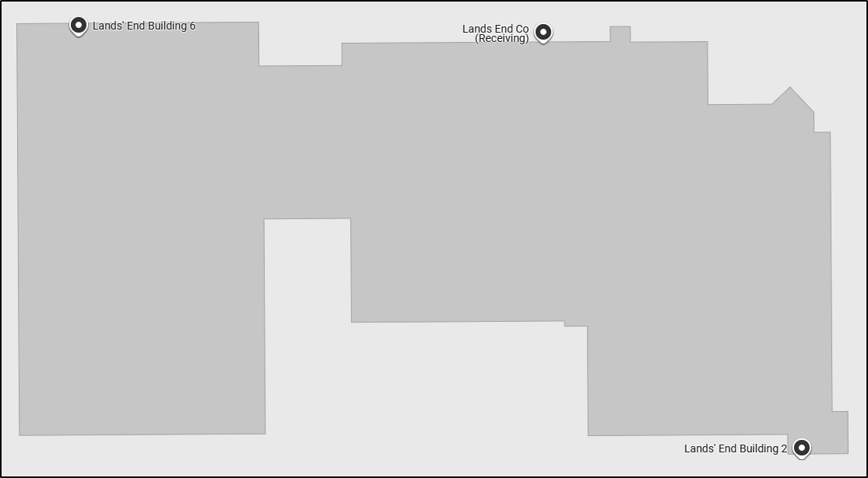
Figure 1 - Dodgeville Building 2 & 6
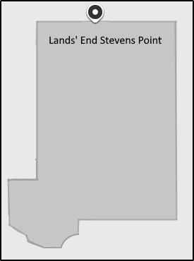
Figure 2 - Stevens Point Building

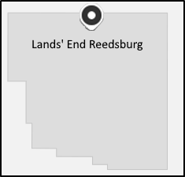
Figure 3 - Reedsburg Building

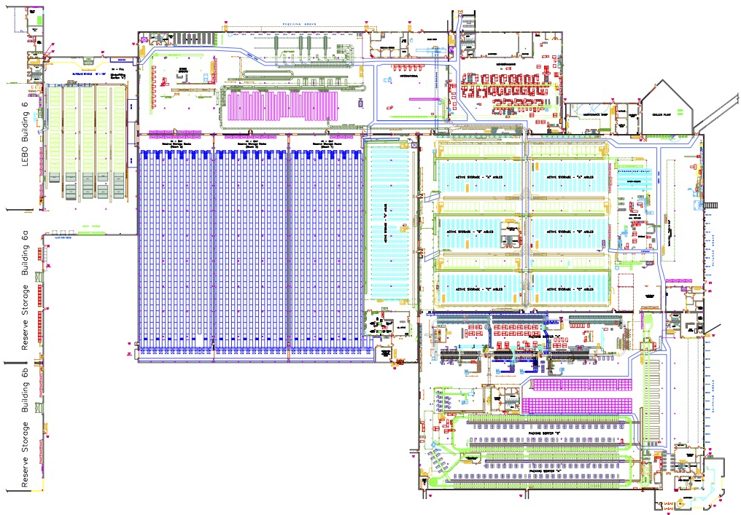
Figure 4 – Dodgeville Building 2 – First Floor

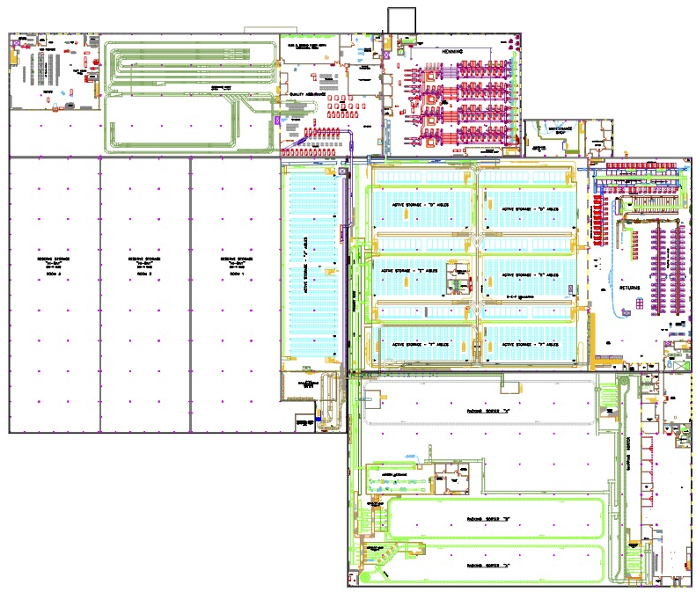
Figure 5 – Dodgeville Building 2, Second Floor

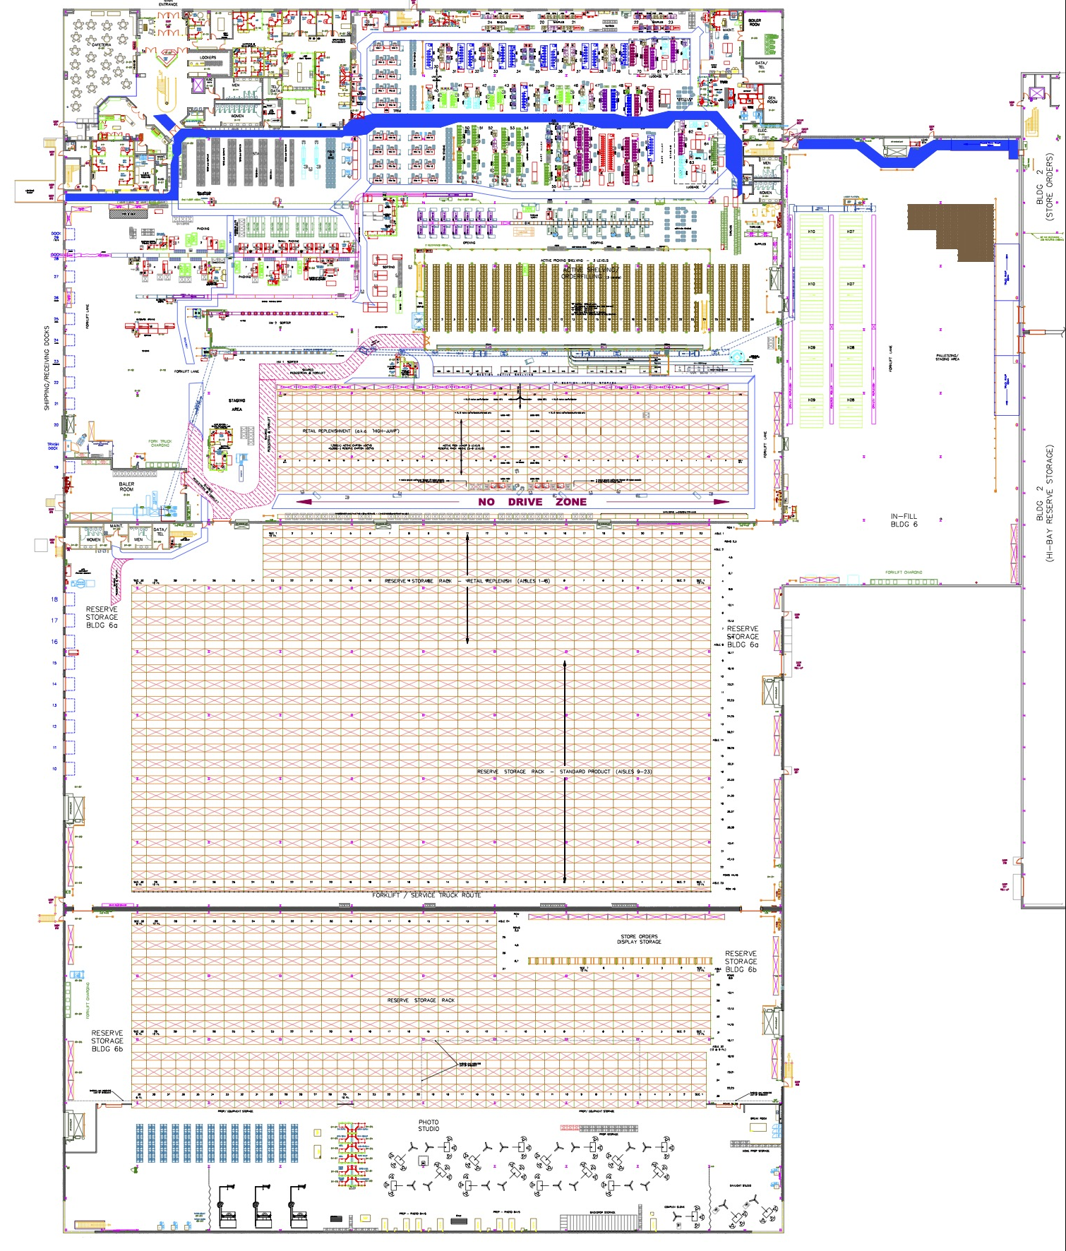
Figure 6 – Dodgeville Building 6, First Floor

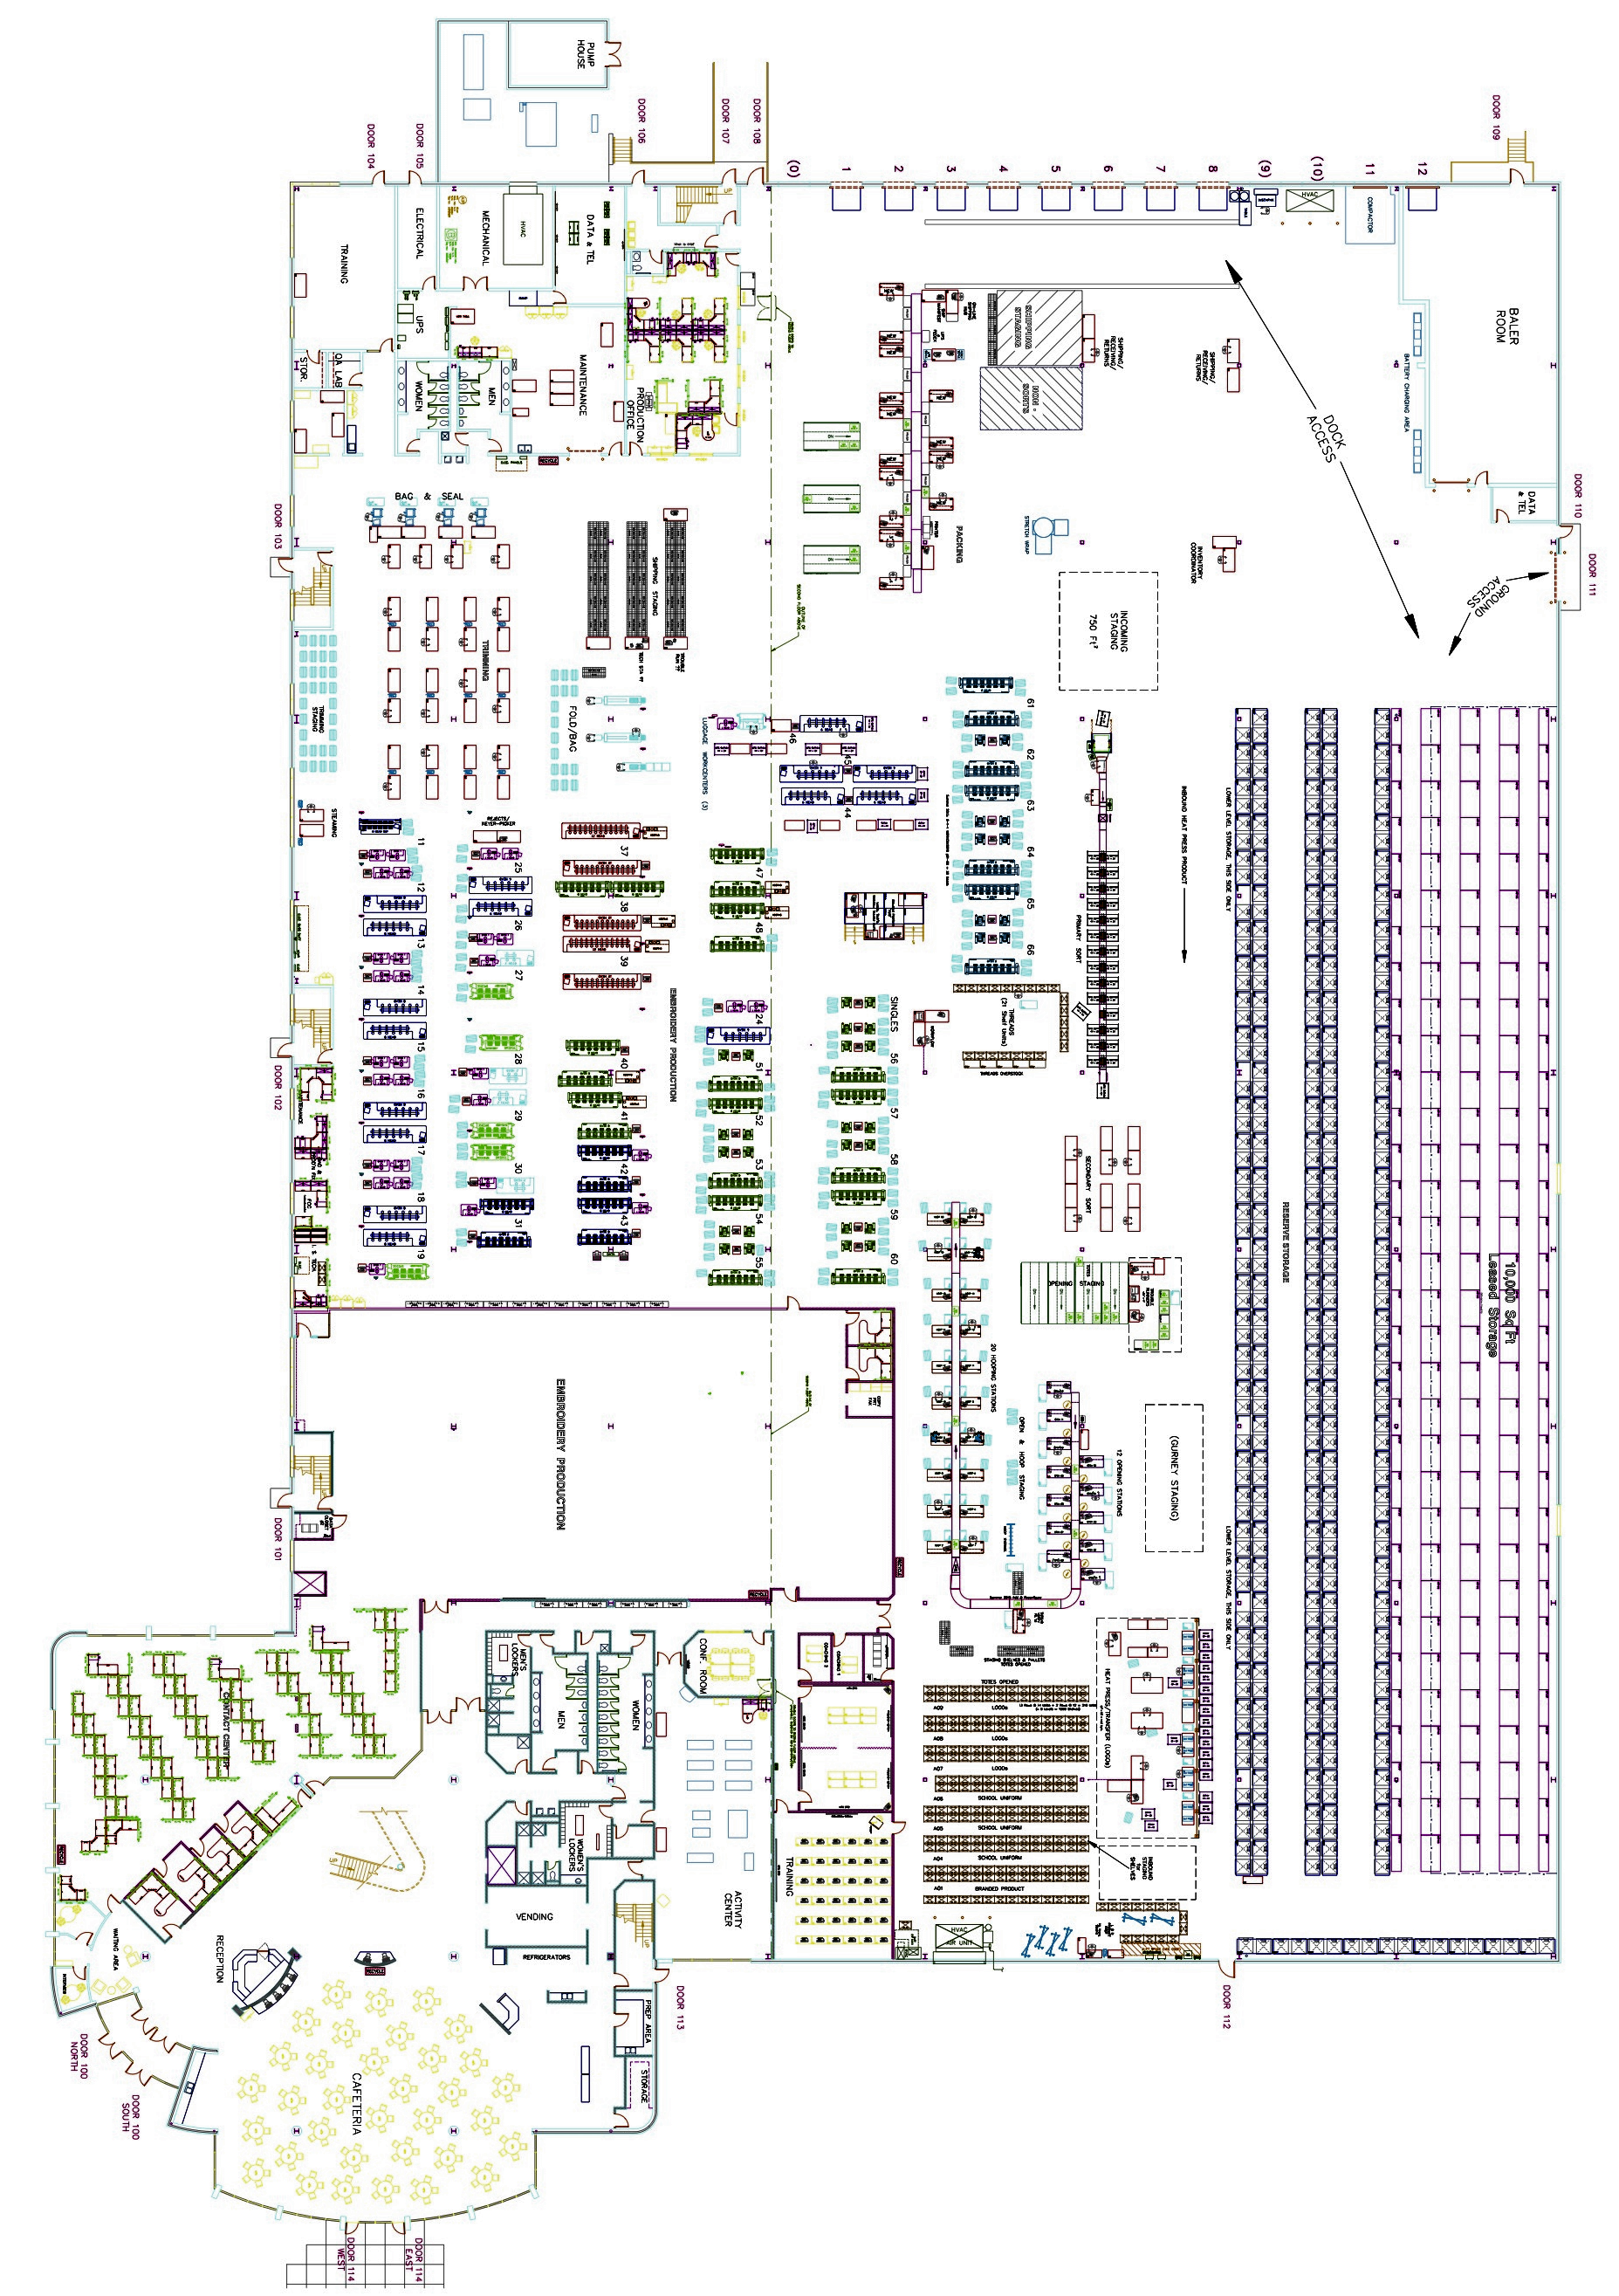
Figure 7 - Steven Point Floor Plan

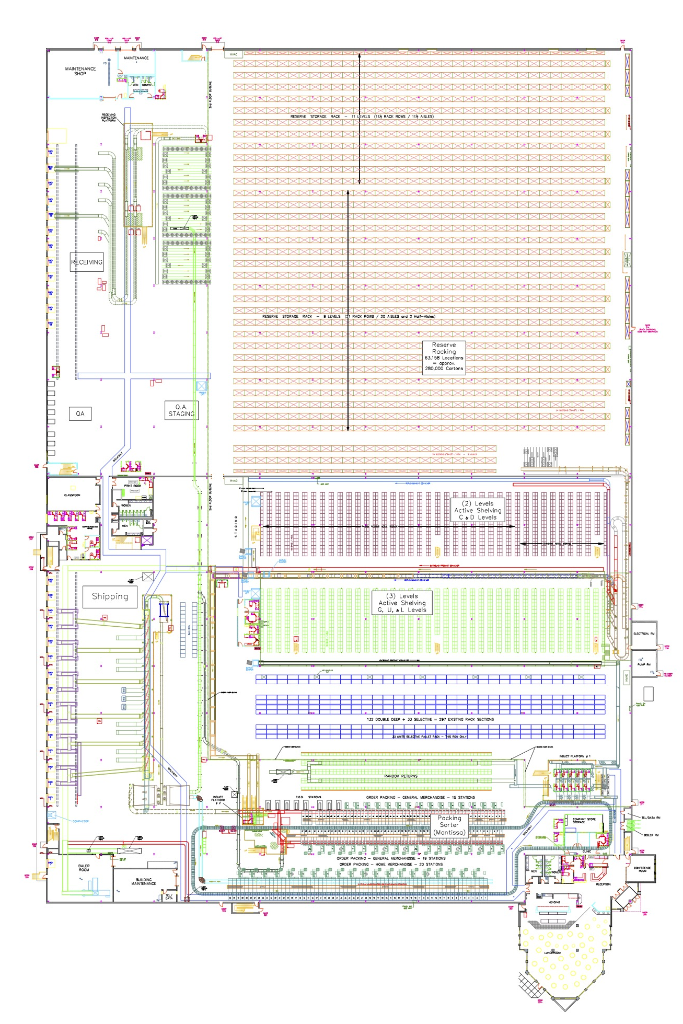
Figure 8 - Reedsburg, First Floor

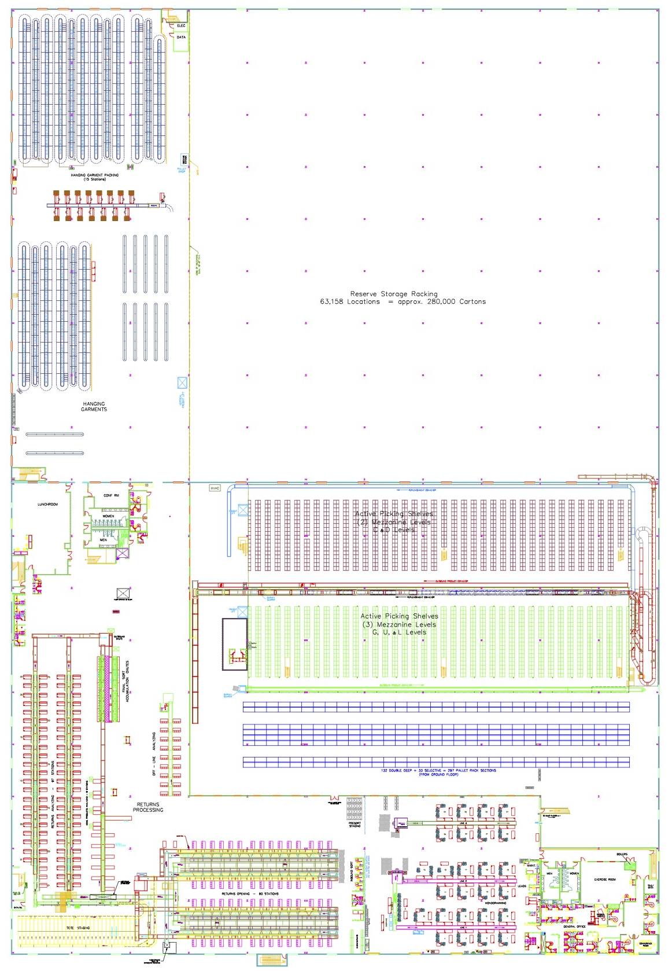
Figure 9 - Reedsburg, Second Floor

Warehouse Management

Key Decisions / Assumptions

General
- This Solution Design Document (SDD) covers the implementation of Manhattan Active Warehouse Management (MAWM). Detailed documentation for Supply-Chain Intelligence (SCI), Labor Management (LM), and Transportation Management (TM) is covered in separate documents.

- Several UI and Mobile features are mentioned and described in this document (e.g. Mobile Receiving).

- To maintain optimal system performance, the Manhattan Active Supply platform databases are configured to automatically purge data older than 90 days. However, this data retention period may be adjusted based on operational volumes and technical assessments outlined in the hardware-sizing document.

- All users must be created or interfaced to Manhattan Active Platform.

- All configuration is displayed in a language determined by the user account within WM.

- The SDD does not provide technical information regarding API calls, FTP, etc. That information is housed in a separate document.

- All tracked items in Manhattan Active Supply Chain Execution must have a scannable barcode in the Item Master for identification.

- All extensions mentioned in the SDD are subject to change based on detailed design conversations.

- Any label formatting not owned by Lands’ End will require a customization.

Interfaces
- Detailed interface mapping between HOST and DM for all inbound and outbound interfaces is documented separately in the Interface Mapping Spreadsheets.
- No file size for any interface into DM exceeds 5 MB, and all files will be in JSON format. Details provided with the detail interface mapping documents.
- Each SKU is unique to Lands’ End.
- The product class/sub-class of each item is interfaced from the host system as part of the item master.
- Only interfaces referenced in the SDD are considered in scope. If an interface is not mentioned, it is not considered in scope for the Global Design.
- Item without defined dimensions are initially created with default dimensions and volume based on their product class or category. These default dimensions are updated once the item is physically received.
- Fields that cannot be mapped directly to an interface field can utilize an extended attribute. This allows Lands’ End to map the value upstream to that extended attribute, which can also be edited in the associated UIs.
- If an interface fails in the MAWM application, it must be resubmitted or resent from upstream. This could involve resending the interface from the source system or resubmitting the message from the integration middleware, depending on the type of failure. Reports can be used to identify when an interface has failed, alerting Lands’ End to research the issue and resubmit the interface upstream once the issue is resolved, following the respective interface troubleshooting steps.

Locations

- All warehouse locations are labeled with a scannable barcode.
- Lands’ End uses Storage Locations with a Storage UOM of “LPN” (reserve locations) to putaway pallets and cases.
- Lands’ End uses Storage Locations with a Storage UOM of "Unit" known as active pick locations for loose unit picking.
- Lands’ End creates permanent location assignments for seasonal items. Additional dynamic assignments can be created during the waving process based on item demand.
- LPN Storage Locations (reserve) should be configured with a 'Temporary' SKU dedication type for single-item assignments and a 'None' SKU dedication type for multiple-item assignments.
- Unit Storage Locations (active) are mostly single SKU locations. For random returns storage locations, Lands’ End uses multi-SKU active locations. The SKU assignment and putaway to these locations are handled manually, as the system does not create multi-SKU assignments or direct inventory to these locations.
- Lands’ End does not track iLPNs in picking locations within WM.
- The location component “Area” is used to define storage and staging locations, specifying the physical building to which the location belongs.
- Randoms returns storage locations are configured with a Storage UOM of “LPN”.

Master Data

Organization
An organization represents the highest-level configuration entity within MAWM. The hierarchy-tree in order from highest to lowest is as follows:
Level 0 – Parent/Holding
Level 1 – Line of Business
Level 2 – Facility Organization, Facility.

Some MAWM configuration and transactional data can be maintained at an L1 organization level to be shared across L2 organizations/facilities. A common use case is a centralized item master so that any updates to an item master (L1) are immediately reflected in every facility (L2) underneath the common organization (L1).
Lands’ End maintains a single L1 organization within their application, with each facility (Reedsburg/Dodgeville) maintained as a separate L2 organization under the L1 parent Lands’ End organization.
Organization (L0) | Line of Business (L1) | Facility (L2)
Lands’ End Inc. (Org Id = LE-0) | Lands’ End Distribution Centers (Org Id = LE) | Reedsburg, WI (Org Id = 4)
Lands’ End Inc. (Org Id = LE-0) | Lands’ End Distribution Centers (Org Id = LE) | Dodgeville, WI (Org Id = 1)

Facilities
The term “facility” typically refers to a physical warehouse, distribution center, store, customer, vendor, etc. All of Lands’ End facilities executing WM are configured under a single Level 1 organization in MAWM and within the respective Level 2 organization for each facility, as displayed in the organigram below.
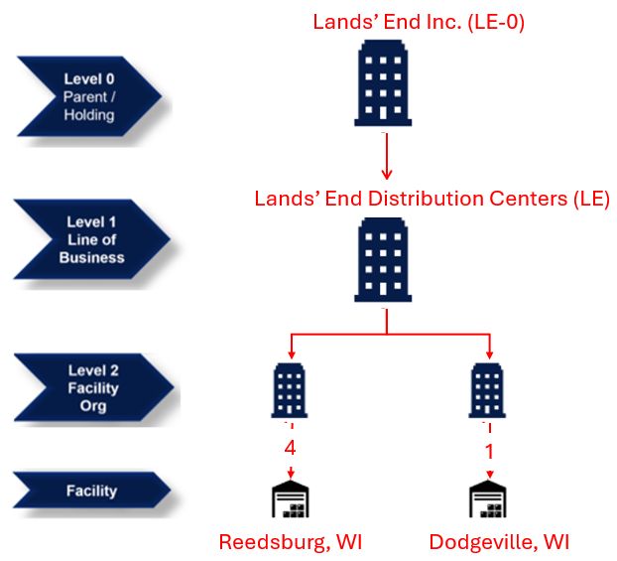
Master Data | L0 | L1 | L2
Master Data | LE-0 | LE | 4 | 1
Master Data | Lands’ End Inc. | Lands’ End DCs | Reedsburg, WI | Dodgeville, WI
Super / Corporate Users | X | X
Warehouse Associates, Temp Users |  | X | X | X
Warehouse Supervisors |  | X | X | X
Items |  | X
Item Facility |  |  | X | X
Facility (DC, Stores) |  | X
Vendors |  | X
Warehouse Storage Locations |  |  | X | X
Inventory |  |  | X | X
Integration (ASN, Orders) |  |  | X | X
Functional Config (Inbound & Outbound) |  | X | X | X

Unit of Measure (UOM)
Lands’ End | Pallet | Case | Unit
MAWM | iLPN | iLPN | Unit or Each

UOM | Receipt | Order Quantity | Pick | Replenishment
UOM | Eaches (Units) | Eaches (Units) | iLPNs / Units | iLPNs

UOM | Weight | Volume | Dimensions
UOM | Pounds (lb.) | Cubic Feet (cuft) | Feet (ft)

Interfaces
The table below outlines the HOST system relevant interfaces that are in scope. Other interfaces such as MHE interfaces and External Parcel Integration (EPI) interfaces are documented in the respective design documents for MHE and EPI.
Name | Source | Integration Layer | Destination | Format | Type
Item | SAP | TBD | MAWM | JSON | Master Data
Facility | SAP | TBD | MAWM | JSON | Master Data
Vendor | SAP | TBD | MAWM | JSON | Master Data
Purchase Order | SAP | TBD | MAWM | JSON | Transactional
ASN  - LPN Level  - Item Level | SAP | TBD | MAWM | JSON | Transactional
Orders  - Store Orders  - Customer Orders  - Production Orders  - Transfer Orders | SAP | TBD | MAWM | JSON | Transactional
PIX  - Inventory Event (Adjustment)  - Receipt PIX  - ASN Verification  - Inventory Sync | MAWM | TBD | SAP | JSON | Transactional
ShipConfirm | MAWM | TBD | SAP | JSON | Transactional
OB ASN | MAWM | TBD | SAP | JSON | Transactional

Note: Detailed interface mapping and message exchange is covered in separate interface spreadsheets by touchpoint.

Inbound Interfaces – Download from HOST to WM
The following interfaces are used to send data from the host systems into the WM application. The respective host or integration layer translates and transforms the information into the standard JSON format required for each interface. These download interfaces provide WM with the necessary master and transactional data for warehouse processing.

Vendor
Lands’ End leverages the Vendor interface to track and store vendor information in MAWM. Vendor information can be used to help drive warehouse processes (inbound rules, etc.). There is also an entry required when performing Vendor Performance.

Facility
The Facility interface is used to track store information for commonly used facilities that Lands’ End ships to and from.

Item
The Item interface is sent from Host to MAWM and is used to track all item specific information that the warehouse requires visibility to. Any fields that are required by Lands’ End but are not associated with a specific field on the base Item template can be added as an extended attribute field.
Items are viewed in MAWM using the Items and Item Facilities screens. WM Mobile also provides the Item Inquiry transaction for mobile users to view the inventory for an item within the facility. The function displays the on-hand and allocated quantities for all locations in the warehouse containing inventory for a scanned item. The mobile user can also drill into additional details about each location – including the total number of – and list of all – iLPNs for each item in a particular location.

Assumptions

- Items are tracked in their lowest shippable unit of measure (UOM).
- Item interfaces include all known item barcodes (Item Codes) and a barcode format is defined for each barcode length.
- Lands’ End does not maintain standard pack or case quantities in the Item Master.
- Dimensions are cubic-scanned in each distribution center (DC) and maintained on the Item Facility record.
- Item Export is used to update the host system with dimensions for items that have already been cubic-scanned in MAWM.
- Item records interfaced from the host system are supplemented with dimensions, if available.
- Any item attributes (e.g., Inventory Type) must be individually enabled at the item level. If an attribute is not enabled for a particular item, even if the attribute information is communicated on the PO/ASN, MAWM does not persist that information to the created inventory.
- Lands’ End does not track lots or batches.
- All SKUs ship as a single unit of measure (UOM). Items with multiple shipping options (e.g., single t-shirt vs. 3-pack) are treated as separate SKUs. An extended attribute is added to the item master to identify pre-packed items.
- Expiration Date or Consumption Priority Date tracking for consumable items (e.g., food, candy) is not maintained as inventory attributes.

Key Interface Values

*Additional values to be added after Item Interface detailed mapping discussions*
Field | Notes
Item ID | SAP Material / SKU / Item
Item Description | Description of the item
Item Barcode | UPC barcode
Sortable indicator | Indicates whether item is sortable (unit sorter)
Conveyable Indicator | Indicates whether an item is conveyable
Garment on Hangar Indicator | Indicates whether an item is GOH or not
Prepack indicator | Indicate whether an item is a prepack.
Attribute Group | “Gift Card” configured to track serial number for gift cards.
NextAppearance | Item Next Appearance Season.
LastAppearance | Item Last Appearance Season.
ContainerType | Determines whether the Item is eligible for BAG cubing or must be cubed into BOX.
FragileItem | Determines if the Item is Fragile or required special handling.
ItemObsolete | Determines if the item is active or obsolete at LE.
VendorBoxEligible | Determines if the item is eligible to be shipped in the vendor box in a singles scenario.  Ex: If we have shoes in a vendor box, then we can pick and pack without using additional packing materials (i.e. don't have to put the shoe box in another box or bag). Sleeping bag could be a ship alone and vendor box eligible.
DropShipItem | Determines if the item is considered a Drop Ship item.
ShipAlone | Determines if the item is required to ship alone as a single oLPN.
GOHItem | Determines if the item is a GOH item.
Ca | Determines if the item is a hemmable pant.
LegacyStyleId | Legacy Style Number.
LongStyleDescription | Long Style Description.
Sortable | Indicated if the item is sortable on the MHE
VelocityCode | Velocity ranking used for slotting rules and reports.
Collection
Theme
KeyItem
CreationSeason
RolloutSeason
FadingSeason
VendorConsignment
ProgramEligible | This field indicates whether the account is an Enterprise Level of Engagement (LEO) account, such as Wells Fargo or American Airlines.
AlertCode | Returns alert code.
ScrapUponReturn
CareLabel

Features
Item Facility
For any values on the Item master that are maintained at the Facility-level and/or need to be protected from host system during item import can be captured in MAWM and housed in the Item Facility record, which has the same fields as the item master record. When pulling item information (dimensions) within MAWM, MAWM first looks to the item facility record to see if a value is populated before moving to the item master.
Item Export
Item Import Exclusion functionality can be leveraged to store fields that need to be protected from HOST import. These fields are not included in the interface mapping and are therefore protected. Any fields maintained by the warehouse are commonly configured for item facility override via the WM UI, so that the Item values captured by the facility (e.g. sorter/MHE related attributes, unit dimensions of length, width, height, weight, volume) are not overridden by updates from the host system.

Purchase Order (PO)
Purchase orders are sent from the host system to WM for every expected warehouse receipt. For each PO, an ASN is either interfaced into WM or created manually within WM to receive against as part of receiving execution. Each PO line interfaced into MAWM is expected to be specific to a SKU and quantity.
Once receiving begins against a PO line, the line is no longer able to be canceled or have the order quantity reduced to below the received quantity. POs and PO lines can be canceled by the host prior to receiving by sending an updated PO interface and specifying what needs to be canceled. In order for POs to be purged out of the system, the PO status must be updated to ‘Closed’ either via an interface update, a backend update, or manually after the necessary research is complete.

Assumptions
- A purchase order (PO) is interfaced into the Warehouse Management (WM) system for any items to be received by Lands’ End.
- All PO updates, including creation and modifications, are initiated by the host system and interfaced into WM. POs are not created or updated directly in WM.
- For a PO to be purged in WM, it must be closed.

Advanced Ship Notice (ASN)
An ASN is required to initiate the receiving execution in WM. Lands’ End receives ASNs from the host system for receipts from vendors (LPN & Item Level ASNs) and returns from third party retailers and customers (Item Level ASN). For incoming receipts from another warehouse, an LPN level ASN is directly interfaced from the host system based on the outbound ASN generated by the sending DC. For vendors that do not create ASNs systematically, the warehouse may choose to manually create an ASN using the Create ASN from PO option in WM. Alternatively, blind ASN receipt is also supported in MAWM. Once receiving begins against an ASN detail, the ASN detail can no longer be cancelled or updated. WM closes an ASN as part of the ASN Verification process. Once cancelled or verified, no further updates are accepted for the ASN.

Assumptions
- One Advance Shipping Notice (ASN) may contain multiple purchase orders (POs).
- One PO may contain multiple ASNs.
- 90% of the vendors create License Plate Number (LPN) Level ASNs, which are interfaced into the Warehouse Management (WM) system from the host system.
- When ASNs are not sent by a vendor, they can be manually created in the warehouse using the “Create ASN from PO” option in WM.
- The “Create a Blind ASN” option is only used to receive customer returns following Lands’ End SOP.

Original Order and Production Order
Store, Customer, Transfer Orders and Outsource Production Orders are downloaded into the Warehouse Management (WM) system from SAP as Original Orders (OOs). The OO provides WM with outbound demand and shipping details, which drive outbound processing. The OO header contains information specific to the overall order, such as order type, shipping requirements, and other fulfillment details. The OO lines contain information specific to each item ordered, including item name, item attributes, and quantity.
During the import process, MAWM evaluates an ‘Order Strategy’ to assign the order planning pipeline. It then applies aggregation rules to either aggregate the original order into an existing distribution order or create a new distribution order. The distribution order is used by MAWM throughout the order fulfillment lifecycle, and MAWM uses the Original Order information to inform the host system when the order is either shipped or cancelled.

Assumptions
- All orders are created with a default status of ‘Released’.
- No changes or updates are made from SAP to an order after it is waved and allocated.
- Order line requirements are always interfaced in units of measure (UOM) of Units.
- Inventory Type and Item Attributes are sent on the order lines.

Process Needs
Lands’ End does not currently plan to interface Process Needs, but LE does use process needs.

Outbound Interfaces – Upload from WM to HOST
The following interfaces are used from WM to the host applications. Base MAWM generates messages in JSON format. The respective host or integration layer translates and transforms the information from the JSON to the necessary format of the host application.

Perpetual Inventory Transactions (PIX)
MAWM maintains detailed four-wall inventory and communicates any changes in inventory levels to host systems through Perpetual Inventory Transactions (PIX) messages. A PIX message is sent to the host system whenever there is a change in inventory quantity or allocability, based on the configuration in MAWM (e.g., via the UI – PIX Generation Strategy). PIX messages are generated across multiple MAWM functions.

To simplify host/integration processing, MAWM creates PIX records with specific transaction types and event names, which together identify the perpetual inventory transaction (PIX). In addition to basic identification details, such as item and quantity, PIX messages have configurable reference codes that enable additional information on the interface. For example, iLPN receiving PIX messages typically contain the ASN number, PO reference number, and line item in these configured reference fields. This configuration is maintained through various PIX Enrichment Transaction Codes UIs (by maintaining velocity templates). Users can view individual PIX messages and their current processing status in the PIX Visibility UI.

There are two primary classifications of PIX messages:
- Inventory Transactions PIXs – Used to update the inventory levels in the host system.
Examples: Receipts, Cycle Counts, Adjustments, Lock/Unlock, etc.
- Informational PIXs – Created to provide information for other non-inventory change functions.
Examples: Order Status Updates, Vendor Performance, Appointment Updates, etc.

The following list details the generic categories of events that generate a PIX to Lands’ End host systems.
Message Type | Event | Frequency | Notes
Inventory Sync | Scheduled JOB | Once per day | A snapshot of inventory is sent at the end of each day to stay in sync with the host system. The message includes both available and unavailable inventory, summarized by item and inventory attributes.
Receipt | Receipt | Per occurrence | When Inventory is received into the warehouse.
ASN Verification | Once an ASN has been completely received | Per occurrence | Typically used to notify the host that receiving is complete for the ASN.
Inventory Adjustments | Inventory Adjustment | Per occurrence | Notifies the host of adjustments made in WM such as applying/removing a condition code, cycle counting, inventory quantity adjustments, transitional state due to cancelled oLPN, etc.
Inventory Availability | Apply/Remove Condition Code | Per occurrence | Notifies when the inventory status changes from available for order fulfillment to unavailable.
Order Status Change |  |  | Optional: PIX is sent to EOM when an order is created or when the order status changes to Allocated. This is used to inform host system that the order should not be cancelled. Order creation message can also be triggered by create order event (not a true PIX).
Order Adjustment |  |  | Optional: PIX is sent to host system when an order line quantity is adjusted due to shortage or cancellation.

Ship Confirmation
For each distribution order processed, WM generates a ship confirmation interface to the Host/EOM. The ship confirmation message includes the order header, order line item, oLPN header, and oLPN detail information.
- The order header and order line item information correspond one-to-one with the Original Order interfaced information and additionally include WM details such as allocated and packed quantities.
- The oLPN header contains specific attributes assigned to the Outbound License plate (oLPN) , such as the oLPN number, estimated and actual weights, and routing or shipment information like tracking numbers.
- The oLPN details include item name and quantity information based on the operational picking and packing executed for the oLPN, as well as the unique serial number when applicable.
Host/EOM applications use the ship confirmation message to confirm the issue of the Original Order and oLPNs shipped by MAWM and identify Original Order Line-item shortages. Host applications perform various updates based on the ship confirmation, such as billing, goods issues, inventory moves and informing the recipient of shipment in transit.

Outbound ASN
Lands’ End use MAWM Outbound ASN for transfer Orders, Outsource Production Orders and any TL or LTL shipments. The Outbound ASN generated by MAWM takes all oLPNs that are associated with a shipment and creates an iLPN Level ASN for the facility to receive against, where the oLPNs = iLPNs for the destination facility.

Gaps and Extensions
GAP# | Name | Why | Description
WM24 | KMAT and Original Item Mapping | VAS Items are generic items and do not contain item dimensions, description and image because it is a generic item. | A custom process is implemented to swap the KMAT item with the original item for inbound interfaces. The same logic is applied in reverse to swap the item back to the KMAT item for outbound interfaces.

Pre-Receiving

Strategy

Pre-receiving refers to the preparatory steps taken before goods arrive at a distribution center. This includes:
- Creating Purchase Orders (POs) and Advance Shipment Notices (ASNs): These documents outline the expected goods and their details.
- Appointment Scheduling: Coordinating specific delivery times to optimize receiving operations.
- Receiving Planning: Determining the best strategies for receiving goods efficiently, such as prioritizing trailer that contains inventory for urgent orders, selecting the appropriate dock door for MHE Receiving vs Mobile receiving and plan the appropriate workforce.
- Yard Management: Planning and managing the flow of trucks and trailers in the yard area and receiving dock doors.
- Unloading: Unload the trailer content for receiving process.

Purchase Orders (POs) and Advance Shipment Notices (ASNs)
Purchase Orders (PO) are created for Vendors in the Host system (SAP) and are subsequently transferred to MAWM. A single Purchase Order may be delivered in multiple shipments (inbound deliveries or trailers) arriving at different times.
Advance Shipment Notices (ASNs) are required to receive inventory into Warehouse Management (WM). Most ASNs are interfaced to MAWM from the Host system for the following ASN Origin types:
- Supplier (P - Vendor ASN)
- Manufacturing Plant (M – Production Orders)
- Warehouse (W - Inventory Transfer)
- Customer (R – Returns)
For Vendors without automated ASN creation capabilities, inbound supervisors manually create ASNs in MAWM using the "Create ASN from PO" function.
For return receipts without ASNs or Return Reference Numbers (RRNs), receiving associates create ASN headers for customer returns. The origin facility is selected based on information present in the return label that is used by SAP to process correctly the receipt PIX, for example, Amazon origin facility.

Appointment Scheduling
Inbound Deliveries and Appointments are created by both Vendors and Lands’ End team members, following the established MATM processes. As Inbound Deliveries are created, they are linked to their corresponding Appointments. If a Vendor cannot create an ASN linked to an Inbound Delivery, Lands’ End users can manually create an Inbound Appointment, following the process outlined in the MATM SDD.
Once an appointment is created in MAWM, the [WM07] logic identifies any related ASNs and groups them into an Inbound Delivery. Each ASN is then individually added to the appointment. This enables Lands’ End to assign appointments to dock doors for inbound processing and to notify SAP when ASNs have been checked in at the receiving dock.

Receiving Planning

As a daily routine, the inbound supervisor oversees incoming inbound deliveries using a custom SCI report and dashboard. These reports provide valuable insights into:
- Incoming volumes
- Appointment types
- Total number of LPNs
- Distribution of conveyable and non-conveyable items
- ASNs containing items without dimensions
The supervisor leverages this information to strategically plan the necessary workforce to meet daily inbound demands. Additionally, they can create Process Needs for specific ASNs to override the default MHE diversion code and assign a custom one.

Yard Management
Once a trailer arrives at the Inbound Office, the receiving clerk checks in the appointment in WM. During the check-in process, an available dock door is either assigned automatically by MAWM or manually selected by the associate.
Lands’ End plans to optimize dock door assignments by considering the trailer's contents, particularly whether they are conveyable or not. Users can leverage the 'Determine Location' action to let MAWM suggest a suitable dock door based on the following:
- Conveyable Contents: MAWM will recommend a dock door that is close to or within the MHE receiving area of the Inbound Dock.
- Non-Conveyable Contents: MAWM will recommend a dock door that is closer to the manual receiving area.
Additionally, information from SCI reports can be used to determine the appropriate yard or receiving dock door.

Unloading
Once an inbound trailer is checked into a dock door, the products are unloaded:
- For conveyable ASNs: Onto an MHE conveyor.
- For non-conveyable ASNs: Directly into a receiving dock, where the user initiates the receiving process.

Assumptions
- Appointments are created via carrier portal, vendor portal, or directly created by the Lands’ End team against a shipment or purchase order.
- Lands’ End may create Inbound Deliveries to group ASNs that have shipped in a physical trailer. These Inbound Deliveries are used for appointment scheduling.
- Receiving is initiated by scanning the ASN or Inbound Delivery, if available.
- Appointments are scheduled via MATM processes.
- Appointment scheduling is only used for inbound trailers.
- Appointment times are not determined by WM.
- Appointment duration is calculated within the Appointment Calendar UI. Appointments block off intervals of time based on LPN quantity, with duration calculated in minutes.
- Blind ASNs are exclusively created to initiate a blind customer return.
- Lands’ End configures a single yard within MAWM that contains multiple yard zones and yard locations.
- All yard slots are single trailer capacity locations
- Users manually select the yard location to check in a trailer.
- Appointments have their associated ASN’s assigned as Appointment Objects prior to Check-In.
- All yard moves are user-directed.

User Stories

User Story: Create ASN from PO
Who | What | Why
Receiving Office | Create an ASN for one or more POs | To generate a receivable object in the scenario that an ASN is not interfaced into MAWM.

Process
- User navigates to the ASNs UI.
- User clicks the [Generate ASN from PO] action and enters ASN ID (or lets system generate) submits the new ASN record.
- User enters PO to find PO Lines.
- User expands PO by selecting + and check box to select all lines for ASN.
- User clicks the [Add to ASN] action and confirms.
- User repeats the process to add other POs to the ASN if required.
- On the summary screen, the user reviews the added lines to ensure accuracy and clicks the [Save and Finish] action when complete.
- Optional: If additional details need to be added to the ASN, like BOL # then
  - User selects ASN created and clicks the [Edit] action.
  - User updates the BOL on the BOL extended attribute field on the ASN and clicks the [Save] action when complete.
- User creates an Appointment following MATM process.

Updates
- Item Level ASN Created in MAWM in ‘In-Transit’ status.
- Selected PO Lines are created as ASN Lines on the ASN
- PO is moved to “Partially Shipped” or “Shipped” status

Screen Flow
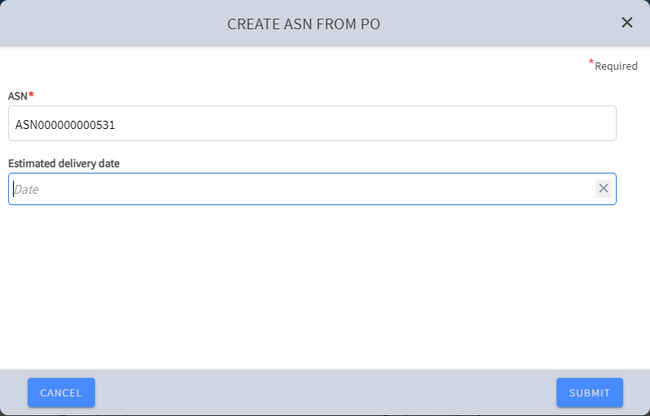
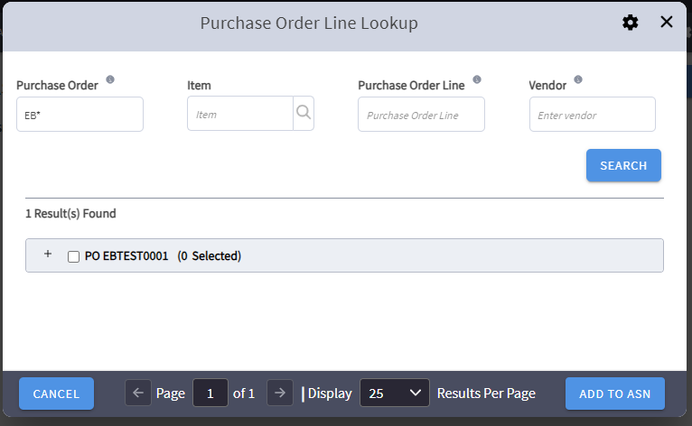
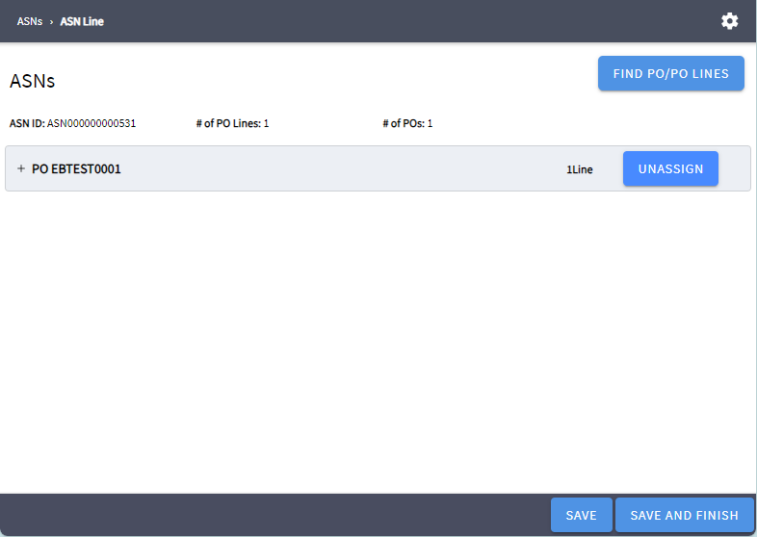

Create ASN (Blind Customer Returns)
Who | What | Why
Receiving Associate | Create an ASN for a non-confirmed return | The returned items are unknow in host system, only available information are printed on the returned LPNs

Process
- User navigates to the ASN UI.
- User ser clicks the [Generate ASN] action and enters or accepts the generated ASN ID and clicks the “Submit” button.
- User select the generated ASN.
- User clicks the [Edit].
- User edits the Origin Type and selects “Customer” and any other ASN attributes if present.
- User clicks the [Save].

Updates
- ASN is created in status “In Transit”

User Story: Process Needs
Who | What | Why
Receiving Associate | Create a Process Need to Assign a Specific MHE Diversion Code to ASNs | Pre-assign MHE diversion codes to MHE receiving LPNs based on business demand requirements.

Process
- User navigates to the Process Needs UI.
- User clicks the [Create] menu option
- User enters required data and select a diversion code that matches with Matthew diversion code.
- User clicks the [Save] action and confirms.

Updates
- Process Needs is created
- ASN LPNs are updated with selected Diversion Code post disposition.

User Story: Appointment Check-In
Who | What | Why
Receiving Office | Upon trailer arrival at the yard, check in the corresponding appointment via the UI. | Checking in the appointment allows the user to capture necessary information about the trailer and direct the driver to the best dock door.

Process
- User navigates to Appointments UI and filters for the Appointment that needs to be checked in using the PO or ASN.

- User selects the Appointment and clicks the option to ‘Check-in’

- WM displays the Check-in screen with areas to insert information from Appointment creation. User populates any required fields that are not pre-populated.

- User may choose to select the ‘Determine Location’ action for MAWM to systematically assign the dock door.

- Alternatively, the user may manually search for and enter the appropriate dock door to assign the trailer to

- User clicks ‘CHECK-IN’ to check-in the Appointment.

Updates
- Appointment moves from ‘Scheduled’ to ‘Checked-in’ status.

- Check in PIX are going to contain ASN Sku Quantity

- Dock door scan is not required.

- Appointment is updated with Dock Door or Yard Location.

- Dock Door is updated from ‘Open’ to ‘In-Use’ status or Yard Location is Updated with the Trailer Information.

User Story: Yard Move Trailer
Who | What | Why
Receiving Office | Move Trailer from Yard location to Dock Door | Trailers may be checked in and located at the Yard. When a door is available, a systematic move can be made to move the trailer form the yard to the selected dock door.

Process
- User enters Move Trailer Mobile.

- WM prompts user for a Trailer

- User scans Trailer to move.

- WM prompts user for a Dock Door.

- User physically moves trailer to a Dock Door and Scan the Dock Door Id.

Updates
- Dock Door is updates to ‘In-Use’ or ‘Available’

User Story: Appointment Check-Out

Process
- User navigates to Check Out UI and filters for the appointment that needs to be checked out.

- User selects the Appointment and clicks the option to ‘Check Out’.

- User clicks ‘Submit’ to check out the appointment.

Updates
- Appointment moves form ‘Checked-in’ to ‘Complete’ status.

- Dock Door is updated from ‘In-Use’ to ‘Open’ status.

Features

Process Needs
Lands' End utilizes "Process Needs" functionality, which is invoked during the LPN Disposition phase of the receiving process. This functionality allows for the selection of specific iLPNs on an ASN for special handling, such as:
- Multi-SKU processing
- Cubiscan measurements
- Quality inspections
- Prepping activities
Permanent process needs can be configured in MAWM to ensure that users are consistently notified of the required processing step for a particular iLPN before it is put away into inventory.
Process needs can be created through the following methods:
- Interface: Automated creation via an external system.
- Data Loader: Bulk upload using Data Loader via Process Needs UI.
- Manual entry: Manual entry via “Process Needs” UI.
Lands' End use the "Process Needs" UI to:
- Monitor the status of each process needs.
- Track the progress of required processing activities.

Dock Doors
Lands’ End configures dock doors for both inbound and outbound processing. However for inbound processing, users configure a preferred sequence of door assignment based on the defined custom attribute dock door group. Users do not configure the actual outbound doors within this inbound door preferred assignment sequence.
Dock | Description
Conveyable MHE Receiving | Dock doors dedicated for LPN MHE receiving.
Non-Con Receiving | Dock doors dedicated for non-conveyable receiving.

Yards
Lands’ End defines a single yard in MAWM. Users configure yard zones as required to distinguish different areas of the yard. Within the yard, users maintain yard slots (yard locations) within WM with a unique yard slot name. All yard locations have a capacity of one trailer.

Appointments
The Appointment Type defines the style of the appointment (i.e. how the trailer is handled for loading or unloading). The table below lists the various MAWM supported inbound appointment types, and defines which ones are used at the Lands’ End.
Appointment Type | Description | Used
Live Unload | The driver remains at the warehouse with the trailer and leaves with the trailer. | Yes
Drop Unload | The driver drops the trailer at the warehouse and leaves without the trailer. | Yes
Pick Up Empty | The driver arrives without a delivery to pick up an empty trailer. | No
Drop Empty | The driver arrives with an empty trailer to leave in the yard. | No

Key Interfaces
Interface | Business Scenario
Item Master | Inform distribution center of expected SKUs.
Purchase Order | Inform distribution center of POs that will be shipped to the facility.
ASN | Inform distribution center of ASN contents prior to arrival.
Inbound Delivery | Inform distribution center of the Inbound Delivery expected at the facility.
PIX | Check-In PIX generated for host notification as appointments arrive to the warehouse.

Reports, Dashboards, Alerts
Name | Description | Frequency | User/Dept | Type
ASN Inquiry Report | Details everything on the ASN. Includes ASN barcode. | As needed | Pre-receiving | WM Report
Appointment Schedule Report | Details of ASN, PO, quantities, and appointment | As needed | Pre-receiving | SCI Report
Appointment Schedule Dashboard | This report provides details of all trailers in the yard or in-transit to the yard, including:  - Appointment Date  - Appointment Type  - Live Unload  - Drop Unload  - Appointment Content  - ASN #  - Number of SKUs  - Number of LPNs | As needed | Inbound Supervisor /  Pre-receiving | Custom SCI Dashboard
Trailer Visibility Planning Report | This report provides details of all trailers in the yard, including:  - Trailer Date  - ASNs in Trailer  - Item Dim Status  - Conveyable LPN vs. Non-Conveyable LPN  The report enables the receiving supervisor to prioritize trailers and plan the workforce for sorting at the MHE divert lanes. | As needed | Inbound Supervisor /  Pre-receiving | Trailer Visibility Planning Report
No ASN Report | Identifies Purchase Orders without ASN to notify associates | As needed | Inbound Supervisor /  Pre-receiving | Custom SCI Report

Gaps and Extensions
GAP# | Name | Why | Description
WM07 | Appointment to ASN Relationship | Inform host system when an ASN has been checked-in. | Add related ANS to an appointment when it is created on MAWM.

Labor Management
Labor management details need to be added after LM design sessions.

Receiving

Strategy

The receiving process is designed to manage the inflow of inventory to the distribution center. MAWM offers flexibility by allowing users to configure receiving strategy that capture and validate necessary information.
Lands’ End employs the following three strategies:
- MHE Receipts: Automated receiving process through an MHE for vendor conveyable LPNs.
- Non-Conveyable Receipts / Mobile Receiving: Processed using Mobile Receiving Transactions, including vendor non-conveyable items, Transfer Orders, and Production Orders.
- Returns Receipts: Handled through the Returns UI for non-bulky items and bulky items through Mobile Returns.

MHE Receipts Strategy
The MHE Receipts Strategy is used to receive Vendor LPN-level ASNs. The process begins when the receiving associates place the LPN from the inbound trailer onto the MHE receiving conveyor belt. The MHE scanner then reads the LPN barcode and sends a “Receive” message to MAWM. Then MAWM processes the “Receive” message, receives the iLPN, and sends an "iLPN Received" message back to the MHE to confirm successful receipt. Post-receiving rules are applied to assign a Condition Code, and LPN Disposition is invoked to determine the destination (e.g., Quality Control (QC), Reserve, Active). Once the iLPN's location is determined, MAWM sends a “Divert Assignment” message to the MHE system to specify the target area or location.
Additionally, MAWM generates an LPN label [WM01] and sends an “ILPN Print” message to the MHE system to print and apply the label to the LPN. After labeling, the iLPNs continue along the receiving conveyor and are diverted to a replenishment induction point or to an inbound sorting lane. The MHE then sends a Putaway Divert Confirmation message to MAWM to confirm when the LPN has been diverted and MAWM use the message to putaway the LPN to respective processing area.
For LPNs allocated to replenish a pick location, the LPN is put away to a pick/drop location where a replenishment associate builds a putaway cart to complete the putaway to the designated pick location. For other LPNs, they are put away into an inbound sorting lane, where a receiving associate performs a sorting process to build pallets based on the putaway zone previously assigned to the LPN.
If an iLPN cannot be received in MAWM and no iLPN Label is sent to the MHE for printing, Matthews prints a generic exception label on the container. This container flows down the receiving conveyor to the post-receiving area, where it cannot be sorted. At this point, associates research the carton to identify the issue and receive it into MAWM if necessary.
Note: As part of the Matthews MHE configuration, the receiving conveyor may be configured to stop after a specific number of failures.

MHE Receiving Touchpoints
Seq | Event | Source | Destination | Touchpoint | Description
1 | Receive iLPN | Matthews | MAWM | As iLPNs are scanned for receipt by MHE | MHE message to inform MAWM of the iLPNs to be received via MHE
2 | iLPN Received | MAWM | Matthews | As iLPNs are confirmed to be received by MAWM | MHE message to inform Matthews that the iLPN was systematically received successfully
3 | Putaway Divert Assignment | MAWM | Matthews | As iLPNs are allocated to go to Active from Receiving | MHE message to inform Matthews of iLPNs and their destinations for diverting
4 | Print LPN | MAWM | Matthews | Post LPN Disposition and LPN label is generated | MHE message with zebra label code (ZPL) to be printed and applied to the received LPN
5 | Putaway Divert Confirmation | Matthews | MAWM | When a LPN is scanned and diverted by the MHE | Message is used by MAWM to locate the LPN into a staging location.

Non-Conveyable Receipts / Mobile Receiving Strategy
The Non-Conveyable Receipts / Mobile Receiving Strategy is used to receive various types of items, including vendor conveyable items (based on operational decisions during peak season or high MHE receiving volumes), non-conveyable items, Transfer Orders, and Outsource Production Orders.
The strategy includes the following receiving criteria/options:
- Receive LPN Level ASN: This option allows receiving LPNs by scanning the LPN without confirming its contents. The receiving transaction calls for disposition, prints the LPN label [WM01], and the user moves the iLPN to the appropriate sortation location based on the determined destination via LPN Disposition. Lands’ End uses the “Receiving Line Override Criteria” to prompt for LPN details for Gift Card LPNs or for an LPN that requires contents confirmation based on the SAP vendor rate.
- Receive Item Level ASN: This option is used when LPN information is not provided. Associates are prompted to scan at least the ASN, Blind LPN Id, item, and quantity to receive the product in the warehouse. Once the LPN is received, the receiving transaction calls for disposition, prints the LPN label [WM01], and the user moves the iLPN to the appropriate sortation location based on the determined destination via LPN Disposition. Lands’ End leverages on the “Copy LPN” feature to receive multiple LPNs containing the same item and quantities by copying the previously received item, quantity, and attributes, for example “Supplies ASN receiving”.
- Bulk ASN Receiving: This option is used for bulk receiving transfer orders and outsource production orders without scanning LPNs.
- Production Orders Receipts: This option is used to receive both in-house production orders. It enables users to scan iLPNs without verifying their contents. The transaction triggers a separate receiving process, similar to LPN-Level Receiving, specifically designed for Production Order Receiving. Additionally, it initiates a System Suggested Putaway process to consolidate all production orders into a putwall cubby location (Multis) or a floor location (Outsourcing, Singles, and Large)

Returns Strategy
The Returns Strategy at Dodgeville handles returned inventory from customers, stores, and third-party retailers. These return processes make up a significant portion of the inbound operations at the Dodgeville Distribution Center (DC) and require additional processing during receiving to determine if the inventory can be re-sold or needs to go through a secondary process. Lands’ End sends receipt details to the host system immediately upon receiving LPNs for returns, without waiting for ASN Verification. As soon as LPNs are received, a receipt PIX for the inventory is sent to the host system.
Once the returned product is unloaded from the truck, the Lands’ End receiving team evaluates it, processes any necessary customer credits, and classifies the product as either bulky or non-bulky items. Based on this classification, the return process can be initiated by one of the two following criteria:
- Returns Station: Used for non-bulky items.
- Mobile Returns: Used for bulky items.
Once a returned product is classified, the returns receiving process begins in MAWM. A user initiates the Return Receiving transaction either on a WM Mobile device or a Return Station via a web browser.
Initial Steps:
- ASN ID Entry:
  - If provided: The user scans or enters the ASN ID.
  - If not provided: The user creates a blind customer return from the ASN UI, associating it with a vendor ID and/or origin facility based on return label information.
- iLPN Generation:
  - MAWM generates an iLPN ID for the return. No blind iLPN labels are scanned. The iLPN label is printed after the receipt is complete.
Item Receipt:
- Item Scan: The user scans the UPC label on the returned item, whether applied by Lands' End or a third-party processor.
- Blind Returns: For blind returns, a custom logic [GAP-17] automatically defaults the Inventory Type to 'USCD' to streamline the process.
- Inventory Attributes: If applicable (e.g., hemming, logoed), the user enters the necessary attributes during the receiving transaction.
  - Hemming: The user enters the true inseam value or 'UNF' for unfinished items.
  - Logoed: The user enters the logo ID for recyclable logos or 'UNF' or 'SCRAP' for other cases.
Quantity and Disposition:
- Quantity: For single-unit returns, the item UPC scan is sufficient. For multiple-unit returns, the user enters the total quantity.
- Alert Validation: Receiving rules are used to checks for any item alerts. If found, a message is displayed to the user, who then validates the alert and selects a disposition code.
- Disposition Code Selection: The user selects a disposition code (e.g., 1st Quality, Not Quite Perfect, Charity, Regis, Scrap, Discontinued) based on the item's condition and any applicable alerts.
- iLPN Label Printing: After the disposition code is selected, an iLPN label is printed with relevant information, including the iLPN ID, item, disposition, class code, etc. [WM01/WM09]
After selecting a disposition code, the iLPN receipt and disposition process is complete. An iLPN label is printed, containing the iLPN ID, item, return disposition, class code, and other relevant information. The labeled item is then placed on a conveyor to be sorted into the designated area based on the selected disposition.
Configuration Note: A Final Disposition Strategy can be configured to automatically assign a disposition code based on the item's alert code.

Assumptions

General Receiving
- Inventory Storage: Inventory at the Dodgeville DC is stored in single-SKU iLPNs. Any multi-SKU iLPNs (excluding pre-packs) received are manually split into single-SKU iLPNs after the initial receipt.
- Blind ASN Receipt: Blind ASNs must be associated with a Purchase Order (PO) to be received in MAWM. Lands' End does not use Supplier Blind ASNs but can create Item and LPN level receipts from a PO.
- Receiving Methods: All receiving processes are performed using WM Mobile/RF/Return Station transactions or MHE events.
- LPN Disposition: LPN disposition is linked to Lands' End receiving transactions.
- PIX Communication: PIX messages are sent to the respective host system as iLPNs are received.
- ASN Verification:
  - ASNs must be verified individually.
  - All ASNs must be verified before proceeding.
  - ASN verification is initiated via the ASNs UI, not from a receiving transaction.
- Tracked Inventory Attributes: Tracked Inventory Attributes are provided in ASN interfaces (iLPN and Item level) to avoid manual entry during the receiving process.
- Vendor Rating Group: Vendor Rating is maintained in SAP by vendor factory (MAWM Vendor Facility Id). A vendor rating group is sent from SAP to MAWM as an extended attribute in the ASN Detail for Item Level ASN or with the ASN LPN for LPN level ASN. This attribute is used in MAWM to perform inbound quality rules.
- Pending Putaway Condition Code: The "Pending Putaway" condition code is used for all receiving processes except Production Order Receiving. It allows the product to be received as available for order allocation while avoiding a second PIX after putaway.
- Production Order Fulfillment Code Validation: A receiving rule criteria is used to validate the proper receiving transaction is used to receive the finished goods of a production order based on the fulfillment code of the ASN.

Returns
- Return ASN Receipt: Return ASNs can be received without a PO.
- LPN Disposition: LPN disposition is not linked to Lands' End returns receiving transactions.
- PIX Communication: PIX messages are communicated to the respective host system as iLPNs are received.
- ASN Verification:
  - Return ASNs are verified individually.
  - All Return ASNs must be verified.
  - ASN verification is initiated via the ASNs UI, not from a receiving transaction.
- Return Tracking Numbers: Return tracking numbers are not captured in MAWM.
- Return ASN Level: Return ASNs are Item Level ASNs.
- Tracked Inventory Attributes: Tracked Inventory Attributes are provided in iLPN and Item level ASN host interfaces to avoid manual entry during the receiving process and [GAP-17] is used to default the attributes for blind receipts.

User Stories
The following User Stories are covered for Lands’ End processes:

User Story: MHE Receiving
Who | What | Why
Receiving Associate | MHE Receiving | Receive inventory using MHE

Process
- iLPN is removed from trailer and inducted onto the receiving conveyor.
- iLPN passes through the MHE scanner.
  - MHE sends a RECEIVE message to MAWM.
- MAWM invokes receiving logic for the iLPN.
  - If the iLPN cannot be received (e.g. Tolerance violation or LPN does not exist), the iLPN is marked by MHE as an exception.
- MAWM invokes LPN Disposition Logic for the iLPN.
- MAWM triggers iLPN label payload to send to MHE system[WM01].
- MHE prints and applies iLPN label to carton.
- The carton continues down receiving conveyor to the sortation/pallet building area.

Updates
- iLPN is received.
- MHE message is generated for MHE.
- ASN status changes to ‘Receiving Started’ if first receipt for ASN.
- ASN received quantity is updated.
- Various condition codes applied depending on LPN Disposition
- Receipt PIX sent to Host.

User Story: Receive iLPN Level ASN
Who | What | Why
Receiving Associate | Receive iLPN Level ASN | Create inventory within the DC

Process
- User enters WM Mobile Receive iLPN Level ASN Transaction in WM Mobile
- MAWM pulls the assigned ASN
  - If multiple ASNs are assigned, user selects the appropriate ASN
- User scans iLPN barcode
- MAWM invokes LPN Disposition
- MAWM triggers iLPN Label to print
- User applies new iLPN label to carton
- MAWM displays assigned Process Need or sort location for iLPN to be located at
- User scans sort location to confirm or takes the iLPN to the appropriate area for processing based on Process Need

Updates
- iLPN is received
- ASN status changes to ‘Receiving Started’ if first receipt for ASN
- ASN received quantity is updated
- iLPN is located to sortation location determined by LPN Disposition
- Various condition codes applied depending on LPN Disposition
- Receipt PIX sent to Host.

User Story: Receive Item Level ASN
Who | What | Why
Receiving Associate | Receive Item Level ASN | Create inventory within the DC

Process
- User enters WM Mobile Receive Item Level ASN Transaction in WM Mobile
- User scans a blind iLPN label for the receipt
- User scans the Item barcode from the container
- User enters quantity to receive onto the iLPN
- MAWM invokes LPN Disposition
- MAWM triggers iLPN Label to print
- User applies new iLPN label to carton
- MAWM displays sort location for iLPN to be located at
- User scans sort location to confirm

Updates

- iLPN is received
- Condition Code applied to iLPN to identify ‘PO Type’ (CORE, QVC, Amazon)
- ASN status changes to ‘Receiving Started’ if first receipt for ASN
- ASN received quantity is updated
- iLPN is located to sortation location determined by LPN Disposition
- Receipt PIX sent to Host.

User Story: Receiving & Palletize
Who | What | Why
Receiving Associate | Receive LPN and Palletize for GOH or Ship Alone items | Create inventory within the DC

Process Steps
- Receiving user navigates to the Receiving & Palletize mobile transaction directly from the menu.
- MAWM prompts user for Dock Door.
- To receive product to the dock door staging location, user scans/enters the Dock Door.
- MAWM prompts user for iLPN to receive.
- User scans iLPN.
- MAWM displays sort location and prompts user to scan iLPN.
  - System-Directed sorting is used, MAWM directs user to scan iLPN if open iLPN exists in the directed sort location, otherwise MAWM prompts user to scan new iLPN.
- User scans the destination iLPN.
- User repeats from iLPN scan for each iLPN.

Process Updates
- ASN Status updated to “In Receiving”.
- iLPN is systematically received and located to the inbound staging location tied to the dock door.
- Pending Putaway Condition Code is applied to the iLPNs.
- Receipt PIX sent to Host.

User Story: Bulk ASN Receiving
Who | What | Why
Receiving Associate | Bulk Receiving Customer Transfer Orders | Create inventory within the DC for customer orders.

Process Steps
- Receiving user navigates to the Bulk ASN Receiving mobile transaction directly from the menu.
- MAWM prompts user for ASN Id to receive.
- User scans ASN Id.

Process Updates
- ASN Status updated to “In Receiving”.
- All ASN iLPN are bulk received and located to the inbound staging or storage location tied to the dock door.
- Pending Putaway Condition Code is applied to the iLPNs.
- Receipt PIX sent to Host.

User Story: Production Order - Outsource Receiving
Who | What | Why
Receiving Associate | Receiving Outsourcing Production Orders. | Create inventory within the DC for customer orders.

Process Steps
- The receiving associate navigates to the “Outsource Receiving” mobile transaction from the menu.
- MAWM prompts the user to scan an Inbound Container for receiving.
- The associate scans the Production Order ID (LPN in MAWM) from the production order paperwork.
- MAWM executes LPN Disposition to determine the next processing location.
- If the Fulfillment Code is "L", MAWM prompts (suggests) the user to scan a location barcode in the dedicated to large production orders zone.
- The user scans a valid location within the displayed zone (e.g., the left side of the receiving dock door).
- Otherwise, MAWM prompts (suggests) the user to scan a Post-VAS Putwall staging location.
- The user scans a valid location within the displayed zone (e.g., the right side of the receiving dock door).
- The user scans a storage location for the outsource production order receiving.

Note: SOP is followed to move the large order pallets or gurneys to the designated packing area after receiving and for non-large orders, the user needs to perform a putaway process after the receiving process is completed. A Receiving Rules Criteria is used to only allows the receiving of ASN with Extended attribute OutsourceVAS is true, otherwise a receiving error message is display “The transaction is configured for Outsource Production Order Receiving”.

Process Updates
- ASN Status updated to “In Receiving”.
- All iLPN (VAS Descriptor Labels) in a pallet are bulk received and located to the selected location.
- Receipt PIX sent to Host to perform a Vendor Inventory Transfer from Outsource vendor facility to Manhattan Warehouse facility .
Note: The Suggested Putaway is used to guide the user in scanning the appropriate location barcode after receiving.

User Story: Production Orders – Outsourcing Damages Receiving (Not used with EOM)
Who | What | Why
Receiving Associate | Receive Production Orders damages. | Receive and adjust damaged goods.

Process
- User enters WM Mobile “Receive Production Orders Damages” transaction in WM Mobile
- The user enters the ASN ID.
- MAWM generates an iLPN ID for the receipt.
- The user scans the item barcode.
- The user enters the quantity to receive onto the iLPN.
- MAWM invokes LPN Disposition with Scrap final disposition (background process)
- User repeats steps # 3 – 5 until all damaged items are received.

Updates
- iLPN is received
- ASN status changes to ‘Receiving Started’ if first receipt for the ASN
- ASN received quantity is updated
- Item-LPN is consumed (adjusted)
- A Damage Receipt PIX sent to Host
Note: The receiving associate or supervisor manually creates an item-level ASN in MAWM to reference the production order ID and default inventory attributes (e.g., inventory type, batch number, and inventory attributes 1 to 3) of the SKU. This ensures that prompts for these details are avoided during the receiving process.

User Story: Production Order – Large Order Receiving
Who | What | Why
Receiving Associate | Bulk Receiving Large Production Orders. | Create inventory within the DC for customer orders.

Process Steps
- Receiving user navigates to the Large Order Receiving mobile transaction directly from the menu.
- MAWM prompts user for ASN Id to receive.
- User scans ASN Id.
- MAWM prompts for a storage location
- User scans a floor storage location dedicated for large production orders in the respective VAS area.

Process Updates
- ASN Status updated to “In Receiving”.
- All ASN iLPN are bulk received and located to the selected floor storage location.
- Receipt PIX sent to Host.
Note: SOP is followed to move the pallet or gurneys to the designated packing area. A Receiving Rules Criteria is used to only allows the receiving of ASN with Extended attribute “FulfillmentCode” equal “L” and OutsourceVAS is false, otherwise a receiving error message is display “The transaction is configured for Large Production Order Receiving”.

User Story: Production Order – Singles Receiving
Who | What | Why
Receiving Associate | Receive Single Line/Single Units Production Orders goods. | Bring completed VAS Production Orders into the DC

Process
- User enters WM Mobile “Receive Production Order - Singles” transaction in WM Mobile
- User scans a post-vas receiving location barcode.
- MAWM prompts for an Inbound Container (LpnId)
- User scans the VAS Id from the descriptor label.
- User places the scanned unit inside a gurney, which is not tracked in MAWM but is used as a transportation container to move all finished goods to the post-VAS singles pack station once the gurney is full or when there are no more finished goods to be received.
- Repeat steps 3-4 if there are more items/iLPNs to be received.

Updates
- iLPNs are received
- iLPN are located in a storage location scanned at the beginning of the process.
- ASN status changes to ‘Receiving Started’ if it is the first receipt for the ASN.
- ASN received quantity is updated.
- Receipt PIX sent to Host for each received LPN.

Note: The "Pending Putaway" condition code is not applicable to any receiving transactions related to production orders. Sort Strategy is configured to use a default location sort location to don’t prompt it during receiving and sorting. A Receiving Rules Criteria is used to only allows the receiving of ANS with Extended attribute “FulfillmentCode” equal S and OutsourceVAS is false, otherwise a receiving error message is display “The transaction is configured for In-House Singles Production Order Receiving”.

User Story: Production Order – Multis, Name Badge & Enterprise Order Receiving
Who | What | Why
Receiving Associate | Receive multi-VAS, multi-unit production order goods, including enterprise orders. | Bring completed VAS Production Orders into the DC

Process
- User enters WM Mobile “Receive Production Order by VAS Label ID” transaction in WM Mobile
- User scans iLPN barcode ( Could be the production Order number (ASN Pallet Id from SAP paperwork ) to bulk receive the entire order or by Lpn Id (VAS Label Id) from descriptor label to receive the finished good by unit.
- MAWM invokes LPN Disposition (background process as part of the receiving process)
- MAWM invoke Putaway (Suggested Putaway)
- MAWM prompts user for a storage location.
- User scans location barcode
- User repeats steps 2 – 6 until all finished VAS items are received.

Updates
- iLPN is received
- ASN status changes to ‘Receiving Started’ if first receipt for ASN
- ASN received quantity is updated
- iLPN is located in a Post VAS Putwall cubby (LPN track storage location)
- Receipt PIX sent to Host.
Note: The "Pending Putaway" condition code is not applicable to any receiving transactions related to production orders. A Receiving Rules Criteria is used to only allows the receiving of ANS with Extended attribute “FulfillmentCode” equal M or X and OutsourceVAS is false, otherwise a receiving error message is display “The transaction is configured for In-House Multi-Units Production Order Receiving”.

User Story: Returns Station UI
Who | What | Why
Receiving Associate | Systematically receive returns, disposition inventory at fixed workstations. | Inventory that has been returned by the customers or stores is sent to the facility to be received and dispositioned.

Process
- If required, the user initiates receipt in a system outside of MAWM to issue credit to the customer and print UPC labels for each unit in the return.
- Users pre-sort the returns inventory by sender, contents, logos, etc.
- The user navigates to the Returns Station UI in a fix station web browser.
- MAWM prompts for returns station and user selects specified station id from drop down
- User clicks “Start Receiving”
- User scans or key enters ASN Id
- If no ASN is available, a Blind ASN ID is created a Blind ASN from ASN UI
- The user scans the item barcode.
- The user enters any required inventory attributes (e.g., inseam, logo).
  - If the returned item is a VAS item and is identified as "not quite perfect" (NQP), the user receives the product with a new batch number. This new batch number is generated within the "Print Blind Labels" UI using a Counter Type of "NQP VAS Return.
- If these attributes are available on the ASN, they do not need to be displayed or confirmed.
- If the item has an active alert, an informational message is displayed to the user.
- The message contains information about a known defect or issue with the SKU, so the user knows what to check during the inspection.
- The user enters the quantity to receive onto the iLPN.
- This step is only necessary if in Quantity Entry Mode.
- MAWM displays a list of available disposition codes for the user to select from.
- The user visually inspects the inventory and selects the appropriate disposition code based on the inventory condition.
- MAWM applies a condition code to the iLPN based on the selected disposition.
- If “1st Quality” or “Store” disposition is selected, the user is taken directly into a sort process.
- MAWM prints an iLPN label for the receipt after LPN Disposition is complete – [WM01/WM09].
- The user places the iLPN onto a conveyor towards the sortation area.

Updates
- iLPN was created in MAWM.
- iLPN is received.
- ASN is created in MAWM if ASN was generated.
- Condition Code applied to iLPN based on Disposition selected.
- ASN status changes to ‘Receiving Started’ if first receipt for ASN.
- ASN received quantity is updated.
- Receipt PIX sent to host.

User Story: Mobile Returns
Who | What | Why
Receiving Associate | Systematically receive returns, disposition inventory. | Inventory that has been returned by the customers or stores is sent to the facility to be received and dispositioned.

Process
- If required, the user initiates receipt in a system outside of MAWM to issue credit to the customer and print UPC labels for each unit in the return.
- Users pre-sort the returns inventory by sender, contents, logos, etc.
- The user enters the WM Mobile Returns Receiving Transaction in WM Mobile.
- The user enters the iLPN ID.
- The user enters any required inventory attributes (e.g., inseam, logo, batch number).
  - If the returned item is a VAS item and is identified as "not quite perfect" (NQP), the user receives the product with a new batch number. This new batch number is generated within the "Print Blind Labels" UI using a Counter Type of "NQP VAS Return.”
- If these attributes are available on the ASN, they do not need to be displayed or confirmed.
- If the item has an active alert, an informational message is displayed to the user. The message contains information about a known defect or issue with the SKU, so the user knows what to check during the inspection.
- MAWM displays a list of available disposition codes for the user to select from.
- The user visually inspects the inventory and selects the appropriate disposition code based on the inventory condition.
- MAWM applies a condition code to the iLPN based on the selected disposition.
- MAWM prints an iLPN label for the receipt after LPN Disposition is complete – [WM01/WM09].
- The user places the iLPN (One Unit LPN) onto a conveyor towards the sortation area.

Updates
- iLPN was created in MAWM.
- iLPN is received.
- ASN is created in MAWM if ASN was generated.
- Condition Code applied to iLPN based on Disposition selected.
- ASN status changes to ‘Receiving Started’ if first receipt for ASN.
- ASN received quantity is updated.
- Receipt PIX sent to host.

Features

Receiving Rules
Using the Receiving Rules, Lands’ End can create criteria which evaluate inbound data at the time of receipt to determine whether receivers need to be notified of a certain scenario and/or prevent receiving of the product until the data condition is rectified.
Lands’ End leverages Receiving Rules to display ‘Item Alert’ messages to the returns receiving auditors during returns receiving to point out special instructions to follow before the disposition code is selected. Items with an active alert have an Item Extended Attribute field populated with a code that correlates to a specific message in MAWM.
Example:
Item | Alert Code | Alert Message
Men’s Cashmere V-neck Sweater | A | Check Frills on Left Sleeve
Men’s Flannel Pajama Pants | B | Check Color Bleeding on Waistband

During receiving returns, the Receiving Rules are configured for each Alert Code to display the corresponding message to the user to they know to check for specific defects. Item Alert codes on the item master, alert messages, and updating receiving rules as needed are manually maintained by warehouse operations teams.
The Receiving Rules framework provides Lands’ End with a lot of flexibility to define and create many different types of rule sets based on the use cases identified. Lands’ End also can force the receiver to capture certain data elements on the item if necessary.

Post Receiving Rules
Post-Receiving Rules are used after the product is received and can be used to for informational purposes (display message to receiver) and/or apply a condition code in the background that can drive putaway. The Post-Receiving Rules framework is like the Receiving Rules in that it provides a lot of flexibility to define several different conditions.

Lands’ End uses Post-Receiving Rules to apply a Cubiscan condition code to iLPNs that are missing dimensional data, so they are sorted and identified as needing to go through the Cubiscan process.

Lands’ End uses Post-Receiving Rules to apply a Multi SKU iLPN condition code to iLPNs that have more than one SKU and require splitting into multiple single SKU iLPNs post receipt.

Process Needs
Lands’ End utilizes Process Needs functionality to be called during LPN Disposition during the receiving process to mark certain iLPNs for Multi SKU, Cubiscan, Quality Control , or prepping. Permanent process needs can be created in MAWM to always notify users that the specified iLPN is required to go to a separate process before being putaway into inventory.

LPN Disposition Strategy
LPN Disposition evaluates each iLPN to determine the downstream workflow that the iLPN should follow. There are multiple paths that an iLPN may be directed down at the time of receiving including Quality Audit, Cubiscan, Prepping, Flowthrough, Direct to Active, or Reserve Storage. To achieve this type of evaluation for each iLPN during receiving, a combination of MAWM functions is used including Receiving Rules, Post Receiving Rules, and Process Needs.
Before LPN Disposition is called, as part of the Receiving Strategy for all iLPNs, Post Receiving Rules are utilized to apply condition codes to iLPNs if they fit a specified set of conditions. These rules are configured to check iLPNs that are missing dimensional data to apply a ‘Cubiscan’ condition code and to check if an iLPN contains multiple SKUs to apply a ‘Multi SKU iLPN’ condition code. These condition codes play a fundamental role in disposition determination during the LPN Disposition process. iLPNs that qualify for multiple rules can have multiple condition codes applied at the time of receipt.
Once the Post Receiving Rules have been systematically performed for the iLPN during receiving, LPN Disposition is then called by MAWM to determine the disposition or destination of the iLPN. LPN Disposition is configured to prioritize certain functions or areas of the warehouse that a given iLPN should be evaluated for first. For example, Lands’ End would want to prioritize any iLPN that is marked as requiring Cubiscan or Quality Audit before putaway or allocation is attempted against the iLPN. If no Quality Audit requirement exists for the iLPN, MAWM would then evaluate if the iLPN can be allocated for a Singles Bulk Flowthrough allocation process. If no open order demand exists for the iLPN, putaway is then evaluated for the iLPN to determine if there is space available in the active pick area. If no locations in active are available, MAWM then allocates the iLPN to a reserve storage location. For detailed Putaway Location Determination processes, see the Putaway section.
Note: iLPNs that are allocated to go directly to active trigger an MHE event to send to the Induction Conveyor with the iLPN and destination information so the MHE can print a ‘destination value’ on the iLPN as it arrives.
At the end of the LPN Disposition process the iLPN is dispositioned for the Quality Audit area for, str Audit, Cubiscan, or Multi SKU iLPN splitting (prepping), allocated against or order or orders with open demand, or allocated to a destination location in the active or reserve storage areas. No tasks are created at this point for the allocations that were created. The iLPNs next step is to be sorted to a pallet or sortation location specified for the destination of the iLPN to build a pallet and aid in the putaway execution process.

Disposition Determination Priorities
- Missing Item Dimensions (Cubiscan)
- Quality Audit Required
- Prepping Required
- Singles Bulk Flowthrough
- Active Allocation
- Reserve Allocation

Post Processing LPN Disposition
iLPNs that are marked for Quality, Prepping, or Cubiscan processes during receiving are moved to the respective areas for the specific actions to be taken on the individual iLPNs. After these processes are complete, any necessary condition codes are removed from the iLPN, such as a QA condition code, and the iLPNs are re-processed through iLPN Disposition as a stand-alone transaction in WM Mobile. The re-processing re-evaluates the iLPN for any additional processes that need to take place before it can go to putaway. For example, an iLPN that required Cubiscan may also be required to go to Quality after being Cubi scanned, this second LPN disposition process ensures that iLPNs are not putaway before all required processes are complete.
At the time the Post Processing LPN Disposition transaction is used to scan an iLPN, a new iLPN Label with the updated disposition may be printed and applied to the container as part of [WM01]. After the iLPN is scanned, depending on the area in the warehouse, users can be taken directly into the sortation process to sort to a pallet or the iLPNs can be taken to the sortation area, where a separate user sorts the iLPN to the proper pallet for putaway.

LPN Disposition & Sort Strategy

Sorting for 1st Quality & Store Seconds
During the returns receipt process, if the returns analyzers disposition the return as a 1st Quality return or a Not Quite Perfect (NQP / Discontinued), MAWM calls LPN Disposition and performs a sortation process for the iLPN. LPN Disposition is configured to sort these iLPNs at the returns analyzer stations, where WM displays the destination sort location and only requires the user to tap to confirm the sort in WM Mobile. This process systematically locates the iLPN to the displayed sort location, 1ST Quality, Store Seconds, Charity, or RTV, and the user physically places this iLPN on the conveyor to the sorting area.
As iLPN arrive in the sorting area on the conveyor from the returns analyzer, if the iLPN label displays 1st Quality users are trained to place these in the proper sort location, no additional scans are required. This inventory is tracked at the location level and is not palletized at this time. The next step for these units is to be taken to the Random Returns area to be putaway.
If the iLPN label displays Not Quite Perfect (NQP/Discontinued) users are trained to place these iLPNs on the conveyor to the store sortation area. Due to the high volume of iLPNs in the Not Quite Perfect area and high number of possible sortation, users are identifying the cubby/slot to place the iLPN into using the Merchandise Group Code printed on the iLPN label. The iLPNs are physically put into bins corresponding with the same Merchandise Group Code of product, there are no systematic scans to the cubbies or bins at this time.
When a bin is full of units, it is moved and replaced with an empty bin. Bin is emptied (like a flow-rack) from the opposite side into a carton. Combine iLPN is then used to create a multi-sku iLPN. They are being putaway into Reserve locations until they are needed for an order.

Sort for Putaway
All other iLPNs that do not fall into the 1st Quality or Not Quite Perfect category are scanned by users with Sort transaction in WM Mobile. This Sort locates the iLPN to an inventory location and sorts to a pallet based on the destination location and contents of the iLPN.
Using the disposition code selected by the returns analyzer and iLPN contents, MAWM sorts to one of the following sort locations and palletizes the iLPNs into a large gurney for Charity. Scrap is automatically consumed and is thrown into a designated scrap bin. These are broad categories that may be broken down further in the sort strategy.

Receiving Exceptions
Exceptions may occur during the receiving process for both MHE receiving and WM Mobile receiving processes. The following sections detail the common receiving exceptions that may occur at the Reedsburg facility.

MHE Exceptions
The following are the common receiving exceptions that may occur during the MHE receiving process. For all these scenarios, Matthews recognizes the error and prints a generic ‘exception’ label on the container, so it is recognizable on the conveyor for users to identify and research. If multiple iLPNs are having exceptions during the MHE receiving process, Matthews may be configured to stop the receiving conveyor after several subsequent failures.
MHE Receiving Exceptions
- iLPN scanned at MHE does not exist on ASN, non-receipt in MAWM.
- iLPN has unreadable barcode, non-receipt in MAWM.
- iLPN received in MAWM, LPN Disposition process does not produce Label for MHE to Print
- iLPN received in MAWM, MHE unable to verify and print iLPN Label.

WM Mobile Exceptions
Receiving exceptions may also occur during the various WM Mobile receiving transactions for both iLPN level and Item level receiving. No exception labels are printed during WM Mobile receiving exceptions, the receiving users place the unreceivable containers to the side to be researched and attempted to be received later. The following is a list of common receiving exceptions for WM Mobile receiving.
iLPN Level Receiving Exceptions
- iLPN scanned not exist on ASN, error displayed to user.

Item Level Receiving Exceptions
Item scanned not exist on ASN, error displayed to user.
Quantity entered for item puts ASN or PO over configured receiving tolerance, warning or error displayed to user.

Key Interfaces
Interface | Business Scenario
Purchase Order | Inform distribution center of POs that will be shipped to the facility.
ASN | Inform distribution center of ASN contents prior to arrival.
Inbound Delivery | Inform distribution center of the Inbound Delivery expected at the facility.
PIX | Check-In PIX generated for host notification as appointments arrive to the warehouse.

Reports, Dashboards, Alerts
Name | Description | Frequency | User/Dept | Type
ASN Receiving Report | Lists all ASN details and quantity, as well as providing scannable barcodes for ASN and Items | As needed before receiving ASN (especially for item level ASNs) | Receiving | WM Report
ASN Status Report | Lists all ASNs expected to arrive at the DC for a given day and current statuses of ASNs | As needed to support receiving and ASN Verification | Receiving | SCI Report/Dashboard
Return ASN Receiving Report | Lists all Return ASN details and quantity, as well as providing scannable barcodes for ASN and Items | As needed before receiving Return ASN | Returns Receiving | SCI Report
Returns by Business | Classifies Returns by the origin of the return: Core, Kohls, Amazon, etc. | As needed | Returns Receiving | SCI Report

Gaps and Extensions
Gap # | Name | Description
WM01 | iLPN Label Payload Trigger Post LPN Disposition | Lands’ End requires a second iLPN label to be printed and applied to inbound cartons containing visual information regarding the destination type to users. This destination determination occurs post LPN Disposition where there is no base MAWM print trigger.  In addition, MAWM is required to send this iLPN Label Payload as an event to the MHE system to be printed and applied via MHE receiving.  Label Formatting that is not performed by the LE team is covered as part of the gap.
GAP17 | Default Inventory Attributes during Receiving | Lands’ End must track inventory attributes on inventory at the time of receiving to segregate inventory in the warehouse that has been returned with a hemmed pant or logoed item. This gap is required to allow LE to default the inventory type and inventory attributes on the receiving strategy, so users are not prompted to enter this information when it is not necessary.  In addition, Lands’ End cannot designate the inventory type for receipts at the item or line level, MAWM just derive the inventory type value from the ASN/PO Header and apply this value as the inventory type to all receipts
WM23 | In-house Production Order ASN | After the good issue of an in-house production order is generated in MAWM, MAWM will generate an ASN to be used for receiving the finished goods once the VAS process is completed in SAP.

Labor Management
Labor management details need to be added after LM design sessions.

Key Interfaces
Interface | Business Scenario
ASN (Item Level) | Inform distribution center of shipment contents prior to arrival.
ASN Verification | Inform host that the ASN has been fully received and should be closed to prevent future receipt against the same ASN.
PIX | Inform host of received inventory or change of inventory status

Reports, Dashboards, Alerts
Name | Description | Frequency | User/Dept | Type
Return ASN Receiving Report | Lists all Return ASN details and quantity, as well as providing scannable barcodes for ASN and Items | As needed before receiving Return ASN | Returns Receiving | SCI Report
Returns by Business Line (Extended Attribute) | Classifies Returns by the origin of the return: Core, Kohls, Amazon, etc. | As needed | Returns Receiving | SCI Report

Gaps and Extensions
Gap # | Name | Description

Labor Management
Labor management details need to be added after LM design sessions.

Post-Receiving

Strategy
As ASNs are received and empty trailers leave the dock doors, Lands’ End monitors the ASNs currently in receipt with an ASN Status SCI report. This report is created to display all ASNs that are expected to arrive at the Dodgeville DC for the day, the status of ASNs which already arrived, and the status of ASNs which receiving has been complete against. This report, along with assistance from the operations team, is used to determine when all contents for a given ASN have been processed. Once all inventory or iLPNs have been received for an ASN, the ASN must be verified to close out the receipt in MAWM. This process is initiated via the MAWM UI by users navigating to the ASNs UI and selecting the ASN which is to be verified. Returns receipts may be configured to automatically perform ASN verification during the receiving process [WM06].
Once the verification action is taken against the specific ASN, MAWM displays a ‘Variance Report’ where users can see if there was a receiving variance on the ASN. This includes inventory that was expected to be received but was not received as well as any overage that was received and was not expected. If there is a variance, users may print a variance report which details the variances and researches the variance before accepting the verification of the ASN. If there is no variance displayed by MAWM, then the receipt was as expected, and users submit the ASN Verification.
As ASNs are verified in MAWM, a ASN Verification PIX is generated and sent to the host system with detailed information about all the inventory that was received into MAWM. The host system uses this PIX to increase inventory in the appropriate buckets. The ASN Verification is a crucial step in the Lands’ End receiving processes as real time receipt PIXs for individual iLPNs are not sent to the host system, therefor until the ASN Verification process is complete, the host system does not have visibility to what has been received into the Dodgeville DC.

Assumptions
- ASNs are verified individually and manually, there is no ability to verify multiple ASNs at once or through a scheduled job.
- All ASNs must be verified.

User Stories

User Story: Verify ASN in UI
Who | What | Why
Receiving Supervisor | Confirm variances and verify ASN | Close the ASN, inform the host that receiving is complete, and book inventory financially to trigger invoicing.

Verify ASN is the process of confirming that what has been received is correct and final. ASN Verification will communicate finalized receipts to the Host. Post ASN Verification, all inventory updates are considered “warehouse adjustments” and are sent to the Host as inventory adjustment PIXes.

Process
- User searches for ASN in ASNs UI
- User selects the ASN and clicks ‘Verify ASN.’
- WM displays the variance screen with the item, quantity expected, and quantity received to provide visibility of any variances.
- User confirms by selecting ‘Verify ASN.’

Updates
- ASN updated to ‘ASN Verified’ status.
- Verification PIX triggered and sent to host system.
- ASN removed from current Dock Door

Key Interfaces
Interface | Business Scenario
ASN Verification | Inform host that the ASN has been fully received and should be closed to prevent future receipt against the same ASN.
PIX | Inform host of received inventory or change of inventory status

Reports, Dashboards, Alerts
Name | Description | Frequency | User/Dept | Type
ASN Variance Report | Details of ASN and the variance (unreceived vs. expected LPNs/ items/ quantities) | As needed, before or during ASN Verification | Receiving | WM Report
ASNs Received not Verified | Displays all ASNs which have been received but not yet verified and the age of the ASN | As needed | Receiving | SCI Report

Gaps and Extensions
GAP# | Name | Why | Description
WM06 | Auto Verify ASN | Close and purge received ASNs | Automatically verify return ASNs after receiving has started, based on configured elapsed days and conditions.

Labor Management
Labor management details need to be added after LM design sessions.

Sorting

Strategy

Once iLPNs arrive at the sortation area, either through MHE receipts or WM Mobile transactions, they are sorted to a specific pallet or location based on their predetermined disposition or destination.
MHE Received iLPNs
- Sort iLPN Transaction: A standalone WM Mobile Sort iLPN & Palletize transaction is used to scan iLPNs off the receiving belt.
- Location and Pallet Assignment: Users are directed to a location to palletize the LPN y putaway zone.
WM Mobile Received iLPNs
- Receive and Sortation: The sortation process can be initiated directly after the LPN is received if the LPN Disposition of the receiving transaction is configured to perform sorting.
- Staged Sortation: Alternatively, iLPNs can be staged and sorted later using a WM Mobile Sort iLPN & Palletize transaction.
Sorting Criteria iLPNs are sorted to pallets based on their allocated destination building, location, and zone. Common destinations include Active, Reserve, Prepping, Packing, and Cross Dock. Once a pallet is full, users end it and start a new one.
Putaway Task Creation: As pallets are completed during the sortation process, MAWM creates a Putaway task for each pallet. Warehouse associates can then pick up these pallets and begin a system directed putaway process.
Exceptions
- Cubiscan: iLPNs marked for Cubiscan are not systematically sorted. They are identified and manually moved to the Cubiscan station for processing.
- MHE Receiving Issues: iLPNs with issues during MHE receiving and labeled by Matthews are also handled manually and not systematically sorted.

User Stories

User Story: Sort iLPN & Palletize.
Who | What | Why
Receiving or Sorting Associate | Sort iLPNs to a Pallet for putaway after Receipt | Sort iLPNs onto individual pallets based on destination determined by LPN Disposition

Process
- iLPN is scanned by Sort User at the end of the Receiving Conveyor
  - If WM Mobile was used to receive the iLPN, users are taken directly into the Sort transaction.
- WM displays the destination sort location for the iLPN and prompts the user to scan a pallet.
- User scans the pallet in the sort location to associate the iLPN to the pallet.
- If the pallet is full, the User Ends the pallet and starts a new pallet in the Sort Location

Updates
- iLPN is associated with the pallet scanned.
- iLPN is staged in the sort location.
- Putaway Tasks for iLPNs start when user scans pallet ID and completes task as directed.

User Story: End Container
Who | What | Why
Receiving Associate | End the sorting process of a pallet in the sorting area. | Initiates putaway task creation

Process
- User selects End Container option in Mobile Menu.
- WM prompts user to scan container.

Updates
- Pallet is closed.
- Putaway task is generated.

Reports, Dashboards, Alerts
Name | Description | Frequency | User/Dept | Type

Gaps and Extensions
GAP# | Name | Why | Description

Labor Management

Labor management details need to be added after LM design sessions.

Vendor Performance

Strategy
Lands’ End uses the Vendor Performance functionality in MAWM to capture any issues or comments with received inventory against Vendors. This information is used to score Vendors based on the quality of the material sent into the warehouse so any necessary actions may be takes to resolve the issues. This Vendor Performance process is separate from the Quality Audit process, which is performed in a separate system outside of MAWM.
To initiate this process, in the Quality Audit area users enter a Vendor Performance transaction in the WM Mobile device. This is a stand-alone transaction that allows Lands’ End to enter the objects that are to be reported against, ASN/PO/iLPN, for various reasons. For example, if all of the inventory for a specific ASN/PO have an issue such as missing labels or incorrect items, Lands’ End would want to scan the ASN or PO and select a Vendor Performance Code that describes the overall issue. If there are single iLPNs with issues, not across the entire PO or ASN, Lands’ End may scan a single iLPN to report the issue.
The Vendor Performance selections are recorded in the MAWM UI and can be used to generate reports for vendors that have repeat offenses to grade the vendor. This grading helps the Lands’ End team determine the number of iLPNs that are required to be sent to the Quality Audit area for future receipts and if any back charges are necessary from the vendors. Multiple Vendor Performance selections can be made against the same entity if necessary. Once all Vendor Performance selections are made, Lands’ End continues with the secondary quality audit process for the true material quality.

Assumptions
- Vendor Rating is maintained in SAP by facility.
- A vendor rating group is sent from SAP to MAWM as an extended attribute in the ASN Detail for Item Level ASN or with the ASN LPN for LPN level ASN. This attribute is used in MAWM to perform inbound quality rules.

User Stories

User Story: Vendor Performance
Who | What | Why
Receiving or QA Associate | Report issues with Received Inventory | Lands’ End keeps records of issues with ASNs or LPNs against certain vendors

Process
- User enters the Vendor Performance Transaction in WM Mobile device.
  - Vendor Performance may also be initiated in-line during receiving.
- WM prompts the user to Scan ASN
  - Not required when called in-line during receiving.
- User scans ASN if required.
- WM prompts user to select Vendor Performance Code
- User selects appropriate Vendor Performance code.
- User enters any additional comments for the Vendor Performance

Updates
- Vendor Performance Transaction recorded.
- Condition Code applied to inventory if applicable.

Reports, Dashboards, Alerts
Name | Description | Frequency | User/Dept | Type
Vendor Performance by Factory | Displays all Vendor Performance transactions recorded against ASNs and displays a breakdown by Facility | As needed to support QA | Receiving/QA | SCI Report

Gaps and Extensions
GAP# | Name | Why | Description

Labor Management
Labor management details need to be added after LM design sessions.

Putaway

Strategy

Putaway is the process of locating and storing received inventory in designated warehouse locations. Lands' End employs a Putaway Planning Strategy defined in MAWM to optimize the putaway process based on business rules.

Putaway Planning Strategy
A putaway planning strategy criteria is defined for the putaway planning strategy, the criteria evaluates item and inventory attributes like Item Category, inventory type, inventory attributes etc. Once the selection criteria matches with the evaluated LPN, the putaway planning evaluates the putaway determination priorities in the following sequence. When a pallet with nested LPN is scanned, the putaway planning mode is configured to scan either a pallet or an iLPN on the pallet to plan the putaway for each LPN on a pallet.
- Active Locations - MAWM first evaluates whether the iLPN can be placed in an active location, considering the maximum capacity of the location. If available, the iLPN is directed to an active location for immediate use.
- Suggested Putaway Zone - If no suitable active locations are found the iLPN is assigned to a reserve zone that is assigned for the selected criteria. Example: Building 2 High Bay Room 1, Building 2 High Bay Room 2, Building 2 High Bay Room 3 etc.
- Zone Base – MAWM evaluates locations based on putaway allocation zone priorities. (To be implemented once the location dimensions and putaway type/size are updated).
Note: Currently, the Suggested/Vicinity putaway process does not account for location capacity. Lands' End relies on an SCI report to monitor zone capacity and adjust zone priorities within the putaway criteria as necessary. In the future, a system-directed putaway process will be implemented. This system will determine the optimal putaway location based on factors such as location capacity, LPN type, and size, once the system's information is accurate. To accommodate equipment requirements for specific reserve zones, Task Path restrictions will be used to direct pallets to designated drop locations. Once the system-directed putaway is in place, the Suggested Putaway Zone determination criteria should be deactivated.

Putaway Task Creation Strategy
After putaway planning, the putaway process generates a Putaway Task. A specific Transaction ID is configured appropriate to process. The following Putaway Task Types (Transaction IDs) are identified for Dodgeville operations:
- Pallet Putaway - System Directed Putaway to move the pallet from staging locations to a building putaway zone for final putaway (Suggested Putaway) .
- LPN Putaway – User directed putaway execution. The transaction will be changed to a system directed execution once the location dimensions and LPN type size are defined.
- Putaway Cart - Fill Active – System directed LPN putaway to an active pick location by putaway cart execution.
- Fill Active – System directed LPN putaway to an active pick location.

Putaway Execution Flow
The putaway execution process is initiated by users logging into the WM Mobile device and into their eligible Task Group for putaway. A forklift users navigates to the WM Mobile Assign Task menu option, and MAWM will assign the next task available for his Task Group. MAWM will direct the user to travel to the source location of the LPN to confirm the pallet or LPN id displayed by MAWM to begin the putaway process. Alternatively the user can initiate a system directed putaway by using WM Mobile System Directed Putaway mobile option. The process will check if the scanned LPN is already allocated for putaway and will assign the task to the user, or it will evaluate the Putaway Planning Strategy to determine the location where the LPN or LPNs needs to go based on the configured business rules in the Putaway planning strategy. Lastly the user can use a User Directed putaway to move the LPN to a specific location as needed.

Putaway to Active Location:
- MHE-Allocated LPNs: These LPNs are directly diverted to the replenishment induction belt and dropped into the pick module.
- Flow Rack Pick Locations: Associates scan the LPN from the replenishment belt to the flow rack location using the Fill Active Mobile transaction.
- Other Active Pick Locations: Associates use the WM Mobile Make Putaway Cart transaction to build a putaway cart and perform multiple LPN putaway.
Putaway to Reserve Location:
For each LPN on a pallet, the associate performs a putaway to a reserve location. Once all LPNs on the pallet are putaway, the pallet is consumed.

Assumptions
- iLPNs are not split during the putaway to active processes. Lands’ End does not put or replenish partial iLPNs to pick locations due to physical restraints.
- Partial iLPNs do not go back to reserve from the active area.
- Puts to active and replenishments to active are always full iLPNs.
- Maximum capacities in active locations are driven by a percentage of 75% fluid inventory that will fit in location.
- Unit Storage Locations (Active) are mostly single SKU locations.
- Multi SKU Unit Storage Locations are only used for Random Returns and follow User Directed Putaway
- WM does not prevent aisle congestion during putaway. Intermediate drop locations can be used to aid with aisle congestion.
- The Pending Putaway (PA) lock code is removed when the iLPN is putaway to the final destination location.
- A SKU typically has a single permanent pick location. However, a dynamic location can be assigned during putaway for high volume items. The number of dynamic locations Lands’ End plans to use for items is ‘3’.
- Vicinity Based Location Determination (suggested putaway zone) is used to determine reserve locations. Lands’ End can change the determination method once the LPN/Size type is provided by the vendors and all locations have been updated.

User Stories

User Story: Pallet Putaway (Suggest Putaway /Tasking Mode)

Who | What | Why
Putaway Associate | Suggest Putaway to Reserve in Tasking Mode for Vendor Receiving. | To move a pallet from staging to a drop location closer to the reserve location assigned to the LPNS.

Process
- User enters Putaway Task Group in WM Mobile Device
- User requests work in WM Mobile for available tasks eligible for the Putaway task group
- WM assigns the user an available putaway task and displays the location and pallet to pick up.
- User travels to location and confirms Pallet to initiate putaway for the iLPNs on the pallet.
- WM initiates the putaway task for the pallet.
- User is suggested with an area/zone/aisle/bay to the operator locate the LPN to a location around its vicinity.
- User scans a location on the suggested zone.
- User is prompted for the iLPN that needs to be putaway.
- User scans the iLPN to confirm.
- Process is repeated for all iLPNs on the pallet.

Updates
- iLPN current location is updated to the scanned location.
- Location inventory is updated.
- If a condition code is removed, relevant PIXs are communicated to the host.
- A labor record(s) is written to credit the putaway.
- Putaway task is completed.

User Story: LPN Putaway (User Directed)
Who | What | Why
Putaway Associate | Putaway LPN into a Reserve Location | User manually determines where an iLPN should be located.

Process
- User navigates to the LPN Putaway Transaction
- User scans an iLPN
- WM prompts user to scan a location
- User scans the location barcode to confirm the putaway
- If there more LPNs to be putaway the user repeats the steps 1 – 4 until putaway all LPN form the pallet.

Updates
- Current location is updated to the scanned location for the LPN
- Location inventory is updated.
- Pending Putaway condition code removed from iLPN.
- PIX inventory adjustment sent to host.

User Story: Pallet Putaway to Replenishment Belt
Who | What | Why
Putaway Associate | Pallet Putaway to Replenishment Belt | To induct pallet LPN to a replenishment conveyor belt.

Process
- User enters Putaway Task Group in WM Mobile Device
- User requests work in WM Mobile for available tasks eligible for the Putaway task group
- WM assigns the user an available putaway task and displays the location and pallet to pick up
- User confirms the pallet to initiate putaway for the iLPNs on the pallet
- WM initiates the putaway task for the pallet
- User is directed to take the pallet to the pick mod induction belt or the bulk picking area to stage iLPNs
- User scans the induction belt barcode
- WM stages all iLPNs on the pallet to the pick mod induction belt location or the bulk picking staging location

Updates
- iLPN current location is updated to the scanned location.
- Location inventory is updated.
- A labor record(s) is written to credit the putaway.
- iLPNs are staged on the conveyor or bulk staging
- Putaway task is in-progress

User Story: Putaway Cart - Fill Active
Who | What | Why
Putaway Associate | Putaway Cart for MHE Fill Active | To build putaway cart to putaway individual iLPNs into active

Process
- User enters the Make Put Cart transaction in WM Mobile device.
- WM prompts the user to scan a Cart ID
- User scans the Cart ID for the putaway cart they are using.
- WM prompts the user to scan iLPNs to assign to the putaway cart.
- User identifies like iLPNs using the visual indicator added by the MHE.
- User scans the iLPNs to assign to the cart.
- Once putaway cart is full of iLPNs, the user Ends the Put Cart
- WM builds a putaway task for the putaway cart and all iLPNs associated to the cart.
- WM takes the user directly into putaway execution and displays the first active location and iLPN.
- User scans the active location to confirm.
- User scans the iLPN to complete putaway for the iLPN.

Updates
- iLPN is updated to ‘consumed.’
- Location inventory is updated.
- A labor record(s) is written to credit the putaway.
- Putaway task is complete.

User Story: Fill Active
Who | What | Why
Putaway Associate | Fill Active | Fill flow rack put location from replenishment belt or putaway a single LPN to an active location.

Process
- User enters WM Mobile and selects ‘Enter Task.’
- WM prompts the user to scan a Container ID
- User scans an available iLPN.
- WM initiates the corresponding putaway task and prompts the user with the destination location.
- User travels to the displayed location and scans to confirm.
- WM prompts the user for the iLPN to put into the location.
- User scans the iLPN to confirm and consume the iLPN inventory into the location.

Updates
- iLPN is updated to ‘consumed.’
- Location inventory is updated.
- A labor record(s) is written to credit the putaway.
- Putaway task is complete.

User Story: Post VAS Putaway
Who | What | Why
Putaway Associate | Suggest Putaway to Reserve in Tasking Mode for Post-VAS LPN Receiving. | To move an LPN from the VAS area to a POST VAS Putwall (with LPN storage locations arranged as putwall cubbies).

Process
- User enters WM Mobile and selects “POST VAS Putaway” transaction.
- MAWM prompts for a LPN scan
- User scan LPN Id from VAS descriptor label.
- User is suggested with an area/zone/aisle/bay to the operator locate the LPN to a location around its vicinity.
- User scans a location on the suggested zone.
- Process is repeated for all iLPNs on a gurney.

Updates
- iLPN current location is updated to the scanned location.
- Location inventory is updated.
- A labor record(s) is written to credit the putaway.
- Putaway task is completed.
Note: PIX are not generated post-putaway because production orders are received without the "Pending Putaway" condition code.

MHE Messages

Name | Source | Destination | Touchpoint | Description
Inbound Putaway | Matthews | MAWM | As iLPNs are scanned and diverted to the proper zone from the replenishment conveyor | MHE message to inform MAWM of the iLPN and the diverted staging location

Features

Alternate
If the system-directed putaway location is already full, or – due to aisle constraints – the user cannot get to the destination location, the user requests an alternate location by using a function key at the Mobile Putaway transaction’s location confirmation screen. When the user requests a system-directed alternate putaway location, the system determines and displays a new destination location to the user. When an alternate putaway location is required, based on configuration, the system can block the original LPN Storage location for subsequent directed putaway (until an investigation into the issue is concluded, and the location unblocked) and/or generate a cycle count task for the original putaway location. Lands’ End may choose to block or generate a cycle count task for the original location during putaway. This is configurable and may be changed in the future. Alternate location requests can also be configured to allow or restrict users from being directed to a location in a separate zone.

Substitute
In addition to system-directed alternate putaway, the user requires the option to manually determine a substitute destination location for the LPN. This can be used if the user is able to visually identify a valid substitute putaway location, instead of requesting the system to determine an alternate location. If the user attempts to locate the inventory to an empty location as a pending allocation for another SKU, WM is configured to display an error message and prevent the user from locating the product. Lands’ End does not allow substitute locations during putaway to active.

Radial Search
When planning putaway for full Pallets that are located in the same rack system as the dedicated active location, MAWM can be configured to follow a Radial search to find the closest available Pallet reserve location to the permanent location for the item.

Vicinity Based Putaway (Suggested Putaway)
Vicinity based putaway, also known as suggested putaway, allows Lands’ End to be directed to a zone or area that a specific iLPN should be put away in while allowing the end user to select the destination location within that zone.

Key Interfaces
Interface | Business Scenario
Item | Provides information that can be leveraged to drive putaway

Reports, Dashboards, Alerts
Name | Description | Frequency | User/Dept | Type
Pending Putaway Tasks | List of all Putaway tasks that are created and yet to be complete | As needed | Receiving/Putaway | SCI Report
Condition Code Aging Report | List of all iLPNs broken by Condition Code with the amount of time each CC has been applied | As needed | Receiving/Putaway | SCI Report
Put Allocation zone Capacity | List the volume capacity by putaway zone and % is available and % of occupied. | Daily | Receiving/Putaway/ Inventory Supervisor | SCI Report

Gaps and Extensions
GAP# | Name | Why | Description

Labor Management
Labor management details need to be added after LM design sessions.

Inventory Control

Cycle Counts Strategy
Cycle counting within the warehouse is crucial to ensuring inventory accuracy. Lands’ End cycle counts each Active and Reserve location at least once per year, while counting the Random Returns location at least twice per year. Cycle counts can be triggered by various exceptions during putaway and picking or scheduled to be generated automatically based on a configured timeline. Lands’ End plans to manually run the Cycle Count rules at the beginning of each month to create cycle count tasks that are completed throughout the month. The Cycle Count rules incorporate the location ‘last count date’ to determine if locations have not been counted within a specific time frame, and to create a cycle count task for locations outside of the time frame. Cycle counts are also created by the Lands’ End team broken down by area, so a mixture of Reserve, Active, and Random Returns counts are created each month.

Assumptions
- Lands’ End utilizes both system generated cycle count tasks based upon scheduled rules (scheduled) and triggers (event-based), and user directed cycle counts.
- WM marks locations as counted regardless of how the count was triggered.
- Lands’ End does not capture item level attributes during the cycle count process. MAWM is configured to Do Not Prompt for item attributes, as they are not available on the inventory to scan users.
- Lands’ End stores any inventory with Item Attribute values (Hem pants or Logos) as Item + Attributes in the random returns area. Cycle Counts for these only require the iLPN labels to be scanned.
- WM is configured to book and update inventory for variances within tolerance immediately.
- Lands’ End uses rule-based configuration for recount threshold. This supports default tolerance thresholds as well as item specific thresholds.
- Lands’ End does not utilize WM Physical Count functionality.
- It is not possible to set different tolerances based on the outcome of a Cycle Count.
- It is not possible to set different tolerance levels for immediate vs deferred updates.
- Lands’ End uses a monetary tolerance value of & 250 to drive inventory updates during cycle counts.
- Rule driven cycle counts are manually run at Lands’ End
- Locations marked with cycle count pending are not blocked from allocation or putaway.
- Active Locations are either Single or Dual SKU locations, with the exception of Random Returns locations.

User Stories

User Story: Cycle Count LPN Storage Location
Who | What | Why
Inventory Control User | Cycle Count LPN Storage Location | For accurate inventory
During cycle count execution for LPN Storage locations (Reserve Locations), WM prompts the user to scan the location, and each iLPN in the location. If the user does not scan an iLPN that systemically exists in the location, the iLPN is updated to Lost status. If the user scans an iLPN that exists in a different location, the iLPN is moved to the location being counted. If the user scans an iLPN that does not exist in the system, the system prompts the user to create the iLPN by entering the item and quantity. Counts for Pallet Storage locations are configured to only require the user to count the total number of iLPNs in the location. If there is a mismatch on the number of iLPNs entered by the user, then WM requires the user to scan each iLPN in location to confirm. Any variance count out of the configured tolerance triggers a re-count task to be generated for a second user to perform the re-count before any inventory updates are made.

Process
- User enters WM Mobile Cycle Count transaction, either through tasking or WM Mobile Menu.
- WM prompts the user for location (displays location if tasked).
- User scans location.
- WM prompts for iLPN.
- User scans first iLPN in location.
- If iLPN does not systemically exist in the location but exists elsewhere in the warehouse, the iLPN is systemically moved the location being counted. If the iLPN does not exist in WM, the user is prompted to create the iLPN by scanning the item and entering quantity. If the iLPN exists as expected in the location, the user is prompted to scan the next iLPN in the location.
- The user scans each iLPN in the location. When completed, the user selects the ‘End Location’ option to indicate that they are done scanning each iLPN physically in the location.
- If all iLPNs that systemically exist in the location are not counted, the uncounted iLPNs are de-located and moved to a ‘Lost’ status.
- If there is a variance under the tolerance, the count is booked.
- If there is still a variance outside of tolerance, a re-count task is created for the location and is deferred to the supervisor.

Updates
- If count associated with task, task moved to ‘Completed’.
- If LPN located to new location that was previously lost, lost condition code removed, LPN located to counted location, and availability PIX generated.
- If new iLPN detected, MAWM creates iLPN and generates inventory adjustment PIX.
- If variance detected where iLPN is not in location, variance iLPN(s) updated with ‘Lost’ condition code and removed from location. Since it is made unavailable, a PIX is generated.
- If a variance is detected outside of a certain threshold, a recount task is generated.

User Story: Cycle Count Pallet Storage Location
Who | What | Why
Inventory Control User | Cycle Count Pallet Storage Location | For accurate inventory

Process
- User enters WM Mobile Cycle Count transaction, either through tasking or WM Mobile Menu.
- WM prompts the user for location (displays location if tasked).
- User scans location.
- WM prompts user for total iLPNs in location
- User counts and enters total number of iLPNs in location.
- If there is a variance, WM prompts user to scan all iLPNs in location.
- User scans first iLPN in location.
- If iLPN does not systemically exist in the location but exists elsewhere in the warehouse, the iLPN is systemically moved the location being counted. If the iLPN does not exist in WM, the user is prompted to create the iLPN by scanning the item and entering quantity. If the iLPN exists as expected in the location, the user is prompted to scan the next iLPN in the location.
- The user scans each iLPN in the location. When completed, the user selects the ‘End Location’ option to indicate that they are done scanning each iLPN physically in the location.
- If all iLPNs that systemically exist in the location are not counted, the uncounted iLPNs are de-located and moved to a ‘Lost’ status.
- If there is a variance under the tolerance, the count is booked.
- If there is still a variance outside of tolerance, a re-count task is created for the location and is deferred to the supervisor.

Updates
- If count associated with task, task moved to ‘Completed’.
- If LPN located to new location that was previously lost, lost condition code removed, LPN located to counted location, and availability PIX generated.
- If new iLPN detected, MAWM creates iLPN and generates inventory adjustment PIX.
- If variance detected where iLPN is not in location, variance iLPN(s) updated with ‘Lost’ condition code and removed from location. Since it is made unavailable, a PIX is generated.
- If a variance is detected outside of a certain threshold, a recount task is generated.

User Story: Cycle Count Unit Storage Location – Enter Quantity
Who | What | Why
Inventory Control User | Cycle Count Unit Storage Location – Enter Quantity | For accurate inventory

For Unit Storage (Active locations), Lands’ End requires users to count each individual unit and confirm the total quantity in the location. If there is a quantity mismatch on the initial count, users are immediately prompted to re-count the inventory. If the count is within the configured tolerance, WM performs immediate updates to the inventory level. If the count is outside of the configured tolerance, no inventory updates are performed, and a re-count task is created for another user to count the location. The re-count task execution flow is the same as initial counts. If a variance persists outside of the configured tolerance after a re-count, the count is deferred to a supervisor or inventory control lead to approval or deny the count in the MAWM UI.
For Random Returns Unit Storage (Active Locations), Lands’ End requires users to scan each individual unit in location rather than counting total quantities for each SKU. The re-count and variance processes are the same as above.

Process
- User enters WM Mobile Cycle Count transaction, either through tasking or WM Mobile Menu.
- WM prompts the user for location (displays location if tasked).
- User scans location.
- WM prompts for Item.
- User scans Item.
- The user enters the quantity for that item.
- If there is a variance under the tolerance, the count is booked.
- If there is still a variance outside of tolerance, a re-count task is created for the location and is deferred to the supervisor.

Updates
- If count associated with task, task moved to ‘Completed’.
- If a variance is detected outside of a certain threshold, a recount task is generated.
- If count is booked, location last count date/time updated.
- If count is booked, cycle count pending flag is set to ‘No’
- If count is booked with variance, Inventory Adjustment PIX is sent to Host.
- If count is booked with variance, location On Hand Quantity is updated.

User Story: Cycle Count Unit Storage Location – Scan each unit
Who | What | Why
Inventory Control User | Cycle Count Unit Storage Location – Scan each unit | For accurate inventory

Process
- User enters WM Mobile Cycle Count transaction, either through tasking or WM Mobile Menu.
- WM prompts the user for location (displays location if tasked).
- User scans location.
- WM prompts for Item.
- User scans first Unit in location.
- The user scans each unit in the location. When completed, the user selects the ‘End Location’ option to indicate that they are done scanning each unit physically in the location.
- If there is a variance under the tolerance, the count is booked.
- If there is still a variance outside of tolerance, a re-count task is created for the location and is deferred to the supervisor.

Updates
- If count associated with task, task moved to ‘Completed’.
- If a variance is detected outside of a certain threshold, a recount task is generated.
- If count is booked, location last count date/time updated.
- If count is booked, cycle count pending flag is set to ‘No’
- If count is booked with variance, Inventory Adjustment PIX is sent to Host.
- If count is booked with variance, location On Hand Quantity is updated.

User Story: Re-count Location

Who | What | Why
Inventory Control User | Re-Count Location | For accurate inventory

As mentioned in the above Cycle Count strategies, Lands’ End plans to use a re-count process when there is a variance counted in a location. Lands’ End plans to use Item Monetary value and Unit Location Percentage tolerances to drive immediate re-count tasks. A Cycle Count supervisor verifies physical count and either accepts or rejects booking. Any variances within $250 are allowed to be booked at the time of counting while a variance over $250 is deferred to a supervisor before any inventory updates can be made.
Re-count tasks are created for locations with a variance over the allowable tolerance. These re-count tasks are executed in the same manner as the original cycle count task. If a variance continues to persist through the re-count tasks and is still outside of the allowable tolerance, the count is deferred to the Counts UI to be reviewed by a supervisor. In the Count UI the supervisor has the option to book the count or reject the count. Booking the count updates the location inventory to the counted value which Rejecting a count is configured to make no location updates and to create a new re-count task to be completed by another user.

Process
- User enters WM Mobile Cycle Count transaction, either through tasking or WM Mobile Menu.
- WM prompts the user for location (displays location if tasked).
- User scans location.
- WM prompts for Item or iLPN, depending on the type of re-count task being executed.
- User completes the re-count task.
- If a variance still exists out of tolerance after the re-count is complete, WM defers the count to a supervisor.
- If no variance exists out of tolerance after the re-count is complete, WM books the cycle count and performs inventory updates based on what was counted in the location.

Updates
- If count associated with task, task moved to ‘Completed’.
- If a variance is detected outside of a certain threshold, count is deferred to a supervisor in the MAWM UI.
- If count is booked, location last count date/time updated.
- If count is booked, cycle count pending flag is set to ‘No’
- If count is booked with variance, Inventory Adjustment PIX is sent to Host.
- If count is booked with variance, location On Hand Quantity is updated.

User Story: Supervisor Book Cycle Counts
Who | What | Why
Inventory Supervisor | Book Cycle Counts | For accurate inventory

Process
- Supervisor navigates to the Inventory Counts UI in MAWM
- Supervisor identifies counts which have been deferred due to tolerance.
- Supervisor makes final decision whether to book the Cycle Count or reject the Cycle Count

Updates
- If the supervisor books the count, inventory updates are made based on the most recent count of the location.
- If the supervisor rejects the count, a re-count task can be created to have users count the location again.

Recall Inventory
The Recall inventory function in MAWM is used to identify inventory within the warehouse that must be removed from current locations and consolidated in one area in the warehouse. The warehouse team dictates what inventory must be pulled from locations by writing rules in the recall inventory strategy. These rules can identify an item directly or a group of items by a similar value on the item master, like Merchandise Group or Product Classification. If the item is not the main reason for recalling the inventory, other options like the inventory current location or values from iLPNs, like ASN or PO, may be used.
After the specific inventory for recall is identified and put into a rule, the warehouse team may determine what to do with the inventory when the rule is run. Condition codes may be applied to all inventory that fits the recall rule, so these items are no longer available to be allocated for outbound orders. In addition, Lands’ End may specify a location that all recalled inventory must be directed to after the rule is run. This allows MAWM to create tasked moves to get the inventory from the current locations to move to the specified area to be processed. If this inventory has already been allocated or picked for an oLPN, MAWM can deallocate the inventory and apply an oLPN condition code to ensure it is not shipped and the inventory can be removed. These options are configurable and not all are required. Once the inventory reaches the desired destination location, it is most commonly used for the Repair PO process and MAWM RTV flows.

User Story: Recall iLPN
Who | What | Why
Inventory Operator | Recall iLPN | Inventory needs to be pulled from storage location into a recall area (i.e. recall inventory to polybag, recall Pallet Flow location to cycle count)

Process Steps
- User navigates to the Recall Inventory Strategy UI.
- Select the appropriate recall strategy and click [Edit].
- Click the Add Recall Inventory Criteria tab.
- Select the Recall Inventory Criteria and click [Edit].
- Click the Rule Selection tab.
- Update rule with criteria for inventory to recall.
- Click [Save and Close].
- Select the Recall Strategy and click more and [Run].

Updates
- Recall tasks created.
- Inventory allocated for recall.
- Condition code applied to inventory.

Prepack Disassemble
A prepack disassembly process is initiated through an interface process from the host system, sending a work order request to MAWM to disassemble a prepack so the individual component units can be sold individually to the retail store.
Once the work order is received in MAWM, the Inventory Manager will run a work order planning (wave) to allocate the available prepacks and generate a picking task to pick them and move them to a workstation where the disassembly process starts.
Once the product is disassembled, the inventory control associate performs an inventory actualization process using the “Prepack Disassemble” WM Mobile transaction, that will consume the prepack inventory and create the inventory of each prepack component unit. These units are then packed into an iLPN and putaway back to an inventory storage location to make them available for a sale order allocation.

Assumptions
- A prepack bill of material (Item BOM) is created in MAWM for each prepack item.
- A disassembly work order is created to disassemble one prepack. An independent work order is interfaced to MAWM to disassemble each prepack item ID.
- The Prepack Work Order Allocation strategy is configured to allocate partially and cancel remaining need.
- The Allocation strategy is configured to allocate full cases from reserve and loose units from active locations.
- Assembly a prepack is out of scope

User Stories

User Story: Create a Disassembly Work Order
Who | What | Why
Inventory Manager | Create an Disassembly Work Order manually from the Work Orders UI | Define number of prepack to be disassemble.

Process Steps
- Use navigate to Work Orders UI – Click on Create Work Order.

- Enter Work Order Details:
- Input Order ID (to be defined by Lands’ End SOP).
- Set Priority.
- Set Order Type to "Prepack Disassembly".
- Ensure Origin Facility matches the currently selected facility ID from the top bar.
- User Click Save

- Select the created Work Order:

- Locate and select the created Work Order.

- Open the Related Link menu and click on "Work Order Finished Goods".

- Enter Work Order Line Details:

- Input Order Line.

- Set Priority.

- Set Status to "Ready".

- Enter Item (Prepack Item ID).

- Input Ordered Quantity and Order Quantity UOM (units) to be allocated and processed.

- Click Save.

- Add Order Line Requested Service:

- Navigate to Details → "Order Line Requested Services".

- Click "Add Order Line Requested Service".

- Select Disassembly as the Service Type.

- Set Sequence # to 1.

- Select "Prepack Disassembly" as the Provided Service.

- Choose ITEM as the Service Unit of Measure.

- Click Submit.

- Assign Pipeline:

- Navigate back to Work Orders UI.

- Select the created Work Order.

- Click the More button and select "Assign Pipeline".

- Choose "LE Work Order" pipeline.

Updates
- Work Order is created and is ready for waving.

User Story: Prepack Disassembly wave run
Who | What | Why
Inventory Manager | Run a wave based on Work Order | The wave is run to generate allocations/tasks and release work to the floor

Process Steps
- User navigates to the Work Orders UI.
- User selects the Work Order(s).
- User clicks [Run Wave].

Updates
- Work Order(s) status updated to Work In Progress.
- Allocations and tasks created.
- Allocatable component inventory decreased.

User Story: Prepack LPN Pull (ILPN Pull)
Who | What | Why
Picker | Pull prepack LPN from reserve. | Move prepack inventory to the prepack disassembly workstation.

Process Steps
- User logs into WM Mobile and enters correct task group for picking.
- User chooses Assign Task for the next available task.
- MAWM prompts user to scan pallet.
- User scans pallet.
- MAWM displays pull location and prompts for iLPN to pull.
- User scans iLPN.
- User repeats from the iLPN scan until all task details for task is complete.
- MAWM prompts user to locate pallet to a Prepack Disassembly Workstation .
- User scans Prepack Disassembly Workstation barcode.

Updates
- Picking task is completed.
- Prepack SKU inventory is reduced from storage location.
- Prepack SKU inventory is added to the Prepack Disassembly Workstation.

User Story : Prepack Pick to Tote (Pick from Active)
Who | What | Why
Picker | Pick prepack units from an active pick location. | Move prepack inventory to the prepack disassembly workstation.

Process Steps
- User logs into WM Mobile and enters correct task group for picking.
- User chooses Assign Task for the next available task.
- MAWM prompts for Tote Id.
- User scans the Tote Id.
- MAWM displays the pick location.
- User scans the pick location barcode.
- MAWM prompts for item to pick.
- User scans item.
- MAWM displays quantity to pick and prompts user to enter picked quantity.
- User enters quantity picked.
- User repeats steps 5 – 10 if the prepack was allocated from multiples pick locations.
- MAWM prompts user to locate tote to the Prepack Disassembly Workstation.
- User scans Prepack Disassembly Workstation barcode.

Updates
- Picking task is completed.
- Prepack SKU inventory is reduced from storage location.
- Prepack SKU inventory is added to the Prepack Disassembly Workstation.

User Story: Prepack Disassembly (Disassembly Service Execution)
Who | What | Why
Packing User | Disassemble a prepack item into its component items. | Update the inventory by consuming the prepack SKU and creating inventory for the base SKU.

Process Steps
- User enters mobile “Prepack Disassembly” transaction in WM Mobile.
- MAWM prompts workstation selection.
- User selects Prepack Disassembly Workstation ID where user is working on.
- MAWM prompts user input work order id.
- User inputs work order id from work order report.
- MAWM displays service list – required quantity for finish goods / Prepacks, to be disassembled.
- User taps the service to confirm.
- MAWM displays component items list with quantity.
- User tap the screen to continue.
- MAWM prompts user to input Prepack Item barcode to dissembled prepacks.
- User inputs quantity.
- Transaction completes.

Updates
- If the partial completion was confirmed, the order us updated to “Work in Progress” otherwise the order is updated as ‘Work Completed’.
- Finish goods work order line’s used quantity is increased.
- Component goods work order line’s completed quantity has increased.
- Prepack inventory is consumed.
- Work Order related PIX is sent to host to decrease the finished goods (prepack) and increase the component goods (base SKU).

User Story: Item Repack
Who | What | Why
Packing User | Repack base SKU into an iLPN | Putaway the base SKU into a storage location to make the inventory available for sales order fulfillment.

Process
- User enters mobile “Item Repack” (Pack iLPN) transaction in WM Mobile.
- MAWM prompts for an iLPN.
- User scans a (new, blind, next-up) iLPN.
  - Note: [Generate iLPN] action is disabled.
- MAWM validates the iLPN and prompts the user for the location that contains the inventory to be packed.
- User scans Prepack Disassembly Workstation barcode.
- MAWM prompts the user for the Item and quantity to be packed.
- User scans the item barcode and indicates the quantity to be packed.
- MAWM call disposition with sorting to build a pallet.
- User Repeat steps 2 – 8 until all components units are packed.

Updates
- Storage location on-hand quantity is reduced.
- iLPN created with inventory in a “Not Allocated” status

User Story: Base SKU Putaway
Who | What | Why
Picking User | Putaway base SKU back to active or reserve locations. | Make the base SKU available for sales order allocation.

Process
- User enter mobile ‘LE Pallet Putaway’ transaction in WM Mobile.
- User scan a Pallet Id
- MAWM directs the user to a storage location for each LPN on a pallet.

Updates
- Inventory is located into a storage location after completing the putaway.

Miscellaneous Inventory Transactions
Lands’ End also utilizes various inventory management transactions to make manual updates throughout the warehouse. The miscellaneous inventory transactions available are, but not limited to:

User Story: Modify iLPN
Who | What | Why
Inventory Control User | Changing the quantity in an iLPN | Determined that systemic item, quantity, item attributes do not match actual physical state.

Process Steps
- User navigates to the WM Mobile – Modify iLPN option.
- MAWM prompts for an iLPN.
- User scans an iLPN barcode.
- MAWM defaults the item to the user.
- User confirms the new quantity.
- User selects Reason Code and enters Reference information (optional) for the adjustment.
- User chooses the [Done] option.

Updates
- iLPN is adjusted to have the new quantity, ‘X’ units are written off from MAWM inventory.
- PIX transaction communicated to host for change of inventory.

User Story: Consume iLPN
Who | What | Why
Inventory Control User | Decrement inventory out of four walls | Inventory is damaged, unsellable, or accidentally duplicated.

Process Steps
- User navigates to the WM Mobile – Consume iLPN option.
- MAWM prompts for an iLPN.
- User scans an iLPN barcode.
- MAWM validates the iLPN.
- MAWM prompts the user to a reason code.
- User selects Reason Code and enters Reference information (optional) for the adjustment.

Updates
- iLPN status changes to “Consumed” (9000).
- Relevant PIX transaction communicated to host for change of inventory.
  - Transaction Type = “MODIFY_ILPN”.
  - Event Name = “INVENTORY_ADJUSTMENT”.
  - From Inventory Bucket = “AVAILABLE” (for allocatable iLPNs) or “UNAVAILABLE” (for unallocatable iLPNs).

User Story: Pack iLPN (from Storage)
Who | What | Why
Inventory Control User | Move inventory from unit storage location into LPN storage location. | Inventory needs to be removed from a pick location and moved to another location.

Process Steps
- User navigates to the WM Mobile – Pack iLPN transaction.
- MAWM prompts for an iLPN.
- User scans a (new, blind, next-up) iLPN.
  - Note: [Generate iLPN] action is disabled.
- MAWM validates the iLPN and prompts the user for the location of inventory being removed.
- User scans location barcode.
- MAWM prompts the user for the Item and quantity to remove.
- User scans the item barcode and indicates the quantity to move.

Updates
- Storage location on-hand quantity is reduced.
- iLPN created with inventory in a “Not Allocated” status

User Story: Create iLPN (from New)
Who | What | Why
Inventory Control User | Increase four walls inventory. | Inventory was found.

Process Steps
- User navigates to the WM Mobile – Create iLPN transaction.
- MAWM prompts for an iLPN.
- User scans a (new, blind, next-up) iLPN.
  - Note: [Generate iLPN] action is disabled.
- MAWM prompts user for Item and quantity.
- User scans item barcode and quantity.
- MAWM prompts user for reason code and reference (optional)
- User selects Reason Code and enters reference information (optional)
  - A Reason Codes is used to identify and tie the creation of inventory (outside of receiving) to specific process (e.g., Returned Inventory, Found Inventory, etc.)

Updates
- iLPN created with inventory
- PIX transaction sent to Host to inform of inventory creation.

User Story: Split Combine iLPN
Who | What | Why
Inventory Control User | Moving inventory from one LPN to another | Split some quantity of the current iLPN into a different iLPN, or move entire iLPN quantity to a new iLPN

Process Steps
- User navigates to the WM Mobile – Split iLPN option.
- MAWM prompts user to scan an iLPN.
- User scans an iLPN barcode.
- MAWM validates the ‘From’ iLPN and prompts the user for an item and quantity to split/move.
- User indicates the iLPNs item and the quantity to split (from 1 unit to the entire iLPN quantity).
- MAWM prompts for the destination iLPN – or else is triggered to generate a new, next-up iLPN.
- MAWM validates the ‘To’ iLPN.
- MAWM completes the split/move and prompts the user to scan another iLPN to split.

Updates
- ‘From’ iLPN quantity is reduced.
- If the quantity of the ‘From’ iLPN is reduced to zero, then the iLPN status is updated to “Consumed”.
- ‘To’ iLPN quantity is increased.
- If a new iLPN is created/generated for the ‘To’ iLPN, then the iLPN status is initially “Not Allocated”.

User Story: Condition Code Assignment and Removal
Who | What | Why
Inventory Control User | Apply or remove condition codes to or from an iLPN | Mark inventory as being allocatable or unallocatable and denote if inventory requires additional processing.

Process Steps
- User navigates to either the WM Mobile – Condition Code Assignment transaction, or else the UI – iLPNs option.
- User scans the iLPN barcode via mobile device or selects the iLPN record from the UI and executes [Apply/Remove Conditions] actions.
- User selects the appropriate condition code to add or remove – unless one is already defaulted for the mobile transaction – and confirms the condition code application / removal.

Process Updates
- Selected condition code is applied to – or removed from – the iLPN record.
- If the condition code is configured as ‘host allocatable’ in MAWM, corresponding PIX inventory adjustment messages are sent to the host.
  - Transaction Type = “APPLIED_CONDITION_CODE” or “REMOVED_CONDITION_CODE”.
  - Event Name = “CONDITION_CODE_CHANGES”.
  - To Inventory Bucket = “AVAILABLE” or “UNAVAILABLE”.

User Story: Re-Identify Item / Bulk LPN Updates
Who | What | Why
Inventory Control User | iLPNs for items where an item needs to be re-classified into a different item. | Edit iLPN header, re-identify the item, or apply/remove condition codes to multiple iLPNs at the same time.

Process Steps
- User Navigates to the UI – Inventory Details menu option.
- User filters for the specific iLPNs in storage locations of the product to adjust.
- User selects the records.
- User selects the additional option button (indicated in MAWM by 3 dots stacked on top of one another)
- Select the [Reidentify item] action.
- User inputs the new Item Name.
- User specifies any required attributes that need to be changed (e.g., expiration date) and selects the Reason Code for the change.
- Once complete, the user selects [Execute] action to complete the item to item transfer.

Updates
- iLPN records are updated based on the information entered by the user.
- PIX transaction is generated indicating a decrement of the iLPNs original product status for each iLPN updated.
- PIX transaction is generated indicating an increment of the iLPNs new product status for each iLPN updated.

User Story: Split Combine oLPN
Who | What | Why
Inventory Control User | Moving inventory from one LPN to another | Split one oLPN into two distinct oLPNs or combine two existing oLPNs into one

Process Steps
- User navigates to the WM Mobile – Split oLPN option.
- MAWM prompts user to scan an oLPN.
- User scans an oLPN barcode.
- MAWM validates the ‘From’ oLPN and prompts the user for an item and quantity to split/move.
- User indicates the oLPNs item and the quantity to split (from 1 unit to the entire iLPN quantity).
- MAWM prompts for the destination oLPN – or else is triggered to generate a new, next-up iLPN.
- MAWM validates the ‘To’ oLPN.
- MAWM completes the split/move and prompts the user to scan another oLPN to split.

Updates
- ‘From’ oLPN quantity is reduced.
- If the quantity of the ‘From’ oLPN is reduced to zero, then the oLPN status is updated to “Cancelled”.
- ‘To’ oLPN quantity is increased.
- If a new iLPN is created/generated for the ‘To’ oLPN, then the oLPN status is “Packed”.

User Story: Item Inquiry
Who | What | Why
Inventory Control User | Check the current inventory of an item | Confirm locations containing a specific item.

Process Steps
- User navigates to the WM Mobile – Item Inquiry option.
- MAWM prompts for an Item.
- User scans Item barcode.

Updates
- MAWM displays the list of locations where the inventory for the item exists, along with the quantity of items available in these locations. The total on hand quantity information is displayed, which is a summation of all on hand quantity within iLPNs in the location.

User Story: iLPN Inquiry
Who | What |  | Why
Inventory Control User | iLPN Inquiry | To investigate iLPNs and identify item inside

Process Steps
- User navigates to the WM Mobile – iLPN Inquiry option.
- MAWM prompts for a iLPN.
- User scans iLPN barcode.

Updates
- MAWM displays the iLPNs contents (items and quantities), status, current (systematic) location – as well as any currently assigned condition code(s) for the iLPN.

User Story: Location Inquiry
Who | What |  | Why
Inventory Control User | Check the current inventory in a location | Confirms the inventory within a specific location.

Process Steps
- User navigates to the WM Mobile – Location Inquiry option.
- MAWM prompts for a Location.
- User scans Location barcode.

Updates
- If location has iLPNs located then MAWM displays the iLPNs and quantity inside each iLPN.
- If location has loose inventory then MAWM displays the item and quantity in the location.

User Story: Print iLPN Label
Who | What | Why
Inventory Control User | Re-print an iLPN label | iLPN label is damaged

Process Steps
- User navigates to the iLPN UI
- User Search the iLPN
- User Selects the ILPN
- User Click Print Label button.
- A pop-up asks the user to provide the desired printer to use for the labels
- User select the required printer.

Updates
- Label gets printed.

Features

Cycle Count Tolerance
Lands’ End uses the tolerance functionality to define when a re-count task needs to be created for a separate user to perform on a location rather than accepting the count variance. The tolerance at Lands’ End is set as $250.

Key Interfaces
Interface | Business Scenario
PIX | Inform host of inventory quantity changes

Reports, Dashboards, Alerts

Name | Description | Frequency | User/Dept | Type
Cycle Count Task Report | Details of all cycle counts tasks and their statuses for the month | As needed | Inventory Control | SCI Report
Cycle Count Variance Report | Details of Variances identified during cycle counts | As needed | Inventory Control | WM Report
Condition Code Aging Report | Details inventory with condition codes and the time the condition code has been applied | As needed | Inventory Control | SCI Report
iLPNs in Reserve with missing Inventory Attributes | Details inventory in reserve locations where required inventory attributes are null | As needed | Inventory Control | SCI Report
Charity and NQP Inventory | Lists all inventory in the warehouse that has been marked as Charity or NQP inventory | As needed | Inventory Control | SCI Report
Store Seconds Containers | Lists all inventory in the warehouse that has been marked as Store Seconds | As needed | Inventory Control | SCI Report
iLPNs Received, not yes Putaway | Lists all iLPNs that have been received but not yet putaway into location. | As needed | Inventory Control | SCI Report
Cycle Count Activity Report | Displays locations counted and SKUs counter per period | As needed | Inventory Control | SCI Report
Cycle Count Inventory Adjustment Report | Displays inventory adjustments which were made due to a Cycle Count variance | As needed | Inventory Control | SCI Report
Scrapped Inventory Report | Displays Inventory which has been consumed due to damages | As needed | Inventory Control | SCI Report

Gaps and Extensions
GAP# | Name | Why | Description

Labor Management
Labor management details need to be added after LM design sessions.

Flowthrough

Strategy
Flowthrough is the process by which received inventory is allocated against Orders immediately after receiving, without having to run a wave. Flowthrough allocation allows Lands’ End to allocate inventory against Orders without having to put the inventory away to a location in the warehouse and running a wave to allocate the inventory. Lands’ End host system imports POs that may fulfill order demand and Original Orders are interfaced into WM prior to the received inventory being dispositioned.
Lands’ End leverages one Flowthrough allocation method:
Singles Bulk Allocation
Singles Bulk allocation happens when a single iLPN is allocated for multiple orders, where all orders are single line/single unit. For Singles Bulk Allocations, WM only creates the allocations but does not create any oLPNs. During the time of allocation, WM allocates the iLPN to a packing location or packing area where users perform the packing process for each unit in the iLPN at a Pack Station. The oLPNs are created during the packing process. When the oLPNs are closed out and packed, the iLPN gets consumed.
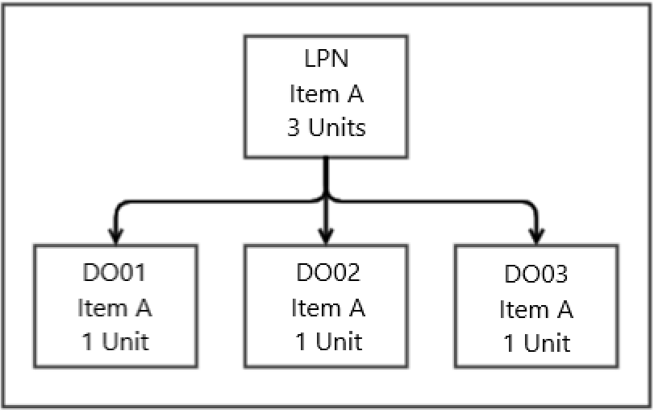

Assumptions
- The Original Orders for Flowthrough demand exist in WM before the inventory is dispositioned.
- Original Order lines are not interfaced with a PO or ASN number for the flowthrough allocation.
- Lands’ End uses ‘Allocation Source Rules’ for singles bulk allocations for Phase 1 go live. The other methods may be configured and used in the future if required.

User Stories
All processes invoking LPN disposition calling Flowthrough Allocation are performed as part of Receiving. See the Receiving section for detailed processes and User Stories.

Features

Order Selection Criteria
As part of the Flowthrough Selection Strategy, WM can be configured to select/determine which order(s) to allocate against using different selection methods outlined below.
Allocation Source PO
In this method, WM identifies the order line to allocate based on the Purchase Order ID of the iLPN = ‘Allocation source ID’ on the order line. To use this method, the order line needs to have the iLPNs purchase order interfaced on the ‘Allocation source ID’ field. This method is typically used when the HOST system allocates store demand directly against PO quantities.
Allocation Source ASN
In this method, WM identifies the order line to allocate based on the ASN ID of the iLPN = ‘Allocation source ID’ on the order line. To use this method, the order line needs to have the iLPNs ASN interfaced on the ‘Allocation source ID’ field. This method is typically used when the HOST system allocates store demand directly against ASN quantities.
Allocation Source Mark For
In this method, WM identifies the order line to allocate based on the ‘Mark for’ value on the iLPN = ‘Allocation source ID’ on the order line. To use this method, both the iLPN and the order line need to have the same ‘Mark for’ value on both objects. This method is typically used when an iLPN lines are specifically earmarked against corresponding order lines. The same ‘Mark for’ value must be interfaced on both the iLPN (via ASN interface) and the Order line by the HOST system.
Allocation Source Destination Facility
In this method, WM identifies the order line to allocate based on the Destination Facility value on the iLPN = ‘Allocation source ID’ on the order line. To use this method, the order line needs to have the iLPNs destination facility (store) interfaced on the ‘Allocation source ID’ field. Furthermore, the iLPN needs to also have the destination facility (store) interfaced (via ASN interface).
Allocation Source Rules
In this method, WM identifies the order line to allocate based on Rules configured in WM. This method is typically used when the HOST system is not able to interface allocation source values on the required objects.

Key Interfaces
Interface | Business Scenario
ASN | Used for interfacing Flowthrough Allocation Source fields
Purchase Order | Used for interfacing Flowthrough Allocation Source fields
Original Order | Informs WM of Customer demand. Also used to interface Flowthrough Allocation Source fields.

Reports, Dashboards, Alerts
None identified.

Gaps and Extensions
GAP# | Name | Why | Description

Labor Management
Labor management details need to be added after LM design sessions.

Order Planning
Order planning is the process by which MAWM performs actions like inventory allocation, cubing, routing for shipping, and order consolidation to fulfill outbound orders from the distribution center's inventory.

Order Profile
The following sections provide a high-level overview of Lands’ End order types and how it will flow through the distribution center. Each order type is placed through following business line:
- Lands’ End Core Business (CORE)
- Lands’ End Outfitter (LEO)
- Lands’ End School Uniform (LESU)
- Lands’ End Fulfilled (LEF) (Amazon, Kohls, etc.)

Order Types
The table below lists the order types that will be used in Manhattan. Order types are used in Manhattan Active to drive processes and criteria based on data values. They also facilitate summarization and provide insights per order type through pre-built dashboards or via custom dashboards within Manhattan Active Supply Chain Intelligence.
Order Type | Business Line | Rate Shop Group | Carrier Service Mode
Production Order – Logo  (PRODLOGO) | CORE/LEO/LESU | null | Truck Load
Production Order – Heat Transfer (PRODHT) | CORE/LEO/LESU | null | Truck Load
Production Order – Monogram (PRODMONO) | CORE/LEO/LESU | null | Truck Load
Production Order – Hemming (PRODHEM) | CORE/LEO/LESU | null | Truck Load
Production Order – Name Badge (PRODNBDG ) | CORE/LEO/LESU | null | Truck Load
VAS Customer Order  (CUSTVASORD) | CORE/LEO/LESU | Not null | Parcel or Truck Load (e.g. Kwik Trip)
Customer Order  (CUSTREGORD)  Customer Order  (CUSTREGORD) | CORE/LEO/LESU LEF-Amazon  LEF-Nordstrom  LEF-Target  LEF-Kohls  LEF-Macys | Not null  Not null | Parcel or Truck Load (e.g. Kwik Trip)  Parcel or Truck Load (e.g. Kwik Trip)
Store Orders (STORORD) | CORE/LEO/LESU | Not null | Parcel (Order.Extended.Rate ShopGroupId not null) or Truck Load based (Order.Extended.Rate ShopGroupId is null)
Replen Order (RPLNORD) | CORE/LEO/LESU | null | Parcel (Order.Extended.Rate ShopGroupId not null) or Truck Load based (Order.Extended.Rate ShopGroupId is null)
Wholesale (WHSLORD) | CORE/LEO/LESU | null | Truck Load
Order Transfer (OTRNORD) | CORE/LEO/LESU | null | Truck Load
Stock Transfer (STKTRNORD) | CORE/LEO/LESU | null | Truck Load
Charity (CHARORD) | Not quite perfect Inventory (NQP) | null | Truck Load
Liquidation (LIQORD) | CORE/LEO/LESU | null | Truck Load
Marketing (MRKTORD) | CORE/LEO/LESU | null | N/A
Photo Shoot (PSHORD) | CORE/LEO/LESU | Not null | Parcel

Customer Orders
Customer orders are shipped directly to residential or commercial addresses using parcel carrier services. If a customer order requires product customization, it is processed as a “VAS Customer Order” after the VAS process is completed through a Production Order.
VAS Customer Order High Level Process Steps
- Production Order Release (Pre-VAS: This initiates the production process for the customized product, SAP release a Production Order to MAWM to pick the core material to produce the final product and ship it to a SAP manufacturing plan (Order Destination Facility).
- VAS Customer Order Release (Post-VAS): After the VAS process is completed and the finished good is received in MAWM (Post VAS Receiving process) , the customer order is released to MAWM from SAP for picking, packing, and shipping based on the following criteria:
  - Single-Line, Single-Unit VAS Orders : A customer order for a single item with a single unit.
  - Large VAS Orders: A single sales order with a large total unit quantity (a configurable value in SAP) for a specific number of SKUs, all requiring the same VAS customization. Example: A single sales order with a total line item quantity greater than 50 and fewer than 4 SKUs, with the same VAS applied to all items.
  - Multi Line/Units VAS Orders: Customer orders with multiple SKUs or multiple types of customizations (e.g., some items embroidered, others monogrammed) or single line/single unit order that required a Gift package.
Example of customer orders/sales order types
Order Type | Old Order Type | Business Line  (Extended Att.) | Fulfillment  Code (EA) | Parcel Rate Shop Group Id (EA) | Carrier Service
VAS Customer Order  (CUSTVASORD) | LE-US-CORE-VAS-SO | CORE, LEBO, LESU | S, M,L,X | Not null | Parcel
Customer Order  (CUSTREGORD) | LE-US-CORE-SO | CORE, LEBO, LESU, LEF-Amazon, LEF-Nordstrom, LEF-Target , LEF-Kohls, LEF-Macys |  | Not null | Parcel, / Truck Load (Kwik Trip)

Production Orders
When a customer order requires product customization, SAP generates one or multiples production orders. These orders are then released to MAWM based on the value-added service (VAS) type, such as Embroidery (Logo) , Monogram, Hemming or Name Badge.
For single-line, single-unit orders with a single-item customization, SAP creates one production order per original sales order. For multi-line sales orders, SAP creates a combined production order, where each order line is a production order.
Production orders are classified into two categories:
- In-house production orders: Produced at the Dodgeville, Reedsburg, or Stevens Point plants.
- Outsourced production orders: Handled by external Value-Added Service (VAS) providers.
The destination facility ID of an original order specifies whether the destination facility is an in-house VAS facility or an outsourced VAS facility.

Production Order – Order Types
Order Type | Fulfillment Codes  (examples)
Production Order – Logo (PRODLOGO) | S, M,L
Production Order – Heat Transfer (PRODHT) | S, M,L
Production Order – Monogram (PRODMONO) | S, M,L
Production Order – Hemming (PRODHEM) | S, M, X
Production Order – Name Badge (PRODNBDG)

Fulfillment Codes
Fulfillment Code | Description
S | Singles
M | Multi Units & Multi VAS or Single Line / Single Unit that required a Gift Box package.
L | Large
X | Multiples VAS operations in one item starting with Hemming VAS operation.
Note: Fulfillment code are also included with VAS Customer Orders (Post VAS Order). Enterprise Orders are identified by an extended attribute, “Enterprise Code,” specifies when an order should be processed as an enterprise production order when the code is not null. Enterprise Order are not aggregated in MAWM.
Example of possible enterprise order codes.
Enterprise Code | Description
CH0001 | Chase Bank
WFS01 | Wells Fargo
Example of VAS Production Facilities
The facilities below are an example of facility id that is used with the production orders destination facility id.
Order Destination Facility Id | Facility Name | Facility Type Description
SAP-4 | Reedsburg VAS Plan | In-house VAS
SAP-1 | Dodgeville VAS Plan | In-house VAS
SAP-7 | Stevens Point VAS Plan | In-house VAS
56345 | Artistic Logo VAS Plan | Outsourcing VAS
35658 | Contract Customizing VAS Plan | Outsourcing VAS

A facility entity/record is created in MAWM and it is used as the Order destination facility ID of a production order. In conjunction with order planning criteria, this determines the appropriate order fulfillment process flow. Additionally, extended attributes, such as "Fulfillment Code", “Enterprise Code”, “School Id” and “Logo Id” are used to identify how a production order is processed in Manhattan. These attributes indicates whether the order is handled as a combined production order, a single-item order, a multi-item order, an enterprise order, a school order, or a large customer order.

Example # 1 – Singles Production Orders
A customer order is created in SAP that requires decoration or customization. Based on the type of decoration, SAP generates a production order.
Pre VAS - Production Order (Original Order, created by SAP based on the customer order)
Order | Customer | Order Type | Full.  Code | Line Num. | Base Item Id | Finished Item Id | Batch  Number | Units | Decoration
PO01 | C001 | PRODLOGO | S | 1 | B301 | E301 | E301-001 | 1 | Basketball Logo
PO02 | C002 | PRODLOGO | S | 1 | B301 | E301 | E301-002 | 1 | Ice hockey logo
PO03 | C003 | PRODLOGO | S | 1 | B302 | E301 | E301-003 | 1 | Football logo

Post VAS - Customer Orders (Original Order)
Order | Customer | Order Type | Line Num. | Base Item Id | Finished Item Id (KMAT) | Batch  VAS ID | Units | Decoration
OO01 | C001 | VAS | 1 | B301 | E301 | E301-001 | 1 | Basketball Logo
OO02 | C002 | VAS | 1 | B301 | E301 | E301-002 | 1 | Ice hockey logo
OO03 | C003 | VAS | 1 | B302 | E301 | E301-003 | 1 | Football logo

Example # 2 - Large VAS Customer Orders / Combine Production Orders
A multi-line customer order is created in SAP that requires one decoration on different SKUs. Based on the type of decoration, SAP generates a combined production order, where each original order line becomes a production order line consolidated into a multi-line production order.
Pre VAS - Combine Production Order
Order | Customer | Order Type | Full.  Code | Line Num. | Base Item Id | Finished Item Id  (KMAT) | Batch Number | Units | Decoration
CPO01 | PO01 | PRODLOGO | L | 1 | B301 | E301 | CHS01 | 250 | Chase Logo
CPO01 | PO02 | PRODLOGO | L | 2 | B302 | E301 | CHS02 | 250 | Chase Logo
CPO02 | PO03 | PRODLOGO | L | 1 | B301 | E301 | KWT01 | 325 | Kwik Trip Logo
CPO02 | PO04 | PRODLOGO | L | 2 | B303 | E301 | KWT02 | 125 | Kwik Trip Logo
Post VAS – Customer Orders (Original Order)
Order | Customer | Order Type | Line Num. | Base Item Id | Finished Item Id | Batch  VAS ID | Units | Decoration
OO01 | C001 | VAS | 1 | B301 | E301 | CHS01 | 250 | Chase Logo
OO01 | C001 | VAS | 2 | B302 | E301 | CHS02 | 250 | Chase Logo
OO02 | C002 | VAS | 1 | B301 | E301 | KWT01 | 325 | Kwik Trip Logo
OO02 | C002 | VAS | 2 | B303 | E301 | KWT02 | 125 | Kwik Trip Logo

Example # 3 - Multis VAS Customer Orders
A multi-line customer order is created in SAP that requires one or multiple decorations on one or more SKUs. Based on the type of decoration, SAP generates a combined production order, where each original order line is transformed into a production order line, consolidated into a multi-line production order based on predefined criteria.
Pre VAS – Multis Combine Production Orders
Order | Cust. | Order Type | Full.  Code | Line Num. | Base Item Id | Finished Item Id | Batch Number | Units | Decoration
CPO01 | C001 | PRODLOGO | M | 1 | B301 | E301 | OO01-001 | 2 | Basketball Logo
CPO01 | C002 | PRODLOGO | M | 2 | B301 | E301 | OO02-001 | 3 | Baseball Logo
CPO02 | C003 | PRODLOGO | M | 1 | B302 | E301 | OO03-002 | 3 | Soccer Logo
CPO02 | C002 | PRODLOGO | M | 2 | B302 | E301 | OO02-002 | 6 | Basketball Logo
CPO03 | C001 | PRODLOGO | M | 1 | B302 | E301 | OO01-002 | 2 | Football logo
CPO03 | C003 | PRODLOGO | X | 2 | B301 | E301 | OO03-001 | 3 | Ice hockey logo

Post VAS – Customer Orders (Original Order)
Order | Customer | Order Type | Line Num. | Base Item Id | Finished Item Id | VAS Id | Units | Decoration
OO01 | C001 | VAS | 1 | B301 | E301 | OO01-001 | 2 | Basketball Logo
OO01 | C001 | VAS | 2 | B301 | E301 | OO01-002 | 2 | Football logo
OO02 | C002 | VAS | 1 | B302 | E301 | OO02-001 | 3 | Baseball Logo
OO02 | C002 | VAS | 2 | B302 | E301 | OO02-002 | 6 | Basketball Logo
OO03 | C003 | VAS | 1 | B302 | E301 | OO03-001 | 3 | Ice hockey logo
OO03 | C003 | VAS | 2 | B301 | E301 | OO03-002 | 3 | Soccer Logo

Pre-VAS Process Overview

Post-VAS Process Overview

Store Orders
Lands’ End retail stores receive inventory through two order types:
- Store Orders: Larger orders to supply seasonal inventory, typically shipped via truckload.
- Replen Store Orders: Smaller orders used to replenish seasonal inventory, shipped via parcel carrier.
Store orders are picked in bulk and distributed to designated store pack locations for retail price tagging and packing after picking. An order strategy is configured to aggregate store orders based on their type and carrier service mode. The aggregation process stops and creates a new distribution order once the minimum distribution order lifecycle status reaches or exceeds the “packed” status or once the order is planned (waved). Since store orders can be shipped via parcel or truckload, two store pack locations are defined in MAWM based on the values of the extended attribute “Parcel ate Shop Group Id” of the order.
Example of Store Orders types
Order Types | Business Line | Parcel Rate Shop Group Id (EA) | Carrier Service Mode
Store Order | Lands’ End Core Business (CORE) | null | Truck Load (TL/LTL)
Replen Store Order | Lands’ End Core Business (CORE) | No null | Parcel (PCL)

Example of Store Pack Location Setup
Below is an example of store pack location setup for store 825 and 830, based on item size category.
Location Id | Location Type | Packing Location Type | Store | Carrier Service Mode
825-01 | Packing | Store Pack | 825 | Truck Load (TL/LTL)
825-02 | Packing | Store Pack | 825 | Parcel (PCL)
830-01 | Packing | Store Pack | 830 | Truck Load (TL/LTL)
830-02 | Packing | Store Pack | 830 | Parcel (PCL)

Wholesale
Wholesale requirements are typically full iLPNs out of reserve, however, if a less than iLPN quantity is required, Lands’ End plans to replenish iLPNs to the Wholesale Dynamic Active zone to pick the required individual units for the order. Wholesale inventory does not have a permanently slotted unit storage location for items. When replenishments are created, if a dynamic location currently exists for the item, MAWM attempts to replenish a full iLPN to the dynamic location. If a full iLPN cannot fit into the location or there is no current location for the item, MAWM creates a new temporary assignment for the item and replenishes a full iLPN to the location.
As needed, Lands’ End packs the inventory in Wholesale Dynamic Active locations back into iLPNs to be stored in iLPN Storage so they may be allocated as a Full iLPN.
Example of Wholesale order type
Order Types | Business Line | Parcel Rate Shop Group Id (EA) | Carrier Service
Wholesale | Specified with the order line | null | Truck Load

Transfer Orders
Lands’ End employs transfer orders to move inventory between its distribution centers. These transfer orders are categorized as follows:
- Stock Transfers: These transfers aim to move inventory between distribution centers to balance inventory levels across them.
- Order Transfers: These transfers aim to move inventory to a specific distribution center to fulfill customer orders placed at that location.
Example of Transfer Orders
Order Types | Business Line | Parcel Rate Shop Group Id (EA) | Carrier Service
Order Transfer | Specified with the order line | null | Truck Load
Stock Transfer | Specified with the order line | null | Truck Load

Special Orders
Lands’ End utilizes Intercompany Orders to transfer or consume inventory without generating a formal sales transaction. Below are the primary types of Intercompany Orders used:
- Charity Orders: These orders involve transferring third-quality inventory, referred to as Not Quite Perfect (NQP) inventory, to charitable organizations. Before waving, the inventory to be donated is manually identified by assigning an Inventory Condition Code matching the charity number (Original Order Customer ID) to each LPN that will be allocated and shipped. Once the inventory is identified, the warehouse associate runs a report in SCI, which breaks down the inventory by Charity Code, SKU, and quantity. This report is used to request a “Charity Order” in SAP for the specified SKUs and quantities.
- Liquidation Orders: These orders pertain to the transfer of 2nd quality inventory for liquidation purposes.
- Marketing Orders: These orders are intercompany transfers with specific instructions or requirements for marketing.
- Photo Shoot Orders: These orders are used to transfer inventory to Lands’ End’s Photo Studio campus, a Prep-Room, or an external Photo Studio. These orders are typically shipped via parcel carrier service.

Example of Intercompany Orders
Order Types | Business Line | Parcel Rate Shop Group Id (EA) | Carrier Service
Charity | Any 3rd quality inventory (NQP) | null | Truck Load
Liquidation | Any 2nd quality inventory | null | Truck Load
Marketing | Specified with the order line | null | N/A
Photo Shoot | Specified with the order line | Specified for external photo studio | Parcel

Order Strategy
An Order Strategy is the main configuration entity in DC Order. It encompasses settings for order aggregation, prioritization rules, order pipeline, planning rules, and cubing estimation when an order is imported or created in MAWM.
Order Strategy | Maximum  Pickup Days if null | Maximum  Delivery Days If null | Maximum Days Between  Pickup and Delivery Date is null
LE Order Planning Strategy | 15 | 15 | 15

Order Aggregation
Order aggregation is a process that combines multiple original orders into a single distribution order based on defined criteria. Once the original orders are imported, they are evaluated against the aggregation criteria configured in the Order Strategy. If an original order meets the criteria, a rule definition and aggregation attributes will determine whether the entire order can be aggregated into an existing distribution order or if a new distribution order should be created. All configured aggregation attributes must match the existing distribution order for the original order to be aggregated. If no matching distribution order is found, a new one is created. This new distribution order will be eligible for further aggregation with future original orders that have matching attributes.
Lands’ End plans to aggregate Order Transfers, Production Orders (Pre VAS), Customer Orders (CORE) and Store Orders.
Note: Each original order will be part of a single distribution order. Once an order is selected with an Order Planning Strategy, it will be locked to prevent further aggregation.
Order Aggregation Criteria By Order Types
Order Type | Aggregate | Aggregate By
Production Order – Logo (PRODLGO) | Yes | Order Type and Order.Extended.LogoId and Order.DestinationFacilityId
Production Order – Heat Transfer (PRODHT) | No
Production Order – Monogram (PRODMONO) | No
Production Order – Hemming (PRODHEM) | No
Production Order – Name Badge (PRODNBDG ) | No
VAS Customer Order (CUSTVASORD) | No
Customer Order (CUSTREGORD) | Yes | Order Type and Customer Name and Destination Address
Store Orders (STORORD) | Yes | Order Type and Destination Facility Id and Designated Carrier Service (Parcel vs Truck Load)
Replen Order (RPLNORD) | Yes | Order Type and Destination Facility Id and Designated Carrier Service (Parcel vs Truck Load)
Wholesale (WHSLORD) | Yes | Order Type and Customer Name and Destination Address
Order Transfer (OTRNORD) | Yes | Order Type and Destination Facility Id
Stock Transfer (STKTRNORD) | Yes | Order Type and Customer Name and Destination Address
Charity (CHARORD) | No | Order Type and Customer Name and Destination Address
Liquidation (LIQORD) | Yes | Order Type and Customer Name and Destination Address
Marketing (MRKTORD) | Yes | Order Type and Customer Name and Destination Address
Photo Shoot (PSHORD) | Yes | Order Type and Customer Name and Destination Address

Order Prioritization
Order priority plays a key role in fulfilling orders and thus facilitates efficient fulfillment. The order priorities are determined by configurable business rules, and a DC Order's Prioritization engine evaluates the prioritization rules to find a matching rule and assign an integer priority value to a distribution order, thus indicating the order's relative priority. The DC Order prioritization rules also determine if the order can be marked as a 'Hot' order and the order is stated as a high priority order.
Example:
Order Prioritization Rules | Order Priority | Hot Order
Order.Extended.HotOrder = true | 1 | Yes
Delivery DTTM = 'Tomorrow' or All Single Unit Single Line Orders  Or Order.Extended.HotOrder = true or (OrderType = “CUSTVASORD” Order.Extended.FullfilmentCode IN (‘S’, ‘L’) | 1 | Yes
Order.Extended.ParcelRateShop = 1 | 10 | No
Order.Extended.ParcelRateShop = 2 | 20 | No
Order.Extended.ParcelRateShop = 3 | 30 | No

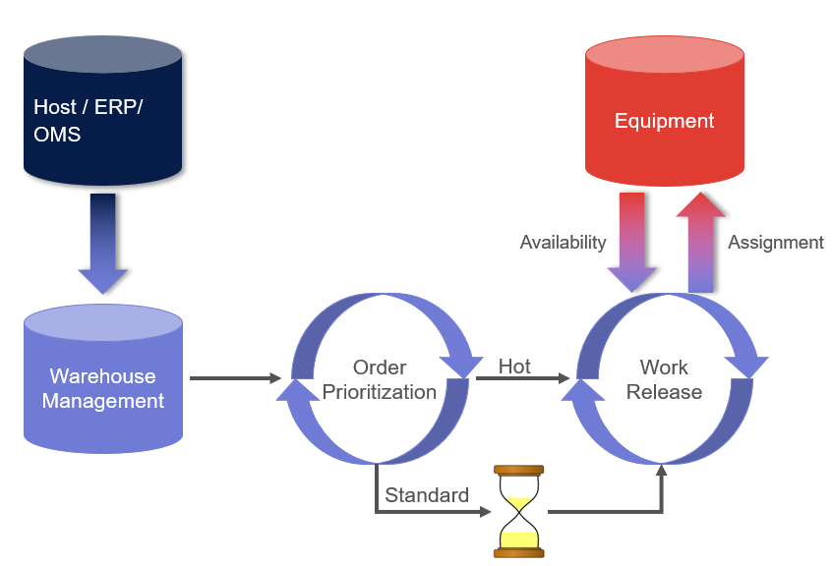

Order Pipeline
An order pipeline outlines the stages through which an order progresses, from creation to completion, involving status changes and procedural steps. Lands’ End uses the following two order pipelines for their current order fulfillment process.
Pipelines and Steps
Pipeline | Pipeline Steps
LE Master Pipeline | - Flowthrough  - Allocation  - Cubing  - Routing  - Picking Task Creation  - Sort/Pack Work Release  - Replenishment  - Replenishment Task Creation  - Replenishment Resource
LE Work Order Pipeline | - Allocation  - Picking Task Creation  - Replenishment  - Replenishment Task Creation  - Replenishment Resource

Pipeline Determination Criteria
The determination criteria are used to assign an order pipeline to an order based on the order processing type. Specifically, the "LE Standard Order Planning" pipeline is used for shipping orders, and the "LE Work Order" pipeline is used for the Prepack Disassemble process. Additionally, the process can trigger an order planning strategy after the pipeline is assigned, based on configured rules. The table below illustrates which orders need to be processed after order creation. All other orders ("catch-all" orders) are planned based on pre-configured order planning schedules or manually through the Order Planning Strategy UI.

LE Order Strategy
Pipeline Determination Criteria | Selection Rules | Pipeline | Order Planning Strategy that is Auto triggered | Interval  (in minutes)  for OPS auto trigger
Hot Customer Orders | Order Type equal “CUSTREGORD” and Order Extended Hot Order is true | LE Standard Order Planning | LE Hot Orders Wave | 1 minute after order download
In-house VAS Customer Orders  (Large and Singles) | Order Type = “CUSTVASORD” and Order Extended Fulfillment Code is “L” OR “S” and OutsourceVAS = false | LE Standard Order Planning | LE In-house VAS Customer Orders Wave | 2 minutes after order download
Work Orders | OrderProcessTypeId = “Work Order” | LE Work Order
Catch All |  | LE Standard Order Planning

Order Planning Strategies
MAWM supports three primary order planning strategy modes:
- Replenishment: Creates replenishment allocations and tasks based on order pool demand. Lands' End will not use the Replenishment Wave but will schedule a Lean Time Replenishment at 10:00 PM Central Time to generate replenishment for active locations before the 11:00 PM CST order planning schedule.
- Wave: Used for batch processing of selected orders requiring specific types of processing. This can be executed manually or automatically on a planned schedule.
- Stream: Used for processing individual orders as they are released into MAWM, particularly for Express and Hot orders within a specific timeframe (e.g., express orders between 6 AM and 2 PM). This strategy runs continuously in the background, ensuring timely action without waiting for a wave.
Note: Lands' End may adjust the timeframe for singles auto waving vs. scheduled waves. A rule within the order planning strategy can be configured to compares the order's creation date/time with a configured timeframe to determine the appropriate mode.
Example of an Order Planning Strategy Criteria Rule to select orders created between 2PM – 7 PM

order.createdTimestamp.hoursFromCurrent(basehour=14)>=5
Note: Base-hour is the hour from which evaluation starts, and the >= number indicates how many hours to evaluate.

Unit Sorter Wave
A Unit Sorter is a high-speed, automated system that efficiently processes and directs items to specific destinations. To optimize the sorting process, wave strategies are employed to group items into batches, increasing pick density and throughput while minimizing idle time.
Lands’ End’s Dodgeville facility utilizes three types of unit sorters:
- Matthews B2 Unit Sorters (Sorter A & B): Dual induction point
- Matthews HM Sorters: Dual induction points
- Beumer Sorter X: Dual induction points
Order planning strategies are configured for each unit sorter, considering factors like induction points and capacity. These strategies are executed every two hours, with a five minutes of difference each one, to select orders that will keep each unit sorter busy for approximately one and a half hours. This approach maximizes pick density and enables the completion of unfinished batches in the next cycle.
Note: All Unit Sorter Order Planning don’t require routing during the planning run (wave), the routing pipeline step is selected as none, the routing process is from the packing transaction.
Order Planning strategies
Order Planning Strategy | Order Selection | Schedule | Notes
LE Sorter X 10-30 Wave  (Sorter Low Season Wave) | Order Type equal “CUSTREGORD” and Order. Extended Is Gift Box Indicator = false or  (Order Type = “CUSTVASORD”  and Order Extended Fulfillment Code is “X” or “M” ) | - 11:00 PM CDT  - 2:00 AM CDT  - 5:00 AM CDT  - 8:00 AM CDT  - 11:00 AM CDT  - 2:00 PM CDT  - 5:00 PM CDT  - 8:00 PM CDT | Induction X for 10,20 & 30
LE Sorter X 10 Wave |  | - 11:00 PM CDT  - 2:00 AM CDT  - 5:00 AM CDT  - 8:00 AM CDT  - 11:00 AM CDT  - 2:00 PM CDT  - 5:00 PM CDT  - 8:00 PM CDT | Induction Y
LE Sorter X 20-30 Wave |  | - 11:05 PM CDT  - 2:05 AM CDT  - 5:05 AM CDT  - 8:05 AM CDT  - 11:05 AM CDT  - 2:05 PM CDT  - 5:05 PM CDT  - 8:05 PM CDT | Induction X
LE Sorters A Wave | Order Type equal “CUSTREGORD” and Order. Extended Is Gift Box Indicator = true or  (Order Type = “CUSTVASORD”  and Order Extended Fulfillment Code is “X” or “M” ) | - 11:10 PM CDT  - 2:10 AM CDT  - 5:10 AM CDT  - 8:10 AM CDT  - 11:10 AM CDT  - 2:10 PM CDT  - 5:10 PM CDT  - 8:10 PM CDT | Induction A
LE Sorters B Wave |  | - 11:15 PM CDT  - 2:15 AM CDT  - 5:15 AM CDT  - 8:15 AM CDT  - 11:15 AM CDT  - 2:15 PM CDT  - 5:15 PM CDT  - 8:15 PM CDT | Induction B
LE HM06 Sorter | Order Type IS “PRODLOGO” OR “PRODHT”  AND  Order Enterprise Code is null  AND  (  Order Fulfillment Code is equal to M OR  (Order Fulfillment Code is equal to S AND SingleLineOrder is false)  )  AND DestinationFacilityId is not null and not equal to SAP-7 | - 11:20 PM CDT  - 2:20 AM CDT  - 5:20 AM CDT  - 8:20 AM CDT  - 11:20 AM CDT  - 2:20 PM CDT  - 5:20 PM CDT  - 8:20 PM CDT | HM06 Induction
LE HM07 Sorter | Order Type IS “PRODLOGO” OR “PRODHT”  AND  Order Enterprise Code is null  AND  (  Order Fulfillment Code is equal to M OR  (Order Fulfillment Code is equal to S AND SingleLineOrder is false)  ) AND DestinationFacility is equal to SAP-7 | - 11:25 PM CDT  - 2:25 AM CDT  - 5:25 AM CDT  - 8:25 AM CDT  - 11:25 AM CDT  - 2:25 PM CDT  - 5:25 PM CDT  - 8:25 PM CDT | HM07 Induction

Customer Order Planning (Non MHE Flows)
The Customer Order Wave is used for singles and Large Customer orders that are process directly in the pack station bypassing the MHE unit sorter.
Note: All Unit Sorter Order Planning don’t require routing during the planning run (wave), the routing pipeline step is selected as none, the routing process is from the packing transaction.
Order Planning strategies
Order Planning Strategy | Order Selection | Order Planning Schedule
LE Singles Stream | Order Type equal to “CUSTREGORD” and Single Line Order is true and Single Unit is true and Order. Extended Is Gift Box Indicator = false | - 20 minutes scheduled job
LE Hot Orders Stream | Order Type equal “CUSTREGORD” and Order Extended Hot Order is true | - 20 minutes scheduled job (to catch any auto wave deselection)  - Dropping Stream for SCI Alert
LE Hot Orders Wave | Order Type equal “CUSTREGORD” and Order Extended Hot Order is true | - Auto trigger 1 minutes after order is created.
LE VAS Large and Singles Orders Wave | Order Type = “CUSTVASORD” and Order Extended Fulfillment Code is “L” OR “S” | - Auto trigger 1 minutes after order is created.
LE VAS Large and Singles Orders Stream | Order Type = “CUSTVASORD” and Order Extended Fulfillment Code is “L” OR “S” | - 20 minutes scheduled job (to catch any auto wave deselection)

Production Order Wave
Production order planning is the Order planning strategy used to schedule multiple production orders, either manually or via a job schedule. When an order meets specific selection criteria, the planning process generates HM sorter batches.
Note: “Production Order” routing strategy is selected to plan outsource shipments during waving.
Order Planning strategies
Order Planning Strategy | Order Selection | Schedule
LE Production Orders Wave | (Order Type IS “PRODHEM” OR “PRODMONO”  OR  Order Enterprise Code is not null  OR  ( (  Order Fulfillment Code is not equal to M OR  (Order Fulfillment Code is equal to S AND SingleLineOrder is true)  ))  )  AND DestinationFacilityId is not null | - 11:00 PM CDT  - 2:00 AM CDT  - 5:00 AM CDT  - 8:00 AM CDT  - 11:00 AM CDT  - 2:00 PM CDT  - 5:00 PM CDT  - 8:00 PM CDT

Retail Wave
Store Order Planning is executed to perform bulk allocation and distribute the allocations through store pack locations based on product merchant groups.
Note: OPS is configured to not lock the Order for further aggregation when it is selected. Routing during the planning run (wave) is not required, the routing pipeline step is selected as none, the routing process is triggered from the packing transaction for parcel orders.
Order Planning strategies
Order Planning Strategy | Order Selection Rules | Schedule
LE Retail Wave | Order Type equal to STORORD and RPLNORD | - Every 30 Minutes

Truck Load Wave
Truck Load wave is used to plan orders that require a truckload carrier service, such as wholesale orders, transfer orders, charity orders, and liquidation orders.
Note: For Amazon, wholesale order, MAWM generates an shipment and Lands’ End shipping office updates it with information from Amazon web portal.
Order Planning strategies
Order Planning Strategy | Order Selection Rules | Schedule
LE Truck Load Wave | Order Type equal Wholesale, Stock Transfer, Order Transfer, Charity orders and Liquidation Orders | - 11:00 PM CDT  - 2:00 AM CDT  - 5:00 AM CDT  - 8:00 AM CDT  - 11:00 AM CDT  - 2:00 PM CDT  - 5:00 PM CDT  - 8:00 PM CDT

Chase Order Planning
Order Planning strategies
Order Planning Strategy | Order Selection Rules | Schedule
LE Chase Wave | Customer Orders, VAS Customer Orders, Production Orders | - 7 AM CST  - 10 AM CST  - 1 PM CST  - 4 PM CST  - 8 PM CST
LE Chase Hot Orders | Customer Orders, VAS Customer Orders, Production Orders | - Every 5 minutes

Fill and Kill Order Planning

Order Planning Strategy | Order Selection Rules | Schedule
LE Fill and Kill Strategy | Order Minimum Status = Released and Order Maximum status > Released and Order Type Not equal to “VAS Customer Orders” | - 10 PM CST
LE Fill and Kill Strategy | Order Minimum Status = Released and Order Maximum status > Released and Order Type Not equal to “VAS Customer Orders” and Order Days from Creation Date is great than 15 days | - 10 PM CST

User Stories

User Story: Run Wave (Order Planning Strategy)
Who | What | Why
Wave Planner | Initiate Waving Process | Select and allocation orders for fulfillment

Process
- User logs into MAWM UI and navigates to the Order Planning Strategy UI
- User selects the appropriate Order Planning Strategy to run based on the planned schedule
- User selects ‘Run Wave’

Updates

- Orders are Selected
- Orders are allocated
- Replenishment allocations are created, if necessary
- oLPNs are cubed (Only for non-Store Waves)
- Work is created (Batches)

User Story: Run Wave (Orders UI)

Who | What | Why
Wave Planner | Initiate Waving Process by Order | Select and allocation orders for fulfillment

Process
- User logs into MAWM UI and navigates to the Orders UI
- User searches for specific order or orders and selects the required orders
- User selects ‘Run Wave’

Updates
- Orders are Selected
- Orders are allocated
- Replenishment allocations are created, if necessary
- oLPNs are cubed
- Work is created (Batches)

User Story: Release Batches
Who | What | Why
Work Planner | Release work to the floor | Select work to release to the floor manually determined by available labor and resources

Process
- User logs into MAWM UI and navigates to the Batch List UI
- User searches for Batches in a ‘Held for Tasking’ status
- User selects the appropriate Batches to release
- User selects ‘Release

Updates
- Batch is Released for Tasking
- Tasks are created
- Task Release MHE message sent to MHE
Note: Batches are configured for automatic release based on the sorting progress, as defined in AU04.

User Story: Pre-VAS Batch and Task Label Printing
Who | What | Why
Pre VAS Wave Planner | Print Batch and Task Labels for Production Orders. | Print Task Labels for production order picking tasks.

Lands' End will configure a batch print strategy to print the Pre-VAS HM Sorter Batch and Picking Tasks between batches. This strategy will also print the remaining picking tasks generated during the Order Planning run (wave), such as VAS LPN Pull and VAS Blk Pick tasks.
Labels are printed after work release by the Pre-VAS Order Planning Manager. The manager reviews the Pre-VAS wave runs for the day, selects a completed wave from the "Wave Runs" UI, and clicks "Print Documents" from the "More" menu in the screen's upper right corner.
A “Pre-VAS Labels” batch print strategy is created with the following two batch print criteria.
Batch Criteria | Selection Rules | Labels (Batch Print Criteria Details)
HM Sorter Labels | Transaction Id is HM LPN Pull or HM Blk Pick | 1 - Batch Label (Start and End)  2 - Task Label
Pre-VAS Bulk Picks | Transaction Id is VAS LPN Pull or VAS Blk Pick | 1 - Task Label (Start Label Only)

Assumption
- The batch and task label payload is enriched with the additional information required to drive the VAS process. [WM26]
- Lands' End owns the batch and task label layout after the label payload is enriched.

Process
- User logs into the MAWM UI and navigates to the "Wave Runs" UI.
- User searches for Production Orders for the required wave date using the Filter sidebar.
- User selects the appropriate Production Order Wave Run in "Completed" status.
- User selects the More button from the bottom-right command bar.
- User selects the "Print Documents" menu option.
- User selects the "Pre-VAS Printing Strategy" and clicks "Submit" to print all Pre-VAS Batch and Task labels associated with the selected wave to the current user's default printer. Alternatively, the user can specify the desired print location by selecting the appropriate parameters from the Printing Document Prompt UI.

Updates
- Labels are printed based on the selected batch print strategy.

Features

Undo Wave
If a wave was incorrectly configured or did not select all the anticipated orders, then a wave should be stopped. This is not intended to be a daily tool as it is resource intensive to revert all waving updates and is generally used when there is no other recourse. If/when required, all users should back out of tasks generated by the wave that will be undone. The undo process will not kick a user out of a task automatically, so all work on that wave needs to stop prior to running undo. If there are oLPNs already picked/packed with inventory, those will be converted to iLPNs for simplified putaway. It is recommended, however, that Undo Wave is not initiated once picking for the wave begins.

End Work
Lands’ End uses an "End Action" to cancel and deallocate all unpacked orders from a specific wave. This action is initiated from “Wave Runs” UI when a unit sorter goes out of service after a work order has been released. Once all open packing work is concluded, Lands’ End moves the inducted products to a storage location and initiates a new wave for one of the available unit sorters to generate new picking and packing work.

Key Interfaces
Interface | Business Scenario
Original Order | Provides facility direction with the SKU and quantity that needs to be shipped to the specified destination. Business object that is waved.

Reports, Dashboards, Alerts
Name | Description | Frequency | User/Dept | Type
Deselected & Canceled Orders | Details orders that have a shortage or cancellation at the time of allocation | As needed | Wave Control | SCI Report
Aged Orders in created or released status | Details orders (customer and transfer) and the amount of time they have been unwaved. | As needed | Wave Control | SCI Report
Rate Shopping Validation Report | Provide an overview of planned Parcel Order post rate shopping | As needed | Shipping Team | SCI Report
Hot Orders Deselects Alerts | Sends an alert when a hot order deselects from an AutoWave | Per Instance | Wave Control | SCI Report
HM Sorter Estimates Gurney and Tote Volumes | Provide an overview of the expected volumes per HM Sorter chute based on the current Sort Divert Assignments. | As needed | Pre-VAS Operational Team | SCI Report

Gaps and Extensions
Gap # | Name | Description
WM26 | Task Label Payload Enrichment | Enrich the batch and task label payload with additional base and extended attributes used during the Value-Added Services (VAS) process lifecycle.

Labor Management
Labor management details need to be added after LM design sessions.

Allocation
Allocation is the process by which WM determines the storage location and inventory quantity pulled from to fulfill an order. Using a rules-based framework, Lands’ End can define how MAWM prioritizes/searches for inventory. Lands’ End can configure which zones to consider within a particular rule, as well as how to prioritize inventory within that rule. For example, WM can be configured to allocate using a method of FIFO for items that track expiration date and use an Ascending Quantity allocation method for other items.
If there is not enough inventory to fulfill the order, WM can be configured to allocate partially and cancel the remaining need, allocate partially and deselect remaining need, deselect entire order need or cancel entire order need. This is a configurable setting within the Allocation Strategy as part of the order criteria rules, meaning different orders can be handled differently if Lands’ End chooses (e.g., Kohl’s LEF orders cancel the entire need vs. USCD orders allocate partially and cancel the remaining need). If the wave cancels any quantity on a line, that quantity is not eligible for further re-allocation from the chase process and will be communicated as shorted quantity back up to Host as an order update PIX and when the ship confirm is generated. If an entire order quantity is canceled at the time of allocation, the ship confirmation is sent instantly to the Host system.
Lands’ End may also define an allocation strategy to run a ‘fill or kill’ wave, where any order that is selected in the wave is canceled if inventory is not sufficient in the warehouse to fulfill the order. The scenario where backorders exist in MAWM and an ASN with the inventory to fulfill those orders is late of canceled, a ‘fill or kill’ wave may be run to cancel these orders and re-send to EOM.

Assumptions
- WM allocates UOMs of iLPNs and Units. No Pack or subpack allocations are in scope.
- Lands’ End uses 2 cubing methods – Cube to Capacity and Cube by UOM.
- The item dimensions maintained in WM are accurate to support cubing.
- WM does not perform order rounding with the wave.
- WM does not perform item substitution with the wave.
- Operations is responsible for undoing waves or undoing orders from waves in the appropriate timeframe.
- Lands’ End does not have multi piece shipments, where 2 packages are bound together and shipped together using shipping label.

Strategies

Unit Sorter Allocation Strategy
A unit sorter allocation strategy is defined for each unit sorter induction point, as shown in the table below.

Order Selection Criteria
Allocation Strategy & Order Criteria | Bulk Allocation Group By | Shortage Option
SA | By Run ID, Order Criteria and Inventory Criteria | Deselect need
SB | By Run ID, Order Criteria and Inventory Criteria | Deselect need
HM06 | By Run ID, Order Criteria and Inventory Criteria | Deselect need
HM07 | By Run ID, Order Criteria and Inventory Criteria | Deselect need
SX | By Run ID, Order Criteria and Inventory Criteria | Deselect need
SX-10 | By Run ID, Order Criteria and Inventory Criteria | Deselect need
SX-20-30 | By Run ID, Order Criteria and Inventory Criteria | Deselect need

Note: The Order Selection is configured as a catch-all for Unit Sorter rule because the order selection occurs during the order planning process. Bulk allocation is grouped by Order and Inventory criteria to ensure it can be used by the Work release strategy across wave or stream runs.

Unit Sorter Inventory Criteria
The unit sorter inventory criteria are designed to enhance efficiency in picking and replenishment operations, particularly in high-demand environments requiring rapid, bulk inventory movements. By strategically configuring both bulk and non-bulk allocation methods, this approach optimizes the flow of goods to the unit sorter induction point, where items are prepared for sorting and distribution.
The criteria incorporate two key allocation types: Bulk Allocation and Non-Bulk Allocation.
- Bulk Allocation: Full LPNs are pulled from reserve locations, minimizing the need for frequent replenishment trips. Items from active pick locations are picked in bulk into totes and efficiently routed to the unit sorter induction point. This process consolidates picking activities and reduces handling time.
- Non-Bulk Allocation: When demand is lower than the quantity in a single LPN, this strategy ensures that loose pick locations are replenished efficiently. Replenishment is triggered only when necessary, balancing inventory availability with the goal of avoiding overstocking in pick locations.
The primary objective of these inventory criteria is to minimize replenishment trips to pick locations while maximizing the density of picks directed to the unit sorter induction point. This approach aligns with the unit sorter’s batch capacity constraints, enabling smoother operations and reducing potential bottlenecks. By effectively balancing bulk and non-bulk allocation, the strategy reduces labor costs, improves throughput, and enhances overall order fulfillment efficiency.
Inventory Zone Allocation Source Priorities
Allocation Zone | Allocate on-hand Only? | Allocation Method | UOM | Process Bulk | Exceed by whole UOM | Initiate Replenishment? | Replenishment Required?
Case Pick | No | Ascending by Inventory Quantity | LPN | Bulk | No | Yes | Yes
Randoms | Yes | Ascending by Inventory Quantity | UNIT | Bulk | No | No | No
Regular Active (Multiples Zones defined in priority seq.) | No | Ascending by Inventory Quantity | UNIT | Bulk | No | Yes | Yes

Customer Order Allocation Strategy (Non MHE)
The customer order wave allocation strategy allocates bulk case from reserve for singles, full cases for an order from reserve and loose units from pick locations with a pick cart.

Order Selection Criteria

Allocation Strategy | Order Criteria Rule | Bulk Allocation Group By | Shortage Option
Customer Orders | Singles (Non VAS) | Order Criteria and Inventory Criteria | Deselect need
Customer Orders | Multi Lines & Multi Units Customer Orders and VAS Orders | Do not group | Deselect need

Singles Inventory Criteria (Non VAS)
Allocation Zone | Allocate on-hand Only? | Allocation Method | UOM | Process Bulk | Exceed by whole UOM | Replenishment Required?
Reserve | Yes | Ascending by Inventory Quantity | LPN | Singles Bulk | No | No
Randoms | Yes | Ascending by Inventory Quantity | UNIT | Non Bulk | No | No
Regular Active (Multiples Zones defined in priority seq.) | No | Ascending by Inventory Quantity | UNIT | Non Bulk | No | Yes

Multi Line & Multi Units Customer Orders and VAS Orders Inventory Criteria

Allocation Zone | Allocate on-hand Only? | Allocation Method | UOM | Process Bulk | Exceed by whole UOM | Replenishment Required?
Reserve | Yes | Ascending by Inventory Quantity | LPN | Non Bulk | No | No
Randoms | Yes | Ascending by Inventory Quantity | UNIT | Non Bulk | No | No
Regular Active (Multiples Zones defined in priority seq.) | No | Ascending by Inventory Quantity | UNIT | Non Bulk | No | Yes

Retail Allocation Strategy

The Retail Allocation Strategy is used to perform full LPN allocations from reserve locations. Any remaining balance is allocated from loose pick locations after replenishment. This strategy is used with LE Retail Wave Order Planning Strategy.

Order Selection Criteria
Allocation Strategy | Order Criteria Rule | Bulk Allocation Group By | Shortage Option
Retail Allocation | Bulk Allocation | By Run ID, Order Criteria and Inventory Criteria | Allocate partially and deselect remaining need

Retail Inventory Criteria
Allocation Zone | Allocate on-hand Only? | Allocation Method | UOM | Process Bulk | Exceed by whole UOM | Replenishment Required?
Reserve | Yes | Ascending by Inventory Quantity | LPN | Bulk | No | No
Randoms | Yes | Ascending by Inventory Quantity | UNIT | Bulk | No | No
Regular Active (Multiples Zones defined in priority seq.) | No | Ascending by Inventory Quantity | UNIT | Bulk | No | Yes

Production Orders Allocation Strategy (Non MHE)
The Bulk Allocation Strategy is used to perform bulk LPN allocations from reserve locations. Any remaining balance is allocated from loose pick locations after replenishment. This strategy is used with the “LE Production Order Wave” Order planning Strategy.

Order Selection Criteria
Allocation Strategy | Order Criteria Rule | Bulk Allocation Group By | Shortage Option
LE Production Order Non MHE Allocation | LE Production Order Non MHE | By Run ID, Order Criteria and Inventory Criteria | Allocate partially and deselect remaining need

LE Production Order Non MHE Inventory Criteria
Allocation Zone | Allocate on-hand Only? | Allocation Method | UOM | Process Bulk | Exceed by whole UOM | Replenishment Required?
Case Pick | No | Ascending by Inventory Quantity | LPN | Bulk | No | Yes
Randoms | Yes | Ascending by Inventory Quantity | UNIT | Non Bulk | No | No
Regular Active (Multiples Zones defined in priority seq.) | No | Ascending by Inventory Quantity | UNIT | Non Bulk | No | Yes

Truck Load Allocation Strategy
The Truck Load Allocation Strategy is designed to streamline the pick-and-pack process for shipments. This strategy begins by allocating full LPNs from reserve locations, allowing them to be shipped directly in their current packaging, which reduces handling and maintains packaging efficiency. Any remaining order demand is then fulfilled from loose pick locations. This strategy is used with truck load order planning for wholesale orders, transfer orders, and donation orders.

Order Selection Criteria
Allocation Strategy | Order Criteria Rule | Bulk Allocation Group By | Shortage Option
Truck Load Allocation | Truck Load | Do not group | Allocate Partial and Cancel Remaining

Inventory Criteria
The following inventory criteria and rule is defined for Truck load allocations.
Criteria | Order Criteria Rule | Bulk Allocation Group By | Shortage Option
Stock Transfer | Order Type = Stock Transfer | Do not group | Allocate Partial and Cancel Remaining

Each criteria is configured to allocate the product in the following zone priorities
Allocation Zone | Allocate on-hand Only? | Allocation Method | UOM | Process Bulk | Exceed by whole UOM | Replenishment Required?
Reserve | Yes | Ascending by Inventory Quantity | LPN | Non Bulk | No | No

The following inventory criteria and rule is defined for Truck load allocations.
Criteria | Order Criteria Rule | Bulk Allocation Group By | Shortage Option
Catch All | Catch All | Do not group | Allocate Partial and Cancel Remaining

Each criteria is configured to allocate the product in the following zone priorities
Allocation Zone | Allocate on-hand Only? | Allocation Method | UOM | Process Bulk | Exceed by whole UOM | Replenishment Required?
Reserve | Yes | Ascending by Inventory Quantity | LPN | Non Bulk | No | No
Randoms | Yes | Ascending by Inventory Quantity | UNIT | Non Bulk | No | No
Active / Loose Pick | No | Ascending by Inventory Quantity | UNIT | Non Bulk | No | Yes

Chase Allocation Strategy
The Loose Pick Allocation Strategy is specifically designed for Cart Picking order planning. This strategy exclusively allocates individual items from loose pick locations and automatically generates replenishment requests based on the demand identified during the order planning run (wave).

Order Selection Criteria
Allocation Strategy & Order Criteria | Order Criteria Rule | Bulk Allocation Group By | Shortage Option
Chase Allocations | Catch All | Do not group | Allocate partially and cancel remaining need

Chase Pick Inventory Criteria
Allocation Zone | Allocate on-hand Only? | Allocation Method | UOM | Process Bulk | Exceed by whole UOM | Replenishment Required?
Reserve | Yes | Ascending by Inventory Quantity | LPN | Singles Bulk | No | No
Randoms | Yes | Ascending by Inventory Quantity | UNIT | Non Bulk | No | No
Regular Active (Multiples Zones defined in priority seq.) | No | Ascending by Inventory Quantity | UNIT | Non Bulk | No | Yes

Fill and Kill Allocation Strategy

Order Selection Criteria
Allocation Strategy & Order Criteria | Order Criteria Rule | Bulk Allocation Group By | Shortage Option
Fill and Kill | Catch All | Do not group | Allocate partially and cancel remaining need

Chase Pick Inventory Criteria
Allocation Zone | Allocate on-hand Only? | Allocation Method | UOM | Process Bulk | Exceed by whole UOM | Replenishment Required?
Dummy Zone | Yes | Ascending by Inventory Quantity | Unit | Non Bulk | No | No

Reports, Dashboards, Alerts
Name | Description | Frequency | User/Dept | Type
Post VAS Singles not fully Allocated | Details of single VAS customer not allocated post receiving. | Scheduled | Wave Control | SCI Email Report

Gaps and Extensions
Gap # | Name | Description

Labor Management
Labor management details need to be added after LM design sessions.

Routing
Routing process determines the ship via (carrier, mode and service level) to be used to ship LPNs out of the warehouse. It can be invoked as part of both wave and stream modes of order planning strategy. Pipeline definition determines at what point an order should be routed. The routing component provides the ability to determine the routing template (routing wave parameter) based on user-defined rules.

TL/LTL Carrier/Service/Ship Via
The carrier, service level, and ship via below are created before the routing strategies, as they will be used for routing configuration.

Service Provider
- Service Provider Id: PVT
- Service Provider Name: Private Truck
- Transportation Carrier: Yes
- SCAC: PVT
- Auto Accept Tender: Yes
- Allow Appointment Creation Outside of Shipment Stop Window.

Service Level
Service Level Id | Description | Shipping Mode
PVT_OCR | Outsource Truck Service | TL
PVT_TRORD | Transfer Order Truck Service | TL
PVT_ WHSL | Wholesale Truck Service | TL
PVT_ STOR | Store Truck Service | TL

Ship Via
Ship Via | Description | Carrier Id | Service Level Id | Mode
OCR | Outsource Truck Load | PVT | PVT_OCR | TL
TRORD | Transfer Order Truck Load | PVT | PVT_TRORD | TL
WHSL | Wholesale Truck Load | PVT | PVT_ WHSL | TL
STOR | Store Truck Load | PVT | PVT_STOR | TL

Store Orders Routing Strategy
Store orders are routed after packing using the "Parcel Routing Strategy". If a parcel resource determination criteria is matched for the packed OLPN, it gets added to the parcel manifest and a parcel shipping label is printed. Otherwise, the OLPN remains in "Packed" status and a generic label is printed. OLPNs that are not manifested are diverted by Matthew's shipping conveyor to an LTL/TL shipping lane, where a shipping associate anchors the OLPN to a pallet by Order ID. These are eventually planned into a shipment using the "Unified Logistics Control" (ULC) UI when the orders are ready to be loaded onto a truck.
Note: Lands' End can define static retail routes and has defined a "Retail Route Strategy" to be triggered post-packing to route OLPNs to parcel or a retail route. However, at the moment, the retail routes are not defined and are out of scope for the initial Dodgeville rollout.

Parcel Routing Strategy
Proship Routing Strategy is used with customer order packing transactions and is triggered after the shipping container (Olpn) is packed. This strategy will only route orders that match the "Parcel Determination Strategy".

Parcel Determination Strategy
The parcel determination strategy define rules for Orders/LPN that qualify for the parcel. If they qualify, a response will include Parcel Rate Shop Group or a ShipVia used to perform a parcel ship request to Proship.

Parcel Resource
The parcel resource rules are used to update the OLPNs with a rate shop group ID or parcel ship via based on order attributes and selection rules. Below is a list of examples of currently defined rules.
Note: The Standard Priority Resource Criteria is configured as the primary criterion to be evaluated in the parcel determination strategy.
Parcel Resource Id | Selection Rule | Ship Via Id | Rate Shop Group Id
Standard | transportationUnit olpn Extended ParcelRateShopGroupId = 3 or Olpn.Order.Extended.Backorder = true |  | 3
Express | transportationUnit olpn Extended ParcelRateShopGroupId = 1 |  | 1
Expedited | transportationUnit olpn ExtendedParcelRateShopGroupId = 2 |  | 2
Global E | Order.Extended.GlobalEOrder = true |  | <<ProShip Global E Rate Shop Group Id>>
PR-USPS Ground Advantage | transportationUnit.olpn.serviceLevelId = "PR-Ground Advantage" and transportationUnit.olpn.extended.BusinessUnit = "<< Applicable Business Unit>>" and  transportationUnit.olpn.carrierId = "PR-USPS" | PR-USPS Ground Advantage
PR-FEDX Home Delivery | transportationUnit.olpn.serviceLevelId = "PR-Home Delivery" and transportationUnit.olpn.extended.BusinessUnit = "KOH" and  transportationUnit.olpn.carrierId = "FEDX" | PR-FEDX Home Delivery
PR-UPSN Priority Mail | transportationUnit.olpn.serviceLevelId = "PR-Priority Mail " and transportationUnit.olpn.extended.BusinessUnit = "XXX" and  transportationUnit.olpn.carrierId = "UPSN" | PR-UPSN Priority Mail
PR-UPSN Parcel Select | transportationUnit.olpn.serviceLevelId = "PR- Parcel Select" and transportationUnit.olpn.extended.BusinessUnit = " KOH" and  transportationUnit.olpn.carrierId = "UPSN" | PR-UPSN Parcel Select
PR-USPS Priority | transportationUnit.olpn.serviceLevelId = "PR- Priority" and transportationUnit.olpn.extended.BusinessUnit = " KOH" and  transportationUnit.olpn.carrierId = " USPS" | PR-USPS Priority
PR-UPSN 2nd Day Air | transportationUnit.olpn.serviceLevelId = "PR-2nd Day Air" and transportationUnit.olpn.extended.BusinessUnit = " KOH" and  transportationUnit.olpn.carrierId = " UPSN" | PR-UPSN 2nd Day Air
PR-UPSN 3 Day Select | transportationUnit.olpn.serviceLevelId = "PR-3 Day Select" and transportationUnit.olpn.extended.BusinessUnit = " KOH" and  transportationUnit.olpn.carrierId = " UPSN" | PR-UPSN 3 Day Select
PR-UPSN Surepost | transportationUnit.olpn.serviceLevelId = "PR-Surepost " and transportationUnit.olpn.extended.BusinessUnit = " KOH" and  transportationUnit.olpn.carrierId = " UPSN" | PR-UPSN Surepost
PR-UPSN Surepost Lightweight | transportationUnit.olpn.serviceLevelId = "PR-Surepost Lightweight" and transportationUnit.olpn.extended.BusinessUnit = " KOH" and  transportationUnit.olpn.carrierId = " UPSN" | PR-UPSN Surepost Lightweight
PR-UPSN Ground | transportationUnit.olpn.serviceLevelId = "PR-Ground" and transportationUnit.olpn.extended.BusinessUnit = " KOH" and  transportationUnit.olpn.carrierId = " UPSN" | PR-UPSN Ground
PR-FEDX Standard Overnight | transportationUnit.olpn.serviceLevelId = "PR-Standard Overnight" and transportationUnit.olpn.extended.BusinessUnit = " KOH" and  transportationUnit.olpn.carrierId = "FEDX" | PR-FEDX Standard Overnight
PR-FEDX 2 Day | transportationUnit.olpn.serviceLevelId = "PR-FEDX 2 Day" and transportationUnit.olpn.extended.BusinessUnit = " KOH" and  transportationUnit.olpn.carrierId = "FEDX" | PR-FEDX 2 Day
PR-FEDX Express Saver | transportationUnit.olpn.serviceLevelId = "PR-FEDX Express Saver " and transportationUnit.olpn.extended.BusinessUnit = " KOH" and  transportationUnit.olpn.carrierId = "FEDX" | PR-FEDX Express Saver
PR-Fedx Ground | transportationUnit.olpn.serviceLevelId = "PR-Fedx Ground" and transportationUnit.olpn.extended.BusinessUnit = " KOH" and  transportationUnit.olpn.carrierId = "FEDX" | PR-Fedx Ground
PR-UPSN Next Day Air | transportationUnit.olpn.serviceLevelId = "PR-UPSN Next Day Air" and transportationUnit.olpn.extended.BusinessUnit = " KOH" and  transportationUnit.olpn.carrierId = "UPSN" | PR-UPSN Next Day Air
PR-UPSN Next Day Air Saver | transportationUnit.olpn.serviceLevelId = "PR-UPSN Next Day Air Saver" and transportationUnit.olpn.extended.BusinessUnit = " KOH" and  transportationUnit.olpn.carrierId = "UPSN" | PR-UPSN Next Day Air Saver
PR-USPS First Class Parcel | transportationUnit.olpn.serviceLevelId = " PR-USPS First Class Parcel " and transportationUnit.olpn.extended.BusinessUnit = " XXX" and  transportationUnit.olpn.carrierId = "UPSN" | PR-USPS First Class Parcel
PR-USPS FIRST CLASS | transportationUnit.olpn.serviceLevelId = "PR-USPS FIRST CLASS" and transportationUnit.olpn.extended.BusinessUnit = " KOH" and  transportationUnit.olpn.carrierId = "UPSN" | PR-USPS FIRST CLASS

Outsource Production Order Routing Strategy
The Outsource Production Order routing strategy is used with all production order planning strategies. This strategy will only route orders/OLPNs that match the "Routing Criteria" (Order.Extended.OutsourceVas = true); everything else remains unrouted.

Bypass Routing
A bypass routing criteria is used to exclude all “in-house” production orders from the routing process (Order.Extended.OutsourceVas = false).

Routing Criteria
If Orders/LPNs do not qualify for Bypass/Parcel/Static Route determination, Transportation Orders are created and Routing Criteria are used to evaluate order groupings and Transport Resource Groups.

Outsource Production Order Routing Criteria
- The “Outsource Production Order Routing” criteria is used to plan outsource shipments at least by Olpn.DestinationFacilityId, Olpn.PickupStartDateTime (When the truck will pick up the orders) .
- Alternative: Outsource shipment cand be created or modified using the “Unified Logistic Control” UI (ULC).
- The criteria is configured with the following parameters:
- Parameter Set : N/A (Keep as Select)
- Add order(s) to existing shipment(s)? Yes (This will re-use shipment created on previous wave that matches the “Shipment Selection” criteria.
- Orders can be added to existing shipments that have this status, or an earlier status. “Accepted”

Transport Resource Group Definition
- Transport Resource Group: Outsource VAS Routing Plan
- Equipment Type: Trailer
- Mode: TL
- Carrier : PVT (Generic Truck Carrier)
- Service Level: Outsource Truck service
Note: Ship Via OCR is created for carrier PVT and Service (Outsource Truck service)

Order Selection Rule
- Order.Extended.OutsourceVas = true

Shipment Selection Rule /Criteria
The shipment selection criteria is used to identify shipments that are included in the shipments creation process. A criteria needs to be created for each outsource VAS provider to evaluate the respective shipments by outsource facility id”
Shipment Selection Rule Name: Outsource Shipments
Criteria
- shipment. Assigned ShipVia = OCR
- shipment.stopList.stopActionId = ‘DL’
- shipment.stopList.facilityId = “<< Oustource Facility Id >>”

Truck Load Routing Strategy
The Truck Load Routing Strategy is used with the “Truck Load Order Planning Strategy” to plan the transportation for “Transfer Orders” using a static route strategy as used in Reedsburg and Routing Criteria to plan Wholesale orders transportation during waving.

Bypass Routing
A bypass routing criteria are used to bypass routing for "Amazon" Wholesale Orders because these orders are planned using the "Unified Logistic Control" UI (ULC) after the routing information is obtained from the Amazon website. This will also bypass the routing of Photo Shoot (PSHORD, PREPROOM) and Marketing (MRKTORD) orders.

Parcel Determination Strategy
No Used

Static Routing Strategy
- Static Routing Strategy: Transfers Orders Static Routing Strategy
- Static Route Response Type: Static Route and Shipment

Order Selection Rule
- Order Type = OTRNORD or STKTRNORD

Static Route Definition
- Static Route: Transfer from Dodgeville to Reedsburg
- Carrier: PVT
- Ship Via Id: TRORD
- Hub Planning : No
- Sunday to Saturday : Yes
Stops
Sequence | Priority | Facility | Role | Action
1 | 1 | 1 | DC | Live Load
2 | 2 | 4 | STORE | Drop

Routing Criteria
If Orders/LPNs do not qualify for Bypass/Parcel/Static Route determination, Transportation Orders are created and Routing Criteria are used to evaluate order groupings and Transport Resource Groups.

Wholesale Order Routing Criteria
The “Wholesale Order Routing” criteria is used to plan wholesale shipments at least by Olpn. CustomerId (or MarkForStoreName or any extended attribute used to identify the customer order).
The criteria is configured with the following parameters:
- Parameter Set : N/A (Keep as Select)
- Add order(s) to existing shipment(s)? No

Transport Resource Group Definition
- Transport Resource Group: Wholesale Routing Plan
- Equipment Type: Trailer
- Mode: TL
- Carrier : PVT (Generic Truck Carrier)
- Service Level: Wholesale Truck service
Note: Ship Via WHSL is created for carrier PVT and Service (Wholesale Truck service)

Order Selection Rule
Order Type = WHSLORD and Customer Id is not AMZ

Shipment Selection Rule /Criteria
The shipment selection criteria is used to identify shipments that are included in the shipments creation process. A criteria needs to be created for each outsource VAS provider to evaluate the respective shipments by outsource facility id”
Shipment Selection Rule Name: N/A (A new shipment is created per wave run)

Cubing
Cubing, or cartonization, is the process of determining the optimal packaging configuration for an order. This involves selecting appropriate container types, assigning items to specific containers (oLPNs), and generating unique identifiers for each oLPN.
Lands’ End leverages both Cube by UOM and Cube to Capacity functionalities depending on the allocation and business needs enforced by rules:
- Cube by UOM: Used with non-bulk allocations from reserve where the original case is allocated to a single order.
- Cube to Capacity: Used to generate an outbound shipping package (oLPN) using item weight, volume, and critical dimensions, among other criteria. WM selects the most appropriate container size for each container type, then calculates the number of oLPNs required to accommodate the order, optimizing space utilization and reducing packaging costs.

Assumptions
- "Ship Alone" and vendor box eligible are always packed into an single item oLPNs.
- A Container Type is defined per unit sorter to determine the current container sizes the unit sorter pack station can handle on a specific wave period.

Container Types
Container types and their respective sizes are used in cube-to-capacity logic to define the capacity of a shipping container. The container type can be configured for a specific customer or can be generic and available for all customers.
Container Type and Size attributes
Name | Required | Description
Bill To | Yes | Indicates the customer ID; enter * if generic oLPN types can be used for any customer
Container Type | Yes | Identifies the physical form of the oLPN
Description | No | Descriptive LPN type information
Container Size | Yes | oLPN size
Description | No | Descriptive LPN size information
Parcel Package Description | No | Descriptive information about the container packaging for parcel purposes  Used in parcel (e.g., Admissibility Package Type
Length | Yes | oLPN length
Width | Yes | oLPN Width
Height | Yes | oLPN height
External Volume | Yes | Exterior volume of the container, including its thickness
Maximum Cubing Volume | Yes | Maximum volume available for cubing (Interior volume)
Tare Weight | Yes | Weight of the container when it is empty
Maximum Cubing Weight | Yes | Maximum weight of the items that the container can hold
Maximum Units | Yes | Maximum number of units in the container. Leave blank if there is no limit

Cubing Strategies

Sorter X Cubing Strategy
The Sorter X Cubing Strategy is used with all Sorter X order planning strategies. It configures cube-to-capacity criteria using specific container types that match the current packing capacity of Sorter X. Each cube-to-capacity criterion acts as a catch-all, and MAWM selects the criterion with the highest priority (first on the list) to determine the container size. This size is based on the container type associated with that criterion. If the container size at Sorter X changes, Lands' End updates the criterion priorities to reflect the supported container sizes before the next wave runs.
Below is an example of the Cubing Strategy and Cube-to-Capacity Criteria. The priority of a criterion can be changed by dragging it to the top of the list, making it active for order planning.
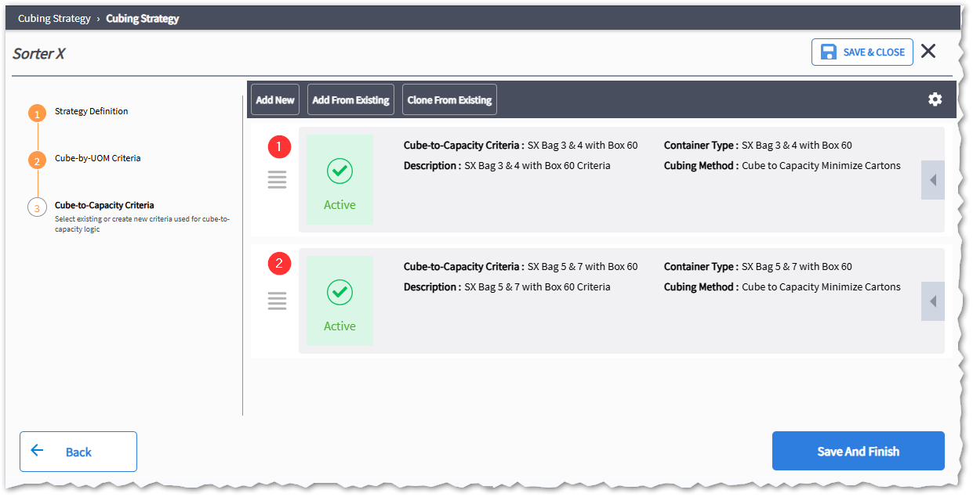
Figure 10 - Sorter X Cubing Strategy
Below two examples of each container type configured for each cube-to-capacity criteria.
- SX Bag 3 & 4 with Box 60

Container Type | Container Size | Size Description | Parcel Package
SX Bag 2 & 3 with Box 60 | SXBagS1 | PolyMailer Bag 2FF | Bag
SX Bag 2 & 3 with Box 60 | SXBagS2 | PolyMailer Bag 3FF | Bag
SX Bag 2 & 3 with Box 60 | SXBox60 | Box60 | Box

- SX Bag 5 & 7 with Box 60
Container Type | Container Size | Size Description | Parcel Package
SX Bag 3 & 4 with Box 60 | SXBagS1 | PolyMailer Bag 3FF | Bag
SX Bag 3 & 4 with Box 60 | SXBagS2 | PolyMailer Bag 4FF | Bag
SX Bag 3 & 4 with Box 60 | SXBox60 | Box60 | Box

Note: Container assignments for Sorter X are configured based on the container's prefix, using the Sort Pack Resource Work Release Criteria selection rule. For example, containers with the prefix 'SXBagS1' are assigned to the 'SXBagS1' Resource Group, and pack stations SX-10-11, SX-10-13, and SX-10-14 are assigned to the 'SXBagS1' Resource Group. Containers with the prefix 'SXBagS2' are assigned to the 'SXBagS2' Resource Group, and pack station SX-10-12 is assigned to the 'SXBagS2' Resource Group.

Sorter A and B Cubing Strategy
The “Sorter A and Sorter B” Cubing Strategy is used with Sorter A and Sorter B order planning strategies. It configures cube-to-capacity criteria using Sorter A and B Cubing Criteria, which evaluates Sorter A and B container types.
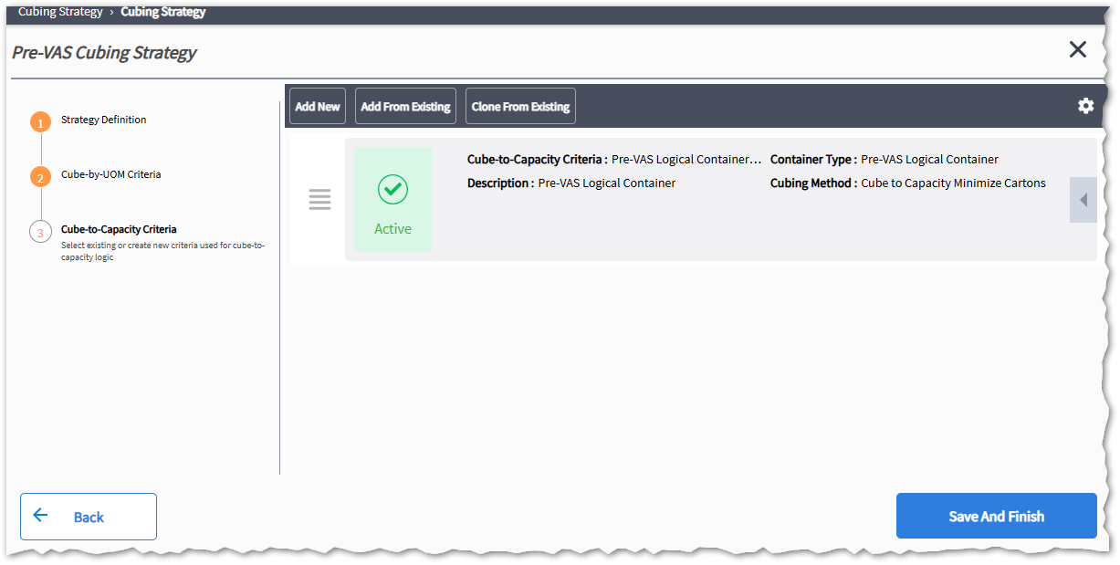
Figure 11 - Sorter A & B Cubing Strategy
Below an examples of Sorter A & B container types configured with the cube-to-capacity criteria.
- Sorter A & B Container Types

Container Type | Container Size | Size Description | Parcel Package
Sorter A & B Container Types | BagS2 | PolyMailer Bag 2FF | Bag
Sorter A & B Container Types | BagS3 | PolyMailer Bag 3FF | Bag
Sorter A & B Container Types | BagS4 | PolyMailer Bag 4FF | Bag
Sorter A & B Container Types | BagS95 | PolyMailer Bag 95FF | Bag
Sorter A & B Container Types | BagS7 | PolyMailer Bag 7FF | Bag
Sorter A & B Container Types | Box60 | Box60 | Box
Sorter A & B Container Types | Box71 | Box71 | Box

Pre-VAS Cubing Strategy
The Pre-VAS Cubing Strategy is used with the 'LE HM06 Sorter Wave', 'LE HM07 Sorter Wave', and 'LE Production Order Wave'. It cubes one production order (Original Order ID) into a single logical container. This strategy uses Pre-VAS Logical Container Criteria (cube-to-capacity criteria) and a Pre-VAS Container Type. The Pre-VAS container type has only one size, set to the maximum dimensions, volume, and weight allowed in MAWM, to cube all units of a production order into a single logical container. Because logo productions are aggregated during order import, the cubing strategy is configured to create one logical container per Original Order ID (Break by Original Order ID).
Figure 12 - HM Sorter Cubing Strategy
Below is an example of the cube-to-capacity criteria.
- Pre-VAS Logical Container Type
Container Type | Container Size | Size Description | Parcel Package
Pre-VAS Logical Container Type | PROD Packing Slip | Production Order Packing Slip | Box

Truck Load Cubing Strategy
The Truck Load Cubing Strategy works with the Truck Load Wave. It cubes unit of measure (UOM) process iLPNs allocated from reserve. The LPN package functions as the shipping container/oLPN. There is a one-to-one relationship between iLPNs and oLPNs. The LPN ID is used as the oLPN ID. Cube-to-capacity is used to cube any remaining allocations picked from unit pick locations. The strategy is configured with cube-to-capacity criteria. These criteria match the packing requirements for each order type planned with the 'Truck Wave' order planning strategy. The image below provides an overview of two criteria used. The first criterion evaluates container types used for shipping 'Photo Studio' order types. The 'Truck Load Container Type' criterion acts as a catch-all.
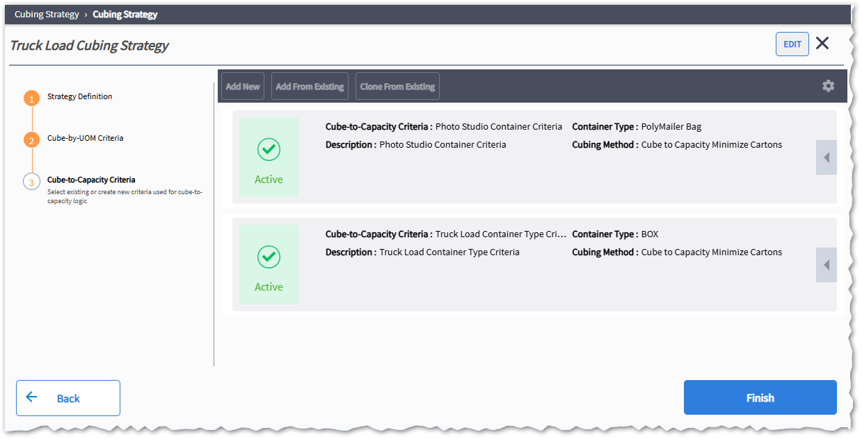
Figure 13 - Truck Load Cubing Strategy
Below two examples of each container type configured for each cube-to-capacity criteria.
- Photo Studio Container Type

Container Type | Container Size | Size Description | Parcel Package
Photo Studio Container Type | Bag3 | Poly Bag 3FF | Bag
Photo Studio Container Type | Bag4 | Poly Bag 4FF | Bag
Photo Studio Container Type | Box60 | Box60 | Box

- Truck Load Container Types
Container Type | Container Size | Size Description | Parcel Package
Truck Load Container Type | Box25 | Box25 | Box
Truck Load Container Type | Box30 | Box30 | Box
Truck Load Container Type | Box60 | Box60 | Box

Non-Cubed Criteria
The non-cubed criteria is used for Store Orders (STORORD , RPLNORD), VAS Customer (Large Orders), Marketing (MRKTORD) and Photo Shoot (PSHORD) are bulk picked into a tote, and items are distributed and packed into non-cube OLPNs at the pack location. To enable this, a cubing strategy is configured with the cubing residual method disabled (set to no), causing MAWM to bypass the cubing process during order planning.
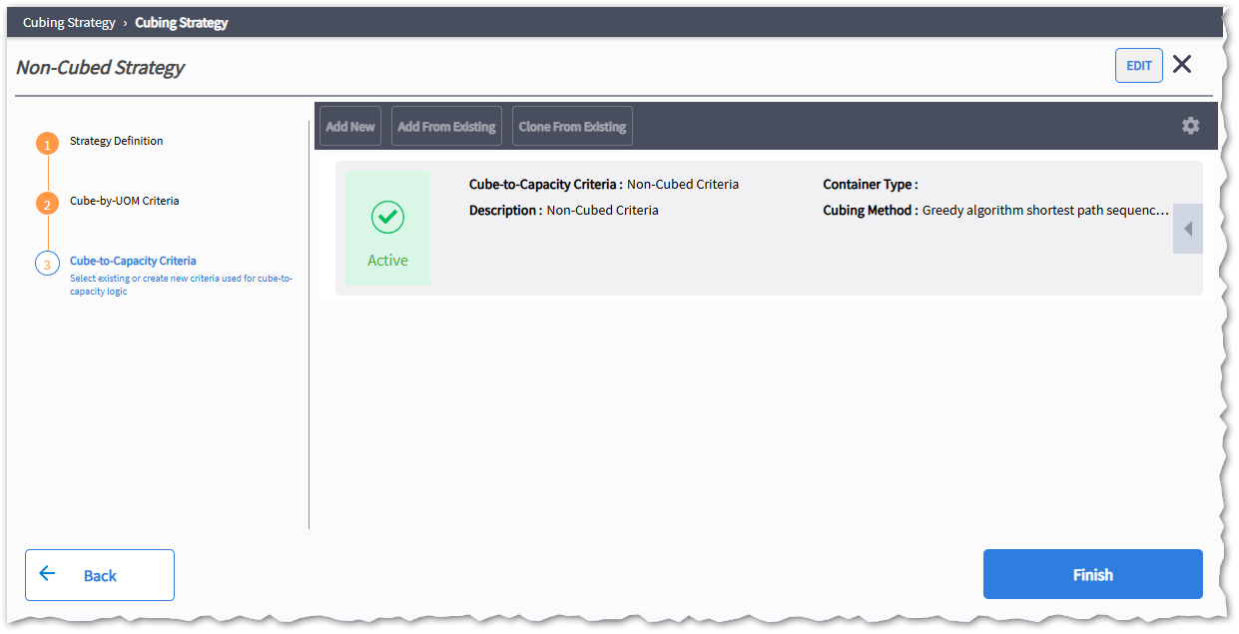
Figure 14 - Non-Cube Strategy

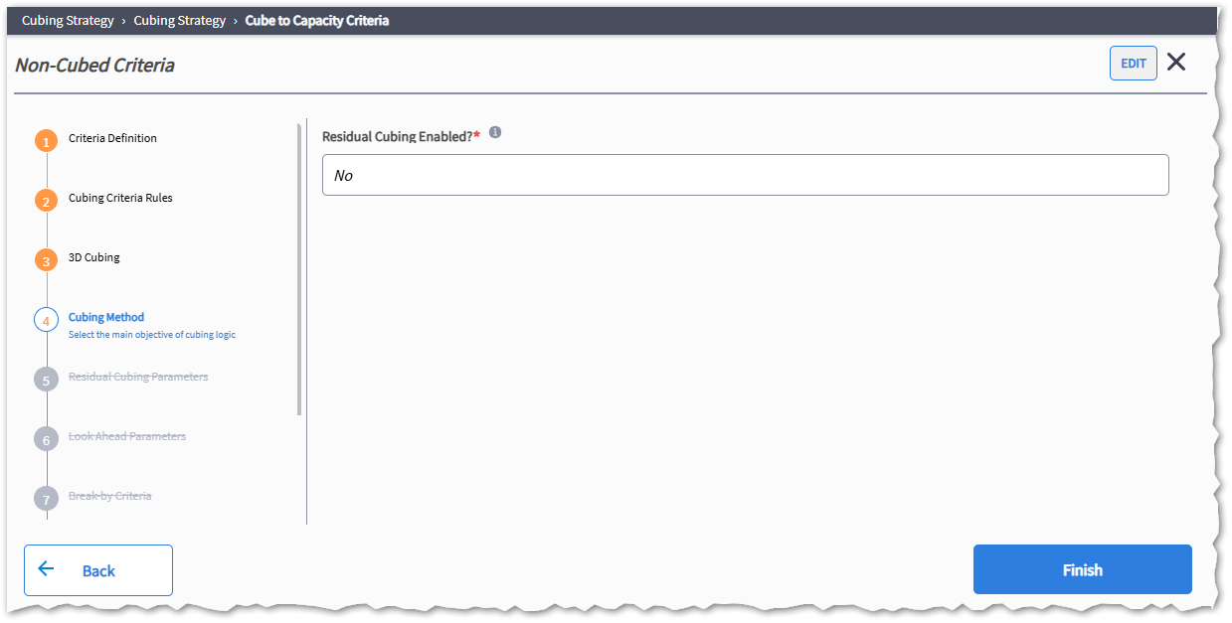
Figure 15 - Residual Cubing Enablement

Work Release
Work Release is a feature that orchestrates the release of tasks to the warehouse floor to efficiently fulfill orders. By assessing the availability of equipment, labor resources, and inventory, Work Release prioritizes critical orders while maximizing resource utilization and equipment throughput. Acting as a control center, it continuously identifies priority tasks and releases them in alignment with the warehouse’s fulfillment strategy.
Work Release maintains a real-time overview of available outbound equipment, such as unit sorters, put walls, and packing stations, alongside current inventory levels and pending tasks. Through its services, it ensures that the right tasks are released to the floor at the optimal time, helping to streamline order fulfillment.
Work Release is powered by two main engines:
- Capacity Manager: This engine evaluates the importance of each task and allocates resources, prioritizing assignments based on equipment capacity and inventory availability.
- Task Release Manager: Task Release Manager generates efficient tasks for the prioritized work determined by the Capacity Manager, releasing them according to equipment capacity and labor constraints.
The workReleaseSchedulerJobSchedule defines the schedule for the work release process, allowing control over the frequency with which work release tasks are initiated. This scheduling ensures that task releases are consistent and aligned with warehouse demands.

Assumptions

- All MHE picking tasks are created in a "Held" status and are released once the MHE system has loaded the batch and it is ready for induction. This process is based on the implementation of the message for each vendor [AU03].

Work
Work is the unit through which the work release manages and allocates equipment capacity. It represents the lowest level of allocation grouping required to release a set of allocations for available inventory and resource capacity. It occupies one unit of capacity for an assigned resource. A resource (equipment) is defined as an entity that processes work. In typical implementations, a resource may be a putwall, sorter chute, or packing station. As allocations are generated during an order planning run, the work release criteria are assigned to the respective work resource based on configured rules that determine how the work will be created, scored, and which resource groups are eligible for the work.
Note: The term resource and equipment are used interchangeably in this document.

Resource Group Family Batching
The work release engine supports two batching modes: Resource Group Family Batching (Pack Wave) and Resource Group Batching (Not Used by Lands’ End).
Resource Group Family Batching is a mode used when a specific amount of work needs to be released and processed by a unit sorter at once. It relies on a group of resource group types, each with its own capacity limits.

Sorter A and Sorter B Resource Group Family
Matthews' B2 unit sorters are divided into two packing sections, labeled "A" and "B." The pack stations are categorized into four types: International, Packing Slip, Bag, and Box. Batches are created for each category and grouped into a Resource Family Group, which determines the batch capacity at any given time, based on the active pack stations. The capacity of each pack station is defined by the maximum Putwall cubbies configured for each pack station.
For example, if Sorter A pack station has 6 chutes per pack station and the unit sorter has 45 active pack stations, then the maximum number of batches to be released per work release run (pack wave download AU02) will be 45 x 6 = 270 batches. If the minimum operating capacity of the unit sorter is 80%, to ensure pick density, then the minimum number of batches that can be released is set to 216 (270 x 0.80). Because the resource batch is created per chute capacity, then the batch size threshold is configured to 1 (100% chute capacity).
Sorter A and Sorter B will have dedicated pack stations, grouped with the following Resource Groups. Each Resource Group consists of batches within a Resource Group Family.
- SA-Box (Sorter A Box Pack Stations)
- SA-Bag (Sorter A Bag Pack Stations)
- SA-Intl (Sorter A International Pack Stations)
- SA-PckSlip (Sorter A Packing Slip Stations)
- SB-Box (Sorter B Box Pack Stations)
- SB-Bag (Sorter B Bag Pack Stations)
- SB-Intl (Sorter B International Pack Stations)

Resource Group Family Config Matrix
Resource Group Family Id | Batch Size Threshold | Manual Batch Release | Maximum Batches to Release | Minimum Batches to Release | Allow Pick Across Batches?
SA-Bag | 1 | N | 270 | 216 | No
SA-Box | 1 | N | ? | ? | No
SA-PackingSlip | 1 | N | ? | ? | No
SA-Int | 1 | N | ? | ? | No
SB-Bag | 1 | N | ? | ? | No
SB-Box | 1 | N | ? | ? | No
SB-PackingSlip | 1 | N | ? | ? | No
SB-Int | 1 | N | ? | ? | No

Resource Group and Work Resource Config Matrix
Resource Group | Resource Group Type | Work Resource | Base Capacity (oLPNs) | Maximum number of units | Maximum allowable volume | Maximum allowable weight
SA-Bag | Sorter A Bag Station | SA-Bag | 20 | Null/Blank | Null/Blank | Null/Blank
SA-Box | Sorter A Box Station | SA-Box | 12 | Null/Blank | Null/Blank | Null/Blank
SA-PackingSlip | Sorter A Bag Station | SA-PckSlip | ? | Null/Blank | Null/Blank | Null/Blank
SA-Int | Sorter A International | SA-Int | ? | Null/Blank | Null/Blank | Null/Blank
SB-Bag | Sorter B Bag Station | SB-Bag | 20 | Null/Blank | Null/Blank | Null/Blank
SB-Box | Sorter B Box Station | SB-Box | 12 | Null/Blank | Null/Blank | Null/Blank
SB-PackingSlip | Sorter B Bag Station | SB-PckSlip | ? | Null/Blank | Null/Blank | Null/Blank
SB-Int | Sorter B International | SB-Int | ? | Null/Blank | Null/Blank | Null/Blank
The work resources defined for Matthews unit sorter are generic work resource which is updated by AU04 with the first divert confirmation message. For this, a work resource is defined in Manhattan, starting with the unit sorter ID followed by the chute ID which is the tote id from the sort divert confirmation message. Below are examples of some chutes work resources configured for Matthews Sorter A and B.
Resource Group Type | Work Resource | Location Id | Base Capacity (oLPNs) | Maximum number of units | Maximum allowable volume | Maximum allowable weight
Packing Chute | SA-101 | SA-10 | 999 | Null/Blank | Null/Blank | Null/Blank
Packing Chute | SA-102 | SA-10 | 999 | Null/Blank | Null/Blank | Null/Blank
Packing Chute | SA-103 | SA-10 | 999 | Null/Blank | Null/Blank | Null/Blank
Packing Chute | SA-104 | SA-10 | 999 | Null/Blank | Null/Blank | Null/Blank
Packing Chute | SA-105 | SA-10 | 999 | Null/Blank | Null/Blank | Null/Blank
Packing Chute | SA-106 | SA-10 | 999 | Null/Blank | Null/Blank | Null/Blank
Packing Chute | SB-101 | SB-10 | 999 | Null/Blank | Null/Blank | Null/Blank
Packing Chute | SB-102 | SB-10 | 999 | Null/Blank | Null/Blank | Null/Blank
Packing Chute | SB-103 | SB-10 | 999 | Null/Blank | Null/Blank | Null/Blank
Packing Chute | SB-104 | SB-10 | 999 | Null/Blank | Null/Blank | Null/Blank
Packing Chute | SB-105 | SB-10 | 999 | Null/Blank | Null/Blank | Null/Blank
Packing Chute | SB-106 | SB-10 | 999 | Null/Blank | Null/Blank | Null/Blank
Configuration Note: Location Id is the ID of a packing location configured with packing location type set as “OUTBOUND_MANUAL_SORTER”
Pack Wave Release
A custom batch release logic is implemented AU04 with the Sort Divert confirmations to release the unit sorter capacity based on the percentage of sort completion and a configurable TaskReleaseThreshold. When the pack wave sortation completion reaches or exceeds the threshold, AU04 releases the unit sorter capacity by renaming the Resource Group Family ID of all batches associated with the active pack wave ID (provided with the sort divert confirmations).
After this update, the unit sorter resource family will have no open batches. During subsequent work release runs, the capacity manager evaluation will determine that the full unit sorter capacity is available, triggering a new pack wave download based on the configured minimum and maximum batch values for the unit sorter resource family group.
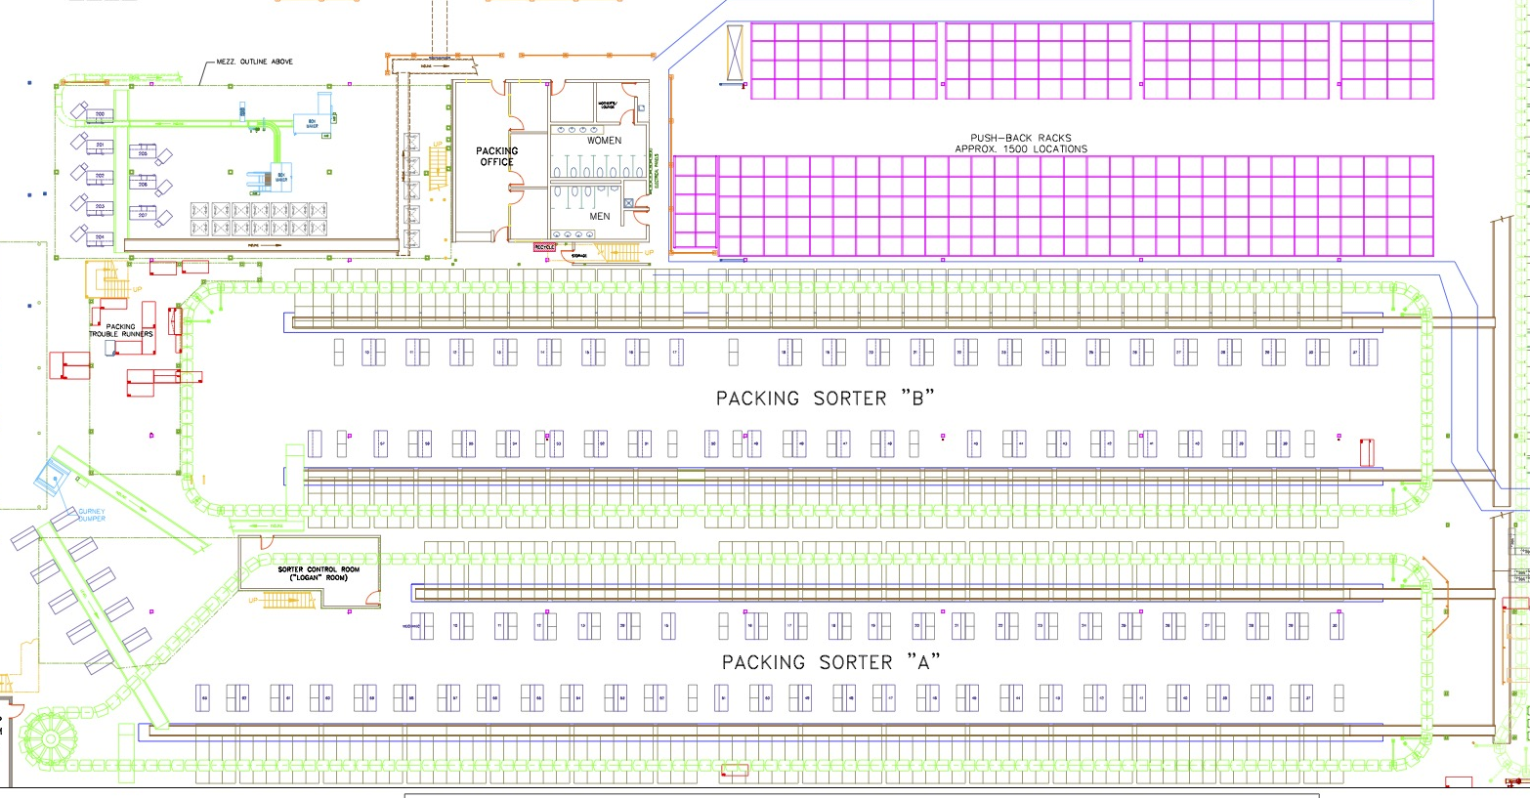
Figure 18 - Matthews' Sorter-A and Sorter-B Floor Plan

Sorter X Resource Group Family
Beumer Sorter-X consists of tilt-tray systems divided into three independently controlled sorters within a single sorting framework.
- Primary Section 10 feeds into Secondary Sections 11, 12, 13, 14, 15, and 16 (packing stations).
- Primary Section 20 feeds into Secondary Sections 21, 22, 23, and 24.
- Primary Section 30 feeds into Secondary Sections 31, 32, 33, 34, 35, and 36.

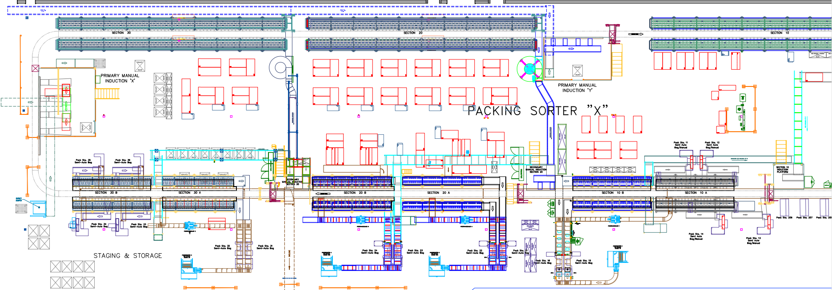
Figure 16 – Sorter-x Floor Plan
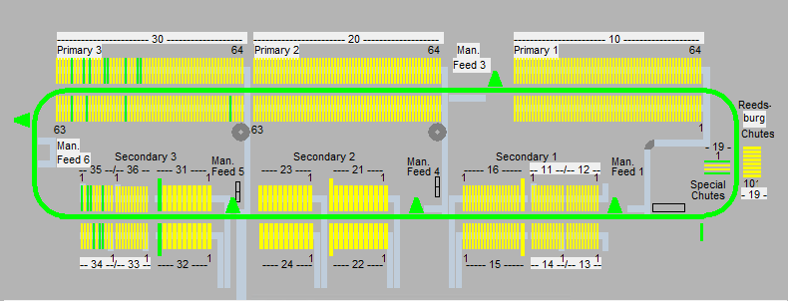
Figure 17 - Sorter-X Layout
The induction point for Primary Section 10, used for the primary sort, is labeled as Induction Y. The belt from this section is delivered to Manual Feed 3 on the diagram above.
For Primary Sections 20 and 30, the induction point is labeled Induction X. The belt from these sections delivers to Manual Feed 6 as indicated on the diagram.

Resource Group Family Config Matrix
Resource Group Family Id | Batch Size Threshold | Manual Batch Release | Maximum Batches to Release | Minimum Batches to Release | Allow Pick Across Batches?
SX10 | 1 | N | 21 | 15 | No
SX20 | 1 | N | 21 | 15 | No
SX30 | 1 | N | 21 | 15 | No
The Sorter X resource group family defines how many batches/subwaves will be released per work release run (Pack Wave Download) within a wave period. Lands' End controls the total number of subwaves in a pack wave by adjusting the maximum number of batches to be released for a wave period. They also control the minimum number of batches to be released to maintain good pick density in the unit sorter.

Resource Group and Work Resource Config Matrix
Resource Group | Resource Group Type | Work Resource | Base Capacity (oLPNs) | Maximum number of units | Maximum allowable volume | Maximum allowable weight
SX-10-S1-Bag | Sorter X Bag Station | SX-10-11 | 10 | Null/Blank | Null/Blank | Null/Blank
SX-10-S1-Bag | Sorter X Bag Station | SX-10-13 | 10 | Null/Blank | Null/Blank | Null/Blank
SX-10-S1-Bag | Sorter X Bag Station | SX-10-14 | 10 | Null/Blank | Null/Blank | Null/Blank
SX-30-S1-Bag | Sorter X Bag Station | SX-30-32 | 10 | Null/Blank | Null/Blank | Null/Blank
SX-30-S1-Bag | Sorter X Bag Station | SX-30-33 | 10 | Null/Blank | Null/Blank | Null/Blank
SX-30-S1-Bag | Sorter X Bag Station | SX-30-36 | 10 | Null/Blank | Null/Blank | Null/Blank
SX-10-S2-Bag | Sorter X Bag Station | SX-10-12 | 10 | Null/Blank | Null/Blank | Null/Blank
SX-10-S2-Bag | Sorter X Bag Station | SX-30-31 | 10 | Null/Blank | Null/Blank | Null/Blank
SX-10-Box | Sorter X Box Station | SX-10-15 | 7 | Null/Blank | Null/Blank | Null/Blank
SX-10-Box | Sorter X Box Station | SX-10-15 | 7 | Null/Blank | Null/Blank | Null/Blank
SX-20-Box | Sorter X Box Station | SX-20-21 | 7 | Null/Blank | Null/Blank | Null/Blank
SX-20-Box | Sorter X Box Station | SX-20-22 | 7 | Null/Blank | Null/Blank | Null/Blank
SX-20-Box | Sorter X Box Station | SX-20-23 | 7 | Null/Blank | Null/Blank | Null/Blank
SX-20-Box | Sorter X Box Station | SX-20-24 | 7 | Null/Blank | Null/Blank | Null/Blank
SX-30-Box | Sorter X Box Station | SX-30-34 | 7 | Null/Blank | Null/Blank | Null/Blank
SX-30-Box | Sorter X Box Station | SX-30-35 | 7 | Null/Blank | Null/Blank | Null/Blank
Configuration Note: Each Sorter-X Work Resource is configured as a packing location with track resource set to yes and packing location type set as “OUTBOUND_MANUAL_SORTER”
The family batch size (wave period) for Sorter-X is determined by summing the work capacity of each packing station and then multiplying the total by minimum number of . This calculation results in 21 sub-waves (resource batch id) within each resource group family batch (wave period / work release batch id).
The following is a scaled-down illustration of the configuration designed to meet the Beumer requirements. In this example, the batch size is 32 OLPNs per subwave for Section 10 and 64 OLPNs per subwave for Sections 20 and 30. Each family group is configured to release a maximum of 21 subwaves per work release to ensure pick density.
MAWM will release 21 subwaves (resource batch) for each Work Release Run (Wave Period). To maintain pick density, the Resource Group family is configured to release a minimum of 10 batches (subwaves). If there are fewer than 10 full batches, MAWM will retain the Work Allocation for up to 3 hours (Work Release Allocation à Created Time stamp Hours From Current >= 3). If the batch is not completed within this timeframe, the Work Release will replan it to Sorter A or B based on the rules defined in the Sort Pack Resource Strategy → Work Release Template Rule.

Resource Group  Family Name | Resource Group | Resource  Group Type | Work Resource | Base Capacity (oLPNs)
SX10  (Sorter-X Section 10) | SX-10-BagS1  (Sorter X10 Bag Size 1) | Bag Pack Stations | SX-10-11 | 10
SX10  (Sorter-X Section 10) | SX-10-BagS2  (Sorter X10 Bag Size 2) | Bag Pack Stations | SX-10-12 | 10
SX10  (Sorter-X Section 10) | SX-10-BoxS1  (Sorter X10 Box Size 1) | Box Pack Stations | SX-10-15 | 10
SX10  (Sorter-X Section 10) | SX-10-BoxS2  (Sorter X10 Box Size 2) | Box Pack Stations | SX-10-16 | 10
 |  |  |  | 40

Resource Group  Family Name | Resource Group | Resource  Group Type | Work Resource | Base Capacity (oLPNs)
SX20  (Sorter-X Section 20) | SX-20-BagS1  (Sorter X20 Bag Size 1) | Bag Pack Stations | SX-20-21 | 8
SX20  (Sorter-X Section 20) | SX-20-BagS2  (Sorter X20 Bag Size 2) | Bag Pack Stations | SX-20-22 | 8
SX20  (Sorter-X Section 20) | SX-20-BoxS1  (Sorter X20 Box Size 1) | Box Pack Stations | SX-20-23 | 8
SX20  (Sorter-X Section 20) | SX-20-BoxS2  (Sorter X20 Box Size 2) | Box Pack Stations | SX-20-24 | 8
 |  |  |  | 32

Resource Group  Family Name | Resource Group | Resource  Group Type | Work Resource | Base Capacity (oLPNs)
SX30  (Sorter-X Section 30) | SX-30-BagS1  (Sorter X30 Bag Size 1) | Bag Pack Stations | SX-30-31 | 8
SX30  (Sorter-X Section 30) | SX-30-BagS2  (Sorter X30 Bag Size 2) | Bag Pack Stations | SX-30-32 | 8
SX30  (Sorter-X Section 30) | SX-30-BoxS1  (Sorter X30 Box Size 1) | Box Pack Stations | SX-30-33 | 8
SX30  (Sorter-X Section 30) | SX-30-BoxS2  (Sorter X30 Box Size 2) | Box Pack Stations | SX-30-34 | 8
 |  |  |  | 32

HM Sorter Resource Group Family
Lands’ End uses four HM sorters, grouping every two HM sorters with a resource group and family to perform double sorting with the goal of maintaining pick density and gaining warehouse efficiency.

Assumptions
- Logo ID Criteria: Logo IDs used for sorting will exclude logo category and work center to optimize picking and sorting efficiency.
- Primary Sort Assignment Limits: Each primary sort assignment will include a maximum number of distinct logo IDs that does not exceed the total number of sort divert destinations in the secondary HM sorter.
- Secondary Sort Assignment Limits: Each secondary sort assignment will contain only one logo ID.
- Primary Sort Initiation: Matthews starts the primary sort process by scanning a batch ID provided on the label of the container of the picked item.
- Secondary Batch Induction: Matthews will control the induction of secondary batches by scanning a gurney ID or batch ID generated by Matthews from primary sorting.
- Jackpot Process : Any instance where a scanned item is inducting for sorting but cannot be read or found will be directed to the exception chute as a jackpot.
- Batch Closure:
  - In ideal conditions, Matthews will automatically close a primary and secondary batch after all items have been sorted. A message is sent to Manhattan to close the open gurneys or totes.
  - A manual close batch option is available in Matthews to force the closure of an active batch and release the divert assignments. A message is sent to Manhattan to close the open gurneys or totes.
- Monitoring Tools: A report and dashboard are built in Matthews to provide visibility into the sorting process. This allows the operation to review sorting progress and identify when a batch is auto-closed or requires troubleshooting. Troubleshooting may involve completing the sorting batch by inducting the missing items or manually closing it.

HM Sorter Layouts
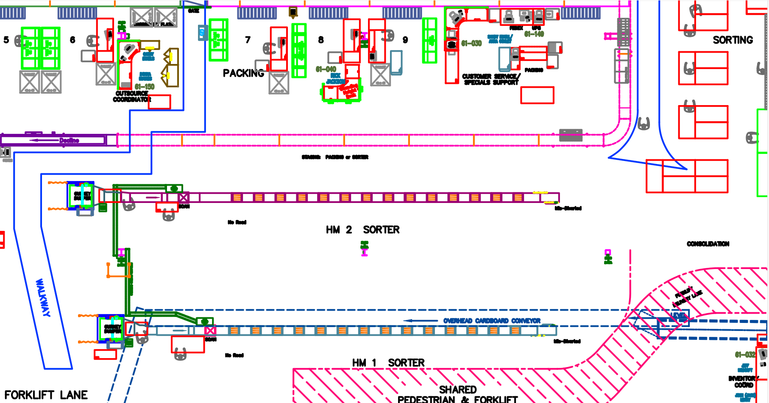
Figure 19- HM Sorter 1 & 2 Building 6, First Floor
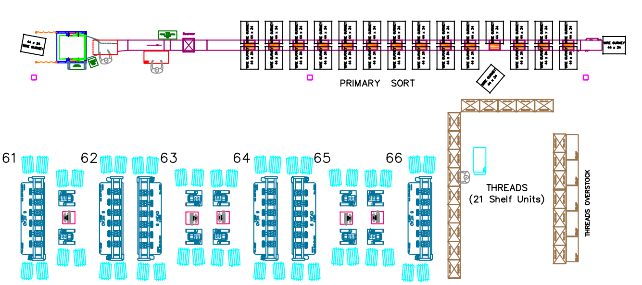
Figure 20 - Stevens Point HM Sorter 1

Process Flow

Sort Strategy
Lands’ End uses four HM sorters, grouping every two HM sorters with a resource group and family to perform double sorting with the goal of maintaining pick density and gaining warehouse efficiency.
The configuration below is a scaled-down illustration of the configuration of Matthews’ HM sorters. In this example, the batch size for each Resource Group is calculated by summing the capacity of each work resource. Each work resource represents a logical divert address in Matthews’ primary HM sorter. The capacity of each work resource in each primary HM sorter chute is calculated by summing the total number of active/operable chutes in the second HM sorter.
In the example below, each resource group defines a primary HM sorter group, one for Dodgeville and a second for Stevens Point, where each one has two chutes (work resources) with a capacity of 2 orders each. Each order that is sorted in an HM sorter represents one VAS Type and one VAS logo.
Production orders are created in Manhattan via an interface process with SAP, where the Production order header will contain an extended attribute “ParentLogoId” where the logo ID is interfaced without category and work center. Manhattan aggregates multiple Production Orders by VAS Type and Logo ID into one Order to ensure all orders for the same VAS Type and Logo ID combination are sorted into one HM sorter chute at the time of order planning.
The maximum batch capacity is calculated by multiplying the total number of work resources by the resource base capacity. In the example below, it is obtained as 2 x 2 = 4 Orders per batch, where each work resource will produce two sub-batches (one sub-batch per resource controlled by Matthews) and each sub-batch will have a maximum of 4 orders, which is the capacity of the work resource that has sorted the units demanded for the orders.
Resource Group  Family Name | Resource Group | Resource  Group Type | Staging Location | Work Resource | Chute Capacity (By Order Id)
HM06 | HM06 | HM Sorter Chute | HM06-IN | HM06-01 | 2
 |  |  |  | HM06-02 | 2
HM07 | HM07 | HM Sorter Chute | HM07-IN | HM07-01 | 2
 |  |  |  | HM07-02 | 2

Example
Assume HM #1 and HM #2 each have 2 available chutes. This means the total batch capacity will be (2 x 2 = 4) distinct logos per batch, generated by MAWM.
Suppose an order planning (wave) in MAWM processes multiple production orders with a total of eight distinct logo IDs. In this scenario, MAWM will generate two batches, each containing four distinct logos.
In Batch #1, WM will assign detail lines that share the same logo ID, grouping up to two distinct logos per HM #1 chute. Matthews will record the output of the first sort for each chute. This output will be used to initiate the second sorting phase by scanning the Tote ID produced per HM #1 chute.
These gurneys will contain two distinct logos that need to be sorted on each HM #2 chute. The process will create a gurney or small tote that will contain a mix of items that share the same logo ID.
Bulk Wave Allocations Examples
Assuming an average case quantity of 10 units per SKU, MAWM will generate the following pulls:
UPC01: 27 full cases from reserve and 5 units from active.
UPC02: 17 full cases from reserve and 5 units from active.

These pulled items will be directed to the staging location in front of the induction belt of HM sorter #1.
SKU | LOGO Id | Units |  | SKU | LOGO Id | Units
UPC01 | LOGO-01 | 50 |  | UPC2 | LOGO-02 | 35
UPC01 | LOGO-03 | 75 |  | UPC2 | LOGO-04 | 55
UPC01 | LOGO-05 | 65 |  | UPC2 | LOGO-06 | 20
UPC01 | LOGO-07 | 85 |  | UPC2 | LOGO-08 | 65
 |  | 275 |  |  |  | 175

HM Sorter WM Batch / “Divert Assignment” Example
HM Sorter | Primary Batch Id | Logical Chute ID | UPC | Logo | Units | Tote Id from primary Sort | HM Sorter | Secondary Batch Id | Source LPNs | Logical Chute ID | Tote Id for MAWM
HM#1 | B_001 | HM01-01 | UPC01 | LOGO-01 | 50 | Gurney-01 | HM#2 | B_001_01 | Gurney-01 | HM02-01 | TOTE-01
HM#1 | B_001 | HM01-01 | UPC02 | LOGO-02 | 35 |  |  |  |  | HM02-02 | TOTE-02
HM#1 | B_001 | HM01-02 | UPC01 | LOGO-03 | 75 | Gurney-02 | HM#2 | B_001_02 | Gurney-02 | HM02-01 | TOTE-03
HM#1 | B_001 | HM01-02 | UPC02 | LOGO-04 | 55 |  |  |  |  | HM02-02 | TOTE-04
HM#1 | B_002 | HM01-01 | UPC01 | LOGO-05 | 65 | Gurney-04 | HM#2 | B_002_01 | Gurney-04 | HM02-01 | TOTE-05
HM#1 | B_002 | HM01-01 | UPC02 | LOGO-06 | 20 |  |  |  |  | HM02-02 | TOTE-06
HM#1 | B_002 | HM01-02 | UPC01 | LOGO-07 | 85 | Gurney-05 | HM#2 | B_002_02 | Gurney-05 | HM02-01 | TOTE-07
HM#1 | B_002 | HM01-02 | UPC02 | LOGO-08 | 65 |  |  |  |  | HM02-02 | TOTE-08

MAWM will generate a Sort Divert Assignment message as illustrated in the table above.
HM Primary Sort Story:
- MAWM will generate a "Divert Assignment" [AU03] message for HM sorter #1 for a sorting batch. This batch will contain 4 chute divert assignments for HM #1 based on the example above, each with 4 chute diverts for HM #2.
- Once a product is picked in MAWM, the user is directed to the HM sorter #1 staging area. Here, the product is consolidated, labeled with the batch ID, and a pick completion message “Divert Assignments Adjustments” is sent to confirm picked items and any shortages. Loose/unit picks are placed in a gurney, while full cases are placed on a pallet. Both containers will have an LPN label with the batch ID.
- A sorter operator scans the batch ID barcode from the gurney or pallet to activate the batch in HM sorter #1 (Function in Pyramid Director) to start with the item induction.
- The batch and its associated sort divert assignments are activated in HM sorter #1.
- The sorter operator scans a blind LPN ID on each HM sorter #1 chute. This LPN ID is used to build a gurney as part of the HM sorting process.
- The sorter operator inducts the picked product onto the HM sorter #1 belt.
- HM sorter #1 diverts the inducted product based on the active sort divert assignments. Matthews sends MAWM a “Primary Sort Divert” [AU03] message with the percentage of primary sort batch completion. Manhattan uses this information to move the inventory to the assigned gurney ID used by Matthews to perform the second sorting.
- Once the primary HM sort is completed, the sort operator reviews an operation report or dashboard in Matthews to verify if the batch has been fully sorted. If the batch is not fully sorted, the operator attempts to locate the missing product and induct it to complete the primary sort. Alternatively, the operator can manually close the active batch in Matthews, which sends a "Batch Complete" [AU03] message Manhattan to move the for the unsorted units to the respective gurneys and close all it to be ready for secondary induction.
HM Secondary Sort Story:
- The sort operator moves the gurneys generated by HM #1 to the HM sorter #2 staging location, ensuring they are arranged in the same sequence as they will be inducted. For example, if HM #1 chute 1 produces two gurneys, both are moved to the beginning of the HM sorter #2 induction point (staging location).
- The operator scans the LPN ID of a gurney from HM #1 to load it as an activate batch in HM sorter #2.
- The sort operator assigns a blind LPN ID on each HM sorter #2 chute. This LPN ID is used to build a new gurney or plastic tote as part of the HM #2 sorting process.
- The operator then inducts the products from the gurneys built during the HM sorter #1 process onto the HM sorter #2 belt.
- HM sorter #2 diverts the inducted products based on the active sort divert assignments. Matthews sends a "Secondary Sort Divert" [AU03] message to MAWM, which includes the blind LPN ID used to build the new gurney or tote.
- Once the secondary HM sort is completed, the sort operator reviews an operation report or dashboard in Matthews to verify if the batch has been fully sorted. If the batch is not fully sorted, the operator attempts to locate the missing product and induct it to complete the secondary sort. Alternatively, the operator can manually close the active batch in Matthews, which sends a "Batch Complete" [AU03] message to Manhattan to move the for the unsorted units to the respective gurneys and close all it to be ready for Outbound sorting (Putawall Sorting) in MAWM.

Resource Group Family Config Matrix
Resource Group Family Id | Batch Size Threshold | Manual Batch Release | Maximum Batches to Release | Minimum Batches to Release | Allow Pick Across Batches?
HM06 | 0.01 | N | 1 | 1 | No
HM07 | 0.01 | N | 1 | 1 | No
HM Sorter will release 1 resource batch per work release run (pack wave download) and each batch will contain a maximum of 26 order assigned per work resource.

Resource Group and Work Resource Config Matrix

Dodgeville HM Sorter Resource Group
Resource Group | Resource Group Type | Work Resource | Base Capacity (Order) | Maximum number of units | Maximum allowable volume | Maximum allowable weight
HM06 | HM Sorter Chute | HM06-01 | 26 | Null/Blank | Null/Blank | Null/Blank
HM06 | HM Sorter Chute | HM06-02 | 26 | Null/Blank | Null/Blank | Null/Blank
HM06 |  | Up to 26 Diverts |  | Null/Blank | Null/Blank | Null/Blank
HM06 | HM Sorter Chute | HM06-26 | 26 | Null/Blank | Null/Blank | Null/Blank

Stevens Point HM Sorter Resource Group
Resource Group | Resource Group Type | Work Resource | Base Capacity (Order) | Maximum number of units | Maximum allowable volume | Maximum allowable weight
HM07 | HM Sorter Chute | HM07-01 | 26 | Null/Blank | Null/Blank | Null/Blank
HM07 | HM Sorter Chute | HM07-02 | 26 | Null/Blank | Null/Blank | Null/Blank
HM07 |  | Up to 26 Diverts |  | Null/Blank | Null/Blank | Null/Blank
HM07 | HM Sorter Chute | HM07-26 | 26 | Null/Blank | Null/Blank | Null/Blank

Feedback Manager
The Feedback Manager in MAWM keeps the work release engine informed about task progress and completion. When a resource is freed up, the Feedback Manager sends a message to the work release engine indicating a capacity change. This creates a continuous feedback loop, ensuring that the work release engine stays updated on the equipment’s capacity status. The Capacity Manager and Work Release use this information to assign work resources and release the next batch for the resource group or resource family group.

Re-Prioritization
The concept of priority is not a static. Priorities can change throughout the day and even after allocation have occurred. Unforeseen delays can occur at any time. Equipment may be understaffed and work can wait for longer than expected. The shipping plan can also change unexpectedly. Weather conditions and carrier availability can result in change of priority for certain. The work release engine provides a solution for this activity. Supervisors can re-prioritize rules for a pending work, by applying a new priority as needed to adapt to the changing conditions.

Sort Pack Resource Strategies
A Sort Pack Resource Strategy is a set of parameters that control how pack allocations are sorted into work resources grouped within a resource group.

Sorter A and B Sort Pack Resource Strategy
The Sorter-A and B Sort Pack Resource Strategy defines how work is distributed across Sorter-A and Sorter B work resources.

Sort Pack Resource Work Release Criteria
Criteria Name | Selection Rules | Resource Group Eligibility
SA-Bag | Allocation.OrderCriteriaId = “SA” and  olpn.Container size Id Start With Bag | SA-Bag
SA-Box | Allocation.OrderCriteriaId = “SA” and  olpn.Container size Id Start With Box | SA-Box
SA-PackingSlip | Allocation.OrderCriteriaId = “SA” and  <<Packing Slip Criteria>> | SA-PackingSlip
SA-Int | Allocation.OrderCriteriaId = “SA” and  <<International Order Criteria>> | SA-Int
SB-Bag | Allocation.OrderCriteriaId = “SB” and  olpn.Container size Id Start With Bag | SB-Bag
SB-Box | Allocation.OrderCriteriaId = “SB” and  olpn.Container size Id Start With Box | SB-Box
SB-PackingSlip | Allocation.OrderCriteriaId = “SB” and  <<Packing Slip Criteria>> | SB-PackingSlip
SB-Int | Allocation.OrderCriteriaId = “SB” and  <<International Order Criteria>> | SB-Int

Sorter-X Sort Pack Resource Strategy
The Sorter-X sort resource strategy defines how work is distributed across Sorter-X work resources.

Sort Pack Resource Work Release Criteria
Criteria Name | Selection Rules | Resource Group Eligibility
SX-BS1 | Allocation.OrderCriteriaId = “SX” and  olpn.Container size Id = SXBagS1 | SX-10-S1-Bag, SX-30-S1-Bag
SX-BS2 | Allocation.OrderCriteriaId =”SX” and  olpn.Container size Id = SXBagS2 | SX-10-S2-Bag, SX-30-S2-Bag
SX-Box | Allocation.OrderCriteriaId =”SX” and  olpn.Container size Id Start With SXBox | SX-10-Box, SX-20-Box, SX-30-Box
SX-10-BS1 | Allocation.OrderCriteriaId = “SX10” and  olpn.Container size Id = SXBagS1 | SX-10-S1-Bag
SX-10-BS2 | Allocation.OrderCriteriaId = “SX10” and  olpn.Container size Id = SXBagS2 | SX-10-S2-Bag
SX-10-Box | Allocation.OrderCriteriaId = “SX10” and  olpn.Container size Id Start With SXBox | SX-10-Box
SX-20-30-BS1 | Allocation.OrderCriteriaId =”SX-20-30” and  olpn.Container size Id = SXBagS1 | SX-30-S1-Bag
SX-20-30-BS2 | Allocation.OrderCriteriaId = “SX-20-30” and  olpn.Container size Id = SXBagS2 | SX-30-S2-Bag
SX-20-30-Box | Allocation.OrderCriteriaId = “SX-20-30” and  olpn.Container size Id Start With SXBox | SX-20-Box, SX-30-Box

HM Sorter Sort Pack Resource Strategy
The HM Sorter Sort Pack Resource Strategy defines how work is distributed across HM06 and HM07 sorter work resources.

Sort Pack Resource Work Release Criteria
Criteria Name | Selection Rules | Resource Group Eligibility
HM06 | Allocation.OrderCriteriaId = “HM06” | HM06
HM07 | Allocation.OrderCriteriaId = “HM07” | HM07

Picking Task Creation Strategy
A Picking task Creation is defined for each Order planning and define what type transaction is used to perform the picking execution.

Sorter A and B Picking Task Creation Strategy
The Sorter A and B Picking Task Creation Strategy is used to defined how the picking task are created for Sorter-A and Sorter-B during work release (direct task creation set to no) .

Picking Task Criteria
All task are created rule based, sequenced based on pick execution sequence break by pick zone and with a Task Threshold criteria to break the task either by pallet or gurney volume building zones.
Criteria Name | Description | Selection Rules | Task Execution mode | Transaction for the Task | Priority
SA Case Pick | Picking for Induction A | Allocation Order Criteria Id = “SA” and Allocation UOM Type Id = LPN  and item.extended.Sortable = true | Pick into iLPN  (Pick into Cart ?) | SA Case Pick | 20
SB Case Pick | Picking for Induction B | Allocation Order Criteria Id = “SB” and Allocation UOM Type Id = LPN  and item.extended.Sortable = true | Pick into iLPN  (Pick into Cart ?) | SA Case Pick | 20
SA Act Pick | Picking for Induction A | Allocation Order Criteria Id = “SA” and Allocation UOM Type Id not equal to LPN  and item.extended.Sortable = true | Pick into Tote | SA Act Pick | 20
SB Act Pick | Picking for Induction B | Allocation Order Criteria Id = “SB” and Allocation UOM Type Id not equal to LPN  and item.extended.Sortable = true | Pick into Tote | SB Act Pick | 20
Config Note: Task Threshold Criteria needs to be defined based on equipment constraints and building zones.

Sorter-X Picking Task Creation Strategy
The Sorter-X Picking Task Creation Strategy is used to defined how the picking task are created for Sorter-X during work release (direct task creation set to no) .

Picking Task Criteria
All task are created rule based, sequenced based on pick execution sequence break by pick zone and with a Task Threshold criteria to break the task either by pallet or gurney volume building zones.
Criteria Name | Description | Selection Rules | Task Execution mode | Transaction for the Task | Priority
SX Case Pick | Picking for Induction X | Allocation Order Criteria Id = “SX” or “SX-20-30” and Allocation UOM Type Id = LPN  and item.extended.Sortable = true | Pick into iLPN  (Pick into Cart ?) | SX Case Pick | 20
SY Case Pick | Picking for Induction Y | Allocation Order Criteria Id = “SX-10” and Allocation UOM Type Id = LPN  and item.extended.Sortable = true | Pick into iLPN  (Pick into Cart ?) | SX Case Pick | 20
SX Act Pick | Picking for Induction X | Allocation Order Criteria Id = SX” or “SX-20-30” and Allocation UOM Type Id not equal to LPN  and item.extended.Sortable = true | Pick into Tote | SX Act Pick | 20
SY Act Pick | Picking for Induction Y | Allocation Order Criteria Id = “SX-10” and Allocation UOM Type Id not equal to LPN  and item.extended.Sortable = true | Pick into Tote | SY Act Pick | 20
Config Note: Task Threshold Criteria needs to be defined based on equipment constraints and building zones.

HM Sorter Picking Task Creation Strategy
The HM Sorter Picking Task Creation Strategy is used to defined how the picking task are created for HM sorter during work release (direct task creation set to no) .

Picking Task Criteria
All task are created rule based, sequenced based on pick execution sequence break by pick zone and with a Task Threshold criteria to break the task either by pallet or gurney volume building zones.
Criteria Name | Description | Selection Rules | Task Execution mode | Transaction for the Task | Prty
HM06 Case Pick | Dodgeville HM Sorter Case Pick | Allocation Order Criteria Id = “HM06” and Allocation UOM Type Id = LPN  and item.extended.Sortable = true | Pick into iLPN  (Pick into Cart ?) | HM06 Case Pick | 20
HM07 Case Pick | Stevens Point HM Sorter Case Pick | Allocation Order Criteria Id = “HM07” and Allocation UOM Type Id = LPN  and item.extended.Sortable = true | Pick into iLPN  (Pick into Cart ?) | SP Case Pick | 20
HM06 Act Pick | Picking for Induction X | Allocation Order Criteria Id = “HM06” or “SX-20-30” and Allocation UOM Type Id not equal to LPN  and item.extended.Sortable = true | Pick into Tote | HM06 Act Pick | 20
HM07 Act Pick | Picking for Induction Y | Allocation Order Criteria Id = “HM07” and Allocation UOM Type Id not equal to LPN  and item.extended.Sortable = true | Pick into Tote | SP Act Pick | 20
HT Logo Pick | Heat Transfer Logo Pick | Allocation.PickAllocationZoneId equal to “<<Heat Transfer Allocation Zone>>” | Pick into Tote | HT Logo Pick | 20
Config Note: Task Threshold Criteria needs to be defined based on equipment constraints and building zones.

Direct Task Release
Work Release is not leveraged for Non MHE Production Orders, Wholesale, Transfers, Pick Cart Orders or Special Orders as each wave creates the associated tasks they are released for immediate execution. Depending on volume and capacities, Lands’ End may also choose to create tasks in a Held status and manually release them as required.

Direct Task Creation Strategy
The Production Order Task Creation Strategy is used to defined how the picking task are created for non MHE production order picks post waving.

Picking Task Criteria
All task are created rule based, sequenced based on pick execution sequence break by pick zone and with a Task Threshold criteria to break the task either by pallet or gurney volume building zones.
Criteria Name & Transaction for the Task | Description | Selection Rules | Task Execution mode | Task Threshold / Break By | Priority
VAS Case Pick | Large and Enterprise Orders Logo VAS LPN Pull | Production Order – Heat Transfer” OR “Production Order - Monogram” OR “Production Order - Logo” AND ( Order Fulfillment Code = S OR L AND  Enterprise Code Not null) | Pick into iLPN | Every distinct value Original Order Id and Pick Allocation Zone  Task Capacity up to a pallet | 20
VAS Act Pick | Large and Enterprise Orders Logo VAS Blk Pick | Production Order – Heat Transfer” OR “Production Order - Monogram” OR “Production Order - Logo” AND (  Order Fulfillment Code = S OR L AND  Enterprise Code Not null) | Pick into Tote | Every distinct production order value (original order id)  Task Capacity up to a gurney volume
SP Case Pick | Large and Enterprise Orders Logo VAS LPN Pull | Production Order – Heat Transfer” OR “Production Order - Monogram” OR “Production Order - Logo” AND ( Order Fulfillment Code = S OR L AND  Enterprise Code Not null) | Pick into iLPN | Every distinct value Original Order Id and Pick Allocation Zone  Task Capacity up to a pallet | 20
SP Act Pick | Large and Enterprise Orders Logo VAS Blk Pick | Production Order – Heat Transfer” OR “Production Order - Monogram” OR “Production Order - Logo” AND (  Order Fulfillment Code = S OR L AND  Enterprise Code Not null) | Pick into Tote | Every distinct production order value (original order id)  Task Capacity up to a gurney volume
HEM VAS Case Pick | Hemming VAS LPN Pull | Production Order – Hemming” AND  Order Fulfillment Code != X | Pick into iLPN | Every distinct Order Extended Hemming Group  Task Capacity up to a pallet | 20
HEM VAS Act Pick | Hemming Multi VAS LPN Pull | “Production Order – Hemming” AND  Order Fulfillment Code = X | Pick into Tote | Every distinct value Original Order Id and Pick Allocation Zone  Task Capacity up to a pallet | 20
Name Bdg Pick | Units pick from active for production order | Allocation.PickAllocationZoneId equal to “<<Name Badges Allocation Zone>>” | Pick into Tote | Every distinct production order value (original order id)  Task Capacity up to envelope volume. | 20
Singles Pulls | Singles Pulls | Order Type Is Equal to “CUSTREGORD” AND  Single Line Order is true AND Single Unit Order is true AND  Order Extended Gift Box Indicator is false | Pick into iLPN | Task Capacity up to a pallet | 20
Single Act Pick | Bulk Pick for singles packing | Order Type Is Equal to “CUSTREGORD” AND  Single Line Order is true AND Single Unit Order is true AND  Order Extended Gift Box Indicator is false | Pick into Tote | Task Capacity up to a gurney | 30
Store Pulls | Store Pulls | Allocation UOM Type Id = LPN  and Order Type Is Equal to “Store Order” or “Replen Store Order” | Pick into iLPN | Task Capacity up to a pallet | 20
Store Act Pick | Bulk pick for put to store | Order Type Is Equal to “STORORD” or “STORRPLNORD” | Pick into Tote | Task Capacity up to a gurney | 30
Olpn to Pallet | Pick Olpn into a pallet from reserve | Order.Extended. ParcelRateShopGroupId is null and  (  Order Type is equal to “WHSLORD” or “OTRNORD” or “STKTRNORD” or “CHARORD” or “LIQORD” or “MRKTORD” or “PSHORD”  ) | Pick into Olpn | Task Capacity up to a pallet | 30
Olpn Pick | Pick units from active into an Olpn | Order.Extended. ParcelRateShopGroupId is null and  (  Order Type is equal to “WHSLORD” or “OTRNORD” or “STKTRNORD” or “CHARORD” or “LIQORD” or “MRKTORD” or “PSHORD”  ) | Pick into Olpn | Olpn Pick | 30
Prepack Pulls | Prepack LPN Pulls | Order.OrderProcessTypeId = "Work Order" | Pick into iLPN | Task Capacity up to a pallet | 20
Prepack Act Pick | Prepack Active Pick | Order.OrderProcessTypeId = "Work Order" | Pick into Tote | Task Capacity up to a gurney | 20
Post-VAS Auto Pick | Post-VAS Auto Pick | Order Type Is Equal to “CUSTVASORD and Fulfillment Code is Equal to “S” or “L” | Pick into Olpn | Olpn Pick | 30
Post VAS Multis Pick | Post VAS Multis Pick | Order Type Is Equal to “CUSTVASORD and Fulfillment Code is Equal to “M” | Pick into Tote | Task Capacity up to a gurney | 20
Config Note: Task Threshold Criteria needs to be defined based on equipment constraints and building zones.
Post-VAS Auto Pick must have Should the Task be Auto Completed? = Yes

MHE Messages
Reference to Lands' End's MHE Communications Document for detailed information on MHE touchpoints and message formats.

Gaps and Extensions
Gap # | Name | Description
AU02 | MHE Message Handlers | Receiving, Shipping and Replenishment Conveyor and pack wave download.
AU03 | MHE Induction and Pick & Short Confirmation | Implement MHE pick and short confirmations and MHE Unit sort pack details.
AU04 | MHE Batch Loaded and Sort Diverts | AU04 – Implement MHE Task release post MHE confirmation and sort diverts confirmations.

Replenishment
Replenishment allocations from LPN storage to unit pick locations are generated during the replenishment wave or picking wave to address picking needs not currently met at the pick locations. Replenishments created during pick waves serve as the primary source of replenishment at Lands’ End, while those generated during replenishment waves supplement any additional requirements. Pick locations are replenished up to their maximum capacity or based on need, as determined by the Replenishment Strategy. Replenishments can also be configured to occur when a user shorts a pick, provided the reason code associated with the pick exception is configured to allow it.
Lands’ End also has the option to configure and use Lean Time replenishment rules to replenish permanent locations for items up to the maximum or existing dynamic locations for the item up to the maximum. Lean Time replenishments do not need order demand in the system to allocate inventory, these are rule-based replenishments that take advantage of down time in the warehouse to top up existing locations to prepare for the next round of picking. Allocations created via Lean Time replenishment follow the same rules and constraints as replenishments created via replenishment wave or picking wave.

Assumptions
- All iLPNs are Single SKU
- Lands’ End does not allocate partial iLPNs for orders or replenishments
- Replenishment eligibility is determined by the maximum number of units for the SKU that can physically fit into the location, same as the putaway eligibility process.
- Replenishments assign items to dynamic locations as needed
- Permanent locations are replenished as a priority, then existing dynamic locations, then new dynamic location assignments
- New dynamic locations are not created if the item currently exists in the maximum number of allowable dynamic locations (configurable, set to 3 on day 1)
- Replenishment waves look at current order demand from orders in MAWM to determine replenishment allocations.

Replenish iLPNs to Unit Storage
At Lands’ End all replenishments come from LPN or Pallet storage with the destination of a Unit storage location. Replenishments from LPN storage that are allocated to the main Unit storage picking module are inducted to the replenishment conveyor after being pulled to a pallet. As replenishment tasks are pulled, an MHE message is sent from MAWM to MHE with destination details of the iLPNs that are to be inducted. The replenishment conveyor takes all iLPNs to the Unit storage area where users Make Put Carts with ‘like’ iLPNs and execute the Put Carts once they are full.
Replenishments from LPN storage can also be allocated to Bulk Unit storage. These replenishments are pulled to a pallet but are not inducted to the replenishment conveyor, these are taken directly to the Bulk Unit storage area to be staged Once pallets are staged in the Bulk area, users make a put cart and complete the putaway for each iLPN on the pallet into the destination locations.
GOH Replenishments require users to palletize the inventory. In Reedsburg, the pallets are placed in designated pick and drop locations to be transported via elevator to the GOH area from main reserve. In Dodgeville, the pallets are staged in a designated GOH staging location. If the replenishment is for iLPNs already in GOH reserve locations, the iLPNs are pulled and staged by the carousel before being put away into their final locations. When pallets arrive at the carousels, users put away each iLPN on the pallet into its destination location within the carousel.

User Story: Pull iLPNs to Pallet for Replenishment Conveyor
Who | What | Why
Replenishment Puller | Pull iLPNs to a pallet and induct to replenishment conveyor | iLPNs are allocated from reserve storage to unit storage. These iLPNs are pulled to a pallet and inducted to the replenishment conveyor to be putaway to the final destination.

Process
- User enters task group and selects Assign Task
- System prompts for pallet
- System directs user to a location and prompts for an iLPN
- User scans iLPN and that completes the pull
- Once all pulls are complete for the replenishment task, users are directed to take the pallet to the induction conveyor
- Users scan the induction conveyor location to locate the iLPNs to the conveyor staging location

Updates
- iLPNs are located to the conveyor staging location
- MHE message is sent to Matthews with iLPN information to expect

User Story: Build & Execute Putaway Cart for iLPNs
Who | What | Why
Put Cart Builder | Make a Put Cart using iLPNs on the replenishment Conveyor | iLPNs are sent to the picking area on the replenishment conveyor. Users build a putaway cart with ‘like’ iLPNs and then execute the cart to complete the putaway.
See User Story: Build & Execute Putaway Cart for iLPNs for additional details on this process.

User Story: Pull iLPNs to Pallet for Bulk Unit Storage
Who | What | Why
Replenishment Puller | Pull iLPNs to a pallet and take to Bulk Unit Storage | iLPNs are allocated from reserve storage to unit storage. These iLPNs are pulled to a pallet and taken directly to the Bulk Unit storage area to be putaway

Process
- User enters task group and selects Assign Task
- System prompts for pallet
- System directs user to a location and prompts for an iLPN
- User scans iLPN and that completes the pull
- Once all pulls are complete for the replenishment task, users are directed to take the pallet to the Bulk Unit storage staging location

Updates
- Pallet and iLPNs are staged at Bulk Unit storage location

User Story: Putaway Bulk iLPNs on Pallet
Who | What | Why
Putaway Associate | Put each iLPN on pallet away into destination location | Pallets for Bulk iLPNs are staged in the Bulk area. Users in the Bulk area pick up the pallets and complete the putaway for each iLPN on the pallet.

See User Story: Putaway iLPNs by Pallet for additional details on this process.

User Story: Pull iLPNs to Pallet for GOH Unit Storage
Who | What | Why
Replenishment Puller | Pull iLPNs to a pallet and take to Elevator or Carousel | iLPNs are allocated from reserve storage to GOH unit storage. These iLPNs are pulled to a pallet and taken to the elevator or directly to the carousel for putaway.

Process
- User enters task group and selects Assign Task
- System prompts for pallet
- System directs user to a location and prompts for an iLPN
- User scans iLPN and that completes the pull
- Once all pulls are complete for the replenishment task
- If iLPNs are being pulled from main reserve storage, users are directed to stage the pallet to the GOH area.
- If iLPNs are being pulled from GOH reserve storage, users are directed to stage the pallet at the carousel for putaway

Updates
- Pallet and iLPNs are staged at Bulk Unit storage location

User Story: Putaway GOH iLPNs on Pallet
Who | What | Why
Replenishment Puller | Pull iLPNs to a pallet and take to Elevator or Carousel | iLPNs are allocated from reserve storage to GOH unit storage. These iLPNs are pulled to a pallet and taken to the elevator or directly to the carousel for putaway.

Process
- User scans a pallet that is staged in the Elevator staging or Carousel staging area
- System takes the user into the associated putaway task
- If the pallet is staged in elevator staging, MAWM directs the user to move the pallet to carousel staging
- From carousel staging, MAWM prompts users to putaway each iLPN into an associated Unit storage location
- MAWM displays the destination Unit Storage location to the user
- The user rotates the carousel around until the destination location is available
- User scans the iLPN directed for putaway and hangs contents on the carousel rack
- This process is complete for each iLPN on the pallet.

Updates
- iLPNs are consumed to the Unit Storage locations
- On Hand quantity for the Unit Storage locations is adjusted
- Replenishment Task is ‘complete’

User Story: Pull Pallet for Replenishment
Who | What | Why
Replenishment Puller | Pull full Pallets for Replenishment | Full pallets, with multiple iLPNs, are allocated from pallet storage to unit storage. Users pull the full pallet and locate it to the destination unit storage location.

Process
- User enters task group and selects Assign Task
- System directs user to a location and prompts for a pallet
- User scans Pallet ID and that completes the pull for the pallet and all iLPNs on the pallet
- MAWM directs the user to take the pallet to the Unit storage location
- User scans the Unit Storage Location to consume pallet contents to the location
- If there are remaining units in the unit storage location from the previous pallet, they are removed from the location, the pallet is dropped, and the additional units are placed on top of the pallet.

Updates

- All iLPNs on the pallet are consumed to the Unit Storage location
- On Hand quantity for the Unit Storage location is adjusted
- Replenishment Task is ‘complete’

MHE Messages
Reference to Lands' End's MHE Communications Document for detailed information on MHE touchpoints and message formats.

Features

Lean Time Replenishment
Lean Time Replenishment is a manual method of triggering replenishment tasks to restock pick locations using inventory from reserve storage locations. This process allows for the generation of replenishment tasks outside the wave task generation process and is typically performed during periods of low shipping volume.
Lean Time Replenishment occurs before running a wave, at the start of the day, or after a wave when all associated picking processes have been completed. It ensures that pick locations are fully stocked and prepared for subsequent waves. The user selects either a range of locations or specific items to replenish. The system then evaluates inventory levels based on either the location's minimum threshold or a specified percentage of its maximum inventory level. If the current inventory level falls below the specified minimum, the system generates a replenishment task to restock the location to its maximum capacity.
Lands’ End runs the Lean Time Replenishment process daily at 10:00 PM CST via a scheduled job to restock all active locations before the order planning wave for the next day. This ensures that active locations are replenished to full capacity before batch release and the picking process begins for the next workday.

Auto Substitute iLPN

During the iLPN pulling process, if MAWM directs the user to a location and prompts for an iLPN that is inaccessible (it is on the bottom or behind other iLPNs and is not scannable or reachable), users have the option to scan another iLPN that is available in the location to attempt to substitute the iLPN. MAWM allows iLPNs to be substituted with other iLPNs if all of the iLPN details are the same between both iLPNs. If the iLPN scanned is not a match for substitution, MAWM gives the user an error and prompts for the initial iLPN. If the iLPN scanned is a match for substitution, MAWM accepts the scanned iLPN for the pull and proceeds to the next task detail. This does not require the user to take an additional action to enable the function.

Alternate iLPN (not currently utilized)

If a user is brought to a location that is physically empty, the user can elect the “Alternate” function. This triggers MAWM to search for other locations that may have matching iLPNs, and if one is found, MAWM will allocate that iLPN and direct the user to that location. If one is not found, MAWM displays a message indicating an alternate could not be found and the user must cancel the replenishment. Regardless, when the “Alternate” function is initiated, based on the reason code entered, MAWM applies a “Lost in Warehouse” condition code to the originally requested LPN, making it unavailable for further allocation (this is configurable based on the reason code entered). Lands’ End has the ability to control which zones MAWM should search based on the exception code entered (or defaulted) when performing an alternate search, as well as whether or not to enforce FIFO.

Skip Cancel

If for whatever reason, the user does not wish to search for an alternate, they can use the “Skip Cancel” function to short the replenishment. This triggers a “Lost in Warehouse” condition code for the missing iLPN, as well as a cycle count for the location.

Key Interfaces
None Identified

Reports, Dashboards, Alerts
Name | Description | Frequency | User/Dept | Type
Replenishment Task List | Details all Replenishment tasks that are created with Replenishment or Picking wave | As needed | Wave Control | WM Report

Gaps and Extensions
None Identified

Labor Management
Labor management details need to be added after LM design sessions.

Picking
MAMW provides a unified picking flow that supports various picking methods, including pick-to-tote, pulling iLPN from storage, picking to cubed and non-cubed oLPN, picking for non-cubed orders, pick-to-pallet, full pallet pull, and pick-to-cart. Both user-initiated and system-initiated picking are supported.
Broadly, picking can be classified as pick-to-tote, pick-to-oLPN, pull iLPN, pick-to-pallet, and pick-to-cart. Lands' End classifies these picking methods with different transaction IDs based on the processing equipment used during and after picking, which can be grouped into task groups with specific labor metrics. The following sections lists the different picking methods and the expected transaction IDs to be configured.

Assumptions
- Lands’ End does not perform Zone Picking or Zone Passing
- All picking is performed using WM Mobile picking transactions
- Picking updates occur real-time, when a user confirms a quantity to be picked, MAWM reduces the on-hand quantity accordingly
- oLPN Level Order Shortages are created for picking shortages
- Picking tasks for Production Orders are user-initiated by scanning the task ID from a task labels printed after waving by the Lands’ End VAS wave manager.
- Two tasks are generated for the Heat Transfer production order by dividing the task based on pick zones(Hi-Bay (BLD02), Std Reserve (BLD06), Heat Transfer Logo Pick Zone (Stevens Point), etc.)
- Large Production Orders and Enterprise Orders could be packed into multiples gurneys post-vas that will share same gurney ID (pallet ID) in Manhattan. SOP is defined by Lands’ End to maintain all gurney together in the floor during the VAS process.

Picking Strategy
The pick strategy defines the business configuration for the picking process. The strategy contains parameters that need to be configured at the strategy level. It also links one or more pick criteria depending on the defined rule.
Tasks are created during wave processing using Picking task creation rules. These rules assign specific pick transactions that identify the respective business processes described in each picking user stories.

User Stories

User Story: HM LPN Pull
Who | What | Why
Forklift Operator  Crane Operator | Pull LPNs from reserve locations. | Pull LPNs from reserved storage locations to fulfill Production Orders, which will be sorted by the HM sorter.

The HM LPN pull transaction is used to pull LPNs from reserve locations into a pallet and putaway to a HM Sorter induction staging location based in the HM Sorter facility.
The tasks are created during task release and are generated based on resource batch IDs without mixing batches. Additionally, tasks are divided by pick zone, pallet capacity and are user-initiated by scanning a task ID from the task labels that are printed post-waving and work release from the VAS wave monitor stations.

Assumptions
- Each order will have a Logo ID attribute, which is used to build batches in the HM sorter and is aggregated in MAWM during order import by Logo ID.
- Heat transfer logo item/material is picked with own picking transaction documented in story 22.3.5.
- A task path restriction is used when the LPN pull is from a high-bay or a reserve location, splitting the task into two or three steps based on the requirements.

Criteria

The HM LPN Pull transaction applies to orders that matches the following criteria:
Order Type IS “PRODLOGO” OR “PRODHT”
AND
Order Enterprise Code is null
AND
(
Order Fulfillment Code is equal to M OR
(Order Fulfillment Code is equal to S AND SingleLineOrder is false)
)
AND Pick Allocation Zone Id is not HT OR NBDG

Process
- User selects the “Production Order” task group.
- User selects the “Enter Task” menu option.
- MAWM prompts for a Task ID.
- User scans the Task ID from the task label.
- MAWM prompts for a pallet.
- User scans the pallet ID from the task label.
- MAWM displays the pull location and prompts for the iLPN to pull.
- User scans the iLPN.
- User repeats steps 7–8 for each LPN pull required for the task.
- MAWM prompts the user to scan a staging location based on the Outbound Putaway Strategy.
- User scans the staging location ID.

Updates
- The task is updated to a ‘Completed’ status.
- The location's on-hand quantity is decremented by the quantity picked.
- The scanned location ID contains all picked items.
- All oLPNs associated with the task details are updated to ‘Picked’ status.
- MHE Pick message is generated.

User Story: HM Blk Pick
Who | What | Why
Picker | Pick units from active into a gurney for HM sorter induction. | Pull units from active storage locations into a gurney to fulfill Production Orders, which will be sorted by the HM sorter.

The HM Blk pick transaction is used to pick units from active locations into a gurney and putaway to a HM Sorter induction staging location based in the HM Sorter facility.
The tasks are created during task release and are generated based on resource batch IDs without mixing batches. Additionally, tasks are divided by gurney capacity and are user-initiated by scanning a task ID from the pick labels (task label) that are printed post-waving from the VAS wave monitor stations.

Assumptions
- Each order will have a Logo ID attribute, which is used to build batches in the HM sorter and is aggregated in MAWM during order import by Logo ID.
- Heat transfer logo item/material is picked with own picking transaction documented in story 22.3.5

Criteria
The HM Blk Pull transaction applies to orders that matches the following criteria:
Order Type IS “PRODLOGO” OR “PRODHT”
AND
Order Enterprise Code is null
AND
(
Order Fulfillment Code is equal to M OR
(Order Fulfillment Code is equal to S AND SingleLineOrder is false)
)
AND Pick Allocation Zone Id is not HT OR NBDG

Process
- User selects the “Production Order” task group.
- User selects the “Enter Task” menu option.
- MAWM prompts for a Task ID.
- User scans the Task ID from the task label.
- MAWM prompts for a Tote ID.
- User scans the Tote ID from the task label.
- MAWM displays the pick location.
- User scans the pick location barcode.
- MAWM prompt for an Item.
- User scans the item UPC.
- User repeats steps 7 through 8 for each LPN pull required for the task.
- MAWM prompts the user to scan a staging location based on the Outbound Putaway Strategy.
- User scans the staging location ID.

Updates

- The task is updated to a ‘Completed’ status.
- The location's on-hand quantity is decremented by the picked-quantity.
- The scanned location ID contains all picked items.
- All oLPNs associated with the task details are updated to ‘Picked’ status.
- MHE Pick message is generated.

User Story: VAS LPN Pull

Who | What | Why
Forklift Operator  Crane Operator | Pull LPNs from reserve locations. | Pull LPNs from reserved storage locations to fulfill Production Orders directed to the VAS opening station (HM sorter not required)

The VAS LPN pull transaction is used to pull LPNs from reserve locations to a VAS Opening station located on each VAS production area.

Assumptions

- Heat transfer logos or monogram logos are manually matched by aligning the Olpn ID on the Task Label [WM26] of the gurney with the Olpn ID on the Task Label of the logo envelope, following the steps defined in Pre-VAS SOP.
- A task path restriction is used when the LPN pull is from a high-bay or a reserve location, splitting the task into two or three steps based on the requirements.

Criteria
The VAS Lpn Pull transaction applies to orders that matches the following criteria picking from Reserve Locations:
Order Type IS “PRODHEM” OR “PRODMONO” AND Pick Allocation Zone Id is not HT OR NBDG
OR
Order Enterprise Code is not null AND Pick Allocation Zone Id is not HT OR NBDG
OR
( (
Order Fulfillment Code is not equal to M OR
(Order Fulfillment Code is equal to S AND SingleLineOrder is true)
)
AND Pick Allocation Zone Id is not HT OR NBDG
)
Task Release Template and Task Creation Threshold Criteria (Break Task by)
At least the following two creation templates are defined to create a VAS Blk Pick tasks.
Task Criteria | Selection Rules | Task Threshold / Break By
Large and Enterprise Orders Logo VAS Blk Pick | Production Order – Heat Transfer” OR “Production Order - Monogram” OR “Production Order - Logo” AND ( Order Fulfillment Code = S OR L AND  Enterprise Code Not null) | Every distinct value Original Order Id and Pick Allocation Zone  Task Capacity up to a pallet
Hemming VA Blk Pick | Production Order – Hemming” AND  Order Fulfillment Code != X | Every distinct Order Extended Hemming Group  Task Capacity up to a pallet
Hemming Multi VAS VA Blk Pick | “Production Order – Hemming” AND  Order Fulfillment Code = X | Every distinct value Original Order Id and Pick Allocation Zone  Task Capacity up to a pallet

Process
- User selects the “Production Order” task group.
- User selects the “Enter Task” menu option.
- MAWM prompts for a Task ID.
- User scans the Task ID from the task label.
- MAWM prompts for a pallet.
- User scans the pallet ID from the task label.
- MAWM displays the pull location and prompts for the iLPN to pull.
- User scans the iLPN.
- User repeats steps 7–10 for each LPN pull required for the task.
- MAWM prompts the user to scan a staging location of an opening station based on the Outbound Putaway Strategy.
- User scans the staging location ID.

Updates

- The task is updated to a ‘Completed’ status.
- The location's on-hand quantity is decremented by the picked-quantity.
- The scanned location ID contains all picked items.
- All oLPNs associated with the task details are updated to ‘Picked’ status.

User Story: VAS BlkPick
Who | What | Why
Picker | Pick units from active into a gurney for production orders. | Pick units from active locations into a gurney for Production Orders.

The VAS Blk pick transaction is used to pick units from active locations into a gurney and putaway into a VAS Opening station (staging location) based on the VAS type post picking outbound putaway rules.

Assumptions
- Heat transfer logos or monogram logos for large or enterprise orders are manually matched by comparing the OLPN ID on the task label of the gurney with the OLPN ID on the task label of the logo envelope, following the steps defined in the Pre-VAS Heat Transfer Logo Marry Process in the Lands’ End Pre-VAS SOP.

Criteria
The VAS Blk Pick transaction applies to orders that matches the following criteria picking from Active Locations:
Order Type IS “PRODHEM” OR “PRODMONO” AND Pick Allocation Zone Id is not HT OR NBDG
OR
Order Enterprise Code is not null AND Pick Allocation Zone Id is not HT OR NBDG
OR
( (
Order Fulfillment Code is not equal to M OR
(Order Fulfillment Code is equal to S AND SingleLineOrder is true)
)
AND Pick Allocation Zone Id is not HT OR NBDG
)

Task Release Template and Task Creation Threshold Criteria (Break Task by)
Task Criteria | Selection Rules | Task Threshold / Break By
Large and Enterprise Orders Logo VAS Blk Pick | Production Order – Heat Transfer” OR “Production Order - Monogram” OR “Production Order - Logo” AND (  Order Fulfillment Code = S OR L AND  Enterprise Code Not null) | Every distinct production order value (original order id)  Task Capacity up to a gurney volume
Hemming VA Blk Pick | Production Order – Hemming” AND  Order Fulfillment Code not equal to X | Every distinct Order Extended Hemming Group  Task Capacity up to a gurney volume
Hemming with Multi VAS Operations VA Blk Pick | “Production Order – Hemming” AND  Order Fulfillment Code equal to X | Every distinct production order value (original order id)  Task Capacity up to a gurney volume

Process
- User selects the “Production Order” task group.
- User selects the “Enter Task” menu option.
- MAWM prompts for a Task ID.
- User scans the Task ID from the task label.
- MAWM prompts for a Tote ID.
- User scans the Tote ID from the task label.
- MAWM displays the pick location.
- User scans the pick location barcode.
- MAWM prompt for an Item.
- User scans the item UPC.
- User repeats steps 7 through 10 for each LPN pull required for the task.
- MAWM prompts the user to scan a staging location based on the VAS BlkPick Outbound Putaway Criteria.
- User scans the staging location ID.

Updates
- The task is updated to a ‘Completed’ status.
- The location's on-hand quantity is decremented by the quantity picked.
- The scanned location ID contains all picked items.
- All oLPNs associated with the task details are updated to ‘Picked’ status.

User Story: Heat Transfer Logo Pick (Logo Pick)
Who | What | Why
Picker | Pick heat transfer logos into a tote (envelope). | Pick heat transfer logos at Stevens Point for heat transfer.

The Heat Transfer Logo Pick (Logo Pick) transaction is used to pick heat transfer logos at the Stevens Point facility. Tasks are generated during the wave process and are created during task release.
The heat transfer tasks are generated for allocations with a pick allocation zone that matches the configuration for heat transfer logo storage locations break by Original Order Id picked into a tote/envelope that is used to marry the logos with the production order in a putwall for orders in sort resource batch or manually married up for hamming, large order or enterprise order at the VAS opening station.

Assumptions
- The labels for logo picks from a wave that has a batch # printed are picked individually, placed in an envelope, and grouped together in plastic tote or plastic bag with the batch label ID on top. This batch label ID is used during the putwall sorting process.
- The labels for logo picks from a wave that do not have a batch # printed are placed in a plastic tote. At the opening station, the envelope is matched with the base SKU by aligning the Order ID printed on the task label attached to the gurney/pallet and the envelope.

Criteria
The Logo Pick transaction applies to pick allocations that matches the following criteria picking from Active Locations:
Allocation.PickAllocationZoneId equal to “<<Heat Transfer Allocation Zone>>”
Task Release Template and Task Creation Threshold Criteria (Break Task by)
Task Criteria | Selection Rules | Task Threshold / Break By
Logo Pick | Allocation.PickAllocationZoneId = “<<HT Allocation Zone>>” | Every distinct production order value (original order id)  Task Capacity up to envelope volume.

Process

- User selects the “Production Order” task group.
- User selects the “Enter Task” menu option.
- MAWM prompts for a Task ID.
- User scans the Task ID from the task label.
- MAWM prompts for a Tote ID.
- The user scans the Tote ID from the task label.
- MAWM displays the pick location.
- User scans the pick location barcode.
- MAWM prompt for an Item.
- User scans the item UPC.
- MAWM prompt the user to confirm the quantity to be picked.
- IF user enter less than the expected quantity the
  - MAWM will prompt user if he like to apply the pick exception
    - Yes – Short pick is executed
    - No – Partial pick is executed (Remaining quantity pick is prompted, step 11)
- User repeats steps 7 through 10 for each LPN pull required for the task.
- MAWM prompts the user to scan a staging location of an opening station based on the Outbound Putaway Strategy.
- User scans the staging location ID.

Updates
- The task is updated to a ‘Completed’ status.
- The location's on-hand quantity is decremented by the quantity picked.
- The scanned location ID contains all picked items.
- All oLPNs associated with the task details are updated to ‘Picked’ status.

User Story: Name Badge Pick (NameBdgPick)
Who | What | Why
Picker | Pick name badges for a production order. | Pick a name badge for Name Badge Production Orders.

The Name Badge Pick (NameBdgPick) transaction is used to pick name badge to be moved to the production area.
The name badge tasks are generated for allocations with a pick allocation zone that matches the configuration for name badge item-locations and are created by Original Order Id and sequenced by Order Line VAS Batch Number (extended attribute).

Assumptions
- The picking task criteria is configured to create the task break by Order Id and sequence the task details ascending by Item Id and VAS batch number (Extended attribute of the Order Line).
- The picking strategy is configured to aggregate the units across Olpn details.
- The VAS Descriptor Label is printed at the VAS opening station using the transaction “Pre-VAS Package / Descriptor Label Print).

Criteria
The NameBdgPick transaction applies to pick allocations that matches the following criteria picking from Active Locations:
Allocation.PickAllocationZoneId equal to “<<Name Badges Allocation Zone>>”

Task Release Template and Task Creation Threshold Criteria (Break Task by)
Task Criteria | Selection Rules | Task Threshold / Break By
Name Badge Pick | Allocation.PickAllocationZoneId = “<<NBDG Allocation Zone>>” | Every distinct production order value (original order id)  Task Capacity up to envelope volume.

Process
- User selects the “Production Order” task group.
- User selects the “Enter Task” menu option.
- MAWM prompts for a Task ID.
- User scans the Task ID from the task label.
- MAWM prompts for a Tote ID.
- User scans the Tote ID from the task label.
- MAWM displays the pick location.
- User scans the pick location barcode.
- MAWM prompt for an Item.
- User scans the item UPC.
- MAWM prompt the user to confirm the quantity to be picked.
- IF user enter less than the expected quantity the
  - MAWM will prompt user if he like to apply the pick exception
    - Yes – Short pick is executed
    - No – Partial pick is executed (Remaining quantity pick is prompted, step 11)
- User repeats steps 7 through 12 for each LPN pull required for the task.
- MAWM prompts the user to scan a staging location of opening station based on the Outbound Putaway Strategy.
- User scans the staging location ID.

Updates
- The task is updated to a ‘Completed’ status.
- The location's on-hand quantity is decremented by the picked-quantity.
- The scanned location ID contains all picked items.
- All oLPNs associated with the task details are updated to ‘Picked’ status.

User Story: MHE LPN Pull
Who | What | Why
Forklift Operator  Crane Operator | Pull LPNs from reserve locations. | Pull LPN from reserve location for Customer Orders packed through a unit sorter / pack station.

The MHE LPN Pull transaction is used to pull LPNs from reserve locations onto a pallet and put them away onto a replenishment belt, directing the LPN to the respective MHE induction points. The picking strategy criteria are configured to depalletize the LPN after putaway, creating an outbound putaway task for each LPN. This task is directed to the induction location configured with the outbound putaway strategy associated with the picking transaction.
Tasks are created during task release and are generated by Work Release Batch ID. They are divided by pick zone and pallet capacity, and they are system-assigned based on the task group associated with the operator.
List of Transaction Ids for case pick
Pick Transaction Id | Description
SX Case Pick | Picking for Induction X
SY Case Pick | Picking for Induction Y
SA Case Pick | Picking for Induction A
SB Case Pick | Picking for Induction B
HM06 Case Pick | Picking for Induction HM06
HM07 Case Pick | Picking for Induction HM07

Assumptions
- A task path restriction is used when the LPN pull is from a high-bay or a reserve location, splitting the task into two or three steps based on the requirements.

Criteria
The MHE Lpn Pull transaction applies to orders that matches the following criteria picking from reserve locations:
(
Order Type is equal to “CUSTVASORD” AND
Order Fulfillment Code is equal to M OR X OR
Order Extended Enterprise Code is not null
)
OR
(
Order Type is equal to “CUSTREGORD” AND
(
Single Line Order is false and Single Unit Order is false OR
Order Extended Gift Box Indicator is true
)
)

Task Release Template and Task Creation Threshold Criteria (Break Task by)
Task Criteria | Selection Rules | Task Threshold / Break By
MHE LPN Pull | Allocation.OrderCriteriaId IS “Sorter A” or “Sorter B” or “Sorter X” and allocation zone is “Reserve” | Every distinct fully allocated LPN ID  Break by Destination Location  Task Capacity up to a pallet

Process
- User logs in to the appropriate task group.
- User requests the next task via the Assign Task mobile transaction.
- MAWM prompts for a pallet.
- User scans the pallet ID/gurney ID.
- MAWM displays the pull location and prompts for the iLPN to pull.
- User scans the iLPN.
- User repeats the iLPN scan process until all task details for the task are complete.
- MAWM directs the user to the pick drop location (Replen Belt) based on the Outbound Putaway Strategy and task path restrictions.
- User scans the pick drop location ID.

Updates

- The task is updated to ‘Completed’ status.
- The location’s on hand quantity is decremented by picked quantity.
- The status of all oLPNs is updated to ‘Picked’.
- MHE Pick message is generated.

User Story: MHE Bulk Pick (SA Act Pck, SB Act Pck, SX Act Pck)

Who | What | Why
Picker | Pick units from active into a gurney for customer orders. | Pick units from active locations into a gurney for Customer Orders to be inducted into a unit sorter.

The MHE Bulk Pick (MHE BlkPick) transaction is used to pick units from active locations into a gurney and putaway into a VAS Opening station (staging location) based on the VAS type post picking outbound putaway rules.
The tasks are created during task release and are generated based on resource batch IDs without mixing batches. Additionally, tasks are divided by gurney capacity and are user-initiated by scanning a task ID from the pick labels (task label) that are printed post-waving from the VAS wave monitor stations.
List of Pick Transaction Ids from active
Pick Transaction Id | Description
SX Bulk Pick | Picking for Induction X
SY Bulk Pick | Picking for Induction Y
SA Bulk Pick | Picking for Induction A
SB Bulk Pick | Picking for Induction B
HM06 Bulk Pick | Picking for Induction HM06
HM07 Bulk Pick | Picking for Induction HM07

Criteria
The MHE BlkPick transaction applies to orders that matches the following criteria picking from active locations:
Order Type is equal to “CUSTREGORD” AND
(
Single Line Order is false and Single Unit Order is false OR
Order Extended Gift Box Indicator is true
)

Task Release Template and Task Creation Threshold Criteria (Break Task by)
Task Criteria | Selection Rules | Task Threshold / Break By
MHE LPN Pull | Allocation.OrderCriteriaId is equal to “Sorter A” or “Sorter B” or “Sorter X” and allocation zone is “Active” | Task Capacity up to a gurney capacity by pick zone

Process

- User logs in to the appropriate task group.
- User requests the next task via the Assign Task mobile transaction.
- MAWM prompts for a Tote ID.
- User scans the Tote ID from the pick label (task label).
- MAWM displays the pick location.
- User scans the pick location barcode.
- MAWM prompt for an Item.
- User scans the item UPC.
- User repeats steps 5 through 8 for each LPN pull required for the task.
- MAWM prompts the user to scan a staging location based on the Outbound Putaway Strategy.
- User scans the staging location ID.

Updates

- The task is updated to a ‘Completed’ status.
- The location's on-hand quantity is decremented by the picked-quantity.
- The scanned location ID contains all picked items.
- All oLPNs associated with the task details are updated to ‘Picked’ status.
- MHE Pick message is generated.

User Story: LPN Pull

Who | What | Why
Forklift Operator  Crane Operator | Pull LPNs from reserve locations. | Pull LPN from reserve location for Customer Orders and Store Orders.

The Pull LPN transaction is used to pull LPN from reserve locations onto a pallet and put them away onto a staging location of a pack zone based on the order types and the Outbound Putaway Strategy. Tasks are created during task release and are generated by Work Release Batch ID. They are divided by pick zone and pallet capacity, and they are system-assigned based on the task group associated with the operator.
To track different labor activities, pull LPNs are classified with the following transaction IDs:
- Singles Pulls: Bulk allocations for singles.
- Store Pulls: Allocation for store pack locations.

Assumptions

- A task path restriction is used when the LPN pull is from a high-bay or a reserve location, splitting the task into two or three steps based on the requirements.

Criteria
The LPN Pull transaction applies to orders that matches the following criteria picking from active locations:
Singles Pulls

Order Type Is Equal to “CUSTREGORD” AND
Single Line Order is true AND Single Unit Order is true AND
Order Extended Gift Box Indicator is false

Store Pulls

Order Type Is Equal to “Store Order” or “Replen Store Order”

Task Release Template and Task Creation Threshold Criteria (Break Task by)
Task Criteria | Selection Rules | Task Threshold / Break By
Singles Pulls | Order Type Is Equal to “Customer Order” AND  Single Line Order = true AND Single Unit Order = true AND  Order Extended Box Indicator is false | Every distinct fully allocated LPN ID  Break by Destination Location  Task Capacity up to a pallet
Store Pulls | Order Type Is Equal to “Store Order” or “Replen Store Order” | Every distinct fully allocated LPN ID  Break by Destination Location  Task Capacity up to a pallet

Process

- User logs in to the appropriate task group.
- User requests the next task via the Assign Task mobile transaction.
- MAWM prompts for a pallet.
- User scans the pallet ID.
- MAWM displays the pull location and prompts for the iLPN to pull.
- User scans the iLPN.
- User repeats the iLPN scan process until all task details for the task are complete.
- MAWM directs the user to the pick drop location (Replen Belt) based on the Outbound Putaway Strategy and task path restrictions.
- User scans the pick drop location ID.

Updates

- The task is updated to ‘Completed’ status.
- The location’s on hand quantity is decremented by picked quantity.
- The status of all oLPNs is updated to ‘Picked’.

Bulk Pick (Pick to Tote/Guney)

Who | What | Why
Picker | Pick units from active into a gurney for customer and store orders. |  | Pick units from active locations into a plastic tote or gurney for Customer Orders, and Store Orders.

Pick to Tote involves picking units from active locations or partially allocated LPNs. These units are then packed with subsequent transactions such as Pack Station, Mobile Packing, or Put to Store. After picking, outbound putaway strategy criteria determine the packing staging location. Tasks are created for both singles bulk allocations for customer orders and for bulk allocations for store pack locations. Task are created by order type and by tote/gurney capacity.
To track different labor activities, pull LPNs are classified with the following transaction IDs:
- Sngl Act Pick: Bulk allocations for singles.
- Store Act Pick: Bulk allocations for store pack locations.

Criteria
The Sngl Act Pick or Store Act Pck transactions applies to orders that matches the following criteria picking from active locations picked into a tote or gurney:
SnglBlkPick

Order Type Is Equal to “CUSTREGORD” AND
Single Line Order is true AND Single Unit Order is true AND
Order Extended Gift Box Indicator is false

StoreBlkPck

Order Type Is Equal to “STORORD” or “STORRPLNORD”

Task Release Template and Task Creation Threshold Criteria (Break Task by)
Task Criteria | Selection Rules | Task Threshold / Break By
SnglBlkPick | Order Type is equal to “CUSTREGORD” AND  Single Line Order is true and Single Unit Order is true and  Order Extended Box Indicator is false | Task Capacity up to a gurney capacity by pick zone
StoreBlkPck | Order Type is equal to “STORORD” or “STORRPLNORD” | Task Capacity up to a gurney capacity by pick zone

Process Steps

- User logs in to appropriate task group.
- User request next task via Assign Task mobile transaction.
- MAWM prompts for Tote Id.
- User scans the Tote Id or Gurney ID.
- MAWM directs user to a location.
- User scans Location to confirm.
- User scans each item's UPC as prompted for each item.
- User repeat steps 5 – 7 until all task details are completed.
- MAWM prompts user to the staging location based on Outbound Putaway Strategy.
- User scans staging location.

Process Updates

- Location on hand quantity is decreased by confirmed pick quantity.
- Task moved to ‘Completed’ status.
- oLPN details associated to the pick tasks are updated to ‘Picked’ status.

User Story: Olpn Pick to Pallet (Olpn2Pallet)

Who | What | Why / When
Puller | Pull iLPNs from reserve storage into a Pallet for shipping. | Pull a full LPN for shipping for the following order types with TL/LTL shipping modes.

The Olpn Pick to Pallet transaction picks full vendor boxes (LPNs) from reserve locations onto a pallet without repacking, allowing for direct shipment of these vendor boxes. This transaction supports Wholesale Orders, Transfer Orders, and Special Orders. Pull tasks are generated by order ID and pallet capacity, and after picking, the pick transaction invokes the outbound putaway strategy to determine the appropriate staging location or order consolidation area.

Criteria
The Olpn Pick to Pallet (Olpn2Pallet) transaction applies to orders that matches the following criteria picking from active locations:
Order Parcel Rate Shop Group Id is null and
(
Order Type is equal to “WHSLORD” or “OTRNORD” or “STKTRNORD” or “CHARORD” or “LIQORD” or “MRKTORD” or “PSHORD”
)

Task Release Template and Task Creation Threshold Criteria (Break Task by)
Task Criteria | Selection Rules | Task Threshold / Break By
Olpn2Pallet | Order Parcel Rate Shop Group Id Is Null AND  (  Order Type Is Equal To “WHSLORD” OR “OTRNORD” OR “STKTRNORD” OR “CHARORD” OR “LIQORD” OR “MRKTORD” OR “PSHORD”  ) | Every distinct fully allocated LPN ID  Break by Order Id  Task Capacity up to a pallet

Process

- User enters task group and selects Assign Task.
- MAWM prompts for pallet.
- MAWM directs user to a location, prompts for location.
- User scans location, system prompts for iLPN.
- User scans iLPN and continues to next location prompted.
- User continues to scan all required iLPNs in the task and then completes the pick.
- MAWM prompts the user with a location ID based on the outbound putaway strategy.
- User scans location ID to confirm the putaway.

Updates
- Task is updated to ‘Completed’ status.
- Location on hand quantity is decremented by picked quantity.
- oLPN status moves to Packed.

User Story: Olpn Pick

Who | What | Why
Picker | Pick units from the active location and pull a fully allocated gurney from the floor location as oLPN. | Pick units from active locations into an Olpn (shipping box or gurney) or pick full allocated gurney from a floor as Olpn for Customer Orders.

The Olpn Pick transaction picks units into planned shipping containers (bags, boxes, gurneys, etc.) using a cross-reference blind Olpn. This transaction supports Wholesale Orders, Transfer Orders, and Special Orders. Picking tasks are generated by Olpn ID, and after picking, the pick transaction invokes the outbound putaway strategy to determine the appropriate staging location or order consolidation area. Once the oLPN reaches the staging or order consolidation area, Lands' End can print a shipping or oLPN content label using the cross-reference Olpn ID.

Criteria
The Olpn Pick transaction applies to orders that matches the following criteria picking from active locations:
Order Parcel Rate Shop Group Id Is Null AND
(
Order Type Is Equal To “WHSLORD” OR “OTRNORD” OR “STKTRNORD” OR “CHARORD” OR “LIQORD” OR “MRKTORD” OR “PSHORD”
)
Task Release Template and Task Creation Threshold Criteria (Break Task by)
Task Criteria | Selection Rules | Task Threshold / Break By
Olpn Pick | Order Parcel Rate Shop Group Id is null and  (  Order Type is equal to “WHSLORD” or “OTRNORD” OR “STKTRNORD” or “CHARORD” or “LIQORD” OR “MRKTORD” or “PSHORD”  ) | Task break by distinct OlpnId

Process

- User enters task group and selects Assign Task.
- MAWM display Olpn Id to be picked
- User scans a cross-reference barcode (blind label) to associate it with the Olpn.
- User MAWM directs user to a location.
- User scans Location barcode to confirm.
- User scans each item's UPC as prompted for each item.
- User repeat steps 3 – 5 until all task details are completed.
- MAWM prompts user to the staging location based on Outbound Putaway Strategy.
- User scans staging location.

Updates

- Task is updated to ‘Completed’ status.
- Location(s) on hand quantity is/are decremented by the picked quantity.
- oLPN status moves to Packed.

User Story: Post VAS Multis Pick

Who | What | Why
Picker | Pick Post VAS LPNs for shipping | Allows Multis Post VAS picking to occur from the putwall and direct users to the unit sorter.

Criteria
The Pick Post VAS LPNs transaction applies to orders that matches the following criteria picking from active locations:
Fulfillment Code Is Equal to “M” AND
(
Order Type Is Equal To “CUSTVASORD”
)
Task Release Template and Task Creation Threshold Criteria (Break Task by)
Task Criteria | Fulfillment Code Is Equal to “M” AND | Task Threshold / Break By
Olpn Pick | Fulfillment Code Is Equal to “M” AND  (  Order Type Is Equal To “CUSTVASORD”  ) | Task break by gurney capacity

Process

- User logs in to appropriate task group.
- User request next task via Assign Task mobile transaction.
- MAWM prompts for Tote Id.
- User scans the Tote Id or Gurney ID.
- MAWM directs user to a location.
- MAWM directs user to an iLPN
- User scans the iLPN.
- User repeat steps 5 – 7 until all task details are completed.
- MAWM prompts user to the staging location based on Outbound Putaway Strategy.
- User scans staging location.

Updates

- Task is updated to ‘Completed’ status.
- Location(s) on hand quantity is/are decremented by the picked quantity.
- iLPN status moves to Allocated.

Picking Exceptions
Picking Exceptions occur when MAWM allocates inventory from a location where the physical inventory does not match systematic inventory. Users arrive at locations and attempt to pick the required quantity, but there is not enough inventory in the location to complete the pick. When users are faced with this situation, the picking exception process begins by users selecting the Pick Exception action in the picking transaction. This Pick Exception is linked to a default Reason Code on the Pick Strategy that determines what MAWM does next for the exception flow. For Lands’ End this reason code is configured to first search for any Alternate locations with available inventory within the user’s current zone. If MAWM finds another location that meets the item demand, the inventory is allocated on the fly and the location is added to the user’s current pick path and sequenced appropriately. MAWM directs the user to continue down the pick path and the pick is completed from the newly allocated location. Alternate location search can be restricted by the users current picking zone, to keep users from traveling too far to complete a pick.
If no alternate location is found after selecting Pick Exceptions, MAWM shorts the unpickable quantity and creates an Order Shortage for the quantity. These Order Shortages can be re-waved (chased) to attempt re-allocation from a new location or once replenishments have been completed. Chase needs are created at the oLPN level at Lands’ End, so any chase allocations are directed to the original cubed oLPN rather than into a new oLPN.
During any picking exception scenario, Lands’ End configures MAWM to generate a Cycle Count task against the location so any issues can be fixed before other users are sent to pick from the same location. In addition, if a location is picked empty during a picking task MAWM prompts the user to complete an in-line Cycle Count to confirm that the location is empty. This is a yes/no decision the user takes to confirm the location is empty, and if so a cycle count is recorded against the location. If the user selects no, MAWM creates a Cycle Count task for a separate user to come complete.

Assumptions

- Lands’ End does not allow users to Skip picks during the picking process as an exception. This decision was made to ensure pickers are not circling back to previous locations requiring additional travel.
- Chase wave picks bypass the MHE unit sorter induction and are directed to a pack station or exception putaway if the OLPN is located at the Hospital putwall.

User Story: Picking Exceptions from LPN Pulls

Who | What | Why
Picker | Follow an exception flow when shortages occur during picking | At times units to be picked out of a location may not be available. The picking exception flow is followed as a prioritized list for users to resolve the shortage.

Process

- User arrives at the directed location to pick inventory into a Tote, Cart, oLPN, or onto a Pallet
- There is a shortage at the location that does not allow the user to fully pick the required inventory
  - The iLPN does not exist in the Reserve location, the user click substitute LPN to replace the LPN with another non-allocate LPN from the reserve location.
  - The full quantity is not available in the Unit location to pick
- User picks any inventory that is available at the time
- If 3 or 5 units are available in the location, the user picks the 3 units
- User selects the Pick Exception action
- If MAWM finds another location to allocate from, user is directed to pick the remining inventory from the location in the pick path
- If MAWM finds no alternative location, message is displayed to the user “No Alternate Locations Found”
- User Picks inventory from the location if it is available
- MAWM Shorts any inventory that is not available to pick from the location in WM Mobile

Updates

- Task is updated to ‘Completed’ status
- Order Shortage records are created for the shorted units

User Story: Picking Exceptions from Active Locations

Who | What | Why
Picker | Follow an exception flow when shortages occur during picking | At times units to be picked out of a location may not be available. The picking exception flow is followed as a prioritized list for users to resolve the shortage.

Process

- User arrives at the directed location to pick inventory into a Tote, Cart, oLPN, or onto a Pallet
- There is a shortage at the location that does not allow the user to fully pick the required inventory
  - The iLPN does not exist in the Reserve location, the user click substitute LPN to replace the LPN with another non-allocate LPN from the reserve location.
  - The full quantity is not available in the Unit location to pick
- User picks any inventory that is available at the time
- If 3 or 5 units are available in the location, the user picks the 3 units
- User selects the Pick Exception action
- If MAWM finds another location to allocate from, user is directed to pick the remining inventory from the location in the pick path
- If MAWM finds no alternative location, message is displayed to the user “No Alternate Locations Found”
- User Picks inventory from the location if it is available
- MAWM Shorts any inventory that is not available to pick from the location in WM Mobile

Updates

- Task is updated to ‘Completed’ status
- Order Shortage records are created for the shorted units

MHE Messages
Reference to Lands' End's MHE Communications Document for detailed information on MHE touchpoints and message formats.

Features

Alternate Location Pick (not currently utilized)

Mobile Picking functionality provides users with the ability to request an alternate pick location if the directed pick location does not contain the required units. WM sequences the alternate pick within the remaining pick details to maintain the pick execution sequence.

Skip/Replenish (not currently utilized)

In addition to being able to skip a pick detail, WM can be configured to create, release, or bump up the priority of an existing replenishment task when a pick detail is skipped.

Picking Shortage

As a last resort during picking, users may short the unpickable inventory. This creates a Chase need at the oLPN or Order level for the shorted units to be re-allocated from a chase wave. Lands’ End will configure the reason code to created the short need to the Olpn.

Replenish Storage Location (not currently utilized)

During research of any inventory shortages during picking, if the supervisor finds that a replenishment does not exist for the location, they have the ability to create a Replenishment for the location using the Replenish Storage Location transaction.

In Line Cycle Counts

During the picking process, if a user picks a location to 0 quantity, MAWM can be configured to prompt the user to confirm if the location is empty. If the location is truly empty and confirmed by the user, MAWM counts this as a true Cycle Count and records it against the location. If the location is not truly empty, a Cycle Count task may be created for the location.

Key Interfaces
None Identified.

Reports, Dashboards, Alerts
Name | Description | Frequency | User/Dept | Type
Order Shortages by Wave/Order | Details the open Order Shortages that have been created due to picking or packing exceptions | As needed | Wave Control | WM Report
Picking Task Report | Details all Open/Assigned/In-Progress/Complete Picking Tasks | As needed | Wave Control | WM Report / Dashboard

Gaps and Extensions
Gap # | Name | Description

Labor Management
Labor management details need to be added after LM design sessions.

Pre-VAS Sorting
Lands’ End utilizes a manual outbound sorting transaction, labeled as “Pre-VAS Order Sort” in the WM Mobile menu, to sort and combine production order materials into a Putwall cubby.
The “Pre-VAS Order Sort” transaction is used to sort bulk-picked production order materials for the following order types and order attributes:
- Production Order – Logo, with Fulfillment Code equal to M and Enterprise Code is null
- Production Order – Heat Transfer
The Pre-VAS sorting area is equipped with a putwall barcode ID and a set of pre-printed cubby labels attached with clips to identify sorting totes. These labels help create a dynamic cubby (a plastic tote or gurney in a sorting table or sorting floor area) by associating it with a specific sorting tote or gurney. Once the sorting process for a particular tote is complete, MAWM releases the cubby during the "Clear Cubby" process. The cubby label can then be reused to sort another production order during the outbound manual sorting process.
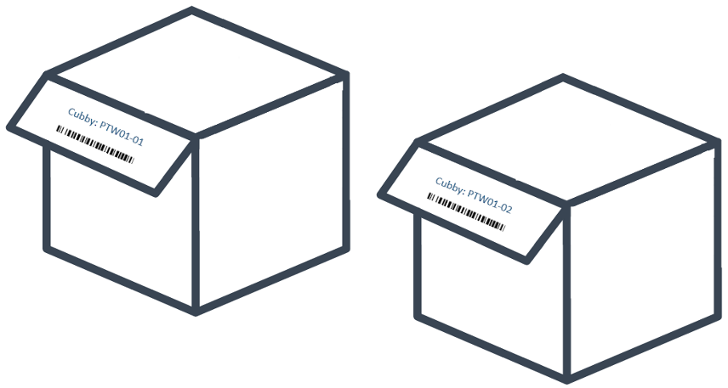
Figure 21 - Example of two dynamic cubbies

User Stories

User Story: Pre-VAS Order Sort

Who | What | Why
Pre VAS Associate | Sort bulk picked units into a tote/cubby by Production Order. | Group the materials needed to fulfill a production order.

Assumptions
- Multiples associates can sort to the same sorting area from distinct gurneys or totes assigned to each associate.

Process

- User navigates to the "Pre-VAS Order Sort" menu option within WM Mobile.
- MAWM prompts for a Putwall ID.
- User scans the Putwall ID at the assigned Pre-VAS Putwall area.
- MAWM prompts for a Tote ID / Gurney ID.
- User scans the Tote ID.
- MAWM prompts for an item.
- User scans an item barcode (UPC) of any item from the scanned tote.
- MAWM search for the Olpn with an open sort demand for the scanned UPC.
- MAWM prompts user to scan cubby
  - First unit for an oLPN?
    - Yes – User scans an empty cubby from the putwall
    - No – User scans the displayed cubby where other units for the oLPN have been previously sorted
- MAWM checks if the sorting process is completed for the Olpn, IF true THEN:
  - MAWM prompts the user with a "Clear Cubby" message.
  - User scans the cubby id [WM02] to accepts the message.
  - MAWM prompts for a tote ID.
  - User scan a tote ID.
  - User moves the tote to the opening station to print the “VAS Descriptor Label” for each unit. [WM25]
- ELSE, the user repeats steps 6 through 10 for the remaining items in the tote (scanned in step 5) or begins a new sorting process by scanning a new Tote ID in step 4.

Updates

- oLPN: Remains in picked status.
- A new LPN/Tote has been created for all items that belong to a production order.

Pre-VAS Sorting Exceptions

User Story: Gurney or Tote Inventory Discrepancies

Who | What | Why
Pre VAS Associate | Find misplaced gurney inventory | Gurney or Tote inventory discrepancy, physical quantity doesn’t match with MAWM.

There are scenarios where a product was not sorted properly in the HM sorter. In other cases, an item pick was confirmed, but the item was not placed in the gurney.
The Pre-VAS associate will investigate the discrepancy by reviewing the "LPN Inventory" SCI report to check the remaining contents of the gurney and then searching for the missing item in previous processing areas, as follows:
- The associate will check the gurney containing unsorted items from the HM sorter for the missing item.
- If the base SKU is not found in the unsorted HM items, or if the gurney or tote being used for Pre-VAS Order Sort is coming from a pick location, the associate will review whether inventory is available at the pick location. If inventory is available, they will adjust the inventory from the active location using a reason code defined in Lands' Pre-VAS Picking SOP.
- If no more inventory is available to replace the missing items, the associate will proceed to close the gurney following the Close Container user story.

User Story: Clear Pre-VAS Putwall

Who | What | Why
Pre VAS Associate | Release a Pre-VAS putwall cubby to use for sorting process. | Move incomplete sorted product from Pre-VAS putwall to a chase putwall.

The "Clear Pre-VAS Cubby" transaction is used when the user, either by mistake, did not clear the cubby during the sorting process, or when the production order or demand quantity was canceled using the "Close Container" transaction, a short pick, or a demand cancellation during chase wave allocation.
The "Clear Pre-VAS Putwall" transaction involves removing the sorted inventory from the respective sorter locations to send the sorted products to the next step of the order fulfillment process, which is the Pre-VAS opening station for the Production Orders fulfillment flow. At the opening station, the descriptor label is printed from MAWM, and the production paperwork is printed from SAP before the items are either moved to the production location or sent to a shipping area to dispatch the items to an outsourced VAS provider.

Process

- User navigates to the "Clear Pre-VAS Putwall" menu option within WM Mobile.
- MAWM prompts for a Putwall ID.
- User scans the Putwall ID at the assigned Pre-VAS Putwall area.
- MAWM search the putwall cubies that ready for packing.
- IF a ready to clear cubby is found, MAWM prompts the cubby barcode to scan.
  - User scans the cubby barcode.
  - MAWM prompts for a tote ID.
  - User scan a tote Id from a blind LPN labels roll.
  - User moves the tote to the opening station to print the “VAS Descriptor Label” for each unit.
- ELSE MAWM display a message “No eligible sorter locations to be cleared for the scanned sorter. (PPK::0059)”

Updates

- oLPN: Remains in picked status.
- A new LPN has been created for all items that belong to a production order.

User Story: Close Container

Who | What | Why
Pre VAS Associate | Short pick the lines that are pending to be sorted that are not physically in the gurney or tote. | All physical item are sorted but the tote remains with pack allocations

While sorting inventory from a picked container (Tote/iLPN), a user may encounter instances where no inventory is found despite the system expecting more items to be sorted. In such cases, the user can click the “Close Container” button to initiate shortage updates for all outstanding sort details within that container. The “Close Container” option is enabled only for supervisors with the appropriate permissions to use it in the “Pre-VAS Order Sort” transaction.

Assumptions

- A default picked inventory exception reason code is configured with the “Pre-VAS Order Sort” criteria to consume the residual inventory and generate an inventory need to chase the allocated Olpn.

Process

- User navigates to the "Pre-VAS Order Sort" menu option within WM Mobile.
- MAWM prompts for a Putwall ID.
- User scans the Putwall ID at the assigned Pre-VAS Putwall area.
- MAWM prompts for a Tote ID / Gurney ID.
- User scans the Tote ID.
- MAWM prompts for item scan.
- User click “Close Container” from the menu action to short all open allocations sine the tote is already empty.

Updates

- oLPN: Remains in picked status.
- MAWM creates an order shortage to chase the current Olpn to the last know sort pack location.

User Story: Residual Putaway

Who | What | Why
Pre VAS Associate | Putaway non sorted items to an active or LPN location. | A production order may be canceled after picking has been completed. This can occur, for example, if inventory has been picked but cannot be sorted due to a lack of pack allocations for the associated LPN detail.

While sorting inventory from a picked container (Tote/iLPN), a user may encounter instances where inventory is found in the container, but there are no outstanding sort details. In this scenario, the residual inventory needs to be moved back to an active location or LPN-tracked location using an inbound putaway transaction.

Packing

Packing is the process of gathering and packaging items to prepare them for shipment to the customer. It involves selecting the right item(s) in the correct quantities and packaging them into a shipping container, known as an oLPN.

The packing functionality is designed to help clients achieve 100% shipping accuracy while increasing picking efficiency.
WM offers a single packing service for all types of packing transactions, including Put to Store, Pack Cubed or Non-Cubed from Tote or iLPN, and Bulk Packing for Retail or E-commerce orders.

The packing process can be initiated by scanning any of the drivers listed below, where the subsequent flow is determined by the packing criteria definition:

- iLPN
- Tote
- OLPN
- Packing Location
- Pack Cart
- Pick Label ID

The packing process can be completed in either of the following ways:

- As a single step, where items are picked from the location and directly packed into the OLPN.
- As a two-step process, where items are first picked from the location into a tote/iLPN and then later packed into the OLPN from the picked tote, or items are first picked from the location into a tote/iLPN and transferred to inventory at the packing location, and then later packed into the OLPN.

The various packing options and their supporting features during the packing process are further explained with the user stories provided below.

Assumptions

- Singles and large production orders always bypass the MHE Unit Sorter pack stations and are packed directly in MAWM using the Pack Station UI for Singles and WM Mobile Packing for Large Customer Orders.
- Order Instructions are displayed to the user during the packing process to instruct users to perform additional steps on containers before shipping. WM does not track if the action was completed by the user.
- Each Pack Station is configured with a valid printer for shipping labels, pack slips, and collates.
- All packing is performed in MAWM, there is no MHE packing process.
- Packing parcel oLPNs calls ProShip for shipping information and any required documentation.

User Stories

User Story: Putwall Olpn Sort (LE Putwall Sort)

Who | What | Why
Packing Associate | Sort bulk picked units into a Putwall cubby by Olpn Id | Units are sorted to a chute that holds a group of oLPNs. An additional sortation is required to be performed to sort the units into cubbies for individual oLPNs.

All oLPNs processed through the MHE Unit Sorter / MHE Pack Sorter are handled via a custom MAWM Mobile Outbound Sort transaction, “LE Putwall Sort” [WM02] which sort picked products into a Putwall cubies . Matthews and Sorter-X Unit Sorters contains a chute/bombay per pack station, each configured with an oLPN capacity matching the total cubbies used in MAWM for putwall sorting once all items are diverted into the pack station chute.
When items are sorted by the MHE, a sort completion message is sent to MAWM containing item and chute information. MAWM creates a Logical Tote [AU04] with this data, enabling packing associates to begin sorting items when all expected item are diverted into the pack station chute/bombay.
Non sortable Items follow a secondary process within the Matthews MHE system. Instead of being inducted onto the Matthews Unit Sorter, these items are taken to the pack station area at the beginning of the process and scanned using a Matthews handheld device. Upon scanning, the same sortation/divert process occurs as with the automated Matthews system, directing the user to place the item into a designated pack station or chute. This process follows the same MHE integration workflow as when an item is inducted into the MHE conveyor.
Matthews pack stations are equipped with a physical putwall with cubbies, while Sorter-X pack stations use a plastic divider labeled as a cubby to divide products on the pack station table by OLPN during the sorting process. This sorting process ensures that all required items are packed into a planned shipping container or OLPN.
In most cases, the first cubby is auto-cleared before the subsequent pre-sorted items (pile of items) are packed because Sorter-X has already sorted the items in the sequence of the required OLPNs. However, if the next subwave becomes active, the packer must transfer the consolidated items from the virtual cubby/plastic divider to a hospital putwall located beside the pack station. Physically, this putwall is a shelf divided into cubbies to facilitate package completion after triaging shortages; either by packing from a hospital chute or by a hospital runner completing item consolidation after a chase wave.
When a chute is full, an ALLOWPACK message is sent to MAWM, indicating it is ready for packing, a Green Light (Matthews Pack Stations) is turned on. If a chute is not marked as ready (LPN.Extended.Allowpack = 'false'), an error is displayed. However, supervisors can override this error if necessary.
After scanning the UPC or VAS Label (VAS Label ID / LpnId) and entering the Country of Origin (when required), MAWM displays the destination cubby. The associate places the item in the cubby and scans it. If it is the first item for an oLPN, a new cubby is assigned; otherwise, the item is directed to the pre-assigned/pre-selected cubby.
When a cubby is full, a message is displayed to inform the user that the oLPN has been fully sorted and the cubby is ready for packing into an Outbound LPN. Upon accepting the "oLPN Packed" message in WM Mobile, the oLPN’s Container Type and Container Size are shown to guide the user in selecting the appropriate bag or box for packing. If the suggested container is deemed unsuitable, the user can adjust the Container Type and Size in WM Mobile.
After packing, special instructions (if any) are displayed. Examples of special instructions used at Lands’ End include inserting shipping materials, fulfilling special customer requests, or applying a “Do Not Open Until {specified date}” sticker [WM02].
Once the instructions are reviewed, completed, and acknowledged in WM Mobile, a print confirmation screen indicates that the oLPN is packed and ready for documentation printing. MAWM sends a Ship Request to the ProShip, which returns a Tracking Number and shipping label. These documents are printed, and the container is placed on the conveyor. Finally, MAWM sends an MHE message to the shipping sorter with the oLPN information, ensuring it is diverted to the correct outbound shipping lane.

Outbound Sort Transaction:
- LE Sort to Putwall: EX02 Country of Origin disabled.
- LE Sort International: EX02 Country of Origin enabled.
- LE Sort to Hospital Putwall: EX02 Country of Origin enabled.

Assumptions

- Each pack station will contain a pre-printed tote id that are used to start the outbound manual sorting / putwall sorting in WM Mobile.
- The Sorter-X pack station table is segmented with cubby labels used to sort the pre-sorter product pile by OLPNs. If the auto-clear cubby message is not triggered after packing the second item pile (subsequent OLPN), the packer will manually pack out the sorted items into a bundle with a rubber band and apply an OLPN cross-reference blind label to identify it at the Hospital putwall.
- The Sorter-X pack station will have 21 tote labels per pack station, representing the active subwave. The tote ID will contain the items dropped from the Bombay.
- The Sorter-X pack station will have 21 hospital chutes per pack station, used for the integration between Sorter-X and MAWM to move non-sorted items when a sub-wave Bombay is manually opened due to not reaching sort completion.
- For VAS finished items, a VAS Label ID (Pre VAS LPN Id) is used instead of a UPC barcode [WM02].

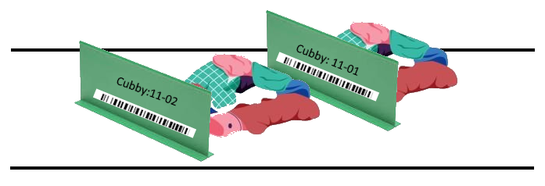
Figure 22 - Sorter-X Cubby Dividers
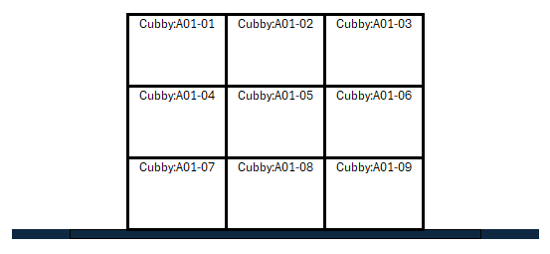
Figure 23 - Matthews Pack Station Putwalls

Process
- User enters WM Mobile and navigates to the “LE Putwall Sort” Transaction.
- System then prompts for a Putwall ID .
- User scans the Putwall ID (Pack Station ID) at the packing area.
- System prompts for a Tote ID. (Sorter-X pack station will have 21 Tote Labes per pack station that represent the active subwave, the Tote Id will contain the items dropped from the bombay)
- User scans the Tote ID (Chute ID in Matthews).
- MAWM prompts for Item Barcode scan.
- Users scan the Pick Label (VAS Label Id) or Item Barcode and WM02 search the appropriate records based on the scanned barcode.
- IF is an International Pack station then MAWM prompts for Country of Origin if required [WM02]
  - User selects the Country of Origin from Item if required.
- MAWM prompts user to scan cubby
  - First unit for an oLPN?
    - Yes – User scans an empty cubby from the putwall or Sorter-X pack station table position.
    - No – User scans the displayed cubby where other units for the oLPN have been previously sorted
- MAWM checks if the sorting process is completed for the Olpn, IF true THEN:
  - MAWM display “Clear Cubby” message.
  - User scan the cubby barcode to clear the message. [WM02].
    - MAWM invokes the packing transaction linked to OB Sort Transaction [WM02].
    - MAWM display Pack Order Instructions
    - User Taps WM Mobile screen to confirm.
    - MAWM display oLPN Type/Size
    - User taps WM Mobile screen to confirm.
    - oLPN goes to packed status.
    - If oLPN shipping mode is Parcel then MAWM sends ship message to Pro-Ship.
      - ProShip send the Shipping Label information back to MAWM to print.
      - oLPN goes to “Manifested” status.
    - Shipping Label is printed.
    - Packing Slip is printed if required.
    - User applies label and other shipping documents as required.
    - User places oLPN on the shipping conveyor belt.
- ELSE, User repeats steps 6 to 10 for the remaining items in the tote/chute (scanned in step 5) or begins a new sorting process by scanning a Chute ID/ Tote ID in step 4.

Updates
- oLPN goes to Manifested status if it a Parcel shipment else goes to Packed status.
- oLPN is updated with a Carrier Tracking Number if it is shipped via a parcel carrier.
- Order Line status updated if all units are packed.
- MHE message sent to Shipping Sorter.

User Story: Gift Box Putwall Sort
Who | What | Why
Packing Associate | Sort bulk picked units into a Putwall cubby by Olpn Id (Gift Box) | Units are sorted to a chute that holds a group of oLPNs. An additional sortation is required to be performed to sort the units into cubbies for individual oLPNs.

Process
- User navigates to the "LE Gift Box Putwall Sort" menu option within WM Mobile.
- MAWM prompts for a Putwall ID.
- User the Putwall ID (Pack Station ID) at the packing area.
- MAWM prompts for a Tote ID / Chute ID.
- User scans the Tote ID (Chute ID in Matthews).
- MAWM prompts for an item.
- User scans an item barcode (UPC) of any item from the scanned tote.
- MAWM search for the Olpn with an open sort demand for the scanned UPC.
- MAWM prompts user to scan cubby
  - First unit for an oLPN?
    - Yes – User scans an empty cubby from the putwall
    - No – User scans the displayed cubby where other units for the oLPN have been previously sorted
- MAWM checks if the sorting process is completed for the Olpn, IF true THEN:
  - MAWM prompts the user with a "Clear Cubby" message.
  - User scan the cubby for verification the cubby that they are clearing.
  - MAWM prompts for a tote ID
  - User scan a tote Id from a blind LPN labels roll /paper pile (pre-printed tote id)
  - User bundles the gift box items with the LPN paperwork and secures them with a rubber band.
  - User place the gift-box items into a gurney.
- ELSE, the user repeats steps 6 through 10 for the remaining items in the tote (scanned in step 5) or begins a new sorting process by scanning a new Tote ID in step 4.

Note: One the gift box gurney is full and it is moved to the Gift-Box pack station area to complete the packing.

Updates

- oLPN: Remains in picked status.
- A new LPN/Tote has been created for all items that belong to a production order.

User Story: Pack Station UI
Who | What | Why
Packing Associate | Pack oLPNs at Pack Station UI | Singles oLPNs are pulled together via full iLPN pulls or a dedicated tote. Singles packing allows for packing without a secondary sortation process.

Single unit customer orders or large production orders are packed using the MAWM Pack Station UI.

Users begin by selecting their pack station ID in the MAWM Pack Station UI. Next, they scan an iLPN, Tote ID, or Gurney ID to view its contents and the associated oLPNs to be packed.
After scanning an iLPN, the user scans the item's UPC barcode to associate it with the highest-priority oLPN. MAWM does not require quantity verification for single-item packs.
For specific workflows (e.g., Completed VAS, Returns, or GOH), pick labels are used for packing. If a pick label is available, users should scan its ID instead of the UPC barcode [WM02].
For international orders, MAWM prompts the user to enter the item's country of origin [WM02]. If no country of origin is required, the item is packed, and a ship request is sent to EPI. Once the shipping label is received, it is printed and applied to the container. Additionally, MAWM sends an MHE message to the sorter to ensure proper shipping lane diversion.

Process
- User navigate to the Pack Station UI in MAWM and selects their current Station ID.
- MAWM prompts for a Tote or GurneyId/IlpnId.
- User scans Tote ID/iLPN to pack out of.
- MAWM prompts for an Item.
- User scans VAS Label ID or Item barcode [WM02].
- MAWM checks of COO is required [WM02].
  - Yes – MAWM displays custom pop-up for user to select COO from.
  - No – No Pop Up displayed to the user.
- Unit is packed against proper detail.
- IF an Olpn goes to packed status
  - If oLPN shipping mode is Parcel then MAWM sends ship message to Pro-Ship.
    - ProShip send the Shipping Label information back to MAWM to print.
    - oLPN goes to “Manifested” status.
  - Shipping Label is printed.
  - Packing Slip is printed if required.
  - User applies label and other shipping documents as required.
  - User places oLPN on the shipping conveyor belt.
- User repeats steps 4-8 until all units in tote are packed.

Updates
- oLPN goes to Packed or Manifested status if the Olpn ship mode is parcel.
- oLPN is updated with a Tracking Number if the Olpn ship mode is parcel.
- Order Line status updated to Packed.
- MHE message sent to Shipping Sorter.

Pack Station UI (Single Olpn Tote)
Who | What | Why
Packing Associate | Pack oLPNs at Pack Station UI from a single Olpn tote. | Pack Olpn from a tote.

Pack Station UI for single olpn tote is used to completed the packing process of gift boxes orders.

Process
- User navigate to the Pack Station UI in MAWM and selects their current Station ID.
- MAWM prompts for a Tote or iLPN (VAS Label Id).
- User scans Tote ID/iLPN to pack out of.
- It is a Single Olpn Tote (All tote details are allocated to same Olpn).
  - Yes – Assign Olpn Cross Reference Label.
- MAWM prompts for an Item
- User scans VAS Label ID or Item barcode [WM02]
- MAWM checks of COO is required [WM02]
  - Yes – MAWM displays custom pop-up for user to select COO.
  - No – No Pop Up displayed to the user.
- Unit is packed against proper detail.
- IF an Olpn goes to packed status
  - If oLPN shipping mode is Parcel then MAWM sends ship message to Pro-Ship.
    - ProShip send the Shipping Label information back to MAWM to print.
    - oLPN goes to “Manifested” status.
  - Shipping Label is printed.
  - Packing Slip is printed if required.
  - User applies label and other shipping documents as required.
  - User places oLPN on the shipping conveyor belt.
- User repeats steps 4-8 until all units in tote are packed.

Updates

- oLPN goes to Packed or Manifested status if the Olpn ship mode is parcel.
- oLPN is updated with a Tracking Number if the Olpn ship mode is parcel.
- Order Line status updated to Packed.
- MHE message sent to Shipping Sorter.

User Story: Large VAS Customer Orders (Non-Cube Packing Flow)

Who | What | Why
Packing Associate | Pack non-cubed units from iLPN into oLPNs via WM Mobile | Pack non cubed units for a large VAS Customer Order.

Large VAS customer orders with the fulfillment code "L" (Order Extended Attribute) are allocated from gurneys or totes located at a post-VAS receiving floor location. The order lines may be allocated across multiple gurneys or pallets before being moved to a designated packing area (Large VAS Order Packing Zone). In this area, packers pack the finished goods into shipping containers, determining the specific container type during the packing process.

Process

- User enters the WM Packing transaction in WM Mobile.
- MAWM prompts for a iLPN or Tote ID or Gurney ID.
- User scans an tote/ilpn barcode.
- MAWM prompts for a Container Type and Size.
- User selects the appropriate container type and size.
- MAWM prompts for an Item.
- User scan the VAS Label ID or Item Barcode and WM02 search the appropriated records based on the scanned barcode.
- MAWM checks of COO is required [WM02].
  - Yes – MAWM displays custom pop-up for user to select COO.
  - No – No Pop Up displayed to the user.
- Unit is packed against proper detail.
- IF an Olpn goes to packed status
  - If oLPN shipping mode is Parcel then MAWM sends ship message to Pro-Ship.
    - ProShip send the Shipping Label information back to MAWM to print.
    - oLPN goes to “Manifested” status.
  - Shipping Label is printed.
  - Packing Slip is printed if required.
  - User applies label and other shipping documents as required.
  - User places oLPN on the shipping conveyor belt.
- User repeats steps 4-8 until all units in tote are packed.

Updates

- oLPN goes to packed status and then to manifested status.
- Tracking Number for oLPN is updated if the Olpn ship mode is parcel.
- Order Line(s) status updated to Packed.
- MHE message sent to Shipping Sorter.

User Story: Pre VAS Packing (Descriptor Label Print)

Who | What | Why
Pre VAS Associate | Pack production order items. | Pack Pre VAS oLPNs and print VAS descriptor label.

To start the production order process, Lands’ End VAS operations teams require that each picked unit be identified with a "VAS descriptor" label. This label is printed for each unit picked in a tote (e.g., tote, gurney, vendor box).
The VAS Opening Station prepares the production order materials by opening the item's original packages and packing them using a transaction in MAWM that invokes custom packing logic. This logic packs each unit into an outbound shipping container (oLPN), which subsequently serves as the pick label ID (VAS Label Id) after the VAS process is completed [WM25].
Additionally, an oLPN cross-reference number is assigned, consisting of the production order number concatenated with the sequence of the oLPN generated for the specific order line. This number is used to reprint a descriptor label if needed after the Pre-VAS packing process [WM25].
If the "Hemming Mono Indicator" is set to "true" for the Original Order Line (OrderLine.Extended.HemMonoIndicator), the system generates a VAS Machine barcode known as the Hemming Monograming VAS Machine Barcode (Eton will have a logic in the scanner to insert a dummy digits at the first 9 and 12 position to make the barcode compatible for ETON machine) (oLPN.HemMonoMachineBarcode) to be printed on the descriptor label [WM25].

Assumption

- The “Print Descriptor Label” is a custom MAWM packing mobile transaction [WM25].
- Heat transfer logos do not require a VAS descriptor label and are automatically packed with each base item scan as part of WM25.
- Name Badge Picking Container is a single Item Lpn in MAWM.
- Heat transfer orders are pack out after the heat transfer are married on a pre-vas putwall following Pre-VAS SOP process.

Process

- User navigates to “Print Descriptor Label” menu option in WM Mobile [WM25].
- MAWM prompts for a Source LPN Id.
- User scans an iLPN (Vendor LPN Id or Gurney ID or Tote Id generated from Pre-VAS Sorting process).
- IF scanned LPN/Tote is a Single Item LPN or a Name Badge Picking Container THEN
  - A “VAS Descriptor Label (Custom Olpn Shipping Label)” is printed with production order information for all Lpn details and each unit [WM25].
  - Otherwise MAWM prompts for an Item/UPC scan
    - A descriptor label is printed with production order information and auto generated LPN Id for a unit of the scanned item/UPC [WM25].
    - Steps 4b is repeated until all units and items are packed and labels are printed.
- Once items are tagged for production, the user moves them to the VAS processing area for In-House productions or nests them (outbound palletization process) into a transportation container for outsourced VAS.

Updates

- For the in-house VAS process, the oLPN is updated to a "packed" status and then to a "shipped" status after a few minutes via the oLPN planning scheduler.
- For the outsourced VAS process, the oLPN is updated to a "packed" status but remains in this status until it is shipped following the outsourced consolidation and shipping process, which includes palletization, truck loading, and shipping.

User Story: Put to Store - Packing
Who | What | Why
Packing Associate | Pack units from iLPNs to oLPN for shipping. | Fulfill store pack allocations for less than full iLPN quantity need to shipping.

For store pack allocations, users deliver iLPNs picked from reserve and totes picked from active to put to store packing zone. Users leverage Put to Store Mobile Packing transaction to pack the iLPN/tote inventory to oLPNs located in store pack locations.

Process

- User navigates to the “Put to Store” mobile transaction in WM Mobile.
- MAWM prompts for a iLPN/Tote Id to pack
- User scans an tote/ilpn barcode.
- MAWM directs to store pack location.
- User scans Olpn Id in store pack location.
- MAWM prompts for an Item.
- User scan the VAS Label ID or Item Barcode and WM02 search the appropriated records based on the scanned barcode.
- MAWM checks of COO is required [WM02].
  - Yes – MAWM displays custom pop-up for user to select COO.
  - No – No Pop Up displayed to the user.
- User repeats steps 4-8 until all units in tote are packed.

Updates

- iLPN inventory decreased and consumed after all units are packed out.
- oLPNs inventory increased.
- Pack Task details are completed.

User Story: Put to Store – Close Container
Who | What | Why
Packing Associate | Close oLPNs ready for shipping. | Systemically pack complete PTS oLPNs in preparation for shipping.

Users identify the opportunity to close PTS oLPNs in two ways. First, the packing associate identifies the oLPN physically reaches capacity and requires closing. Second, packing supervisors review an oLPN aging report to identify oLPNs reaching a certain timeframe requiring closure to ship the inventory. In either scenario, the operator leverages Put to Store end oLPN menu action to pack complete the oLPNs.

Process

- User navigates to the “Put to Store” mobile transaction in WM Mobile.
- MAWM prompts for a iLPN/Tote Id to pack
- User selects “End Olpn” menu action.
- MAWM prompts for oLPN to close
- User scans Olpn Id from store pack location

Updates

- Olpn is updated to Packed status.
- If oLPN shipping mode is Parcel then MAWM sends ship message to ProShip.
  - ProShip send the Shipping Label information back to MAWM to print.
  - oLPN goes to “Manifested” status.
  - Tracking Number for oLPN is updated.
- Shipping Label is printed.
- Packing Slip is printed if required.
- User applies label and other shipping documents as required.
- User places oLPN on the shipping conveyor belt.
- Order Line(s) status updated to Packed.
- MHE message sent to Shipping Sorter.

Packing Exceptions Stories

Exceptions during the packing process may occur for both putwall packing as well as singles pack station packing. An exception occurs when the expected inventory at the time of packing is not available to pack into the oLPN. Like a picking exception, MAWM creates an open Olpn Shortage to attempt to re-allocate the inventory to be picked and married up with the original oLPN.
Lands’ End runs a chase wave to allocate inventory only for shorted oLPNs. The chase inventory is picked into a tote by pack zone and are directed to the respective packing zone using outbound putaway strategy post-picking.
If chase allocations are re-waved and cannot be allocated, the shortage is canceled and the oLPN goes to a “picked” status in the exception putwall. oLPNs which have the shortages canceled can be processed with a Clear Outbound Sort location (“LE Clear Hospital Putwall) transaction to remove the oLPN from the exception putwall and to pack it at a Pack Station UI or in WM Mobile packing.
Alternatively, to circumvent the waving allocation cancellation process, users may manually cancel specific order or oLPN shortages via the Order Shortages UI. When a shortage is canceled, the same process mentioned above occurs where the oLPN in the putwall is now ready to be removed and packed.
This evaluation would need to take place during the packing process to determine if the oLPN being packed, or any oLPN associated with the order, has an inventory shortage. If there is a shortage, MAWM would display that the oLPN is to be canceled to the user so it may be taken to the proper area to be returned to inventory. The order and order line statuses would also be updated to canceled and order cancellation PIXs would be sent to the Host system.

User Story: MHE Chute Close (Matthews Pack Stations)

Who | What | Why
Packing Associate/MHE | Short remaining units at a Chute in MHE | Chutes are closed and inventory that was expected but did not arrive is shorted to be re-allocated.

The exception flow begins when the packing associate uses the MHE Light Indicator to determine if a chute has been closed in the MHE or manually closes the chute by pressing the PTL button. These processes close the current chute and short any remaining inventory that is assigned to chute, which may not have arrived. A Chute Close message is sent from Matthews to MAWM, containing the chute, batch, and shorted contents. MAWM processes the message and systematically shorts the inventory, creating chase needs for the oLPN so the missing inventory can be reallocated, picked, and matched with the original oLPN contents to be packed out in full.

Additionally, as part of WM08, further validations are performed when the Close Chute message is received by MAWM. WM08 checks for any remaining task details associated with the oLPN that are still in the MHE Unit Sorter Pack location or that have not yet been inducted. These task details are also shorted or marked to be shorted. These shorts are communicated to the MHE to eliminate the need on the MHE system, ensuring no units are jackpotted or sent to chutes with remaining needs on the MHE side.

After the chute contents are shorted in MAWM, users may now clear the contents of the incomplete cubby from the putwall frame into an oLPN to be moved to the exception putwall area. The Clear Outbound Sort Location transaction is selected in WM Mobile, the user scans the putwall frame that the cubby to be cleared exists in and scans the incomplete cubby to remove the contents. An oLPN must be associated to the contents of the cubby that is being cleared for an exception, after scanning the cubby to clear the contents the user scans a blind cross reference oLPN ID to move the contents into. This cross reference oLPN is used to transport the contents to the exception putwall where users perform a manual ‘Outbound Putaway’ to locate the oLPN contents into a new exception putwall cubby.
At times, inventory remains in the MHE Pack Location after a run due to exceptions. When this is required, a separate WM Mobile transaction is configured to Pack from Pack Location. When this transaction is entered, users can scan the MHE Pack Location and use the ‘Close Container’ action to short all the remaining inventory on the belt. As part of [AU01], this also sends an MHE message to Matthews to remove the inventory needs from the MHE system as well. This ensures that both systems are aligned with the shortages and order needs.
If packing is taking place via the Pack Station UI in MAWM and inventory is short, users select the ‘End Tote’ action on the UI to short the remaining units and create Chase needs for each unit in MAWM. Singles shorts are not required to go a putwall, these are fulfilled individually.

Assumptions

- The Close Container action is disabled in the WM Mobile device to prevent users from shorting the inventory during the sortation process, all shorts must come from the MHE system.
- “Close Container” action menu from Outbound Sorting transaction and “End Tote” action menu from pack station UI is controlled by resource permissions only allowed for the trouble-runners roles.

Process

- User performs Outbound Sort until all units for a chute have been sorted, but not all cubbies are empty
- Users force close the chutes in the Matthews by pressing the PTL button at the chute to close it
- Matthews sends a Chute Close message to MAWM.
- MAWM shorts any unsorted inventory from the current pack station tote/chute.
- MAWM invokes WM08 custom processes.

Updates

- Order Shortages are created for the shorted inventory at the oLPN level.
- Shorted inventory is moved to a ‘Lost’ bucket or into an iLPN.

User Story: Clear Putwall

Who | What | Why
Packing Associate | Clear contents from cubbies after chutes are closed | Cubby contents with shorted inventory must be removed so the next chute can be sorted into the putwall

Process

- User enters WM Mobile and navigates to the “LE Clear Putwall”.
- MAWM prompts for a Putwall ID.
- User scans the Putwall ID / Pack Station ID.
- MAWM prompts for a Cubby ID.
- User scans the Cubby ID that wants to clear.
- MAWM prompts for an oLPN ID.
- User scans the blind cross-reference oLPN ID to move the cubby contents.
- User performs a LE Hospital putaway to locate incomplete oLpn into the Hospital putwall.

Updates

- Cubby contents are moved to the oLPN which is next located to an Hospital cubby.
- Cubby is cleared and is available for new outbound sort process

User Story: Hospital Runner Putaway (Outbound Putaway – User Directed)

Who | What | Why
Packing Associate | Locate shorted oLPN contents to exception putwall. | Shorted oLPNs are located to an exception putwall where chase allocations are brought and married to the original oLPNs to be packed.

Process

- User enters WM Mobile and navigates to the “LE Hospital Runner OB Putaway”.
- MAWM prompts for an Olpn ID.
- User scans the cross-reference oLPN ID of the order with shorted contents.
- MAWM prompts for a Cubby ID (Location Barcode) in the Hospital area.
- User scans an empty Cubby ID in the designated exception putwall area (A metal shelf beside the pack station)

Updates

- oLPN contents are located to the exception putwall cubby.

User Story: Hospital Putwall Sort (Hospital Runner)

Who | What | Why
Hospital Runners | Sort shorted oLPN contents to exception putwall per pack station | Shorted oLPNs are located to an exception putwall where chase allocations are brought and married to the original oLPNs to be packed.

Assumptions

- Exception putwalls are configured for each unit sorter vendor, such as Matthews Exception Putwall (Sorter-A & Sorter B), and Sorter-X Exception Putwall, where the associated cubbies are physically located beside each pack station.
- Each exception putwall cubby is defined with a location ID prefix that identifies the corresponding pack station in the packing zone.

Process
- User navigates to the "LE Hospital Putwall Sort" menu option within WM Mobile.
- MAWM prompts for a Putwall ID (Matthews Hospital Putwall ID or Sorter-X Hospital Putwall ID).
- User scans the Putwall ID at the assigned to the pack station area.
- MAWM prompts for a Tote ID.
- MAWM prompts for Item Barcode scan.
- Users scan the Pick Label (VAS Label Id) or Item Barcode and WM02 search the appropriate records based on the scanned barcode.
- IF is an International Pack station then MAWM prompts for Country of Origin if required [WM02]
  - User selects the Country of Origin from Item if required.
- MAWM prompts user to scan cubby where Olpn with the shortages is located
- User scans cubby barcode to confirm the inventory movement.
- MAWM checks if the sorting process is completed for the Olpn, IF true THEN:
  - MAWM display “Clear Cubby” message.
  - User scan the cubby barcode to clear the message. [WM02].
  - User scans the blind cross-reference oLPN ID to validate and move the cubby contents to oLPN to move it to a Hospital Pack Station.
- ELSE, User repeats steps 6 to 10 for the remaining items in the tote/chute (scanned in step 5).

Updates
- oLPN: Remains in picked status.

User Story: Re-print VAS Descriptor Label
Who | What | Why
Pre-VAS Packing Associate | Re-print a VAS Descriptor label (Olpn Shipping Label) | Labels is damaged or missing.

Process
- User navigates to “Olpn 2.0” UI.
- User remove all defaults filters by clicking the “Clear All” button from the Filters sidebar.
- User type the Production Order ID as the “Cross Reference LPN” with an asterisk (*) at the end and presses "Enter.”
- MAWM searches for related OLPNs and limits the search results based on the entered values. If OLPNs are found, they are displayed. Otherwise, the message "No record found" is displayed.
- IF oLPNs are found:
  - Users selects the oLPN that corresponds to the damaged label ID.
  - User clicks the “More” button and selects “Print oLPN”.
  - User selects “Shipping label” as the “Document Template Type”.
  - User selects “VAS Descriptor Label” as the “Document Template”.
  - User selects printer closest to them and clicks the “Submit” button.
- ELSE, user repeats step 3-5 until they find the required oLPN to be printed.

Updates
- VAS Descriptor label is printed.

MHE Messages
Reference to Lands' End's MHE Communications Document for detailed information on MHE touchpoints and message formats.

Features
None Identified

Key Interfaces
None Identified

Reports, Dashboards, Alerts
Name | Description | Frequency | User/Dept | Type
Orders with Shortages | Displays orders with open PSI records which require a chase wave to be run for allocation. | As needed | Wave planner | SCI Report

Gaps and Extensions
Gap # | Name | Description
WM02 | Country of Origin Capture at Packing | Items on Orders with an international destination must capture the Country of Origin for each unit at the time of packing.  This is required for both Outbound Sortation Packing and Pack Station UI
WM02 | Display Special Instructions during Outbound Sort | During the Outbound Sort process, when a user is taken info the packing process, any Special Instructions (Order Instructions) required for the order must be displayed to the user. If there are multiple instructions, they are all displayed to the user. This includes inserts and catalogs.
WM02 | VAS Requirements | This is an all-encompassing gap for the VAS special processes:  1. VAS Pick Label ID  2. Consume Tote Contents to Inventory  3. Cancel Order Line Qty on consumption  4. Retail Pick Label ID on inventory as attribute  5. Message to SAP/ EOM with Pick Label ID to Allocate by Pick Label ID
WM25 | Pre VAS Packing and Descriptor Label Print - Mobile Transaction | Pack Pre VAS Items and generate print descriptor label.

Labor Management
Labor management details need to be added after LM design sessions.

Outbound Putaway
The outbound putaway is the process of moving any outbound containers into a packing location after picking them up or to a consolidated location after packing. It is supported in both tasking and non-tasking (stand-alone) mode. After the users pick the allocated items into a tote/iLPN/oLPN, if they need to be directed to a pack location to place the picked container, then Outbound Putaway is used to do this. Similarly, once the oLPN is packed, if the user needs to be directed to the consolidated location to place the packed oLPN, outbound putaway transaction is used to achieve this as well.

Assumptions
- Store Pack Location Determination is used during wave only for Store Orders and Replen Store Orders
- Order Type, Order Fulfillment Code, Order Enterprise Code, and Order Destination Facility (Production Plan) are the minimum order attributes used to drive Outbound Putaway for Production Orders.
- Customer Orders are putaway to a staging location (other pack locations) based on packing requirements (e.g. MHE Induction location, Single Pack Station location, etc.).
- Pick Task Creation groups picking tasks at least by order type, enterprise code, and fulfillment code. Please refer to the task creation strategy and criteria for additional details.

Pre-VAS Putaway Strategy
The "Pre-VAS Putaway Strategy" defines the outbound putaway criteria used to guide the picker or "Pre-VAS" associated to the appropriate packing location based on business rules associated with the "Pack Location Determination Strategy.

Stevens Point Putaway Flow
The following table provides a macro overview of the outbound putaway flow based on the fulfillment code of the Stevens Point production orders.
Heat Transfer Production Orders
FC | Outbound Putaway Flow
S | Pick Complete > Ship Dock > Load Truck> Rec Dock > Pre-VAS Putwall > Pre-VAS Opening Station
M | Pick Complete > Ship Dock > Load Truck> Rec Dock > HM Sorter > MHE Induction > Pre-VAS Putwall > Pre-VAS Opening Station
L | Pick Complete > Ship Dock > Load Truck> Rec Dock > Pre-VAS Putwall > Pre-VAS Opening Station
Note: FC = Order.Extended.FulfillmentCode
Non Heat Transfer Production Orders
FC | Outbound Putaway Flow
S | Pick Complete > Ship Dock > Load Truck> Rec Dock > Pre-VAS Opening Station
M | Pick Complete > Ship Dock > Load Truck> Rec Dock > HM Sorter > MHE Induction > Pre-VAS Putwall > Pre-VAS Opening Station
L | Pick Complete > Ship Dock > Load Truck> Rec Dock > Pre-VAS Opening Station
Note: FC = Order.Extended.FulfillmentCode

Dodgeville Putaway Flow
The following table provides a macro overview of the outbound putaway flow based on the fulfillment code of the Dodgeville production orders.
Dodgeville Production Orders
FC | Outbound Putaway Flow
S | Pick Complete > Pre-VAS Opening Station
M | Pick Complete > HM Sorter > MHE Induction > Pre-VAS Putwall > Pre-VAS Opening Station
L | Pick Complete > Pre-VAS Opening Station
Note: FC = Order.Extended.FulfillmentCode

Stevens Point Shipping Dock Putaway Criteria (Tasking)
The Stevens Point Pre-VAS Outbound Putaway is triggered after pick completion from either the “SP Case Pick” , “HM07 Case Pick” or “SP Act Pick” , “HM07 Act Pick” transactions.
Putaway Flow
- Pick Complete à Stevens Shipping Dock
Outbound Putaway Criteria
- Criteria Name: Stevens Point Shipping Dock Putaway
- Transaction Id: SP Ship Dock
- What should be the Destination Location Determination Mode? System-determined
- Pack Location Determination Strategy: Stevens Point Staging Determination (Other Pack Locations)
- Task Creation Strategy : Stevens Point Shipping Dock Putaway

Stevens Point Load Trailer (WM Mobile)
The Stevens Point Load Trailer Outbound Putaway transaction, accessed from the WM Mobile menu, moves picked inventory to a trailer location for tracking "In-Transit" inventory.
Putaway Flow
- Stevens Shipping Dock àStevens points “In-Transit location”
Outbound Putaway Criteria
- Criteria Name: SP Load Trailer
- Transaction Id: SP Load Trailer
- What should be the Destination Location Determination Mode? System-determined
- Pack Location Determination Strategy: Stevens Point Truck Location (Other Pack Locations)
- Task Creation Strategy : SP Load Trailer

Assumptions
- SOP is followed to determine the Pallets and gurneys that needs to be loaded to the truck using “SP Load Trailer.

Process
- User The user navigates to "SP Load Trailer”
- WM prompts the user to scan an outbound container, gurney, or pallet.
- WM executes the Outbound Putaway Strategy and Criteria to determine the available truck location.
- WM prompts for a "Truck Location" (Other Pack Location)
- The user scans location barcode.
- The user repeats steps 2–5 until all required pallets and gurneys are moved to the truck.
- The user prints two copies of the Stevens Point manifest report [SCI Report] for the truck driver’s acknowledgment.

Updates
- Inventory is moved to an “In-Transit” truck location.
- PIX is sent to SAP to notify the inventory is moved from Dodgeville to an “In- transit inventory bucket” to “SP”. [GAPD31]

Note: A PIX transaction needs to be generated from MAWM to SAP to move inventory from the Dodgeville facility to the Stevens Point inventory bucket in SAP [GAPD31]. The base solution will require manually applying the Condition Code to the LPNs from the LPN UI after OB putaway completion.

Stevens Point Unload Trailer (WM Mobile)
The Stevens Point Unload Truck Outbound Putaway transaction, accessed from the WM Mobile menu, moves "In-Transit" inventory to a Stevens Point pack location serving as a "Receiving Staging" area for production orders.
Putaway Flow
- Stevens points “In-Transit location” à Stevens Point Receiving Dock Location
Outbound Putaway Criteria
- Criteria Name: SP Unload Trailer
- Transaction Id: SP Unload Trailer
- What should be the Destination Location Determination Mode? System-determined
- Pack Location Determination Strategy: Stevens Point Receiving Location (Other Pack Locations)
- Task Creation Strategy : SP Unload Trailer
Note: Stevens Point Receiving Location Strategy, is configured with one catch all criteria

Process
- User The user navigates to "SP Unload Trailer”
- WM prompts the user to scan a container, gurney, or pallet.
- User scan a gurney or pallet id to be unloaded.
- WM executes the Outbound Putaway Strategy and Criteria to determine the next location.
- WM prompts for a "Stevens Point – Receiving Dock Locations” (Other Pack Location)
- The user scans a location barcode to complete the putaway process.
- The user repeats steps 2–6 until all required pallets and gurneys are unloaded from the truck.

Updates

- Inventory is moved from the “In-Transit” truck location to a receiving dock location located at Steves Point.
- PIX is sent to SAP to notify the inventory is moved from “in transit inventory bucket” to “SP” stock bucket.[GAPD31]

Heat Transfer Logo Outbound Putaway (Tasking)
The Heat Transfer Logo Outbound Putaway is triggered after pick completion from "HT Logo Pick" picking transaction.
Putaway Flow
- Pick complete à HT Putwall Staging
Outbound Putaway Criteria
- Criteria Name: Heat Transfer Putwall Staging
- Transaction Id: HT Putwall Staging
- What should be the Destination Location Determination Mode? System-determined
- Pack Location Determination Strategy: Heat Transfer Staging Determination (Other Pack Locations)
- Task Creation Strategy : HT Putwall Staging

HM06 Outbound Putaway (Tasking)
The HM06 Outbound Putaway is triggered after pick completion from either the “HM06 Case Pick” or “HM06 Act Pick” pick transactions.
Putaway Flow
Pick Complete à HM06 Staging
Outbound Putaway Criteria
- Criteria Name: HM06 Staging Putaway
- Transaction Id: HM06 Putaway
- What should be the Destination Location Determination Mode? System-determined
- Pack Location Determination Strategy: HM06 Staging Zone (Other Pack Locations)
- Task Creation Strategy : HM06 Staging Putaway

Pre-VAS Opening Station Putaway (Tasking)
The Pre-VAS opening station putaway is triggered after pick completion from either the VAS LPN Pull or VAS Ack Pick or HEM VAS Act Pick , HEM VAS Act Pick , Name Bdg Pick transactions.
Putaway Flow
- Pick Complete à Pre-VAS Opening Station
Outbound Putaway Criteria
- Criteria Name: Pre-VAS Opening Station Putaway
- Transaction Id: Pre-VAS OST
- What should be the Destination Location Determination Mode? System-determined
- Pack Location Determination Strategy: Pre-VAS Opening Station Zone (Other Pack Locations)
- Task Creation Strategy : Pre-VAS Opening Station Putaway

Pre-VAS Putaway (WM Mobile)
The Pre-VAS Putaway criteria, accessed from the WM Mobile menu, move staged inventory to the next packing location based on the configured Pack Location Determination Strategy rules.
Putaway Flow
- Pack Location à Next Pack Location
Outbound Putaway Criteria
- Criteria Name: Pre-VAS Putaway
- Transaction Id: Pre-VAS OB Putaway
- What should be the Destination Location Determination Mode? System-determined
- Pack Location Determination Strategy: Pre-VAS Pack Location (Other Pack Locations)
- Task Creation Strategy : Pre-VAS Putaway

MHE Induction Putaway Strategy

Sorter A, Sorter B and Sorter X MHE Induction Putaway (Tasking)
The “Sorter A, Sorter B and Sorter X MHE Induction” putaway is triggered after pick completion from either the “MHE LPN Pull” or “MHE Bulk Pick” transactions, for Sorter A, Sorter B, and Sorter X, based on the corresponding induction pick transaction associated with each induction point or manually from “MHE Induction” WM mobile menu transaction.
Putaway Flow
- Pick Complete à Order Filling Belt à MHE Induction Putaway
- Manually from MHE Induction menu Item.
Outbound Putaway Criteria
- Criteria Name: AU03MHEInduction
- Transaction Id: “MHE Induction”
- What should be the Destination Location Determination Mode? System-determined
- Pack Location Determination Strategy: “Unit Sorter Induction Zone” (Other Pack Locations)
- Task Creation Strategy : “MHE Induction Putaway”
- Task Creation Strategy from Drop Location : No required

HM Sorter Induction Putaway (WM Mobile)
The “HM Sorter Induction” putaway is triggered manually from “HM Sorter Induction” WM mobile menu transaction when the product is ready for induction.
Putaway Flow
- Manually from MHE Induction menu Item.
Outbound Putaway Criteria
- Criteria Name: AU03MheInductionAndPickShortConfirmation
- Transaction Id: “HM Sorter Induction”
- What should be the Destination Location Determination Mode? System-determined
- Pack Location Determination Strategy: “Unit Sorter Induction Zone” (Other Pack Locations)
- Task Creation Strategy : “HM Sorter Induction Putaway”
- Task Creation Strategy from Drop Location : No required

LE Outbound Putaway Strategy
The "LE Outbound Putaway Strategy" defines the outbound putaway criteria used to guide the picker or floor associate to the appropriate packing location based on business rules associated with the "Pack Location Determination Strategy of each defined outbound putaway criteria.

Singles Pulls Putaway (Tasking)
The Singles Pulls putaway is triggered after pick completion from either the “Singles Pulls” or “Single Act Pick” transactions.
Putaway Flow
- Pick Complete à Singles Pack Station Zone
Outbound Putaway Criteria
- Criteria Name: Singles Putaway
- Transaction Id: Singles Putaway
- What should be the Destination Location Determination Mode? System-determined
- Pack Location Determination Strategy: Singles Pack Station Zone (Other Pack Locations)
- Task Creation Strategy : Singles Putaway

Put to Store Putaway (Tasking)
The Put to Store putaway is triggered after pick completion from either the “Store Pulls” or “Store Act Pick” transactions.
Putaway Flow
- Pick Complete à Store Packing Zone
Outbound Putaway Criteria
- Criteria Name: Put to Store Putaway
- Transaction Id: Put to Store Putaway
- What should be the Destination Location Determination Mode? System-determined
- Pack Location Determination Strategy: Put to Store Zone (Store Pack)
- Task Creation Strategy : Put to Store Putaway

Workstation Putaway (Tasking)
The Workstation putaway is triggered after pick completion from either the “Prepack Pulls” or “Prepack Act Pick” transactions.
Putaway Flow
- Pick Complete à Workstation
Outbound Putaway Criteria
- Criteria Name: Workstation Putaway
- Transaction Id: Workstation Putaway
- What should be the Destination Location Determination Mode? System-determined
- Pack Location Determination Strategy: Put to Store Zone (Workstation for Assembly and Disassembly)
- Task Creation Strategy : Workstation Putaway

Staging Putaway (Tasking)
The Staging putaway is triggered after pick completion from either the “Olpn to Pallet” or “Olpn Pick” transactions.
Putaway Flow
- Pick/Pack Complete à Staging Location
Outbound Putaway Criteria
- Criteria Name: Staging Putaway
- Transaction Id: OB Staging
- What should be the Destination Location Determination Mode? System-determined
- What should be the Consolidation Location Determination Strategy? “Staging Consolidation Criteria”
- Task Creation Strategy : Staging Putaway

Anchor Olpn (WM Mobile)
The Anchor Olpn “Follow the Leader” putaway transaction, accessed from the WM Mobile menu, moves packed inventory to a staging location, where it is consolidated either by “Shipment ID” when the order is part of a planned shipment, or by “Order ID” after packing is completed at the store pack location or when an Olpn is diverted by Matthews into an LTL/TL shipping lane.
Putaway Flow
- Pack Complete à Staging Location
Outbound Putaway Criteria
- Criteria Name: Staging Putaway
- Transaction Id: Anchor Olpn
- What should be the Destination Location Determination Mode? User-directed
- What should be the Consolidation Location Determination Strategy? “Staging Consolidation Criteria”
- Task Creation Strategy : Anchor Olpn

Process
- User The user navigates to "Anchor Olpn” menu option in WM mobile.
- WM prompts the user to scan an outbound container.
- WM executes the Outbound Putaway Strategy and Criteria to determine the Order consolidation location.
- WM prompts for a "Staging Location”
  - IF previous pallet is present, MAWM will prompt it to scan the pallet id
  - ELSE user opens a new pallet by scanning a pallet id from a blind label.
- The user repeats steps 2–5 until all required Olpns are consolidated in a pallet.

Updates

- Shipping containers are nested into a parent Lpn ID (gurney or pallet).
- Current location of the shipping container and pallet is updated with the scanned location ID.

Outbound Putaway (WM Mobile)
The “Outbound Putaway” transaction, accessed from the WM Mobile menu, is configured as a user-directed outbound putaway used in exceptional scenarios to move a container with order allocation to a user-specified location like a pack-and-hold location or any other shipping dock location. Additionally, this transaction can be used to remove an OLPN from a pallet (de-palletize) if required.
Putaway Flow
- User directed flow post picking or post packing.
Outbound Putaway Criteria
- Criteria Name: Outbound Putaway
- Transaction Id: Outbound Putaway
- What should be the Destination Location Determination Mode? User-directed
- What should be the Consolidation Location Determination Strategy? N/A
- Task Creation Strategy : N/A

Process
- User The user navigates to "Outbound Putaway” menu option in WM mobile.
- WM prompts the user to scan an outbound container.
- WM Prompt for a location barcode
- User scans the location barcode corresponding to the destination where he want to move the outbound container.

Updates

- The shipping container's location is updated with the current Location ID that matches the scanned location barcode.
- IF Olpn from a pallet was scanned, the Olpn is removed from the pallet and is updated with the current Location ID that matches the scanned location barcode.

Features
None Identified

Key Interfaces
Not applicable for this section

Reports, Dashboards, Alerts
Name | Description | Frequency | User/Dept | Type
Stevens Point Truck Manifest | Displays items loaded onto a Stevens Point truck that is located in an "in-transit" staging location in MAWM. | As needed | Shipping | SCI Report

Gaps and Extensions
None Identified

Labor Management
Labor management details need to be added after LM design sessions.

Shipping
After packing, conveyable oLPNs from both the putwall frames and singles pack stations are placed on a conveyor belt leading to the Shipping Sorter induction area. There, users scan each oLPN into the Matthews MHE Shipping Sorter, which directs it to the appropriate shipping lane based on the MAWM message sent at pack completion.
As oLPNs are diverted, the Matthews MHE system scans them for confirmation [AU01] and sends a divert confirmation message to MAWM with lane details. This updates the oLPNs' location in MAWM via MHE outbound putaway [AU01], where they are consolidated into bulk metal containers for loading onto parcel carrier trailer.
For truckload shipments, a shipping associate scans the shipping container using the “Anchor oLPN” transaction on a mobile device. This initiates the consolidation of oLPNs into pallets or totes based on the Shipment ID and stop ID or by Order Id if the Olpn is not planned in a shipment and the Order.Extended.ParcelRateShopGroupId is null

Assumptions
- ProShip owns and maintains manifests for parcel OLPNs, which are shipped via job schedule after the OLPN is diverted and put away into the parcel carrier divert lane.
- Once a shipment, order, or oLPN reaches "Shipped" status, it cannot be systematically updated.
- Appointments for outbound shipments are not used.
- Outbound Shipments are checked-in to an outbound shipping dock door when is ready for loading.
- Parcel oLPNs are not systemically loaded onto a trailer in MAWM. Loading is entirely driven by SOP.
- End of Day process is not used and Parcel Carrier manifest is managed in ProShip.
- No shipments are created in WM for oLPNs being shipped via parcel carrier.
- Outbound pallets can have oLPNs from different orders but must be on the same shipment.
- Outbound pallets and loose oLPNs can be loaded onto a shipment.
- Once a shipment is closed and/or oLPNs/orders are in ‘Shipped’ status, no additional systemic changes can occur to those entities.
- When a pallet needs to be unloaded from a trailer, a WM Mobile unloading transaction must be used to systemically unload the pallet. The pallet can be unassigned from the shipment or re-loaded to the same shipment.
- Shipments can be created, combined, or split via the Unified Logistics Control UI.
- The BOLs for shipments are printed when closed and given to the driver before departure.

Parcel Shipping

User Story: WM Mobile De-Manifest oLPN

Who | What | Why
Loading Associate | De-Manifest an oLPN | oLPNs may need to be de-manifested if a cut off time is missed, or inventory needs to be removed to it is not shipped.

Process

- User enters the WM Mobile De-Manifest Transaction in WM Mobile
- WM prompts the user to scan an oLPN
- User scans the oLPN ID that is to be de-manifested
- WM constructs Void Request EPI message for all oLPNs and sends to ProShip

Updates

- oLPNs go to Packed status on successful Pro response

User Story: WM Mobile Manifest oLPN

Who | What | Why
Shipping Associate | Manifest Individual oLPNs. | Ship oLPN with a parcel carrier.

Lands’ End uses the WM Mobile Manifest for exceptional flow, where an OLPN needs to be re-manifested or manually shipped after packing.

Process

- User enters the WM Mobile Manifest Transaction in WM Mobile.
- WM prompts for outbound container.
- User scans the oLPN.
- WM perform a EPI Ship request to ProShip.

Updates

- oLPNs go to Manifested status on successful ProShip response

User Story: Weight & Manifest oLPN in UI

Lands’ End also has the option to update an oLPN after the packing process if the shipping method initially determined must be changed or an update to the Container Type or Size is required. For these exceptions, Lands’ End users navigate to the Weigh & Manifest oLPN UI in MAWM where the oLPN ID to be updated is entered. MAWM pulls the current oLPN information and displays it to the user. Here users may update the actual weight, ship via, container type, container size, or the dimensions of the shipping container.

Olpn Planning Strategy
Who | What | Why
Job Schedule | Ship Confirm Olpn | Generate a ship confirmation message to SAP to perform a customer invoice and perform good issue.

Lands’ End use Olpn Planning Strategy to ship confirm all Parcel Olpn for Customer Orders in a manifested status.
The following job schedule is configured to auto-ship confirm the Olpns with the following criteria.
Parcel Order Olpn Ship-Confirm : Auto-ship confirm Olpn with ship date equal to current date in manifested status every configurable n minutes.
Note: Initial configuration will be configured to runs the job schedule every 20 minutes.

LTL Shipping
Orders planned for truckload shipments, including Transfer Orders, Outsourcing Production Orders, Store Orders and any other special order that needs to shipped non-parcel truck , are palletized by Shipment ID and stop ID or by Order Id if the Olpn is not planned in a shipment and the Order.Extended.ParcelRateShopGroupId is null.
When the carrier arrives for pickup, the Shipping Supervisor assigns the shipment to an available dock door for loading. If the oLPNs are staged near the shipping dock, the shipping associate uses the Load Trailer transaction after the trailer is checked in via the Shipment UI.
For Amazon Wholesale orders, shipments are planned in Amazon Seller Central, where carrier and shipment information is created. These shipments are not communicated to or planned within MAWM. Once all oLPNs for an Amazon Wholesale order are picked, packed, and staged in the order consolidation location, the Lands’ End team uses the Amazon Seller Central portal to plan the shipment. Using information from the portal, the user updates the corresponding shipment record in MAWM with the Bill of Lading (BOL) and trailer information.
After the shipment is planned and created in MAWM, a Shipping Supervisor can use the ULC user interface to modify the shipment as needed, such as by unplanning oLPNs or moving them to another shipment based on operational requirements.
When a shipment is ready for loading, a mobile user logs into a WM Mobile loading transaction to scan a pallet in the corresponding shipping lane. If the pallet’s shipment has been assigned to a dock door, WM displays the dock door, and the mobile user validates it. WM is configured not to allow users to assign a shipment to a dock door if it isn’t previously assigned. As each pallet is successfully loaded, WM updates the status of each oLPN on the pallet to ‘Loaded’ and clears the current location.
Once the shipment is fully loaded, the ‘Close shipment’ process is initiated through the Shipment UI, and WM checks if there are any oLPNs assigned to the shipment that are not loaded. If every oLPN is loaded, WM closes the shipment, initiates the ship confirm process for the oLPNs on the shipment, moves the inventory out of the 4-walls, and generates the appropriate documentation including bill of lading. If there is a variance of oLPNs that were expected to be loaded, WM displays an error, the shipment will remain open, and no further updates are made to the oLPNs on the trailer. If the user determines that the oLPN cannot be loaded onto the shipment for any reason, the user may choose to move the oLPNs to a new shipment.

User Story: Manual Shipment Creation
Who | What | Why
Shipping Associate | Manually Create Shipment for Order/oLPNs  Manually Assign Order/oLPNs to Shipment | Ship out inventory from warehouse and generate ship confirm for HOST

Process Steps
- Shipping Associate navigates to Unified Logistics Control UI and filters by Order or oLPNs.
- Shipping Associate selects Orders and/or oLPNs for Shipment.
- Shipping Associate adds Orders and/or oLPNs to Shipment:
  - If an existing Shipment does not exist, then select the ‘Manually Create Shipment’ option.
  - If an existing Shipment does exist, then select the ‘Assign to Shipment’ option.
- End Transaction.

Updates
- Order and/or oLPN(s) are assigned to selected Shipment
- Shipment is created or updated with selected Order/oLPN(s)

Screenshot
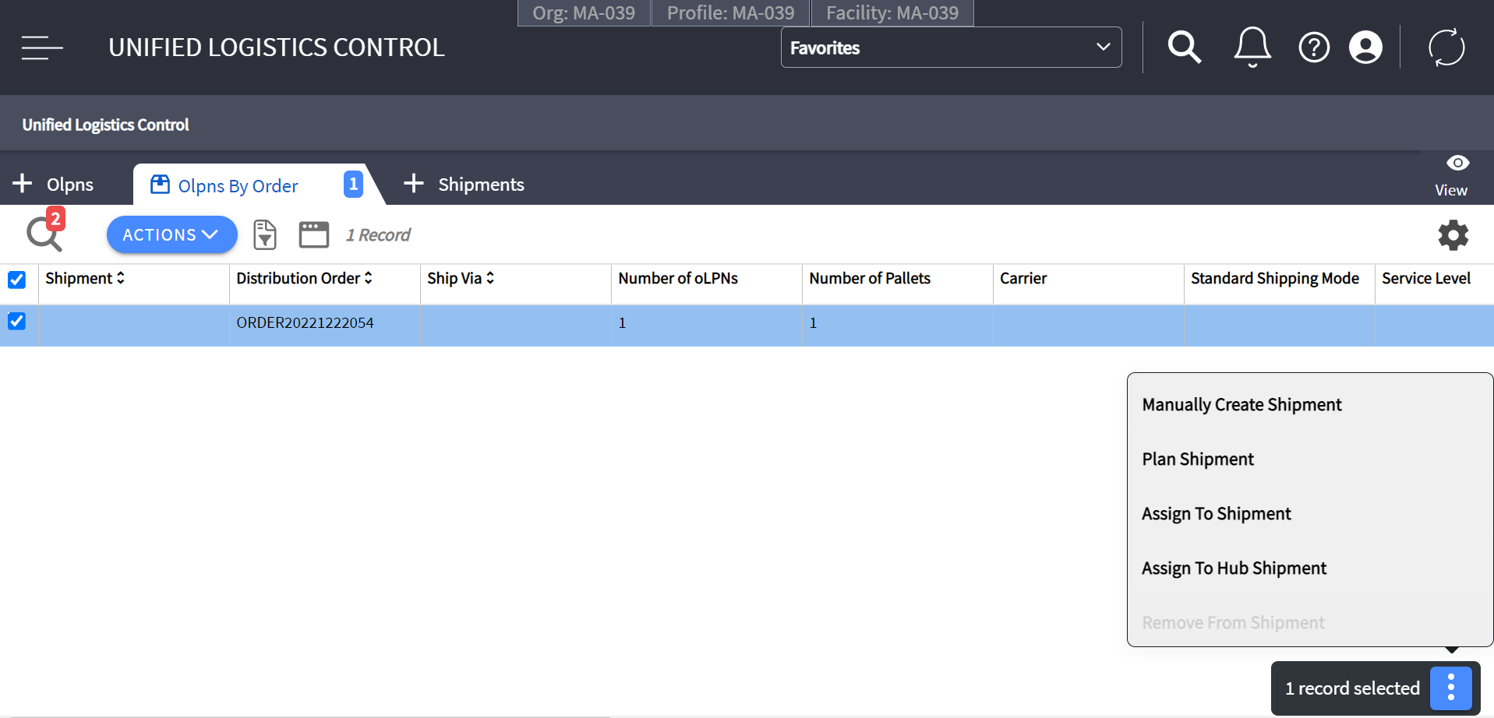

User Story: Shipment Updates
Who | What | Why
Shipping Associate | Update shipment information like BOL Number, Pro Number, seal, etc. | Shipment information needs to be updated based on the transportation planning provided by the customer, such as Amazon, etc.

Process Steps
- Shipping Associate navigates to Unified Logistics Control UI and filters for a Shipment.
- Shipping Associate selects the Shipment.
  - If an Shipment header information needs to be edited, then selects “Edit” menu action button. not exist, to edit the header information.
  - Else, clicks on the view button to view the shipment details and edit a specific detail like Bill of Lading number, Seals, Pro Number, etc.
- End Transaction.

Updates
- Order and/or oLPN(s) are assigned to selected Shipment
- Shipment is created or updated with selected Order/oLPN(s)

Screenshot
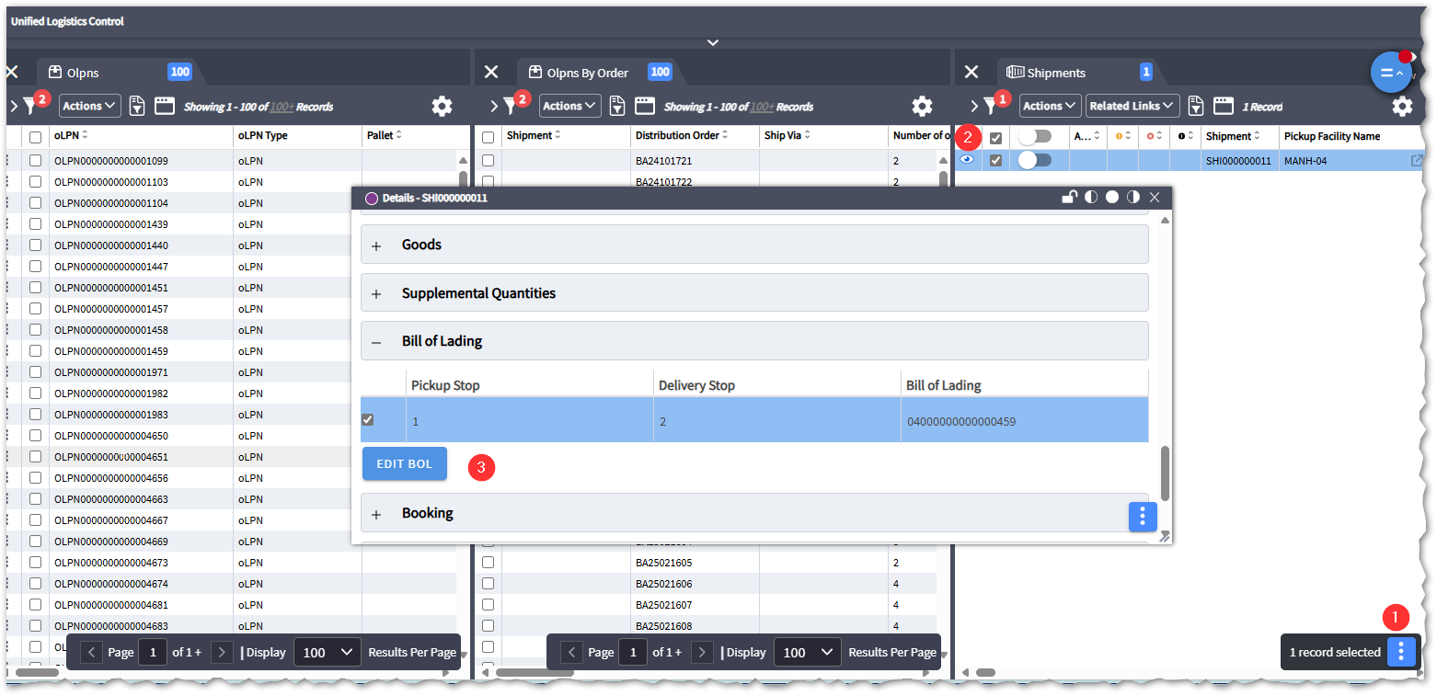

User Story: Load Trailer

Who | What | Why
Shipping Associate | Load oLPNs onto Trailer | Load packed oLPNs onto trailers to be shipped out of the warehouse

Load Trailer transaction is used when the oLPNs are consolidated in a dock door staging location before loading. This means multiple oLPNs are ready for a single shipment. A shipping associate checks in the shipment at a dock-door and then loads the oLPNs onto the truck one by one.

Assumptions
- Order consolidation locations or staging locations are used to consolidate truckload pallets and gurneys via outbound putaway post-packing.
- A shipment is check-in into a dock door.

Process
- User enters WM Mobile and navigates to the Load Trailer transaction
- MAWM prompts for a Dock Door.
- User scans Dock Door
- MAWM prompts for an Shipping Container ID (Olpn Id or Pallet Id)
- User scans Shipping Container ID
- User repeat step 3-4 for each Olpn in the shipping dock staging area.

Updates
- oLPN is updated to ‘Loaded’ status.
- Add the status of the shipment once all olpn are loaded.

User Story: Unload Olpn
Who | What | Why
Shipping Associate | Unload oLPNs onto the shipment | A previously loaded oLPN or outbound pallet may need to be unloaded for several reasons (e.g. Damaged during loading, over-weight truck, etc.)

Process

- User enters WM Mobile and navigates to the Unload Olpn transaction
- MAWM prompts for an Olpn
- User scans oLPN
- User repeat step 2-4 for each Olpn that needs to be unloaded.

Updates
- oLPN status is updated to “Packed” status.

User Story: Close Shipment
Who | What | Why
Shipping User | Close LTL/TL Shipment | Ship inventory from the warehouse

Once loading is complete, the shipment clerk initiates the Close Shipment process from the Shipment UI. During this process, WM updates the loaded oLPNs to Shipped status and generates a Ship Confirm/Invoice for the HOST.
If there are any variance oLPNs during the close shipment process, WM is configured to display the variance to the user. Per SOP, the user researches the variance before accepting to close the shipment. This permission may be disabled for certain users where supervisor involvement is desired. If the variance is accepted, WM is configured to either leaving the oLPN unplanned or transfer it into a new shipment based on the close shipment strategy configuration.
Lands’ End configures the Close Shipment / Close Trailer process to print the BOL documents. Alternatively, a user may choose to print documents from the fixed station Shipment UI or the WM Mobile Print Outbound Documents transaction.
Please see online help documents for more information on base flow: http://masc.helpdocsonline.com/close-shipment-process

Process
- Shipping employee navigates to Shipment UI and filters for shipment to close.
- Shipping employee selects shipment and selects the ‘Close Shipment’ option.
- Shipping supervisor clicks ‘Save’ to confirm shipment closure.
- If there are any variances, a warning message is displayed to the user.
- User accepts the warning message if the shipment is ready to be closed (despite the variance)

Updates
- Shipment updated to ‘Closed’ status.
- Loaded oLPNs updated to ‘Shipped’ status.
- Ship confirm (invoice) generated.
- Variance oLPNs are unassigned from the shipment,
- Bill of Lading report is printed.

Production Order Ship Confirm
The Order Ship Confirm Strategy UI allows users to configure rules to select orders for invoicing. WM does not notify the host that an order has shipped until it has been invoiced. Ship Confirm can be triggered manually through the UI, configured to run automatically on a scheduler, or configured to run upon end of day processing.
Lands’ End configure ship confirm scheduler to execute every 10 minutes to check the “In-House” productions orders with minimum and maximum status are equal to Staged (7400).
Selection Rule
Order.Extended.OutsourceVas = false
OriginalOrder.MaximumStatus = 7400 (Stage)
OriginalOrder.MinimumStatus = 7400 (Stage)

MHE Messages
Reference to Lands' End's MHE Communications Document for detailed information on MHE touchpoints and message formats.

Features
None Identified

Key Interfaces
Interface | Business Scenario
Ship Confirm | Provides information to HOST on shipped inventory for store invoicing purposes
Outbound ASN | Provides an LPN Level ASN that is receivable in the destination Facility

Reports, Dashboards, Alerts
Name | Description | Frequency | User/Dept | Type
Bill of Lading | Provides a detailed information such as Ship From, Ship To, Shipping Instructions and  Customer Order Information | As Needed | Shipping | WM Report
Outsourcer Truck Load Report | Provide a list of VAS descriptor labels sent to an Outsource VAS provider. | As Needed | Shipping | SCI Report
Shipment Statuses | Displays list of in-progress shipments | As Needed | Shipping | WM Report
oLPNs packed not shipped | Displays list of oLPNs which have been packed and manifested/loaded but not yet shipped | As Needed | Shipping | SCI Report

Gaps and Extensions
Gap # | Name | Description

Labor Management
Labor management details need to be added after LM design sessions.

Miscellaneous Warehouse Processes

User Stories

User Story: Audit oLPN

Who | What | Why
Shipping Associate | Audit a marked oLPN | oLPNs need to be audited on occasion to ensure quality and accuracy before shipping out of the warehouse.

Lands’ End plans to audit a certain percentage (10%) of oLPNs as they are packed before they can be shipped from the warehouse. In addition to auditing 10% of all oLPNs that are created, Lands’ End may configure additional audit percentages based on the user who packed the oLPN.
Outbound audits in MAWM are considered blind audits where users must confirm all contents in the oLPN without being prompted with what is expected to be in the oLPN. In addition to a SKU & Quantity audit, Lands’ End plans to check that the proper packaging was used, all the right inserts are available in the container, and a weight check to make sure inventory weights are accurate. These audits take place outside of MAWM.
oLPNs flagged for audit are marked with an ‘Audit Required’ indicator and are diverted down an Audit only lane if inducted to the Shipping Sorter. MAWM sends a flag on the MHE message to Matthews if an audit is required on an oLPN. MAWM is configured to not allow manifesting or loading of oLPNs requiring an audit.
If during the audit a variance is found, MAWM applies a variance condition code to the oLPN, and users may print an oLPN Variance report from MAWM with details of the variance. Lands’ End associates are required to research and fix the oLPN variance before auditing the oLPN again to remove the condition code.

Process

- User enters WM Mobile and navigates to the Audit oLPN Transaction
- MAWM prompts the user to enter an oLPN.
- The user scans the oLPN to be audited.
- MAWM prompts the user to scan an item.
- The user scans an item within the oLPN.
- If the item is not systemically present in the oLPN, WM displays an error message, and the user removes the item from the oLPN. If the item is systemically present, WM prompts for the quantity.
- MAWM prompts the user to enter the item quantity.
- The user enters the quantity for the item.
- If the entered quantity exceeds the expected quantity, WM displays an error message along with the expected systemic quantity, and the user removes the over-packed quantity from the oLPN. If the entered quantity is less than or equal to the expected quantity, WM returns to the item prompt.
- If there are more items in the oLPN, the user scans the next item. If there are no more items, the user selects the "End Container" option to complete the audit.
- WM evaluates whether a variance exists in the audit.
  - If a variance exists, the user is prompted to redo the audit, and the system returns to the item prompt.
  - If no variance is found, the audit is completed, and oLPN quantities remain unchanged.
- After the recount, if no variance is found, the audit is completed without any updates to oLPN quantities. If a variance still exists after the recount, oLPN quantities are updated to reflect the recount result.

Updates

- Audit Condition Code is removed from oLPN on successful audit
- oLPN locked with Condition Code on Variance Audit
- If inventory updates are enabled, oLPN inventory is updated after audit
- If shortage reason code is selected, MAWM creates an Order Shortage to be waved
- Variance inventory is consumed or moved to a lost inventory bucket depending on configuration.

User Story: Palletize oLPNs

Who | What | Why
Warehouse Associate | Palletize oLPNs | To group oLPNs onto a pallet via WM Mobile

Lands’ End may need to manually palletize oLPNs onto a pallet for outbound shipping or staging processes where a pallet may be scanned in place of individual oLPNs. This process also used transfers and off the shipping sorter.

Process

- User enters WM Mobile and navigates to the Palletize oLPN Transaction.
- WM prompts the user for the Pallet to assign oLPNs to
- User scans pallet ID
- WM prompts the user for oLPNs to assign to the pallet.
- User scans oLPNs to assign to the pallet
- User continues to assign oLPNs to the pallet until there are no more oLPNs or room on the pallet
- User selects the ‘End Pallet/Container’ action in the transaction to end

Updates

- oLPNs which were assigned has Parent LPN ID = Pallet ID

Acknowledgement
Your signature is required as proof of acceptance of the Customer Flow Document in its current state.
[LAND] |  | [LAND]
By:  Signature | _________________________________ | By:  Signature | _________________________________
Name:  Printed | _________________________________ | Name:  Printed | _________________________________
Title: | _________________________________ | Title: | _________________________________
Date: | _________________________________ | Date: | _________________________________

[LAND] |  | [LAND]
By:  Signature | _________________________________ | By:  Signature | _________________________________
Name:  Printed | _________________________________ | Name:  Printed | _________________________________
Title: | _________________________________ | Title: | _________________________________
Date: | _________________________________ | Date: | _________________________________

[LAND] |  | [LAND]
By:  Signature | _________________________________ | By:  Signature | _________________________________
Name:  Printed | _________________________________ | Name:  Printed | _________________________________
Title: | _________________________________ | Title: | _________________________________
Date: | _________________________________ | Date: | _________________________________

